CSV Folder Importer

Executive Summary
Automated CSV and Excel Import Service for SQL Server
June 3, 2026

Business Problem
Many business processes generate data in CSV or Excel format that must be loaded into SQL Server for reporting, analysis, or downstream processing. Manual import steps are error-prone, time-consuming, and difficult to schedule reliably. Operations teams need a simple, hands-off mechanism to keep SQL Server tables current without developer involvement each time new data arrives.

Solution
CSV Folder Importer is a lightweight Windows Service that automates the import of CSV and Excel files into SQL Server. It monitors a configurable root folder on the file system. Each subfolder within the root maps directly to a SQL Server table — when a file is dropped into a subfolder, the service detects it immediately and imports the data.

The solution requires no coding knowledge to operate. Business users simply drop files into the appropriate folder; the service handles everything else.

Key Features
- Automatic table creation — the first file dropped into a subfolder defines the table structure; no manual SQL required
- Immediate processing — files are detected within seconds via Windows file system events
- Scheduled safety net — a configurable periodic scan (default every 5 minutes) catches any files missed by real-time detection
- File archival — successfully imported files move to a timestamped archive; failed files move to a review folder
- Audit trail — all import activity logged to SQL Server with timestamps and severity levels
- Zero-downtime configuration — connection string, root folder, and polling interval configurable without redeployment
- Professional installer — Windows Installer (MSI) guides administrators through configuration and service setup in minutes

How It Works
Step | Action | Outcome
1 | Administrator creates a subfolder (e.g. Orders) under the root folder | Service begins watching that folder immediately
2 | User drops a CSV or Excel file into the subfolder | File is detected within seconds via FileSystemWatcher
3 | Service reads the file header row to determine column names | SQL table is created automatically on first import
4 | Data rows are bulk-loaded into the SQL table | Table is truncated and reloaded on each subsequent import
5 | File is moved to _Success or _Failed archive folder | Source folder stays clean; full history preserved with timestamps

Flow Diagram
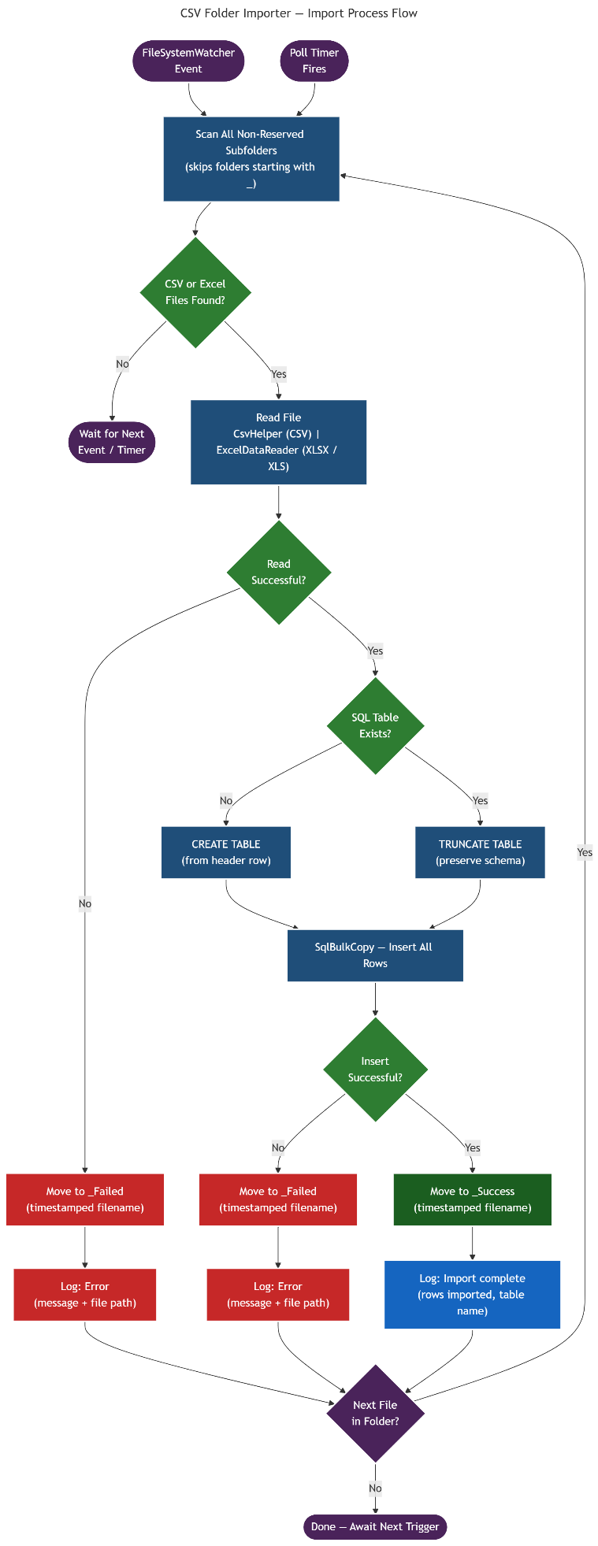

Technical Requirements
Requirement | Specification
Operating System | Windows 10 / 11 or Windows Server 2016+ (64-bit)
.NET Runtime | .NET 9 (framework-dependent deployment)
Database | SQL Server 2016 or later (Express edition supported)
File Formats | CSV (.csv), Excel 2007+ (.xlsx), Excel 97-2003 (.xls)
Installation | MSI installer; requires Administrator privileges
Network | TCP/IP access to SQL Server required from the host machine

Benefits
Benefit | Detail
Eliminates manual imports | Removes error-prone, repetitive steps from operations workflows
Seconds to data | Files are processed within seconds of arrival, not hours or days
Scales without code | Adding a new data feed requires only creating a subfolder — no development
Full audit trail | Every import is recorded in SQL Server with timestamp and outcome
Simple to operate | No developer needed for day-to-day operation
Self-healing service | Automatically restarts after failures with configurable recovery delay

Deployment
The solution is delivered as a single MSI installer. During installation, administrators provide the SQL Server connection string, the root folder path, and the polling interval. The installer creates the database, registers and starts the Windows service, and configures automatic restart on failure — all in a single guided workflow taking less than five minutes.

Once installed, the service requires no ongoing maintenance. It starts automatically with Windows, restarts itself after unexpected failures, and maintains its own audit log in SQL Server.

