CSV Folder Importer

Technical Reference
Architecture, configuration, and implementation details
Version 1.0
June 3, 2026

Overview 3
1. Architecture 4
1.1 Component Overview 4
1.2 Startup Sequence 4
1.3 Worker Execution Loop 4
1.4 Flow Diagram …………………………………………………………………………………………………………..5
2. Configuration 6
2.1 appsettings.json 6
2.2 [dbo].[Settings] Table 6
2.3 AppSettings Record 6
3. Database Schema 7
3.1 [dbo].[Settings] 7
3.2 [dbo].[Logging] 7
3.3 Dynamically Created Import Tables 7
4. File Import Behavior 8
4.1 First File in a Subfolder 8
4.2 Subsequent Files in a Subfolder 8
4.3 File Locking Retry 8
4.4 File Archival 8
4.5 Reserved Folder Names 8
5. Supported File Formats 8
6. Installer Details 9
6.1 Build Requirements 9
6.2 Build-Installer.ps1 Steps 9
6.3 MSI Custom Actions 9
6.4 setup.ps1 Responsibilities 9
7. NuGet Packages 9
8. Logging 10

Overview
CsvFolderImporter is a .NET 9 Windows Service that monitors a root folder on the file system. Each direct subfolder maps to a SQL Server table. When a CSV or Excel file is dropped into a subfolder, the service imports it into the corresponding table, dynamically creating the table on first use and truncating it on subsequent imports.

1. Architecture

1.1 Component Overview
Component | Type | Responsibility
Program.cs | Entry point | Loads config, validates settings, builds IHost
Worker.cs | BackgroundService | Orchestrates startup scan, FileSystemWatcher, and periodic polling
FolderMonitorService | Service class | Manages FileSystemWatcher; dispatches files to FileImportService
FileImportService | Service class | Reads files, manages table lifecycle, moves files to _Success/_Failed
FileReaderService | Static utility | Parses CSV (CsvHelper) and Excel (ExcelDataReader) into FileData
TableService | Service class | Executes all SQL DDL and DML (CREATE, TRUNCATE, BulkCopy)
SettingsService | Service class | Loads IsEnabled=1 rows from [dbo].[Settings]
SqlLoggerService | Service class | Writes to [dbo].[Logging] and FileLoggerService
FileLoggerService | Service class | Writes timestamped .txt log in the executable directory

1.2 Startup Sequence
- FileLoggerService constructed — captures pre-database errors to disk
- Connection string loaded from appsettings.json
- SettingsService.LoadAsync() reads [dbo].[Settings] (IsEnabled = 1 rows only)
- AppSettings.From() maps raw dictionary to strongly-typed immutable record
- RootFolderPath validated — service exits if missing or non-existent
- IHost built with AddWindowsService(); Worker registered as BackgroundService
- Host.RunAsync() — control passes to Worker.ExecuteAsync()

1.3 Worker Execution Loop
The Worker runs three concurrent mechanisms:

Mechanism | Description
Startup scan | Processes all existing files in all subfolders on service start (if ProcessExistingFilesOnStartup = true)
FileSystemWatcher | Fires immediately when a .csv, .xlsx, or .xls file is created or renamed in any watched subfolder
PeriodicTimer | Triggers a full rescan every PollIntervalMinutes — safety net for missed file system events

1.4 Flow Diagram

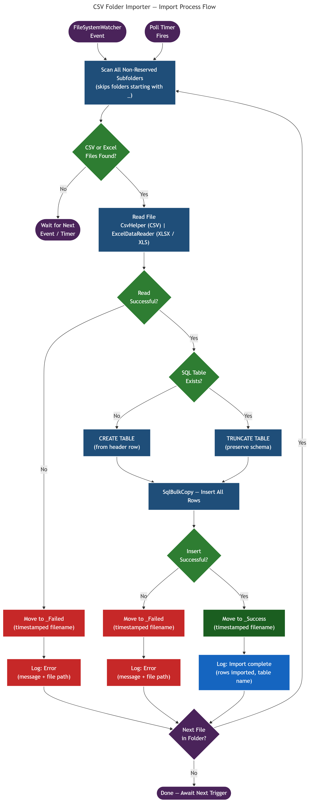

2. Configuration

2.1 appsettings.json
Contains only the SQL connection string. All other settings live in [dbo].[Settings].

{ "ConnectionStrings": { "CsvFolderImporter": "Server=venus-01;Database=CsvFolderImporter;User Id=sa;Password=sa;TrustServerCertificate=True;" } }

2.2 [dbo].[Settings] Table
Name | Default Value | Description
Logging.MinLevel | Information | Minimum LogLevel written to [dbo].[Logging] (Trace / Debug / Information / Warning / Error / Critical)
RootFolderPath | C:\ImportData | Root folder to monitor; each direct subfolder becomes a SQL table
PollIntervalMinutes | 5 | Minutes between full folder rescans
ProcessExistingFilesOnStartup | true | Whether to process existing files when the service starts

2.3 AppSettings Record
All settings are immutable after startup. A service restart is required to apply changes to RootFolderPath. PollIntervalMinutes and Logging.MinLevel changes take effect after restart only.

3. Database Schema

3.1 [dbo].[Settings]
CREATE TABLE [dbo].[Settings] ( [SettingID] INT NOT NULL IDENTITY(1,1), [Name] NVARCHAR(100) NOT NULL, [Value] NVARCHAR(500) NULL, [IsEnabled] BIT NOT NULL DEFAULT (0), CONSTRAINT [PK_Settings] PRIMARY KEY CLUSTERED ([SettingID] ASC) );

3.2 [dbo].[Logging]
CREATE TABLE [dbo].[Logging] ( [LogID] BIGINT NOT NULL IDENTITY(1,1), [LoggedAt] DATETIME NOT NULL DEFAULT (GETDATE()), [LogLevel] INT NOT NULL DEFAULT (2), [Message] NVARCHAR(MAX) NULL, CONSTRAINT [PK_Logging] PRIMARY KEY CLUSTERED ([LogID] ASC) );

LogLevel values: 0 = Trace, 1 = Debug, 2 = Information, 3 = Warning, 4 = Error, 5 = Critical

3.3 Dynamically Created Import Tables
Each import table follows this pattern. All data columns are NVARCHAR(MAX):

CREATE TABLE [dbo].[Orders] ( [OrdersID] BIGINT NOT NULL IDENTITY(1,1), [OrderDate] NVARCHAR(MAX) NULL, -- from CSV/Excel header row [Customer] NVARCHAR(MAX) NULL, -- one column per header in the first file imported CONSTRAINT [PK_Orders] PRIMARY KEY CLUSTERED ([OrdersID] ASC) );

Column names are taken from the first row of the first file imported into a subfolder. Subsequent files must match the same column names; the table is truncated before each import.

4. File Import Behavior

4.1 First File in a Subfolder
- TableService.TableExistsAsync() checks sys.tables for the target table
- TableService.CreateTableAsync() creates the table using the file's header row as column names
- Data rows are inserted using SqlBulkCopy

4.2 Subsequent Files in a Subfolder
- TableService.TableExistsAsync() returns true
- TableService.TruncateTableAsync() truncates the table (preserving schema)
- Data rows are inserted using SqlBulkCopy

4.3 File Locking Retry
FileImportService waits up to 30 seconds (retrying every 500 ms) for a file to become readable. This handles files that are still being written to disk when the FileSystemWatcher event fires.

4.4 File Archival
After processing, the source file is moved to a subfolder within the same watch folder:
- Success: {watchFolder}\_Success\{name}_{yyyyMMdd_HHmmss}{ext}
- Failure: {watchFolder}\_Failed\{name}_{yyyyMMdd_HHmmss}{ext}

Collision handling: if a file with the same timestamp already exists, an integer suffix is appended (_1, _2, ...).

4.5 Reserved Folder Names
Any subfolder whose name starts with an underscore (_) is ignored by both the scanner and the FileSystemWatcher. This prevents recursive processing of _Success and _Failed folders.

5. Supported File Formats
Format | Extension | Parser | Notes
CSV | .csv | CsvHelper 33.x | Auto-detects encoding via BOM; trims whitespace; tolerates missing fields
Excel 2007+ | .xlsx | ExcelDataReader 3.7 | Reads first worksheet only; first row is the header
Excel 97-2003 | .xls | ExcelDataReader 3.7 | Requires CodePagesEncodingProvider registration at startup

6. Installer Details

6.1 Build Requirements
Requirement | Detail
.NET 9 SDK | Required to publish the application
WiX v7 global tool | dotnet tool install --global wix
WiX EULA | Accepted automatically by Build-Installer.ps1 (wix eula accept wix7)
WiX extension | WixToolset.UI.wixext — provides dialog templates

6.2 Build-Installer.ps1 Steps
- Accepts WiX EULA (wix eula accept wix7)
- Adds WixToolset.UI.wixext extension
- dotnet publish — Release, win-x64, framework-dependent
- Copies SQL\CsvFolderImporter.sql and setup.ps1 to publish output
- Reads connection string from appsettings.json; writes Installer\DefaultValues.wxi
- Generates Installer\bin\Release\AppFiles.wxs by enumerating publish output (PowerShell)
- wix build — produces CsvFolderImporterSetup.msi

6.3 MSI Custom Actions
Action | Trigger | Purpose
RunSetupScript | After WriteIniValues (install) | Runs setup.ps1 as SYSTEM — updates config, creates DB/tables, registers and starts service
RemoveService | Before RemoveFiles (uninstall) | Stops the service (Stop-Service) and deletes it from SCM (sc.exe delete)

6.4 setup.ps1 Responsibilities
- Reads setup_config.ini (written by MSI IniFile components from dialog values)
- Updates appsettings.json with the SQL connection string
- Parses connection string into sqlcmd parameters (server, auth type, trust certificate)
- Forces TCP connection (tcp: prefix) to avoid Named Pipes failures with remote servers
- Runs CsvFolderImporter.sql against SQL Server (creates DB, tables, seeds settings)
- Upserts RootFolderPath and PollIntervalMinutes in [dbo].[Settings]
- Creates the root import folder if it does not exist
- Registers the Windows service using New-Service
- Starts the service
- Configures failure recovery via sc.exe failure (restart after 60 s on 1st and 2nd failures)

7. NuGet Packages
Package | Version | Purpose
CsvHelper | 33.0.1 | CSV parsing with BOM detection and whitespace trimming
ExcelDataReader | 3.7.0 | Excel file reading (.xlsx and .xls)
ExcelDataReader.DataSet | 3.7.0 | DataSet adapter for ExcelDataReader
Microsoft.Data.SqlClient | 5.2.2 | SQL Server connectivity and SqlBulkCopy
Microsoft.Extensions.Hosting | 9.0.0 | IHost and BackgroundService infrastructure
Microsoft.Extensions.Hosting.WindowsServices | 9.0.0 | AddWindowsService() for SCM integration

8. Logging
SqlLoggerService fans out every log call to two channels:
- [dbo].[Logging] — filtered by the Logging.MinLevel setting
- FileLoggerService — always written regardless of level

FileLoggerService creates a timestamped file (Log_yyyyMMdd_HHmmss.txt) in the executable directory at startup. This captures errors that occur before the SQL connection is available (e.g., bad connection string, missing database).

Log rows older than one year are purged from [dbo].[Logging] on each service start.

