**To make it more similar to the actual game, I went back implemented a Debris Room and a Sloping Room that must be gone through in order to get to the caves and obtain all necessary items. With these additions, I added the Rod, and made the bird afraid of the Rod so that it must be dropped in order to obtain the bird (along with the initial implementation of having the cage).**

Properties Files: Rod, Debris Room, Sloping Room, updated Chamber and Orange River Chamber

Cave Rooms: Debris Room, Sloping Room, updated Room Directory and Cave Test Main

Items: Rod, Updated Bird, updated Item Directory

Test Classes: Rod Test, Debris Room Test, Sloping Room Test, updated Item Directory Test

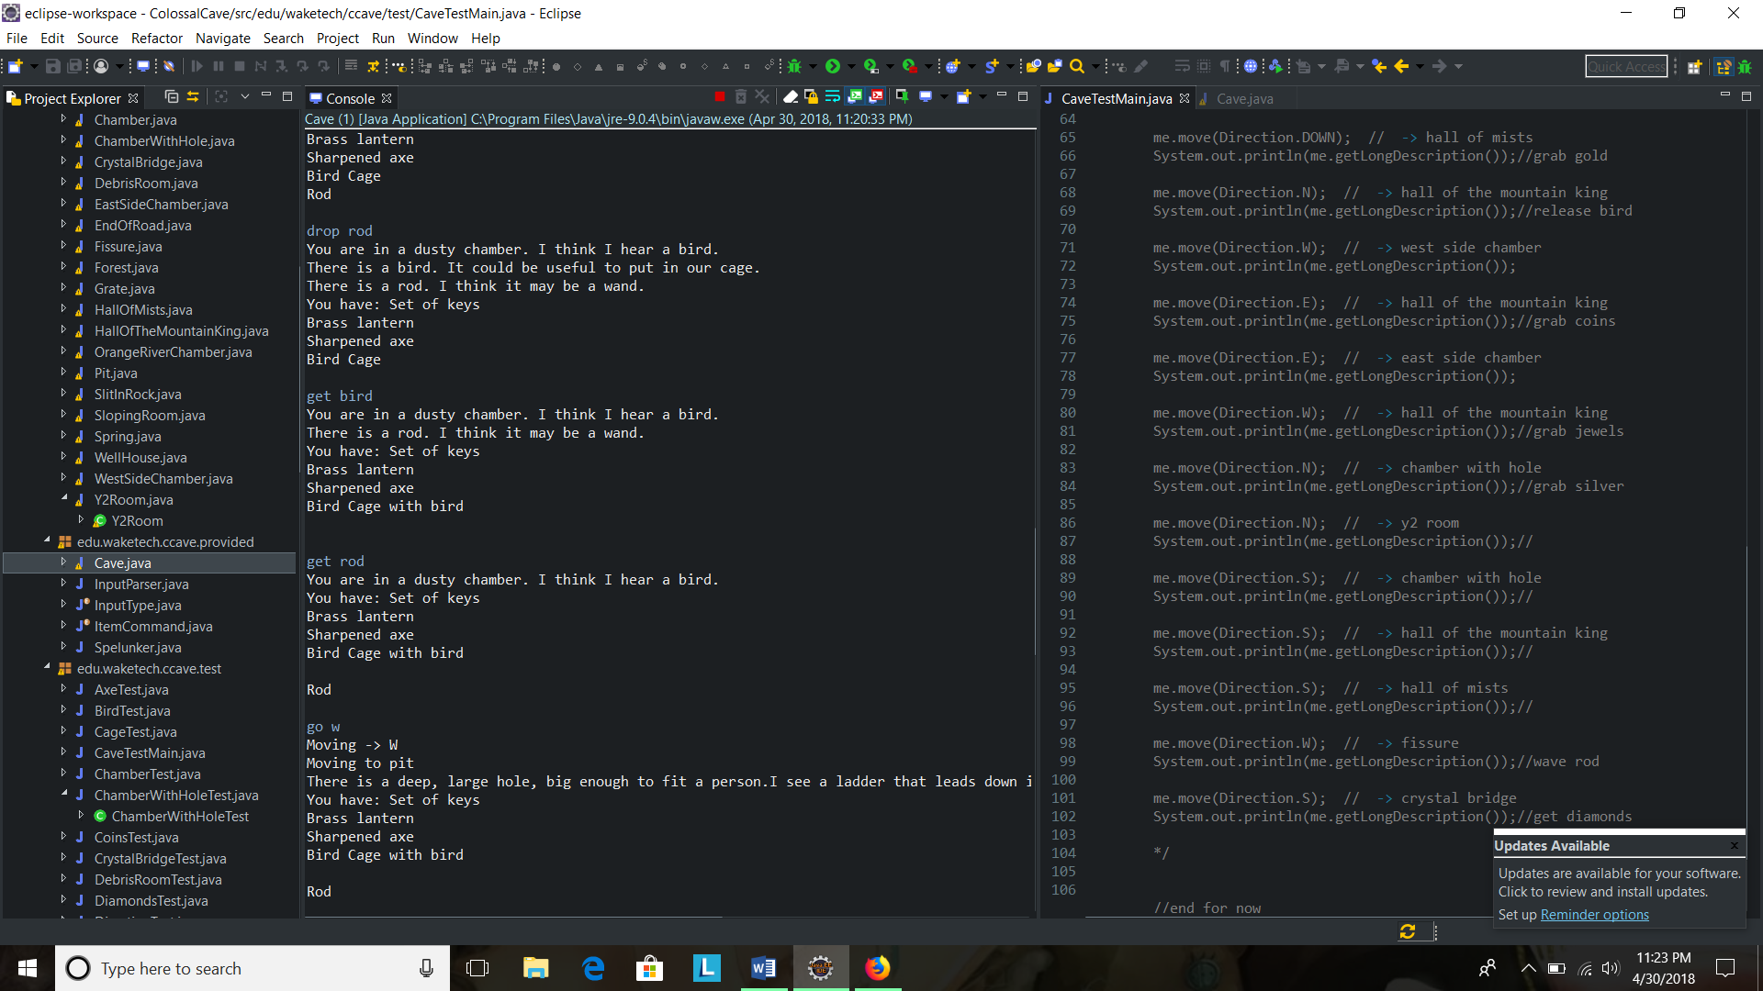

**Added magic word xyzzy to transport between debris room and wellhouse- had to update cave main, input parser, and input type.**

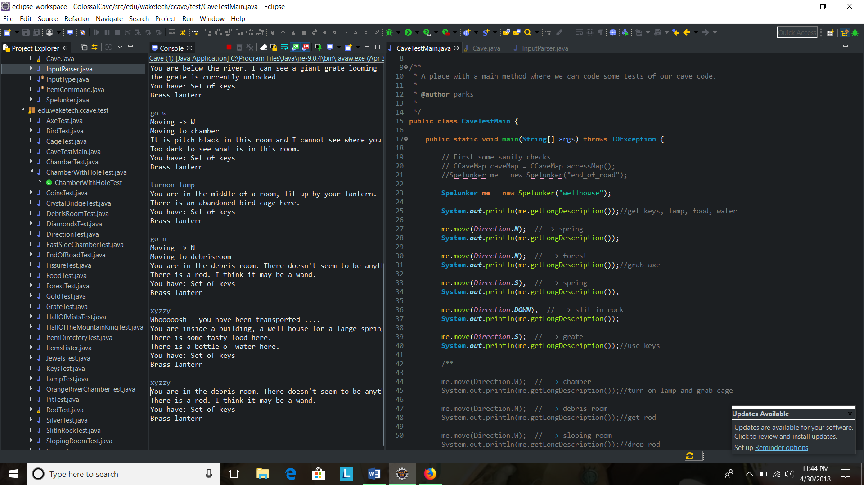

**Picking up where my initial game left off (in concurrence to actual game) from the chamber with a hole you can now go to the Y2 room where you will encounter a dwarf to throw your axe at (that you grabbed from forest).**

Properties Files: Y2, updated Chamber With Hole

Cave Room: Y2 Room

Item: Updated axe

Test Class: Y2 Room Test

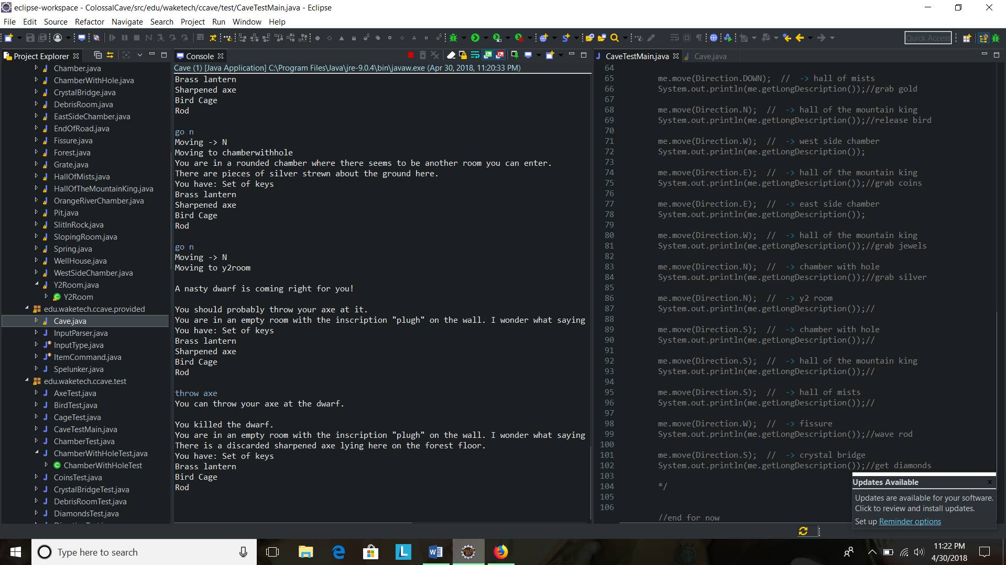

**From there I have implemented additional classes, items, and special commands according to the game to take you to the Fissure where you have to wave the rod to make the crystal bridge appear, from there you can enter the crystal bridge, and you can get diamonds.**

Properties Files: Fissure, Crystal Bridge, Diamonds

Cave Rooms: Fissure, Crystal Bridge, updated Room Directory

Item: Updated Rod, Diamonds

Test Class: Updated Rod Test, Fissure Test, Crystal Bridge Test, updated Cave Main Test, Diamonds Test

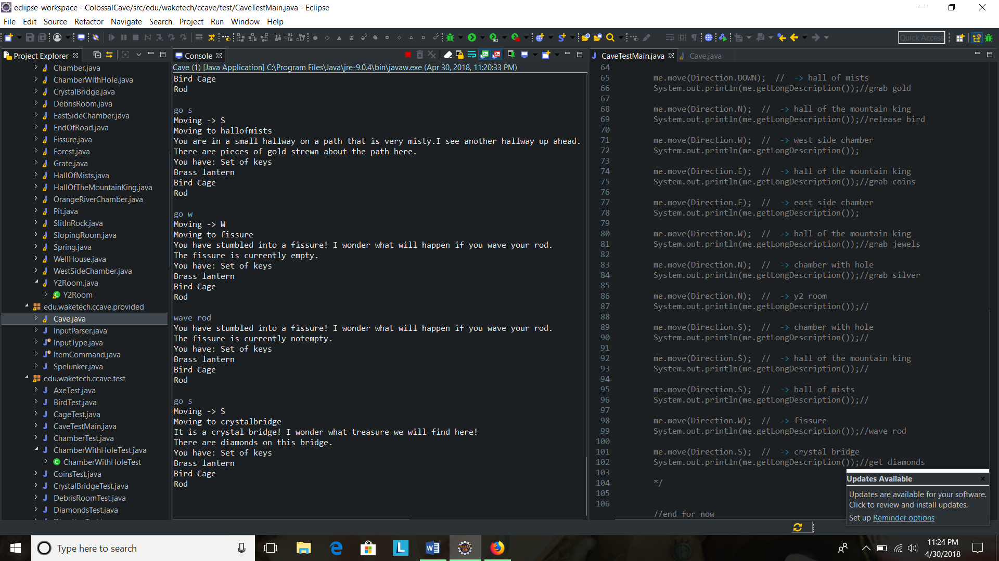

**Save and Restore:**

**Rewrote Cave Main class in order to save/restore game. Updated Spelunker and Item Directory with used methods in Cave Main. Had to implement Serializable interface in Item Directory and Room Directory, CCave Element, CCave Item, CCave Room.**

