**From the initial options given:**

5, Exit: WORKS

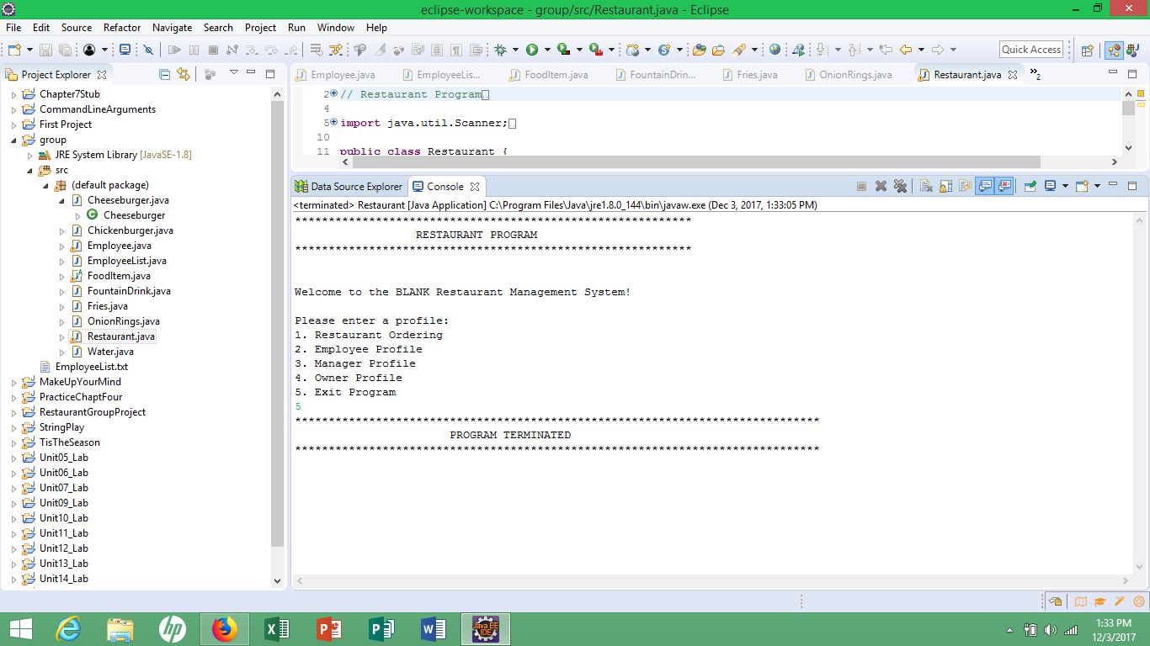

2, Employee Profile:

* Entering a new user ID and PW does not work- only if on the prescribed list of employees on text file (not sure if that is how it was supposed to be set up and/or you can create new user elsewhere in program); if that is the case- which looking at the code I think so, it correctly blocks entry minus the login/Password is incorrect looping and printing too many times

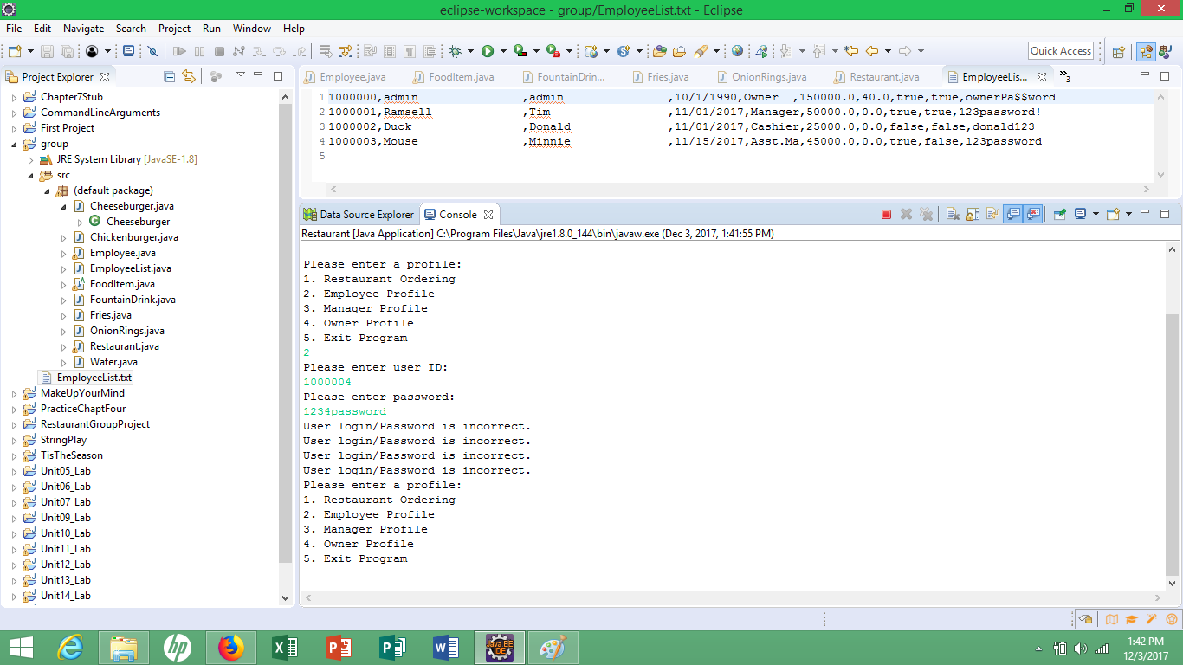

* Admin is the only one that works 100% for first initial log in

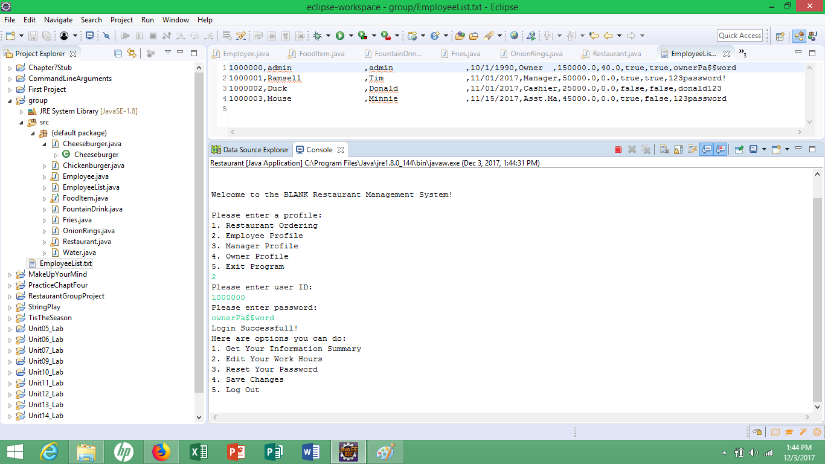

* Timothy works besides the initial output print of “Incorrect login/Password”

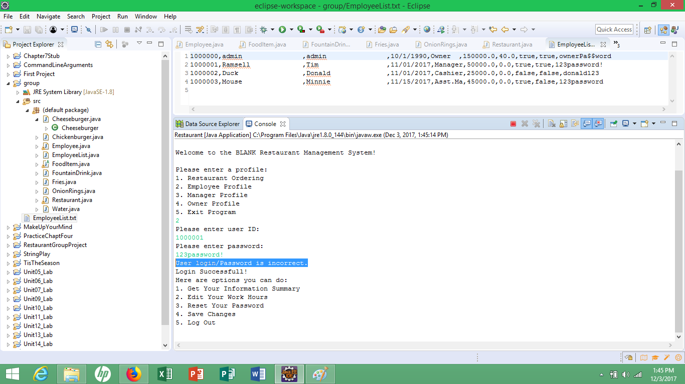

* Donald does not work at all- tried multiple times- as well as it has the multiple looping print statement problem

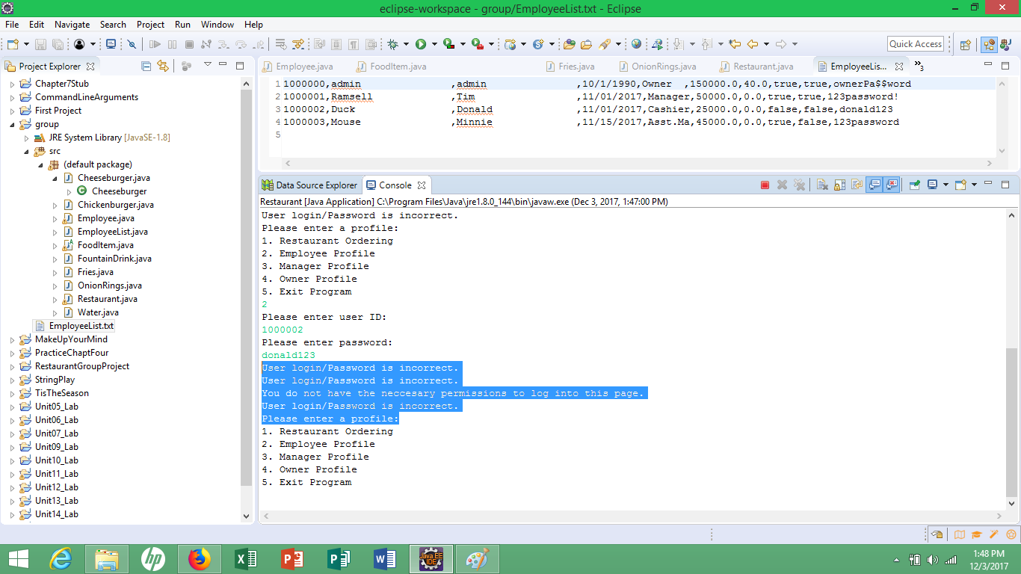

* Mouse works but also has the initial multiple looping print statement of “incorrect login/Password”

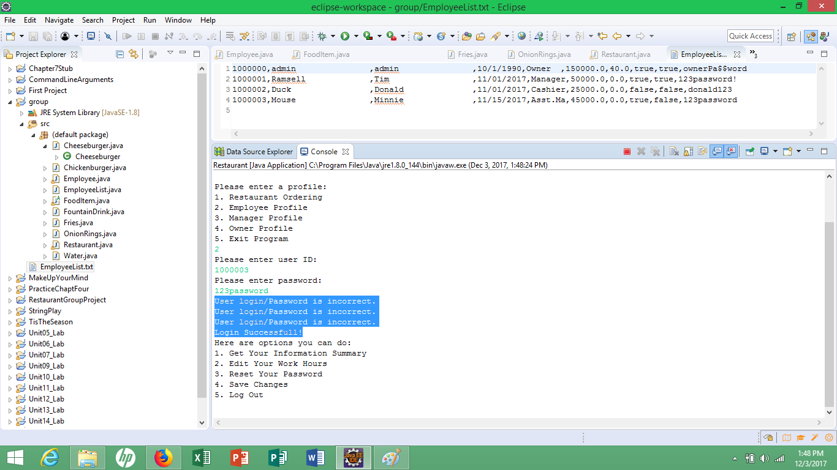

**Need to revisit this code potion to correct the improper looping and printing of the else statement**

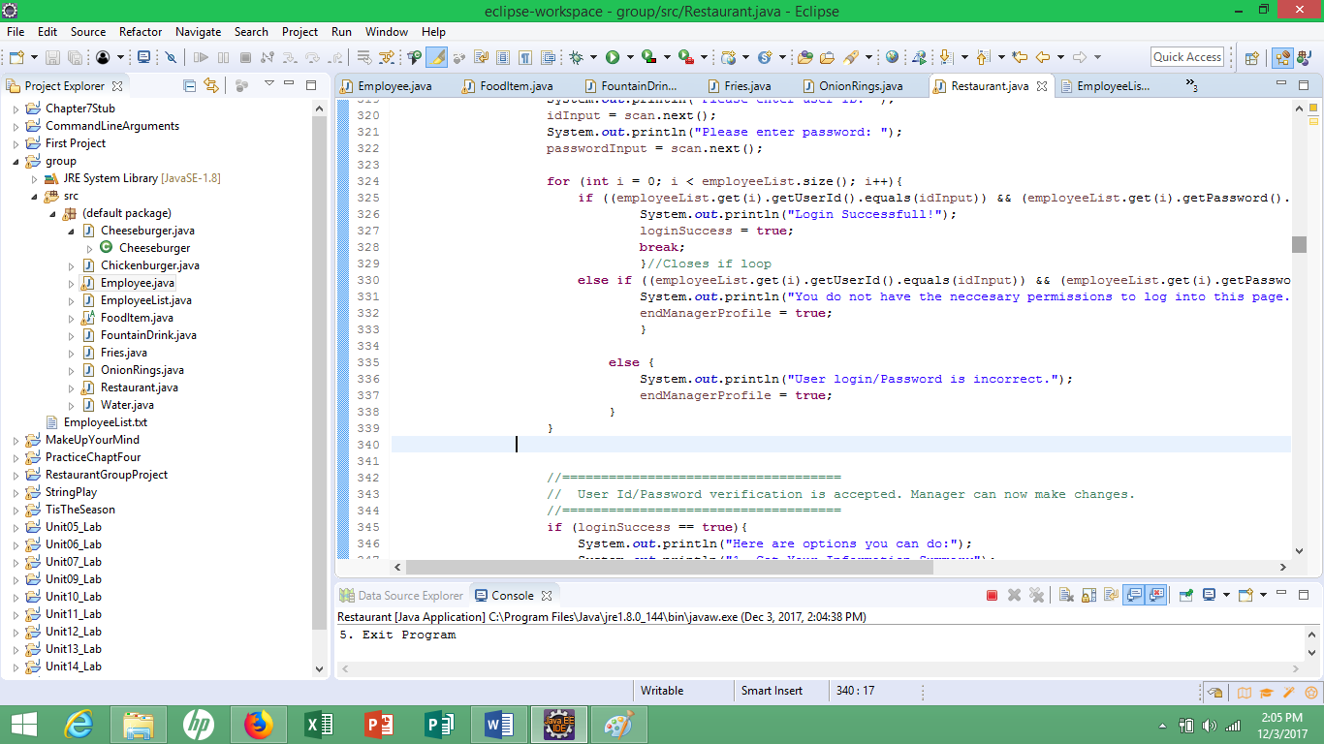

3, Manager Profile

* Entering Timothy’s info as manager works besides again the incorrect loop statement of “incorrect login/Password”

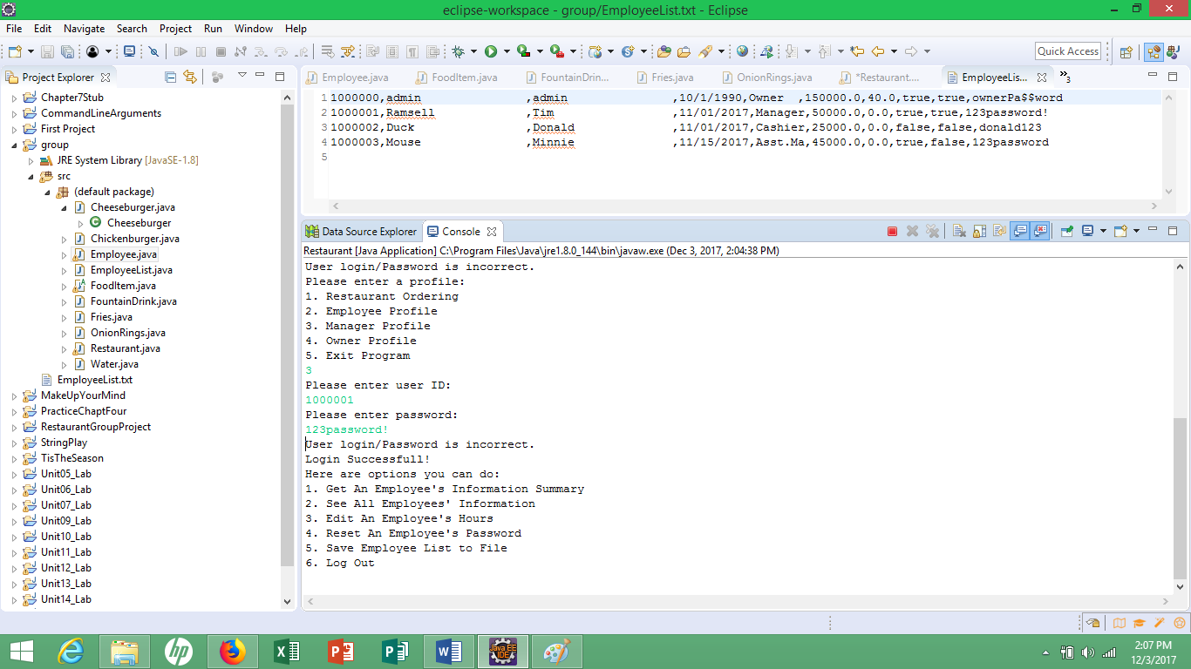

4, Owner Profile

* Entering the admin info as owner works 100% for the initial log in

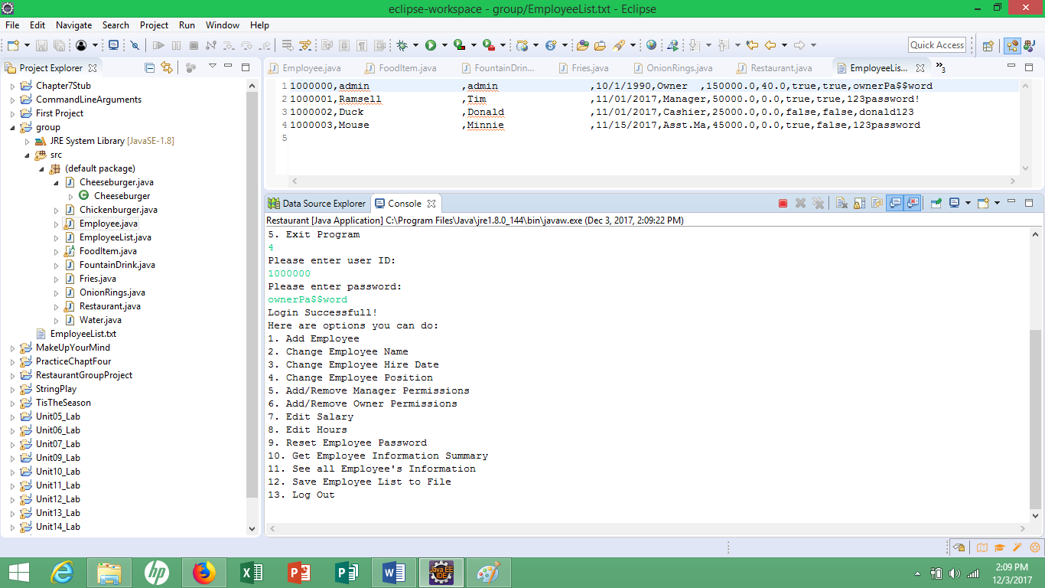

1, Restaurant Ordering

* Entering 1 works 100% bringing you to ordering screen

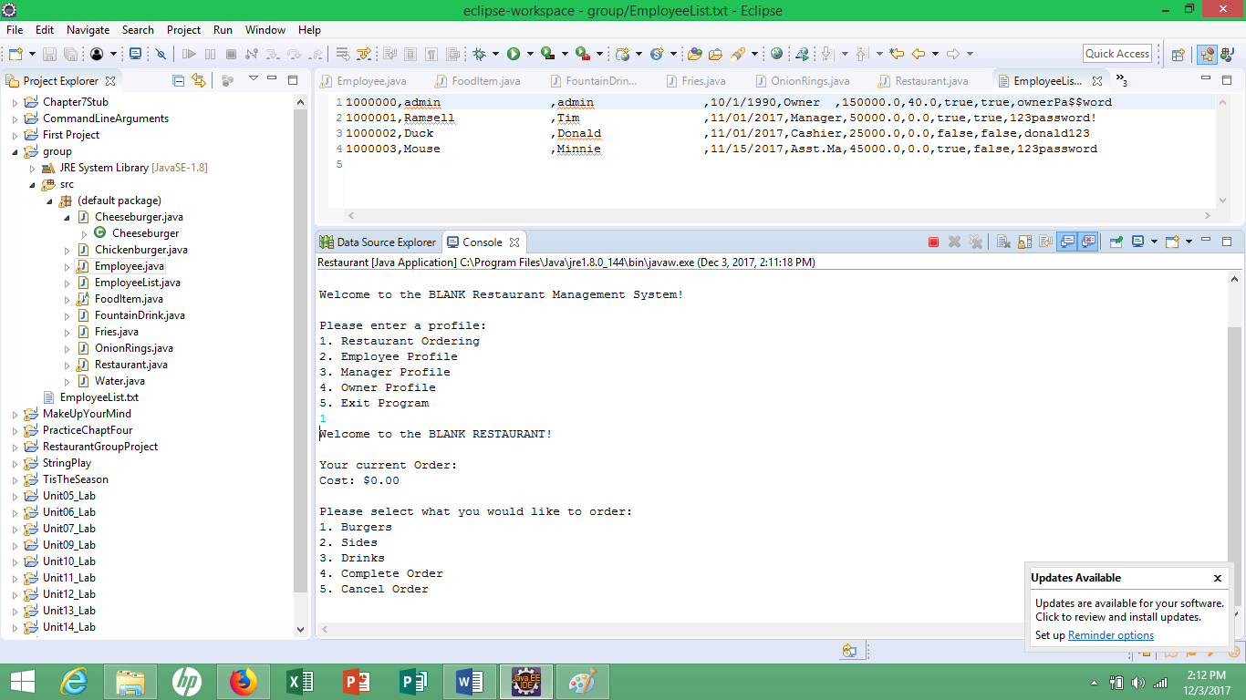

* Entering 1 works 100% to bringing you to the burger screen

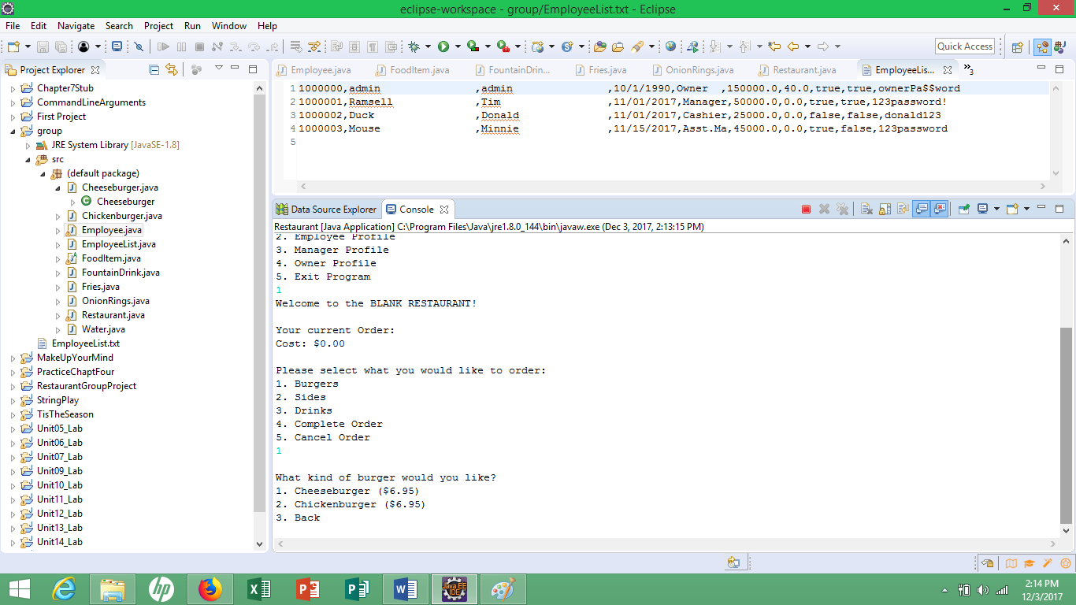

-Entering 1 works 100% to bringing you to the cheeseburger and modification screen

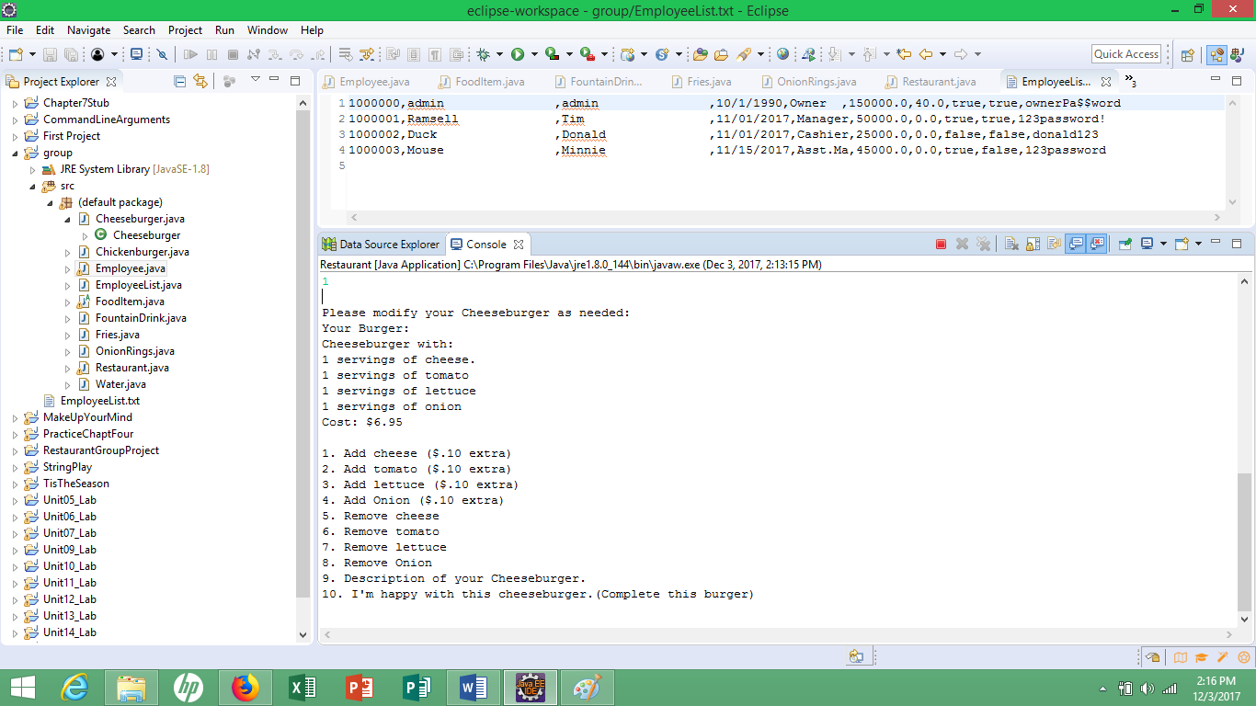

* Entering 10 works 100% at showing order/cost and taking you to the next menu screen

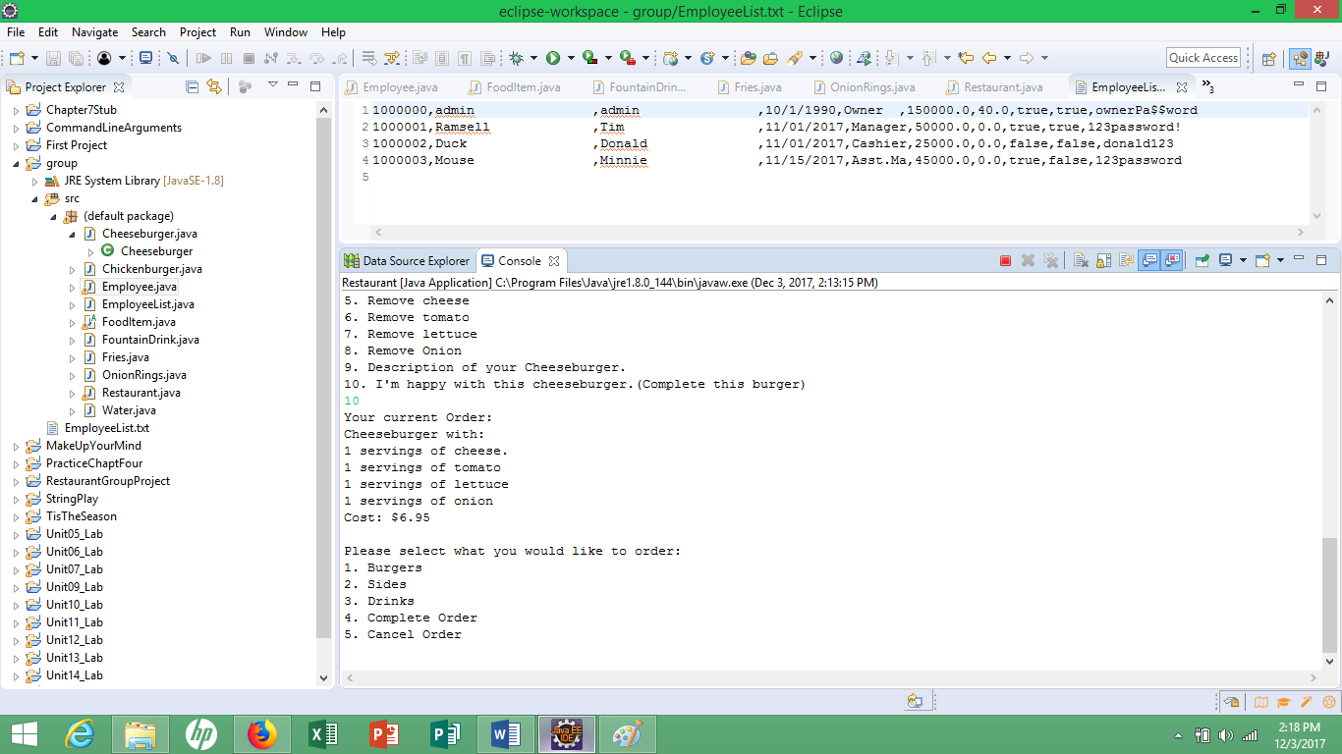

* Entering 4 works 100% at showing order/cost/completing order and taking you to pay screen

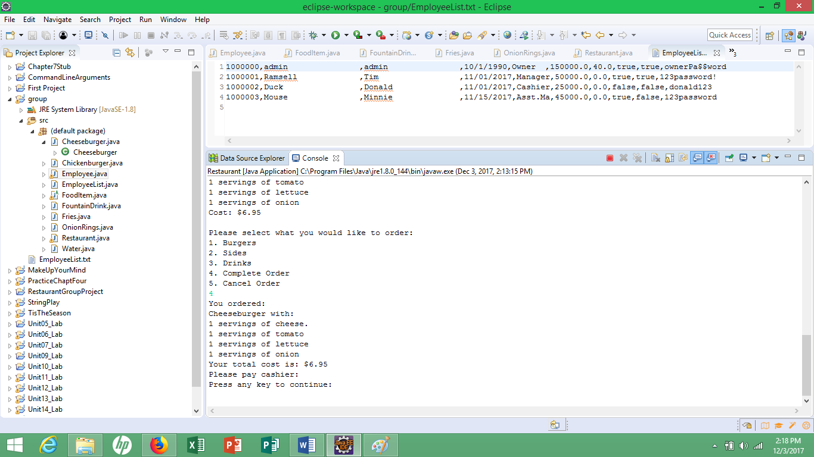

* “Press any key to continue” does not work if it is a space bar key or enter key- worked when I hit “a”- coded to only work for letter keys? Did not try to hit a number or special character key

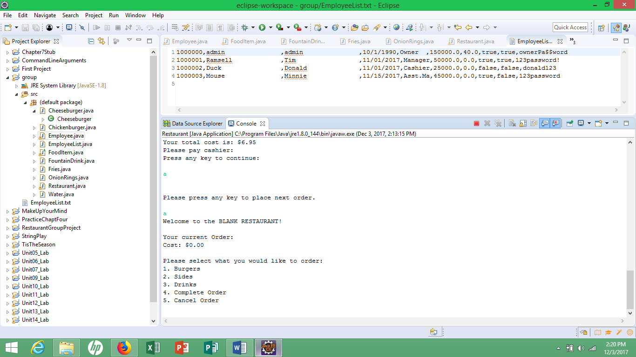

* From ordering screen, pressing 2 100% works on taking you to side menu screen

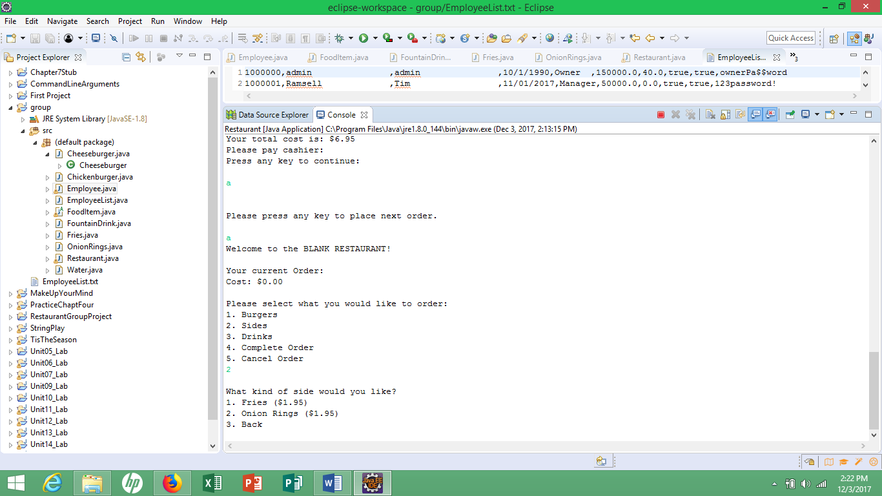

* Entering 1 from side menu screen works 100% on adding fries and total cost to order

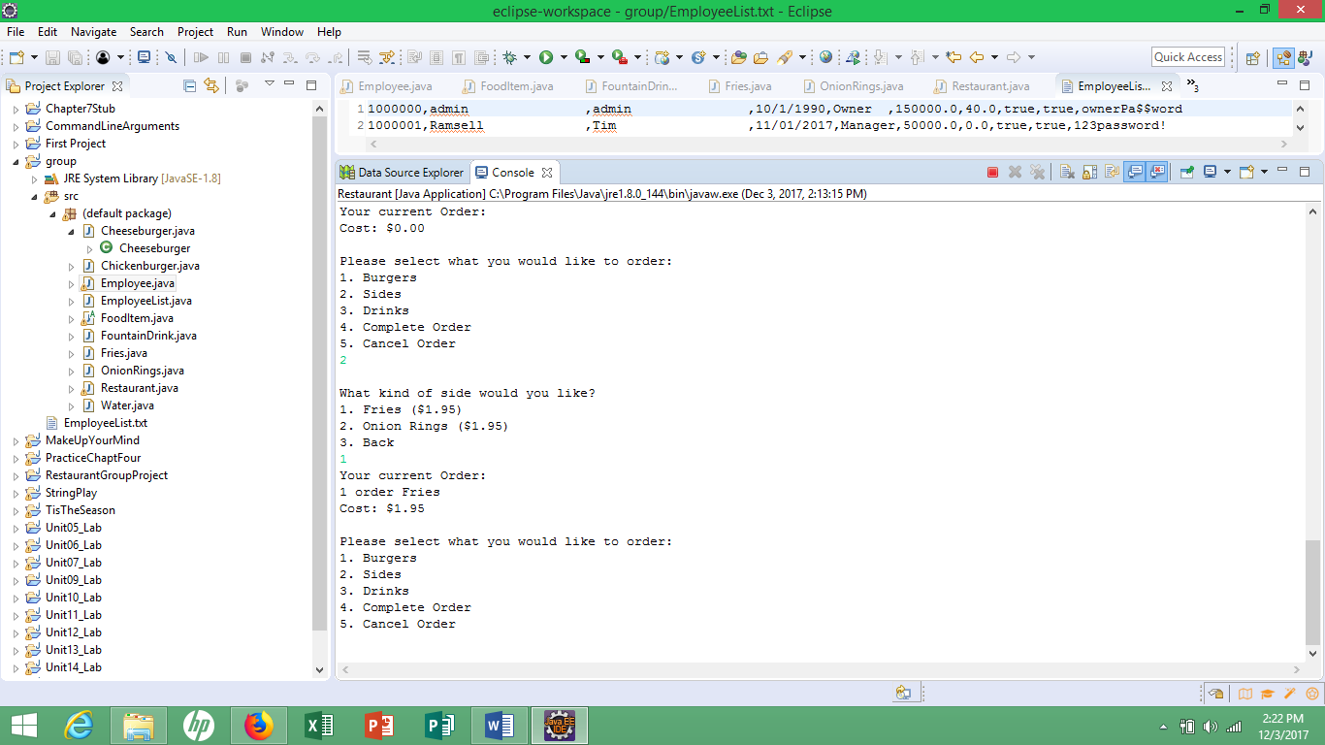

* Entering 5 100% works at cancelling order

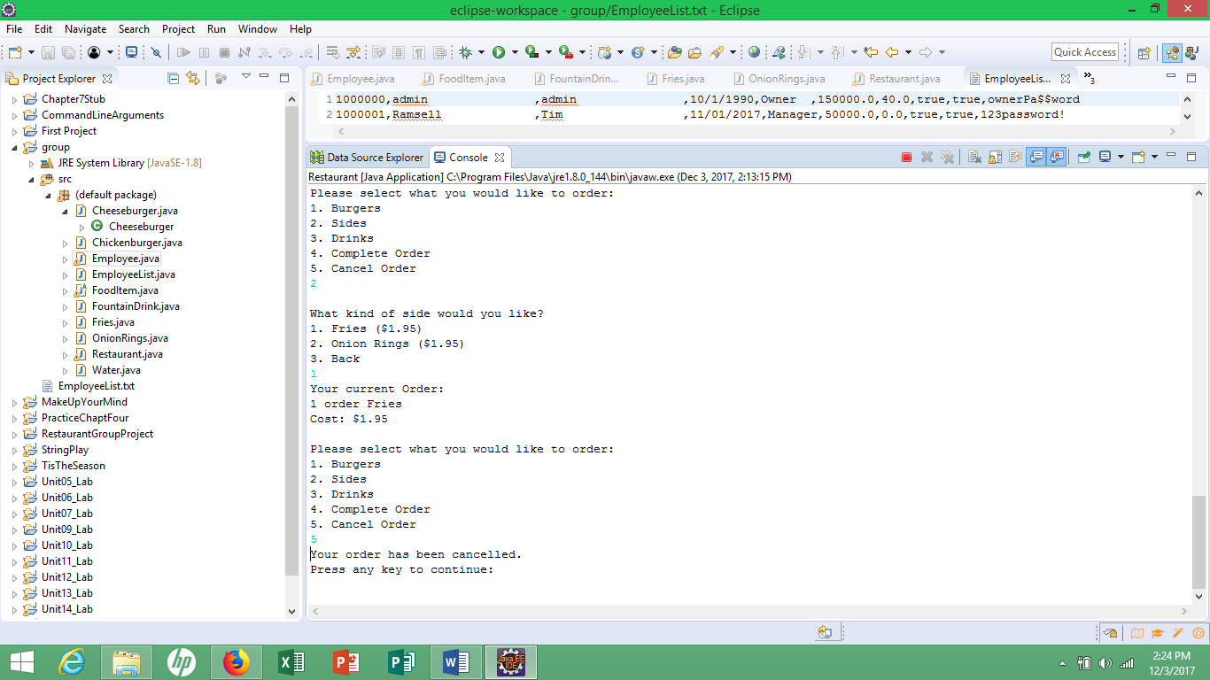

* Answered my own question about special keys and number keys- they will work for “press any key to continue” but space bar key and enter key still do not

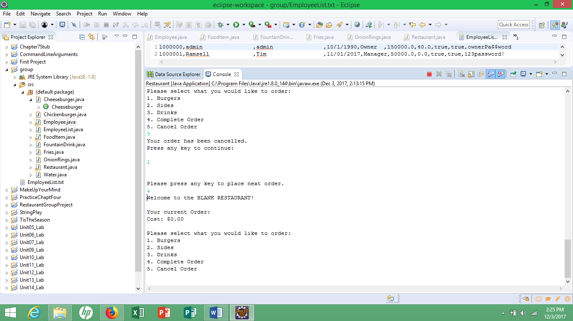

* From menu ordering screen pressing 3 works 100% on taking you to drink menu screen

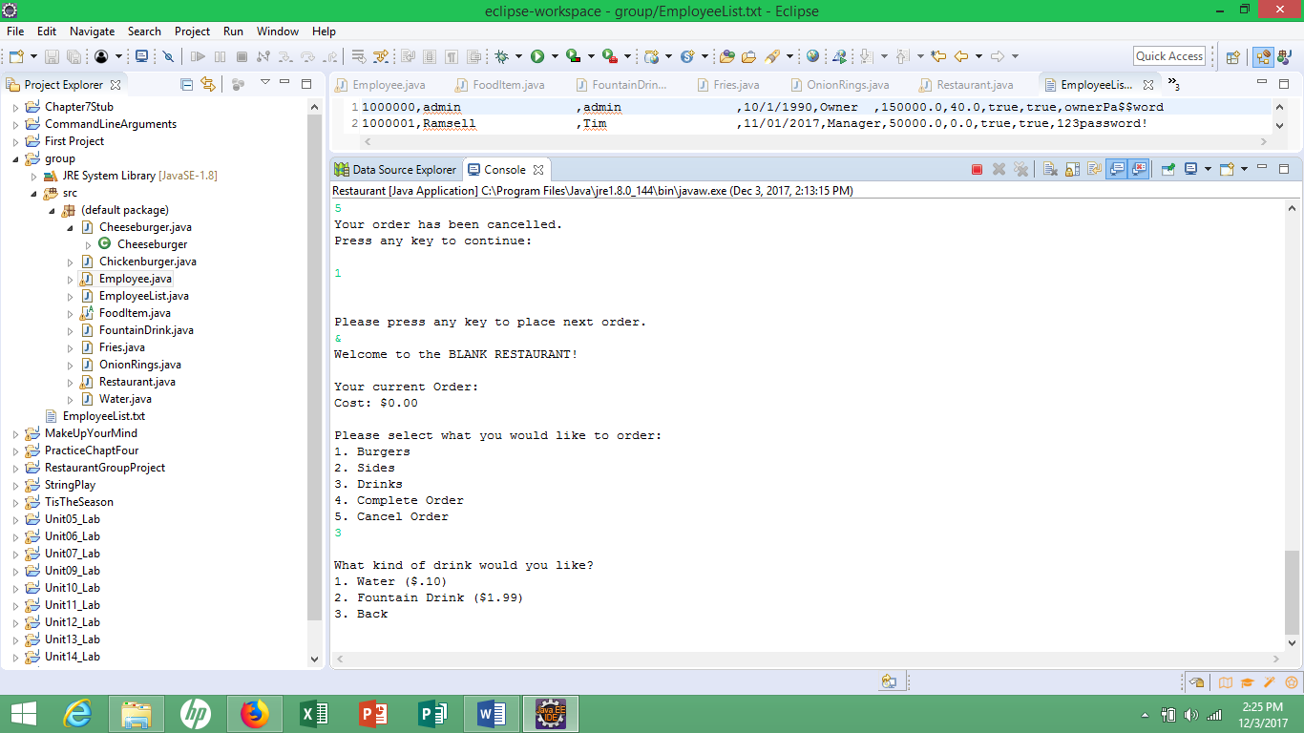

* Entering 3 works 100% at taking you back to initial menu screen

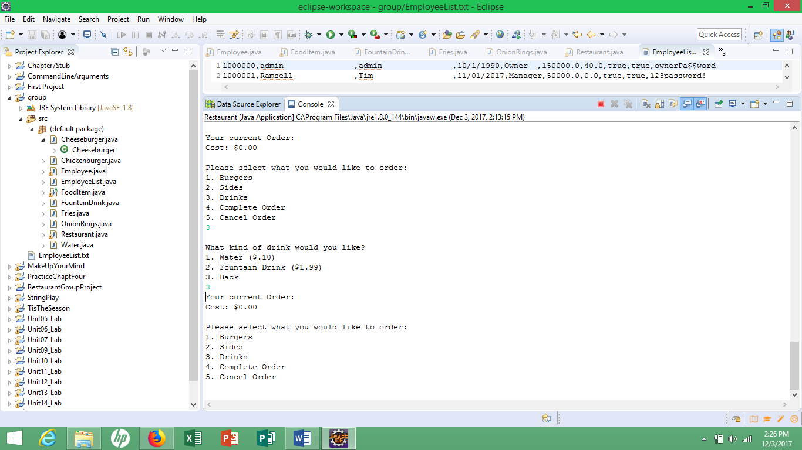

* From initial ordering screen, going back to burger options, entering 2 works 100% at taking you to chicken burger ordering options

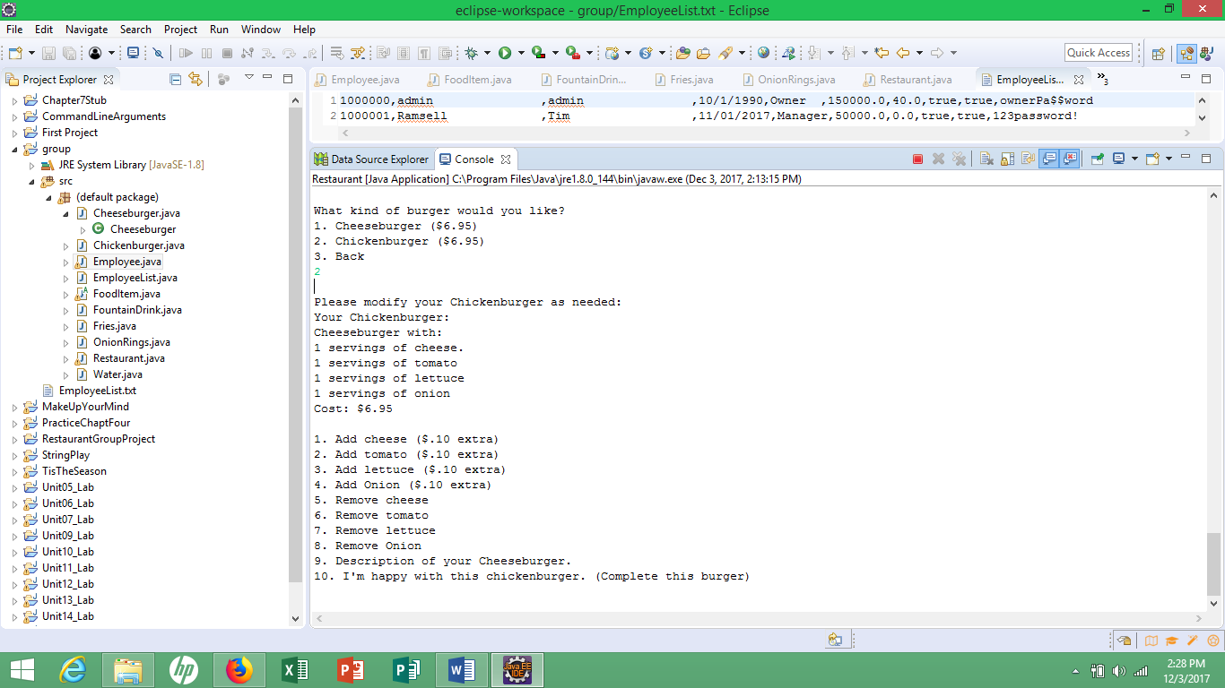

* From chicken burger modification screen, entering 1 correctly adds extra cheese and cost

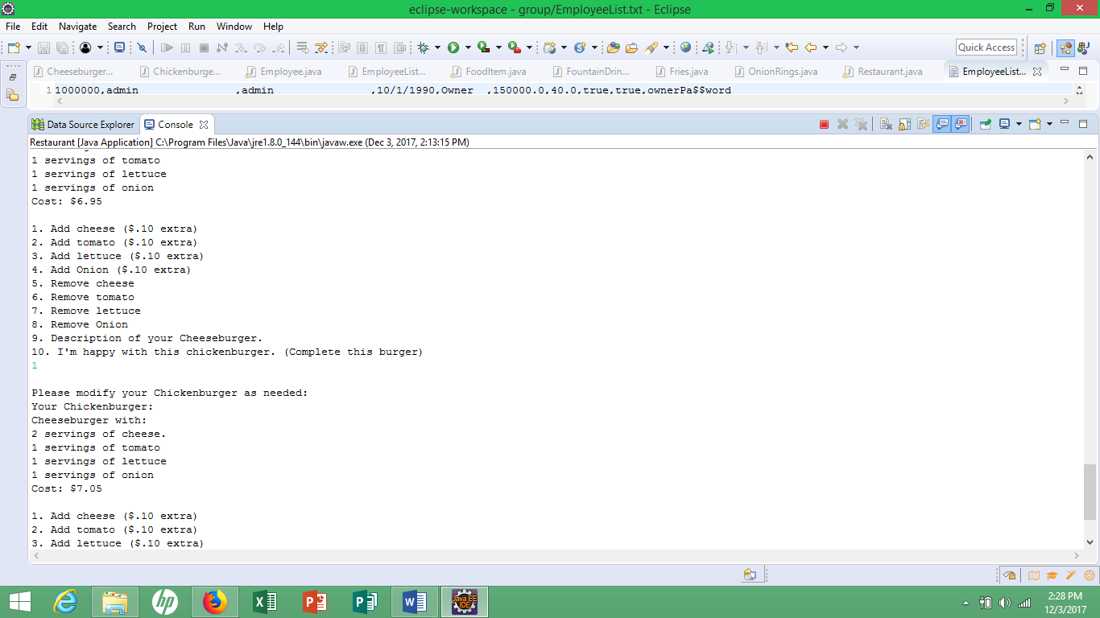

* Entering 9 correctly reflects what is on “burger”

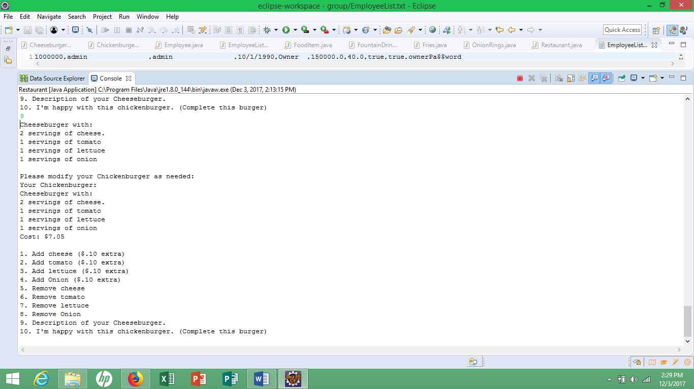

* Entering 8 correctly removes onion from “burger”

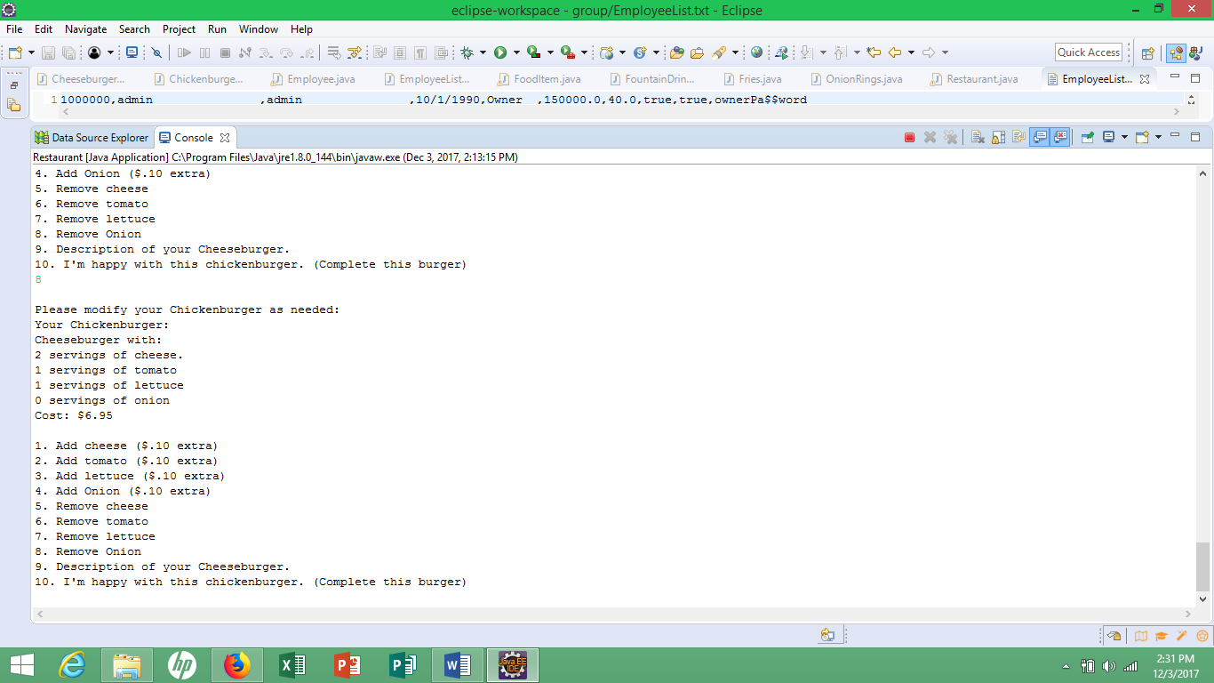

* Was able to complete order again with accurate order and cost

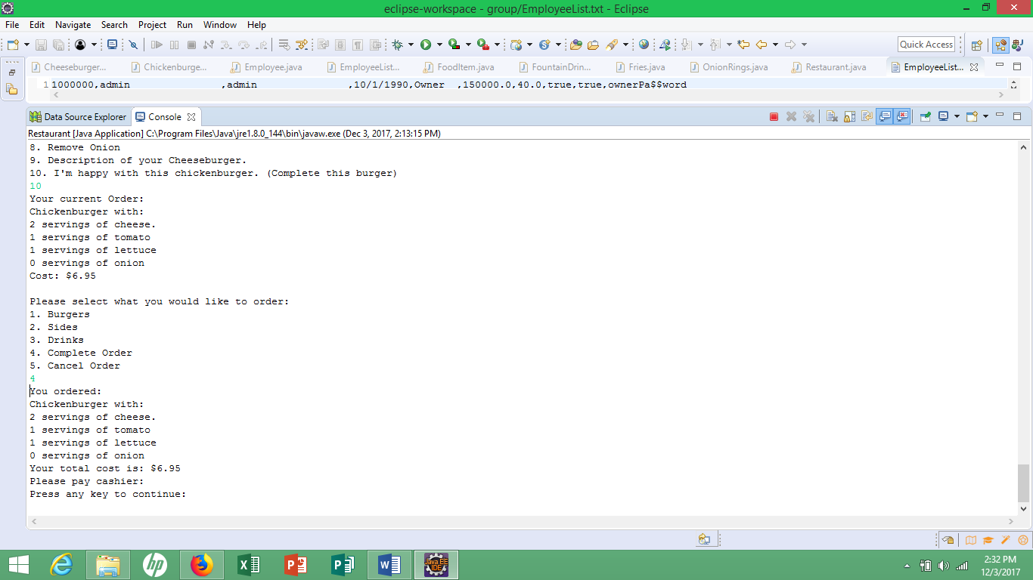

* Entering 3 for “BACK” on all burger, sides, and drink options all works 100%

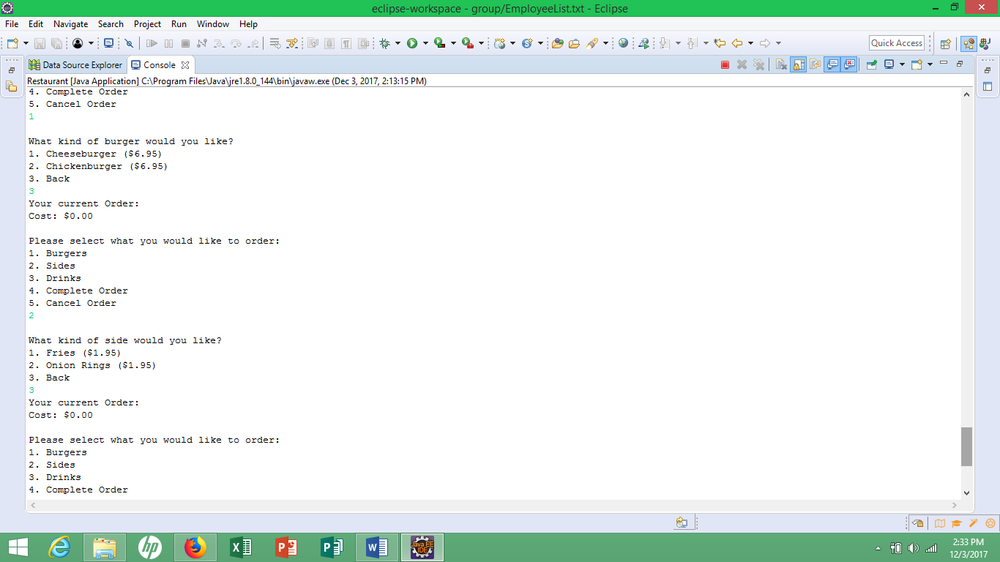

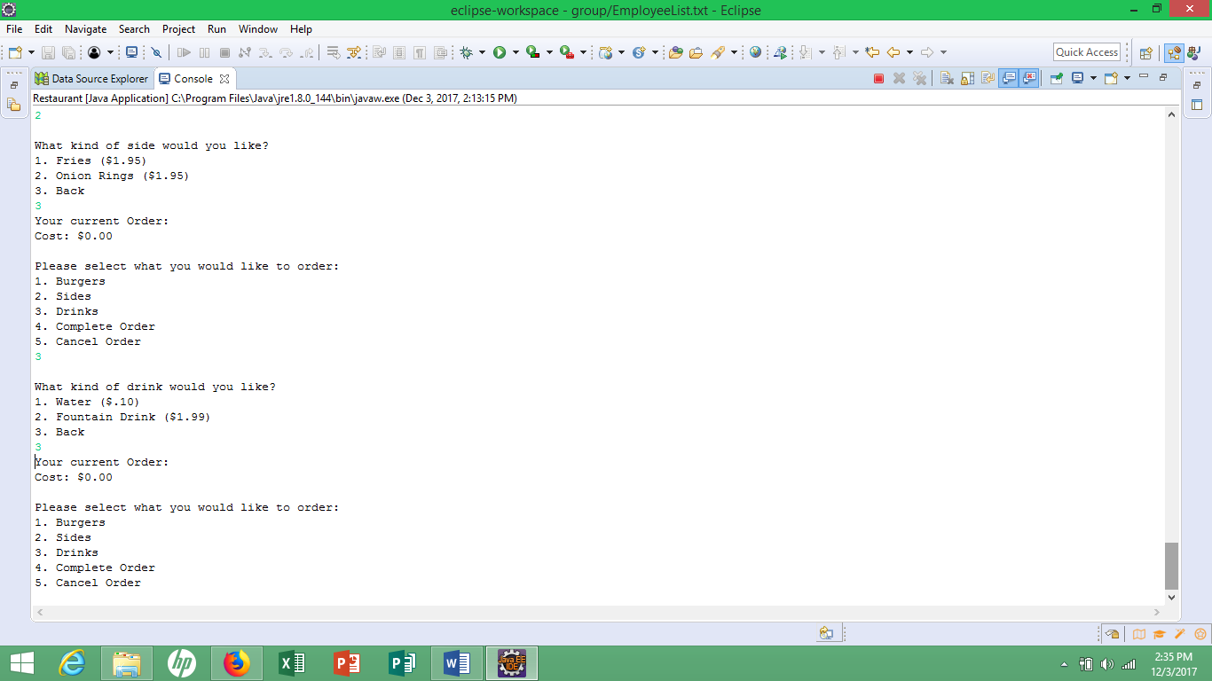

* **Through random additional testing found adding and removing items such as drinks, sides, and burger toppings all worked- did not encounter any issues not addressed already**

