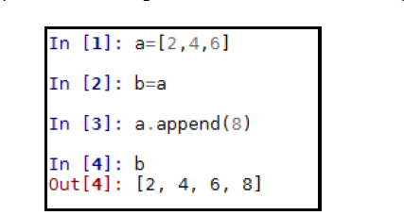

Variables in python:

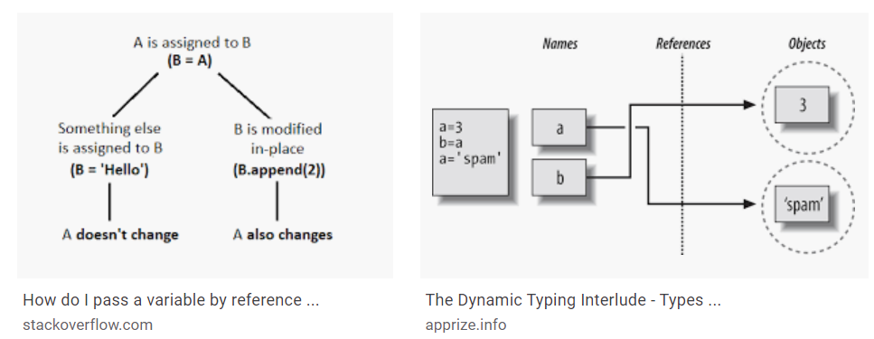

Variables scope:

If nothing found raises Name Error; built in: (FALSE, TRUE, NONE etc..)

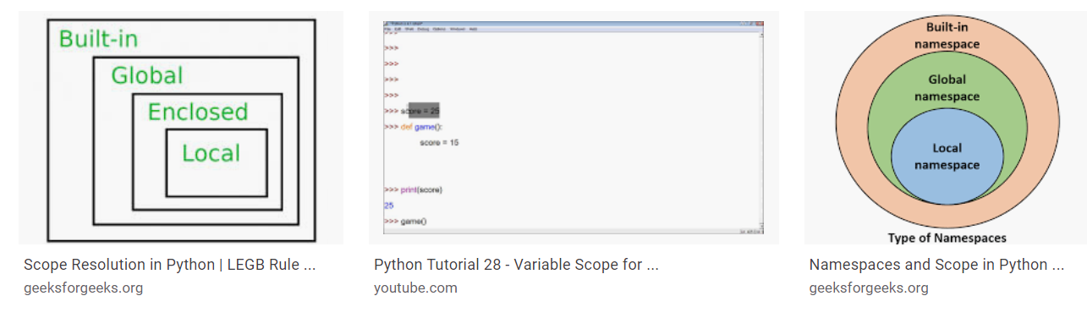

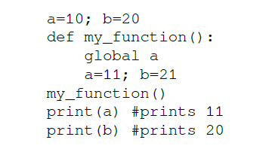

Program execution:

Python program consists of statements. Program completes when all the statements executed.

Import

Function definition

Class definition

Variable assignment

All will have same status. No priority one over another.

The way to control the program execution is by using:

Conditional execution (if, else)

Loops (for, while)

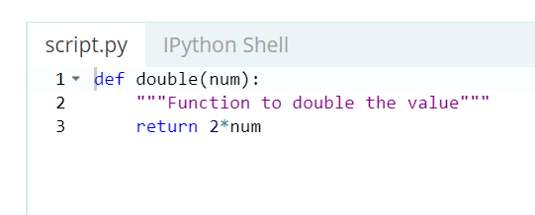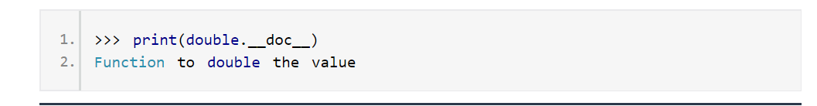

Data types and objects:

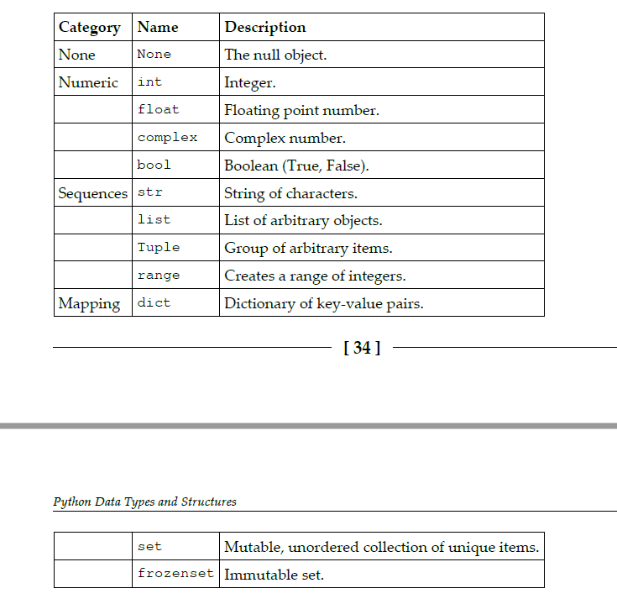

Generators:

<http://www.blog.pythonlibrary.org/2014/01/27/python-201-an-intro-to-generators/>