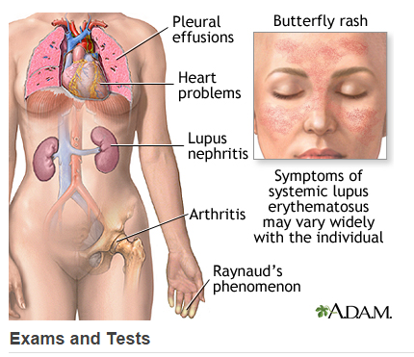

The given picture is that of the organs affected due to a disease called systemic lupus erythematosus (SLE). It is an autoimmune disease. Based on your current understanding of human physiology, answer me the following:

Q1. Based on the picture, list down the organs affected because of SLE (2 marks).

Q2. List the conditions that you see in the picture and define to me in general what it means? (Ex. What does pleural effusion mean?) Hint: There are 5 conditions shown in the picture (2 marks).

Q3. Describe to me what happens to the physiology of heart, kidney, and lungs when a person suffers from SLE. I just want to know what disturbances will happen to the normal physiology. Please do not describe me the normal physiology (6 marks).

I shall also try to answer these questions. Try it out and apply your knowledge. I hope it is fun!