Capstone Pre-Submission: Employee Attrition Prediction at PeopleFirst Global Services
Nov 1, 2026 · @Aarthi

1. Business Problem Understanding and Objective Formulation
PeopleFirst Global Services is a large multinational company working in technology consulting, business process services and engineering. The company has grown fast, but many employees are leaving. When an experienced employee leaves, the company loses money on hiring and training a replacement, and projects get delayed. Right now HR only reacts after someone resigns.
We have been given historical employee data with a large number of records. It includes details like age, department, salary, performance ratings, promotions, working hours, training and survey scores. It also has a column that shows whether the employee left the company (attrition).
The main business problem is that employee attrition is high, and the company does not know in advance who is likely to leave or why.
Business objectives
- Identify the reasons for employee attrition.
- Identify employees who are planning to leave before they resign, so HR can take action early.
- Find out which retention initiatives will help reduce attrition.
Analytical objectives
- Find out which factors are most related to employees leaving.
- Build a machine learning model to predict which employees are at risk of leaving.
- Identify the factors that made people stay longer, to help decide on retention initiatives.

2. Challenges and Constraints
- Not all are useful: some columns, like the reference IDs, may have nothing to do with attrition and only add noise.
- Some overlap: for example, satisfaction, engagement and work-life balance scores may measure similar things.
- Risk of learning noise: with many features, a model can learn noise in the training data and perform poorly on new data.
Assumptions and limitations: we assume the data is accurate and that the attrition column reflects employees who actually left. The data is a one-time snapshot, so it shows patterns but cannot fully prove the causes of attrition.

3. Background Study / Literature Review
We reviewed two studies on predicting and reducing employee attrition with machine learning.
- Predicting Employee Attrition Using Machine Learning Techniques (Fallucchi et al., 2020, Computers, MDPI): the authors used the IBM HR Analytics dataset (about 1,470 employees and 35 features). They compared several classifiers, including Naive Bayes, logistic regression, KNN, decision tree, random forest and SVM, using a train-test split and 5-fold cross-validation. They focused on recall, so that fewer leavers would be missed, and Gaussian Naive Bayes performed best. Monthly income, overtime, age, distance from home, total working years and job involvement were linked to attrition.
- "How to make them stay?" – Diverse Counterfactual Explanations of Employee Attrition (Artelt and Gregoriades, 2023, arXiv): the authors point out that accurate models such as ensembles and neural networks are hard to interpret. They use counterfactual explanations, which show what would need to change for an employee to stay. They apply these across groups of employees to suggest company-level retention actions.
What we learned: attrition is usually treated as a classification problem. Several models should be compared, and recall matters more than accuracy because missing a leaver is costly. Predictions are most useful when they also explain what changes would make employees stay, which supports our objective of identifying retention initiatives.

4. Proposed Methodology / Solution Approach
Since the data has a column showing whether each employee left, we will treat this as a supervised learning (classification) problem. We will also use some unsupervised learning methods to understand the data better.
- Data Cleansing: Apply various data cleaning techniques to prepare the dataset. identify irrelevant features based on business knowledge.
- Data preparation: We create a correlation matrix we identify the features which has maximum impact on attrition
- Dimensionality reduction: use PCA to combine related columns and LDA to find the features that best separate employees who left from those who stayed.
- Clustering: use K-means to group employees with similar profiles, which can help HR plan different retention actions for each group.
- Model building: start with simple models (logistic regression, Naive Bayes, KNN, decision tree), then try ensemble methods (bagging and boosting) and a simple neural network.
- Insights and recommendations: use the best model and its important features to identify high-risk employees and suggest retention actions.

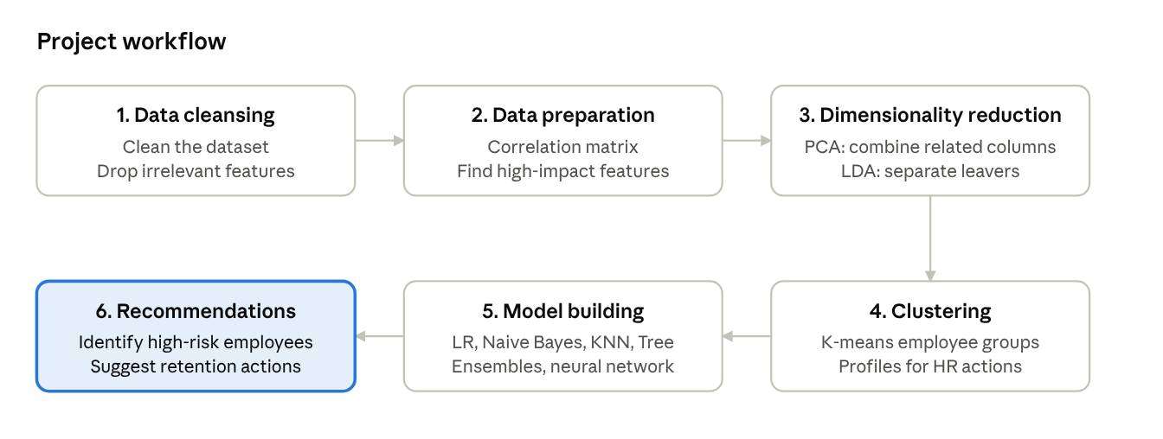
project workflow · 8 stages
Figure 1: Project workflow. This approach helps HR identify employees who are likely to leave before they resign, understand the main reasons, and take suitable action, such as reviewing promotions, reducing workload or improving engagement.

5. Proposed Timeline
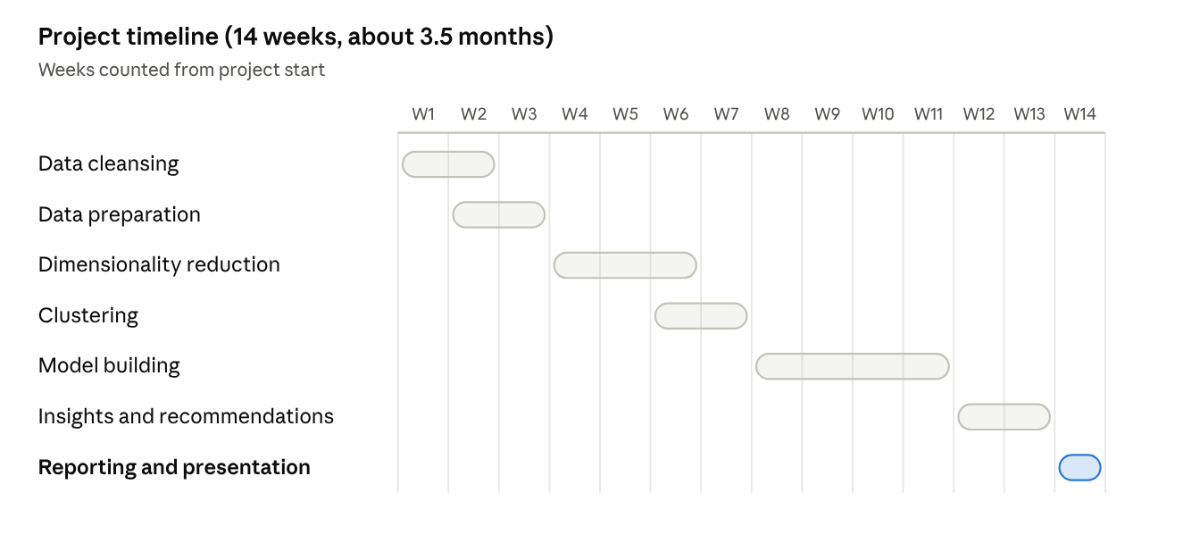
proposed timeline · 14 weeks
The plan assumes an 14-week window (about 3.5 months), with more time given to the analysis and modelling stages. Some tasks overlap so that we can finish on time.
Key milestones: cleaned dataset (week 3), key features and employee groups identified (week 7), final model (week 11), recommendations (week 13), final report and presentation (week 14).

6. Expected Deliverables / Outputs
- Cleaned dataset (week 3): the dataset after data cleansing, with irrelevant features removed.
- Feature analysis (week 3): a correlation matrix showing which features have the most impact on attrition.
- Reduced feature set (week 6): results of PCA and LDA, showing the combined and most useful features.
- Employee groups (week 7): K-means clusters, with a short profile of each group.
- Machine learning model (week 11): the final model, with a comparison of all the models tried.
- Business recommendations (week 13): a list of high-risk employees and suggested retention actions for each group.
- Final report, dashboard and presentation (week 14): a summary of the project for management, with charts of attrition trends, high-risk groups and a short proposal for how HR could use the model regularly.

