Hotkeys | Help  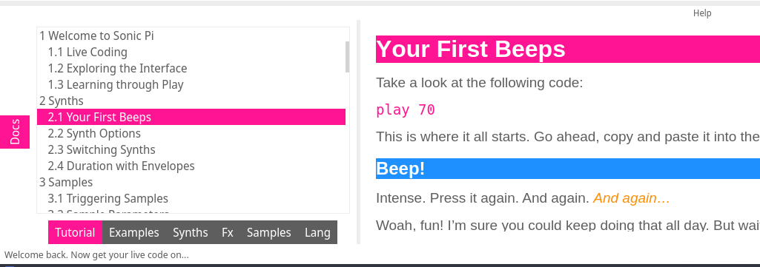  Check out the examples by typing: load_example and look at the help section: | 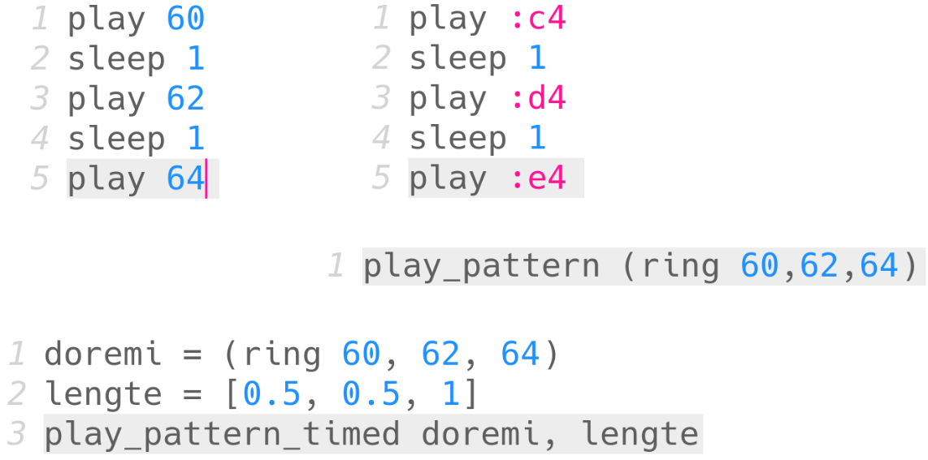  Single Notes
  Run | Alt + r
  Stop | Alt + s
  Copy | Alt + c
  Paste | Alt + v
  … | …
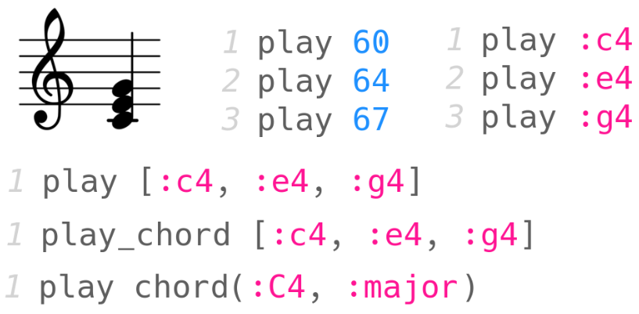  Chords | Synths  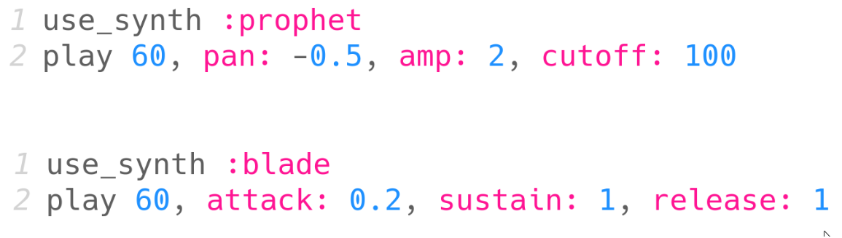  Check the manual for more details! | 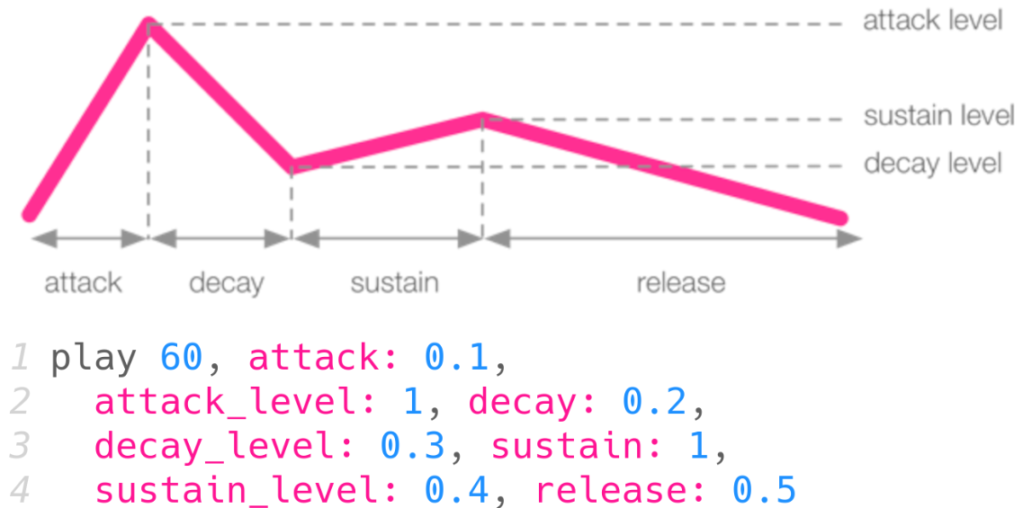  Envelopes
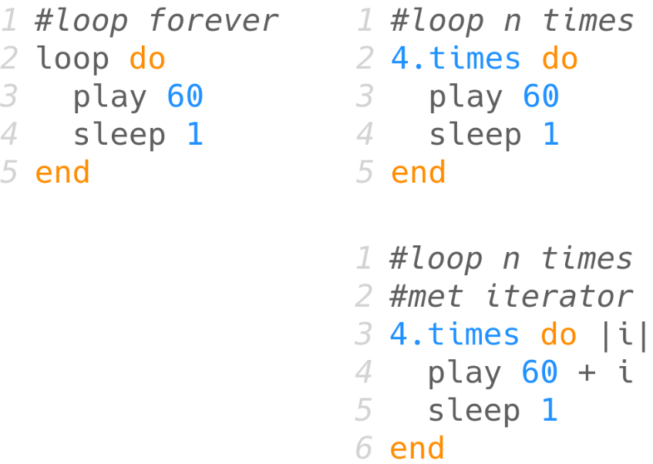  Loops | More Loops  Use in_thread to play multiple loops at the same time  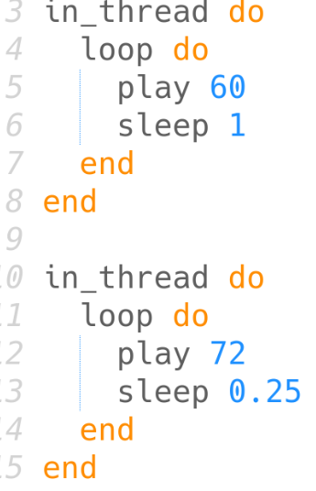 | 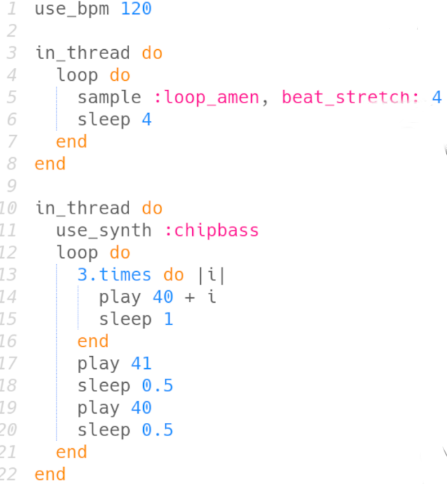  Yet more loops
Samples  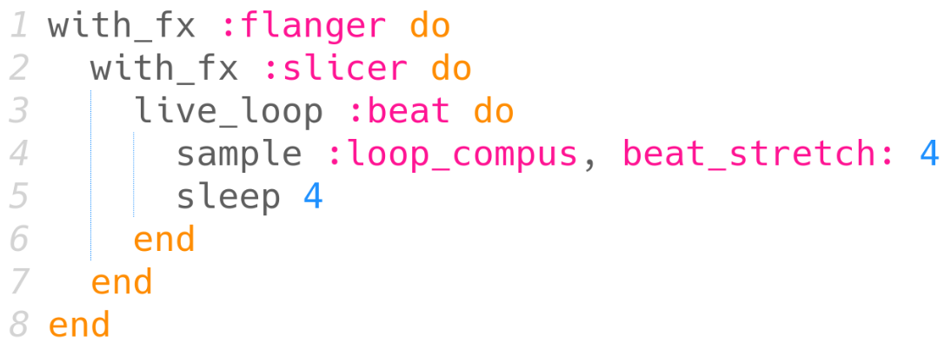  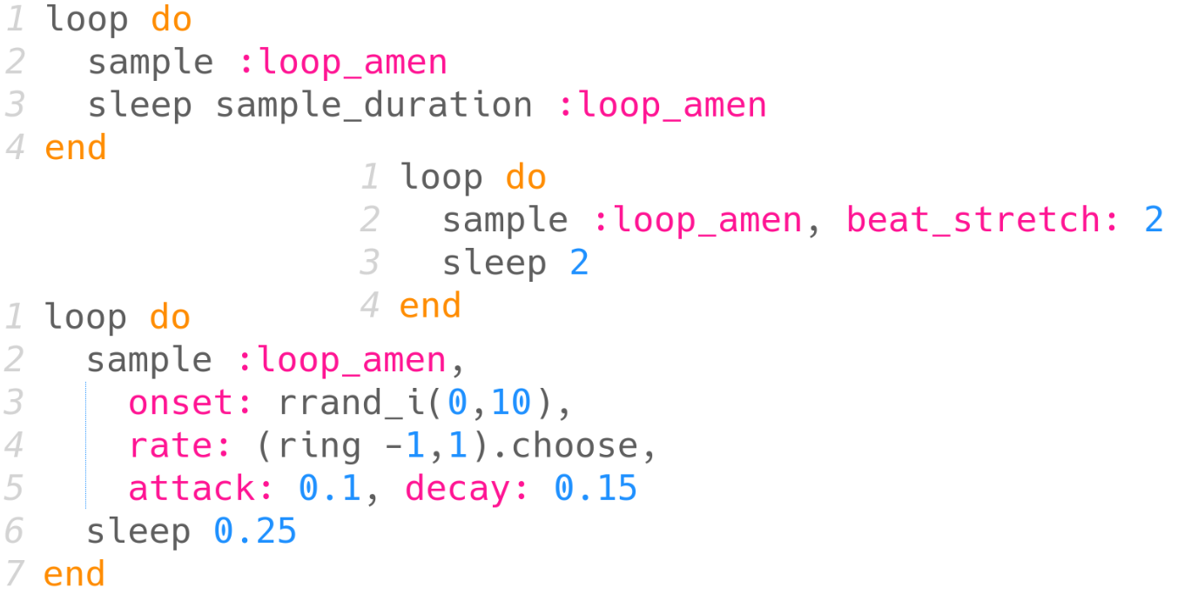 | Live loops  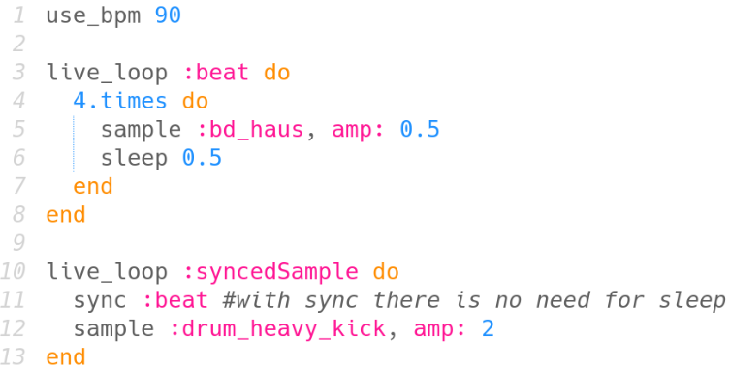  The music keeps going while you code. | Effects  Put the with_fx blocks around the loops, not in the loops, to reduce load on your cpu!
Random  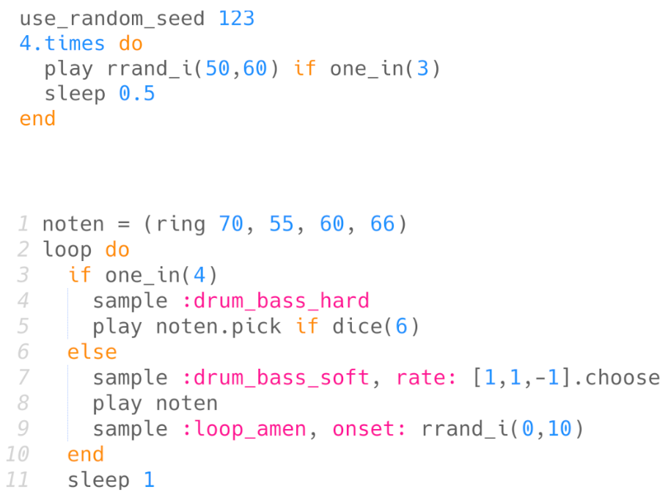  Random is pseudo-random so you can replay and share your compositions and they wil sound the same. | Midi and OSC  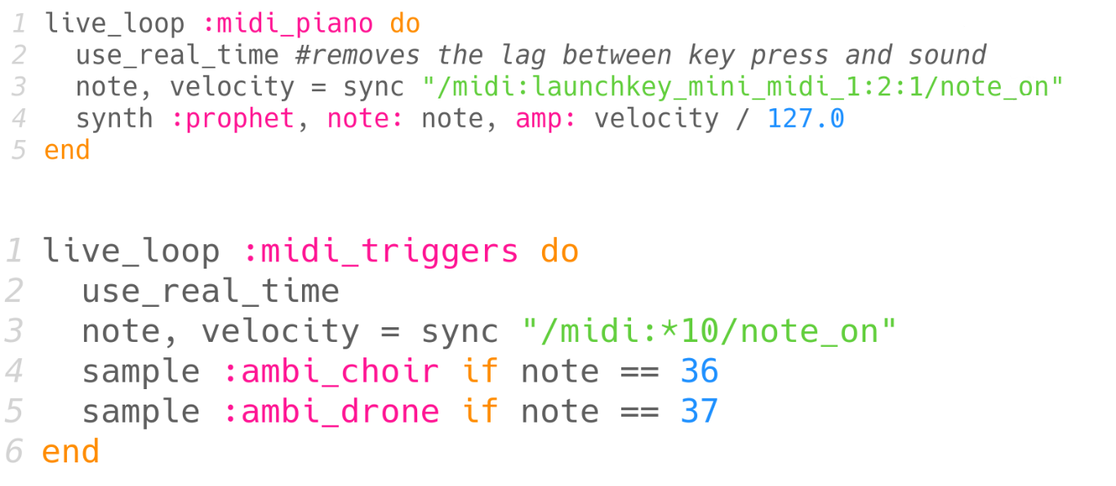  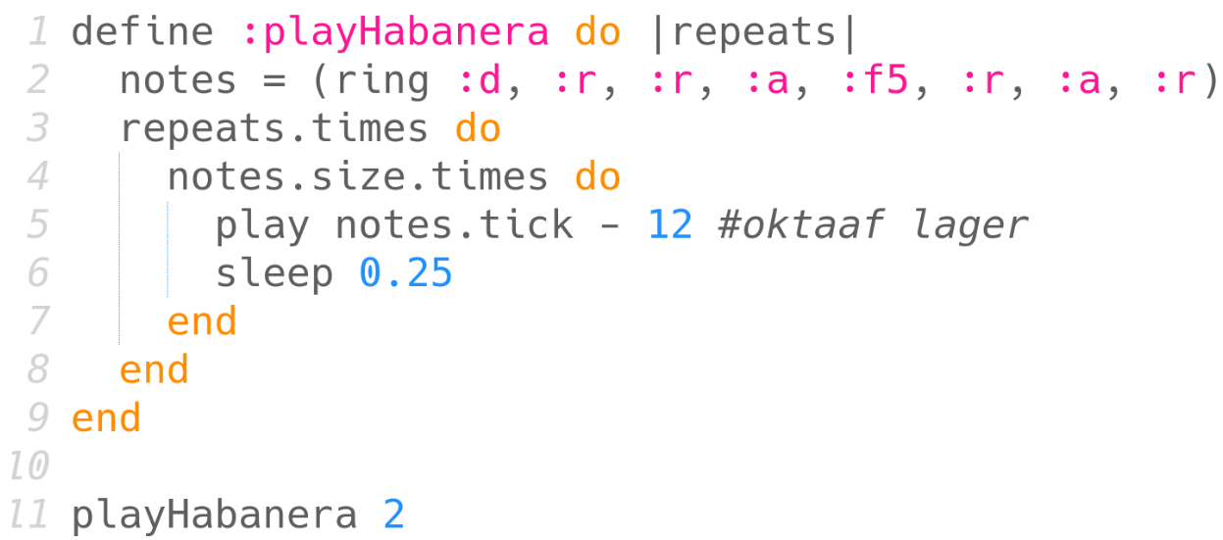  Use MIDI and OSC to use Sonic Pi with other code, external MIDI controllers and even DAWs! | Functions

