Django-Posgresql

* **Connect from Django to Posgresql Guid**
* **In Posgresql**

1. **Set up the software : download and set up Posgresql and Django on the machine.**
2. **Create passwork of Database Posgresql**
3. **Create new Login/Group Roles and that go to Privilege and turn on all the top 5 buttons.**

* **In Django**

1. **Each program have it own security in other to connect them together we need to install “ pip install psycopg2 ”**
2. **In Django there is a file name “ models.py ” click on the file and past this script**

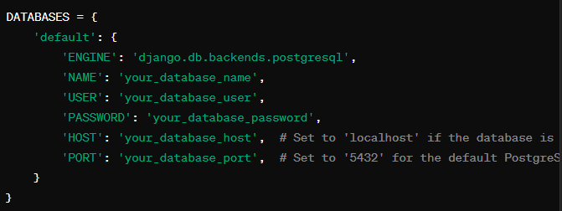

1. **Open new terminal : and to make change on model use cmd “ py manage.py makemigrations ” and run than “ py manage.py migrate ”**
2. **Than go to database and click on schemas and create a new table, after that modify the variable and insert the data to table.**