# General Conclusions

Over the last 10 years, the number of Kickstarter campaigns had increased dramatically. Between 2012 and 2014, the monthly number of campaigns hovered around 30. Heading in Q2 2014, we saw a marked increase to 96 campaigns. For approximately the next 3 years, the average number of campaigns stayed within this range with a sharp decrease in Q1 2017.

In order to get a better understanding of successful campaigns, we can take a look at the volumes of campaigns by category. The graph below illustrates the top three categories and the corresponding total campaigns:

* Theatre (1393)
* Music (700)
* Technology (600)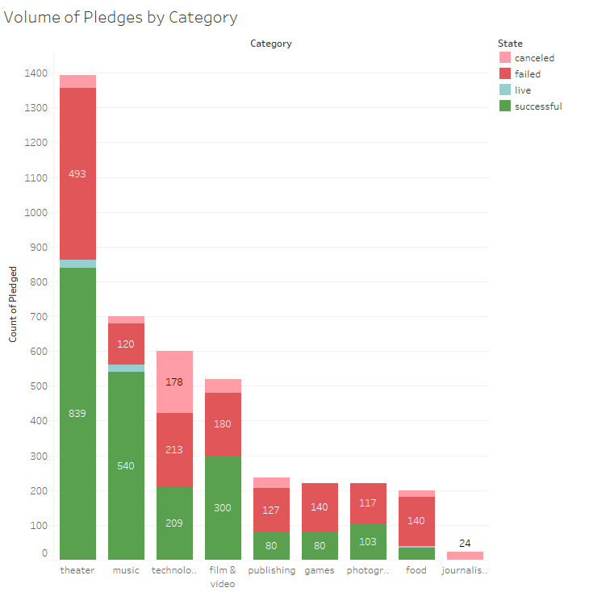

Although **Theatre** had the largest number of campaigns, it did not have the highest success rate. **Theatre** has a success rate of 60% while **Music**, which has approximately half the volume, displayed a 77% success rate. **Technology** campaign comes in third place. However, the success rate is vastly lower at 34%. Compared to the other two categories, almost half of all Technology campaigns are either canceled or failed.

Despite having a low success rate, **Technology** campaigns attract large donations. Over all, **Technology** campaigns totaled close to $24 billion. Of this, $19 million were associated with successful projects. Digging down a little further, approximately $18 million of these successful **Technology** Kickstarter campaigns were related to **Hardware-related** projects.

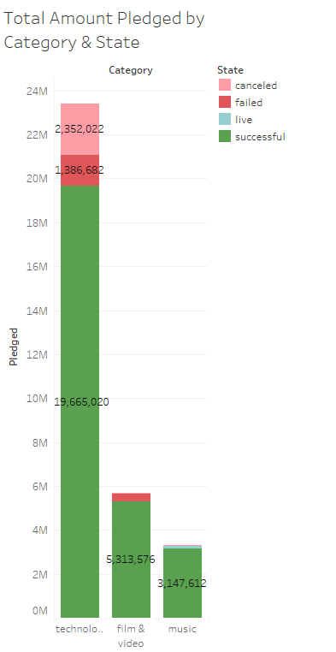

# Limitations

The

# Recommendations For Future Work

* Take a more in depth analysis of the projects which failed or were canceled. This may provide some insights in specific categories or sub-categories to prospective candidates should take caution with.
* In order to obtain more context on why campaigns were canceled or failed, the project owner could be prompted to provide a reason (e.g a drop down menu). This could potentially improve the quality of the data.
* Using the timestamps for Deadline and Launched At, calculate the duration of the campaign. Complete analysis to determine if there is a relationship between the time take to reach goal and successful campaigns