

glass size estimator

Installation Guide



April 17, 2019

Read hughes, alvin huynh, Andrew Scoggins

**For The Code User**

Installation of the GlassSizeEstimator.exe is simple and derives from a Microsoft Software Installer (MSI). To start, someone who has access to the C# code. This user should end up seeing something similar to this:

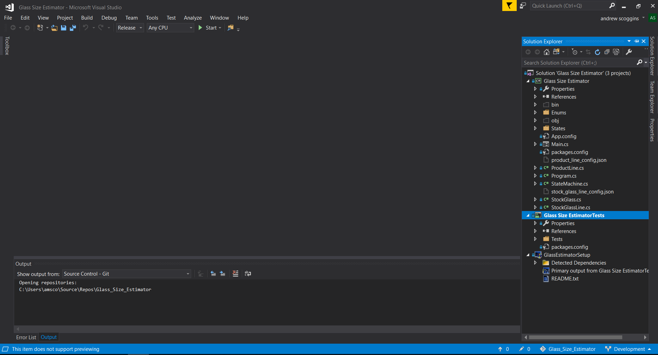

Following the user should right click and then run the GlassEstimatorSetup with the *Build* button (assuming changes haven’t occurred this build should succeed, else someone with C# knowledge should find and debug the project, and take appropriate actions).

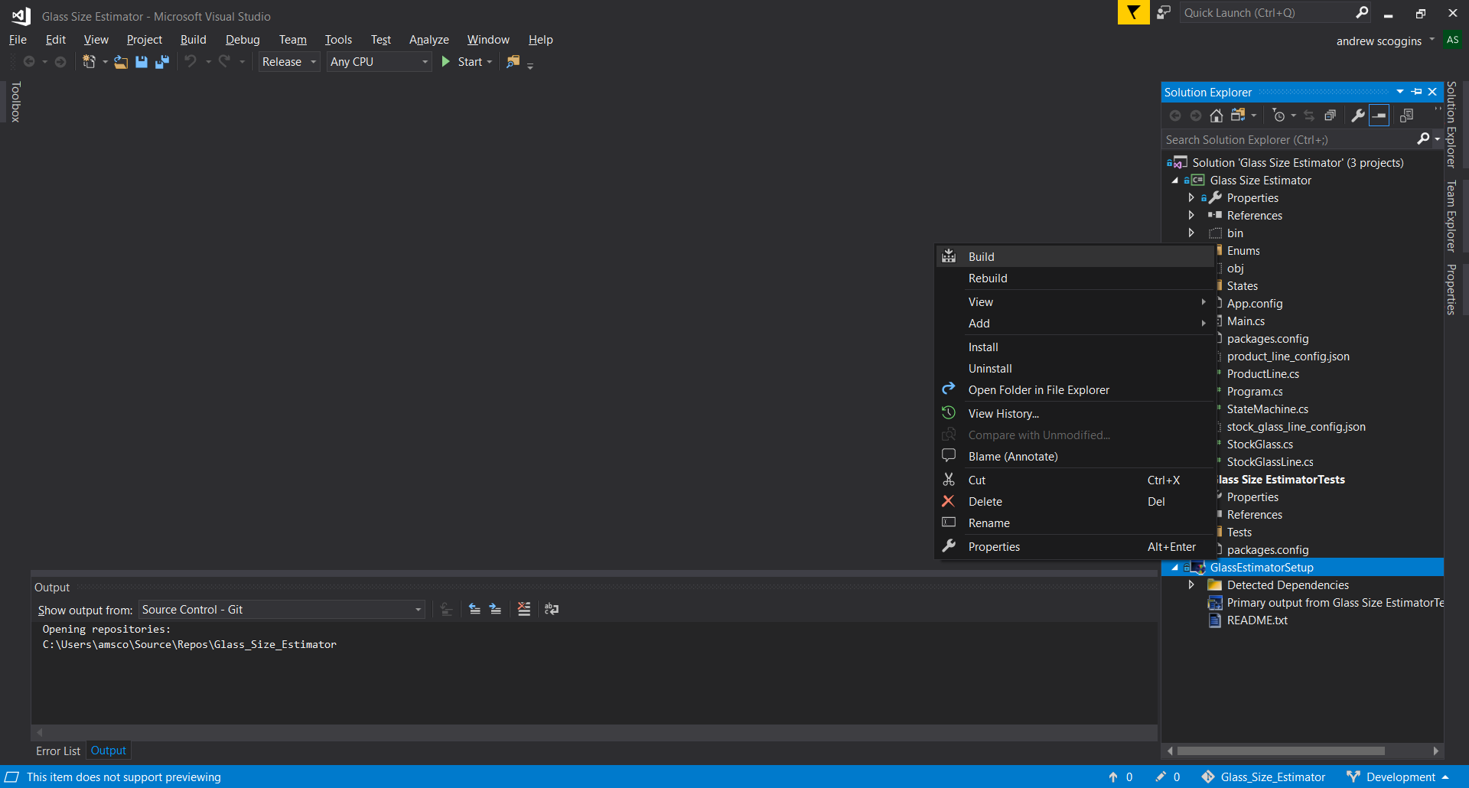

Upon which a successful build should look as shown:

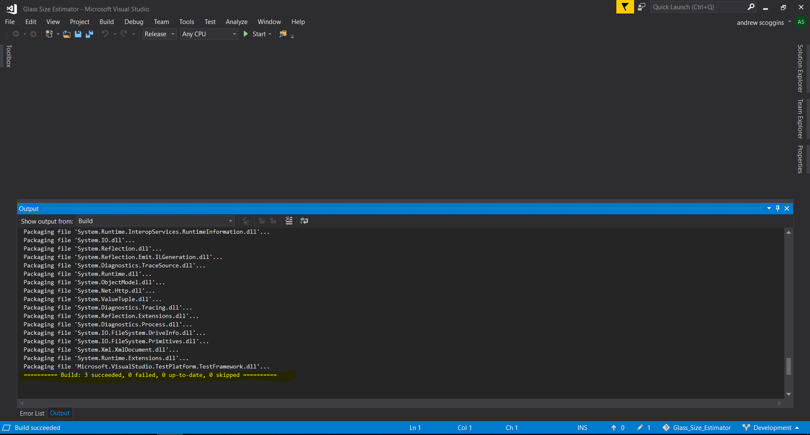

Afterwards, the one who has access to the code should locate in their File Explorer the location of the program as shown below:

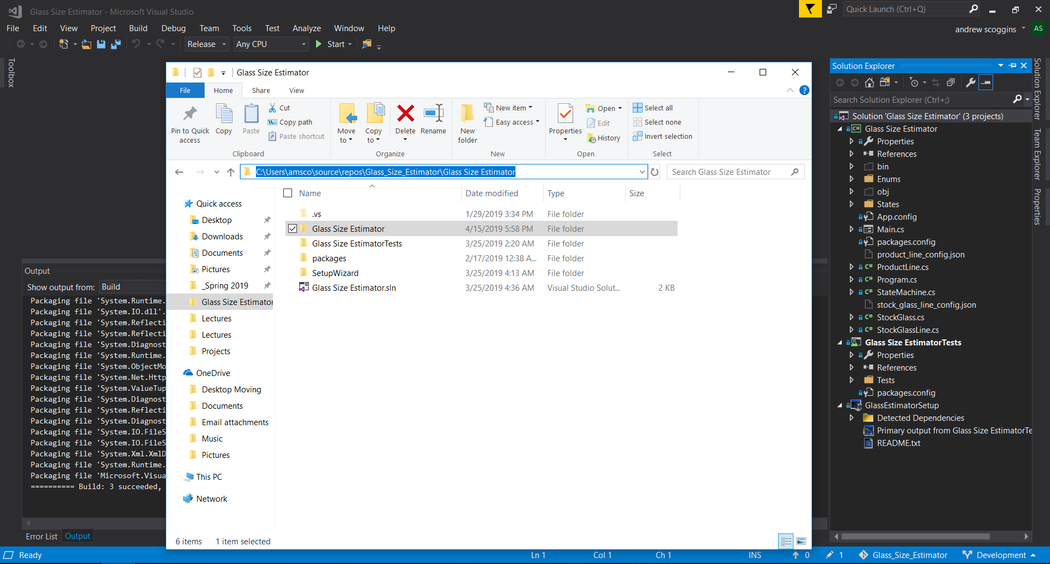

Open the “SetupWizard” folder and follow the files through until you get to two choices called Debug and Release. You may use either depending on if anyone alters the C# code (if there is an error, try to use the other initially). But from here open the folder and run either the setup.exe or the GlassEstimatorSetup.msi. I would just run the MSI.

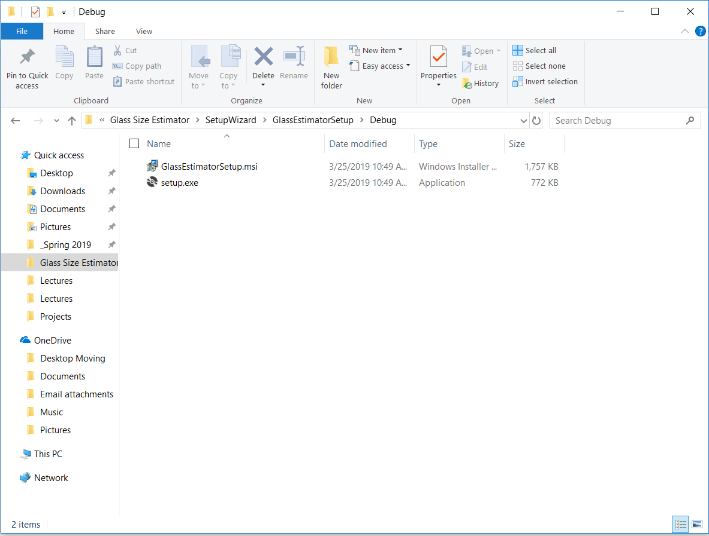

Your computer will ask you if its okay to make changes to the hard drive, accept these and choose “Yes”. I already have the software installed so the next step will go straight to the file location. The installer defaults to C:\Program Files (x86)\HMICardinal\GlassEstimatorSetup, depending on your computer registry system (could be x64, etc). You may have problems installing this if you have a premade HMICardinal folder in this directory at all you may experience some issues:

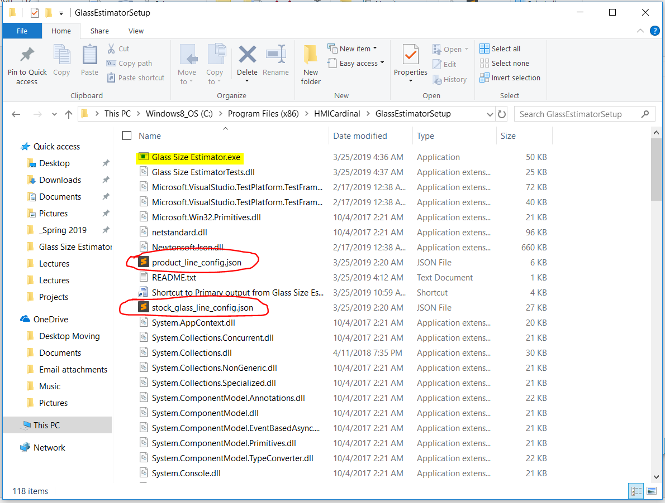

Here you will find the GlassSizeEstimator.exe which will actually run the program. The two red circled files will not be in this folder by default you will have to add them from the previous file location found in the repository code (to edit to this folder **you may have to have administrative access**):

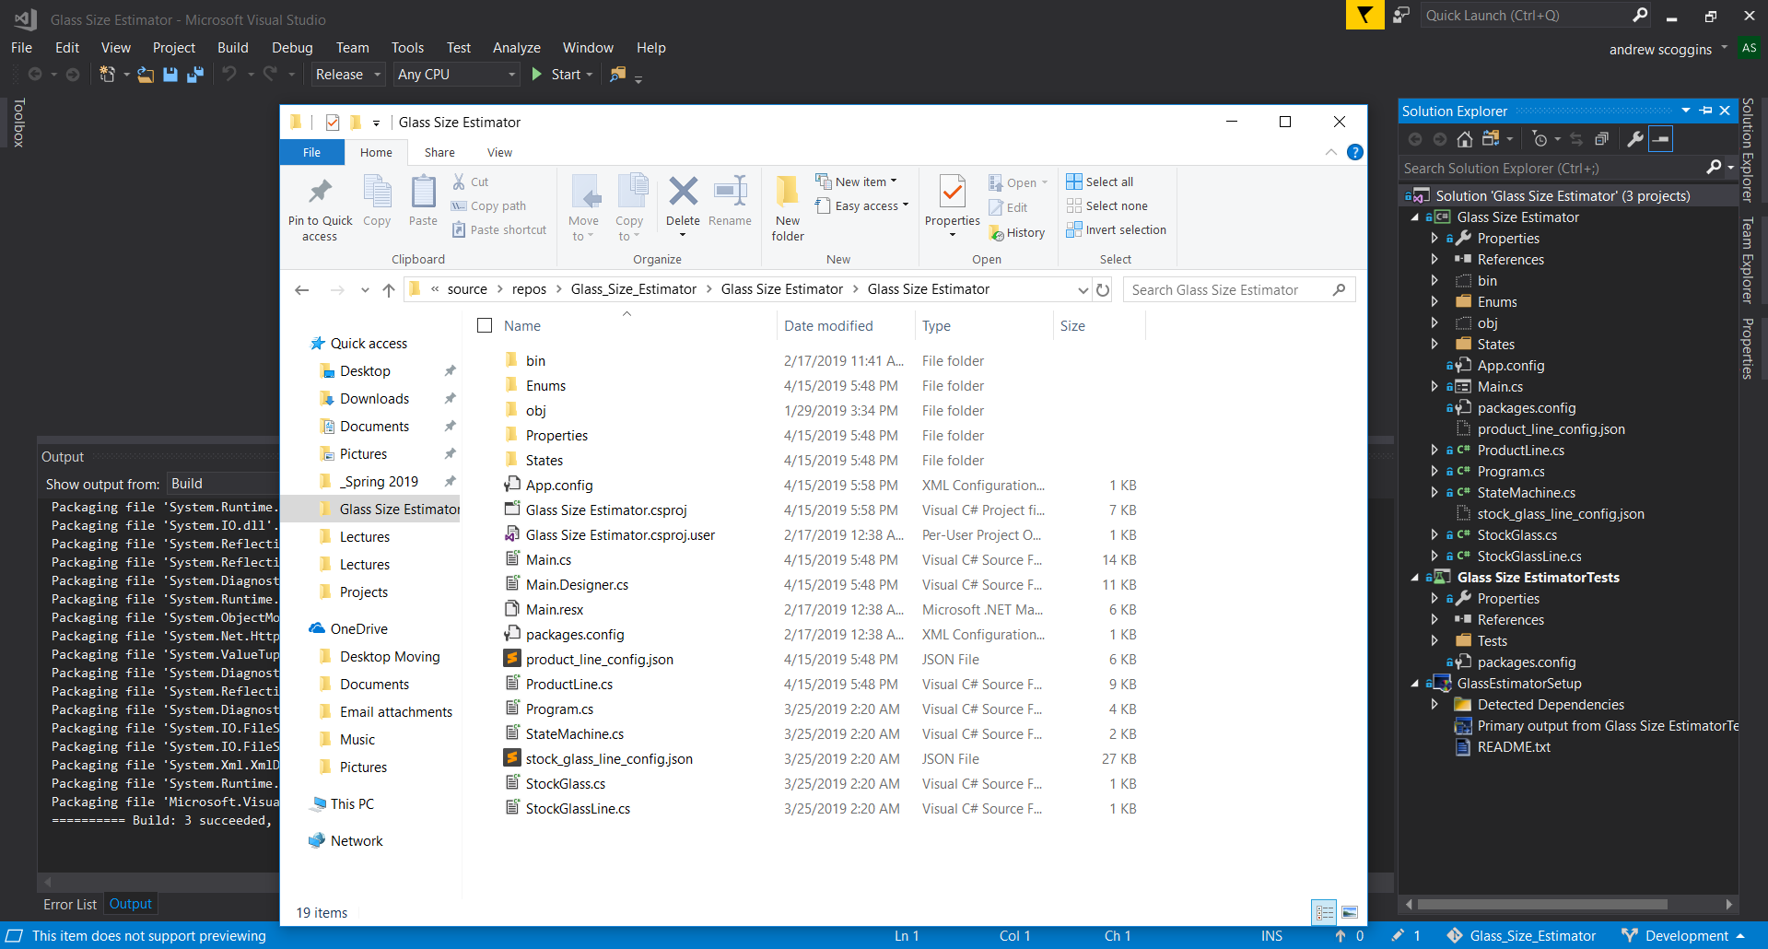

If the files are not there you may find them in the location below. Or if you want to run the code locally without installing, you will need to move those files into this folder then run the regular (non-test, non-setup) project in visual studio. This will need to be debug/release based on what mode you want to use in visual studio/what you set it up for in the wizard.

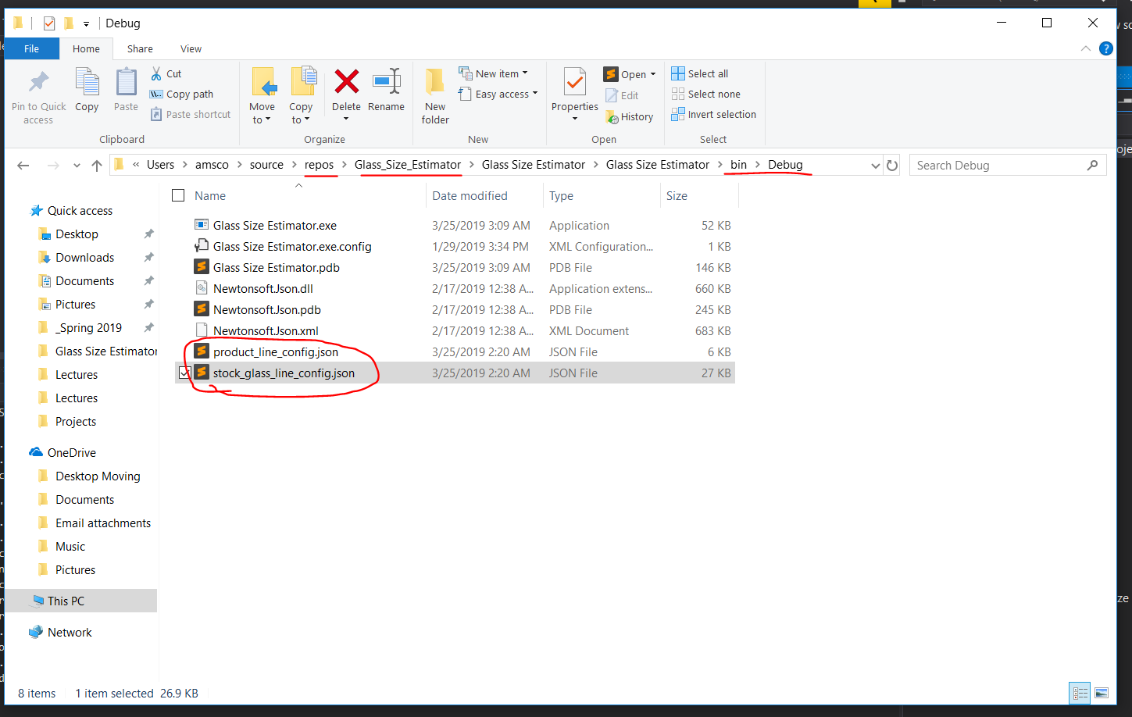

If these files are not in this folder, you may see this error message:

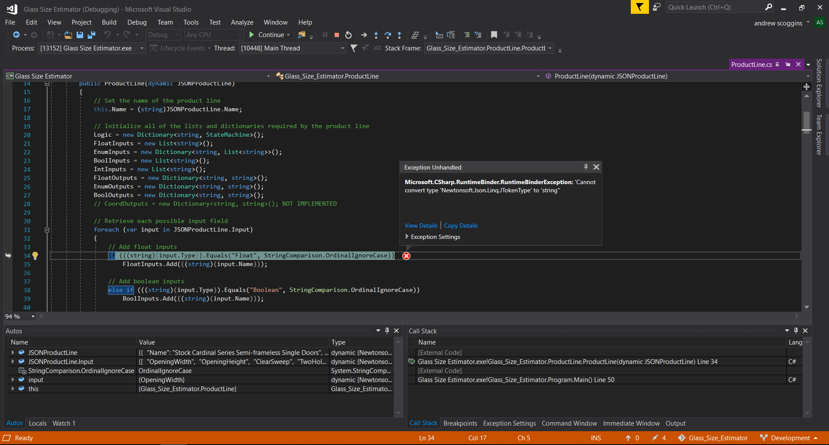

If all succeeds, you should see the program as follows:

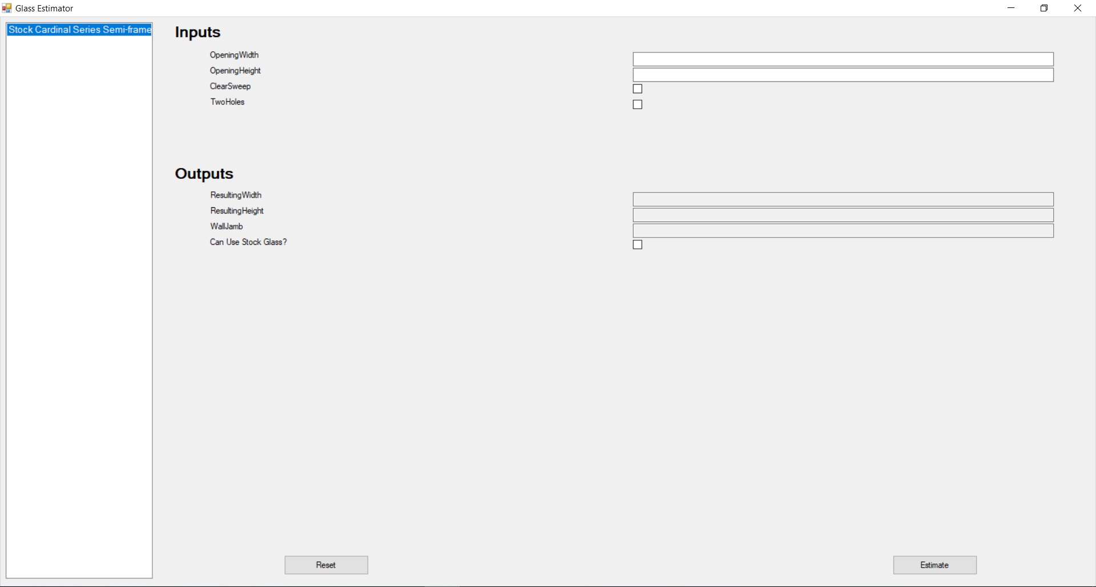

**For The Non-Code Accessor/User**

Installation of the GlassSizeEstimator.exe is simple and derives from a Microsoft Software Installer (MSI). To start for someone who has no access to the code repository, you will need to be given the 3 main components mentioned above but also reiterated again here (by a code holder):

1. GlassEstimatorSetup.msi/setup.exe

2. product_line_config.json

3. stock_glass_line_config.json

Once these three files are given in some manner (Note: you can not send .exe or .msi through email….you will have to change the file extensions and change them back or use an online drive to share), the user will just have to run the setup/MSI.

Your computer will ask you if its okay to make changes to the hard drive, accept these and choose “Yes”. I already have the software installed so the next step will go straight to the file location. The installer defaults to C:\Program Files (x86)\HMICardinal\GlassEstimatorSetup, depending on your computer registry system (could be x64, etc). You may have problems installing this if you have a premade HMICardinal folder in this directory at all you may experience some issues:



Here you will find the GlassSizeEstimator.exe which will actually run the program. The two red circled files will not be in this folder by default you will have to add them to this file location from the given files. To edit to this folder **you may have to have administrative access.**

If all succeeds, you should see the program as follows:

