My Awesome Paper

Gavin Simpson

2020-04-02

# Abstract

Something, Something

# Introduction

This is an R Markdown document. Markdown is a simple formatting syntax for authoring HTML, PDF, and MS Word documents. For more details on using R Markdown see <http://rmarkdown.rstudio.com>.

When you click the **Knit** button a document will be generated that includes both content as well as the output of any embedded R code chunks within the document. You can embed an R code chunk like this:

summary(cars)

## speed dist   
## Min. : 4.0 Min. : 2.00   
## 1st Qu.:12.0 1st Qu.: 26.00   
## Median :15.0 Median : 36.00   
## Mean :15.4 Mean : 42.98   
## 3rd Qu.:19.0 3rd Qu.: 56.00   
## Max. :25.0 Max. :120.00

# Methods

These are some totally awesome methods that I’ll be discussing in my paper. As mentioned in Introduction, this paper discusses a range of method including method 1 (Wood 2017) and method 2 that was first introduced by Pedersen et al. (2019).

# Results

You can also embed plots, for example:

Note that the include = FALSE parameter was added to the code chunk to prevent printing of the R code that generated the plot.

As shown in Figure 1, you will see my totally awesome result.

Table 1 also shows some frikkin awesome results in table form!

# Discussion

Blah, Blah, Blah

# Conclusions

Give me the Nobel Prize

# References

Pedersen, E.J., Miller, D.L., Simpson, G.L., and Ross, N. 2019. Hierarchical generalized additive models in ecology: An introduction with mgcv. PeerJ **7**: e6876. doi:[10.7717/peerj.6876](https://doi.org/10.7717/peerj.6876).

Wood, S.N. 2017. Generalized additive models: An introduction with r, second edition. CRC Press.

# Figures

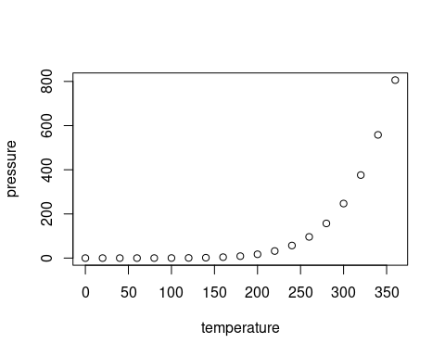

Figure 1: Look at this totally awesome result!

# Tables

Table 1: A table of totally awesome results!

|  |  |  |  |  |  |  |  |  |
| --- | --- | --- | --- | --- | --- | --- | --- | --- |
|  | mpg | cyl | disp | hp | drat | wt | qsec | vs |
| Mazda RX4 | 21.0 | 6 | 160.0 | 110 | 3.90 | 2.620 | 16.46 | 0 |
| Mazda RX4 Wag | 21.0 | 6 | 160.0 | 110 | 3.90 | 2.875 | 17.02 | 0 |
| Datsun 710 | 22.8 | 4 | 108.0 | 93 | 3.85 | 2.320 | 18.61 | 1 |
| Hornet 4 Drive | 21.4 | 6 | 258.0 | 110 | 3.08 | 3.215 | 19.44 | 1 |
| Hornet Sportabout | 18.7 | 8 | 360.0 | 175 | 3.15 | 3.440 | 17.02 | 0 |
| Valiant | 18.1 | 6 | 225.0 | 105 | 2.76 | 3.460 | 20.22 | 1 |
| Duster 360 | 14.3 | 8 | 360.0 | 245 | 3.21 | 3.570 | 15.84 | 0 |
| Merc 240D | 24.4 | 4 | 146.7 | 62 | 3.69 | 3.190 | 20.00 | 1 |
| Merc 230 | 22.8 | 4 | 140.8 | 95 | 3.92 | 3.150 | 22.90 | 1 |
| Merc 280 | 19.2 | 6 | 167.6 | 123 | 3.92 | 3.440 | 18.30 | 1 |