“ls” allows you see all the files and folders in your Computer Science directory account
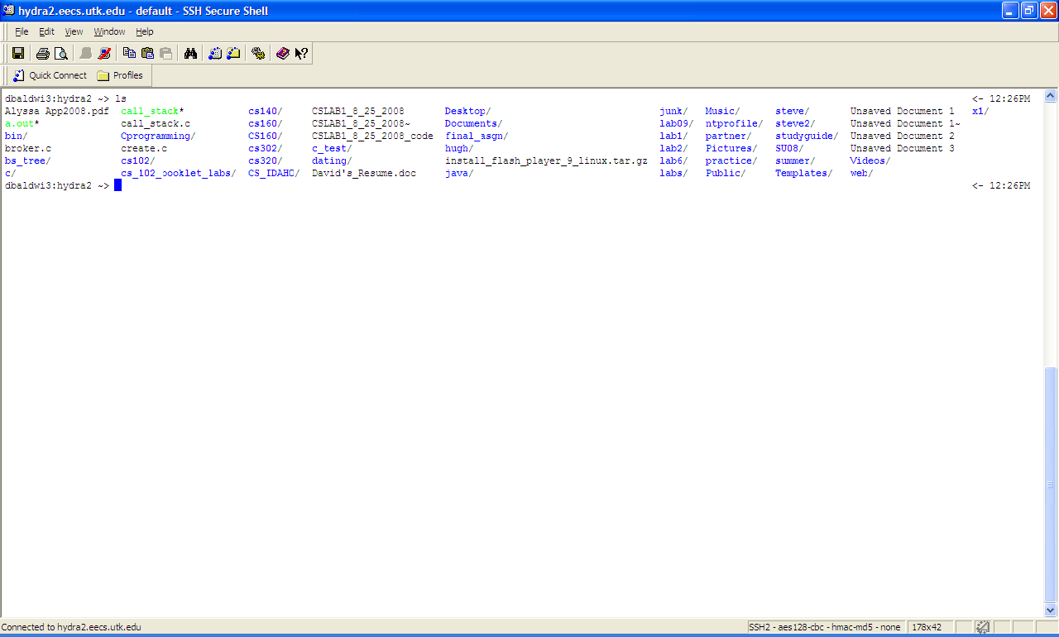
If you want to move quickly to a particular directory you must first type “cd” then space. Then you can simply type a few letters and then press “tab”. “cd” stands for “change directory”. In this example we want to get to the “cs_102_booklet_labs” folder to do so we first type “c” then press tab. Below are all the folders than it found that began with “c”.

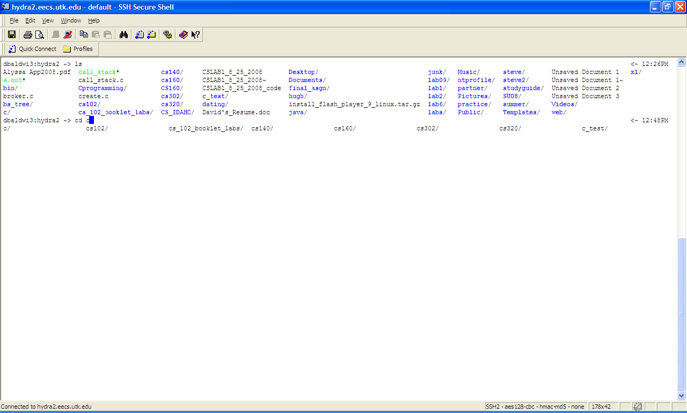
Now we still did not get “cs_102_booklet_labs” folder specifically when we typed “c” then tab. So lets try and type “cs” and see what we get.
As you can tell, even with “cs” we still need to type out more letters.
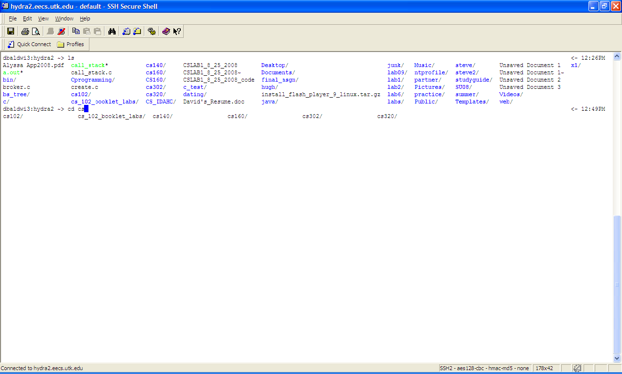
This time when you typed “cs_” then tab the rest of the letters were instantly filled in. This functionality comes in handy when you have lots of folders to navigate through. When I first was introduced to the idea of using this functionality, three years ago, I never thought I would ever use it. I was definitely wrong, now I know I would be angry if they ever removed it.
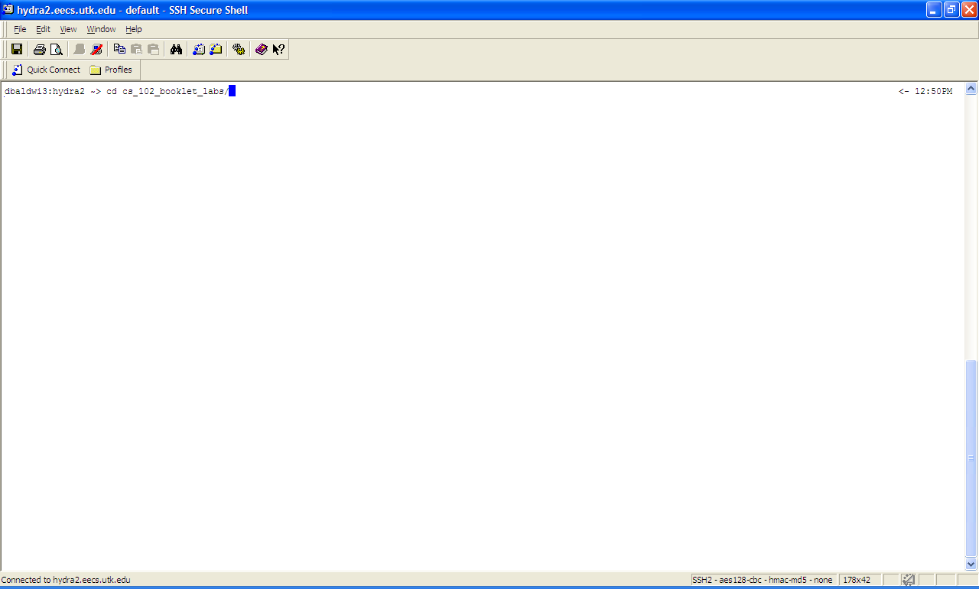
Here are a few example of me navigating through my CS account, to help be sure you got the technique down pack.
Changing directory to a sub folder: cs_102_booklet_labs
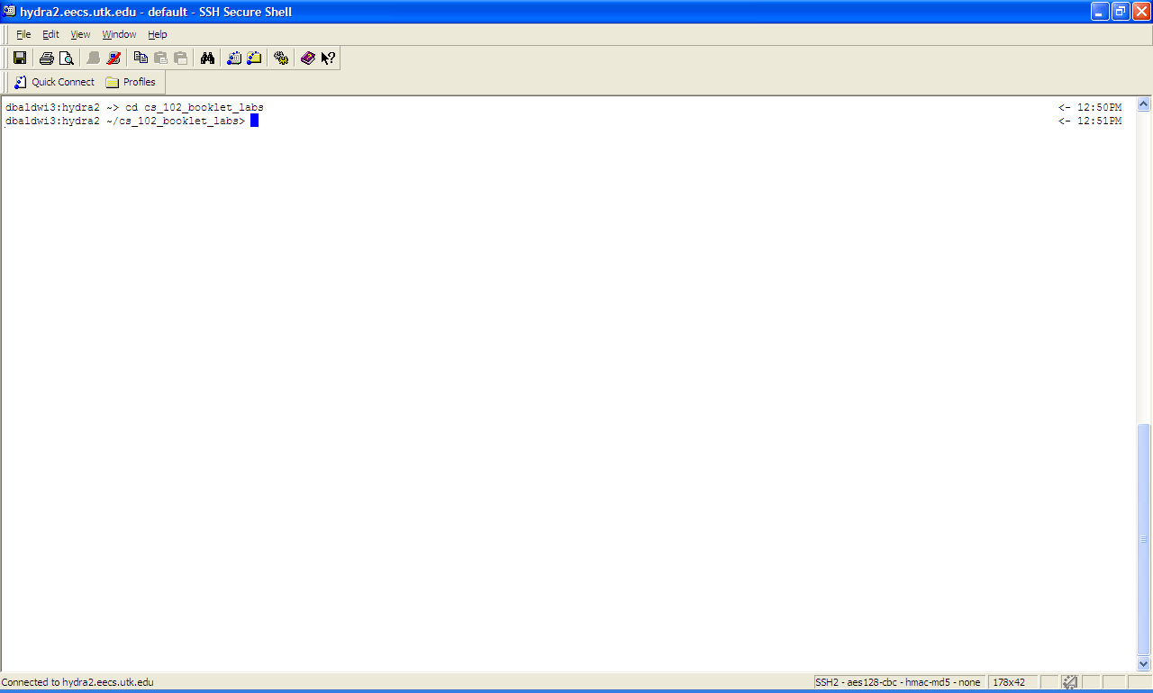

Changing directory to lab1….
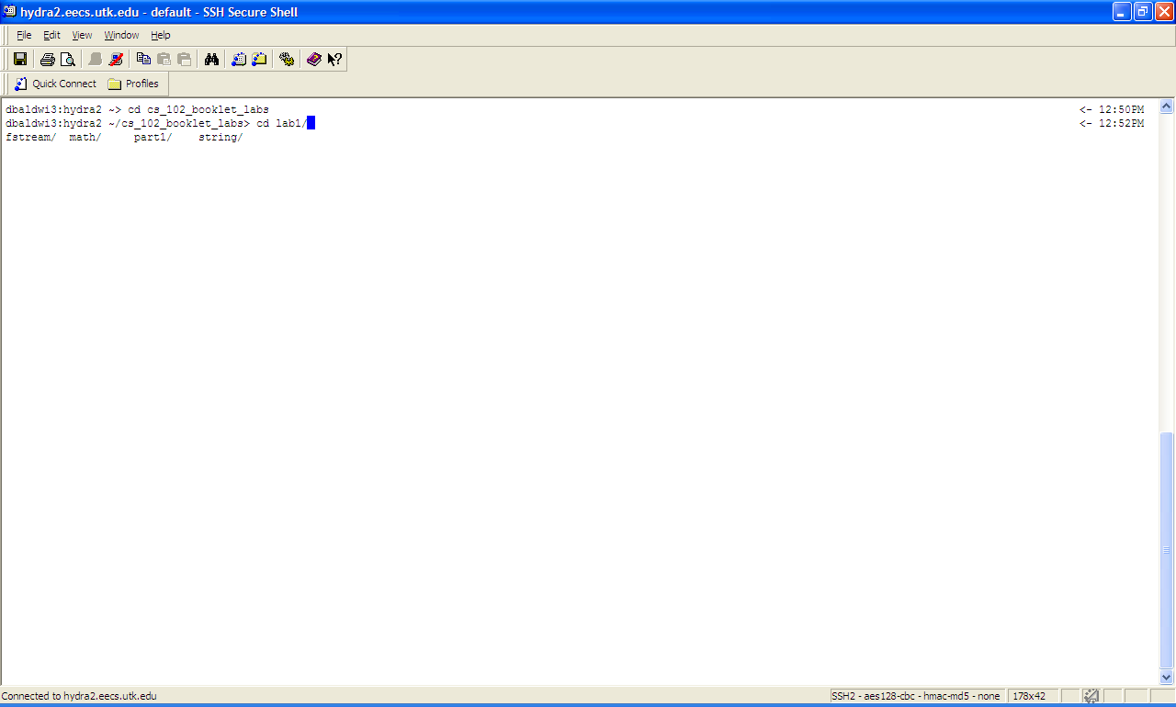
Now to purpose of the CS course…creating C++ programming files you use to code your program in.
You first type “vi” then the name of the file you want to create as shown below.
Thus the format for creating a file in “vi”: vi [file name]
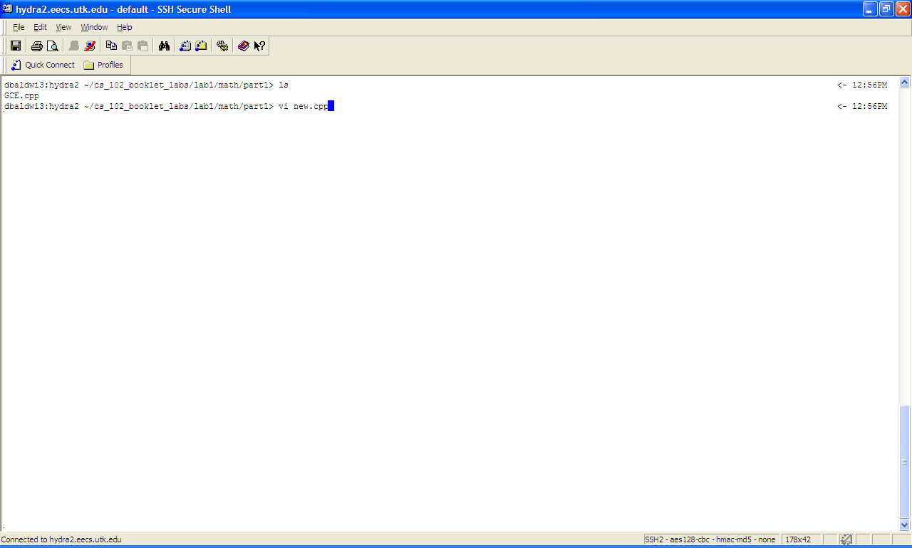

When you hit “I” on the keyboard you add information to the file that you are viewing. “I” means “INSERT”, which is why “INSERT” shows up in the bottom left corner.
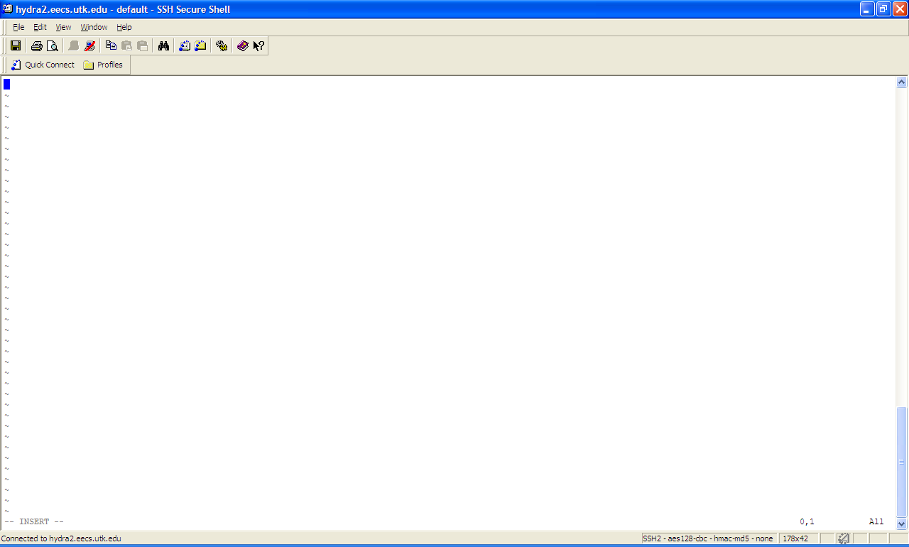

Hit “esc” if you want to exit out of any mode that your are currently in (in this case we exited out of “INSERT” mode).
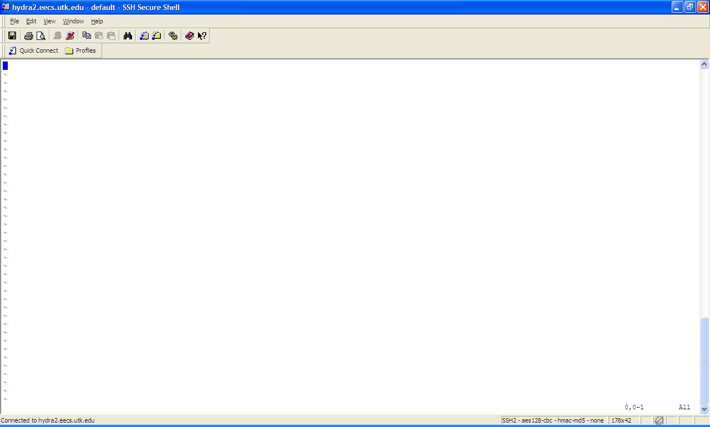

Now, re-enter INSERT mode, then type the following message (and no this will not the a computer program code). Now lets save what we typed by hitting the “esc” key then type“:w” as shown below.
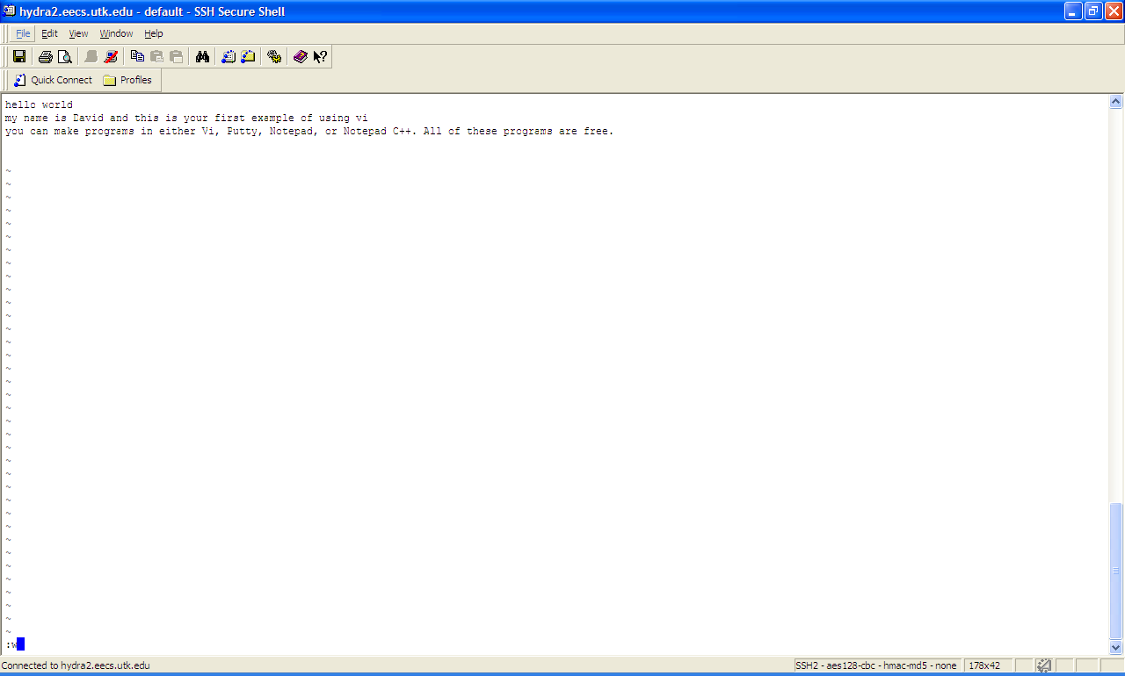

When you save a file, vi tells you what the name of the file is (look at the bottom left corner)
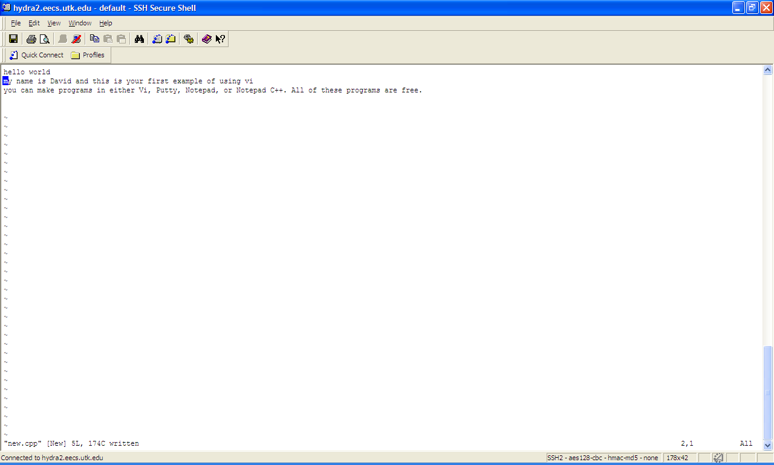

If you want to exit “vi” type “:q”
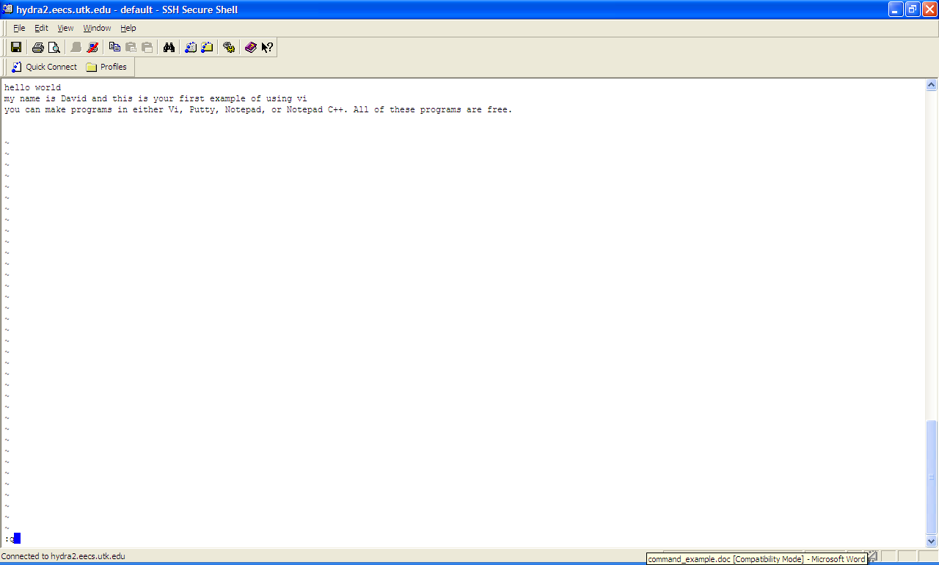

So now you see that the file was actually created when you saved it (look at bottom ).
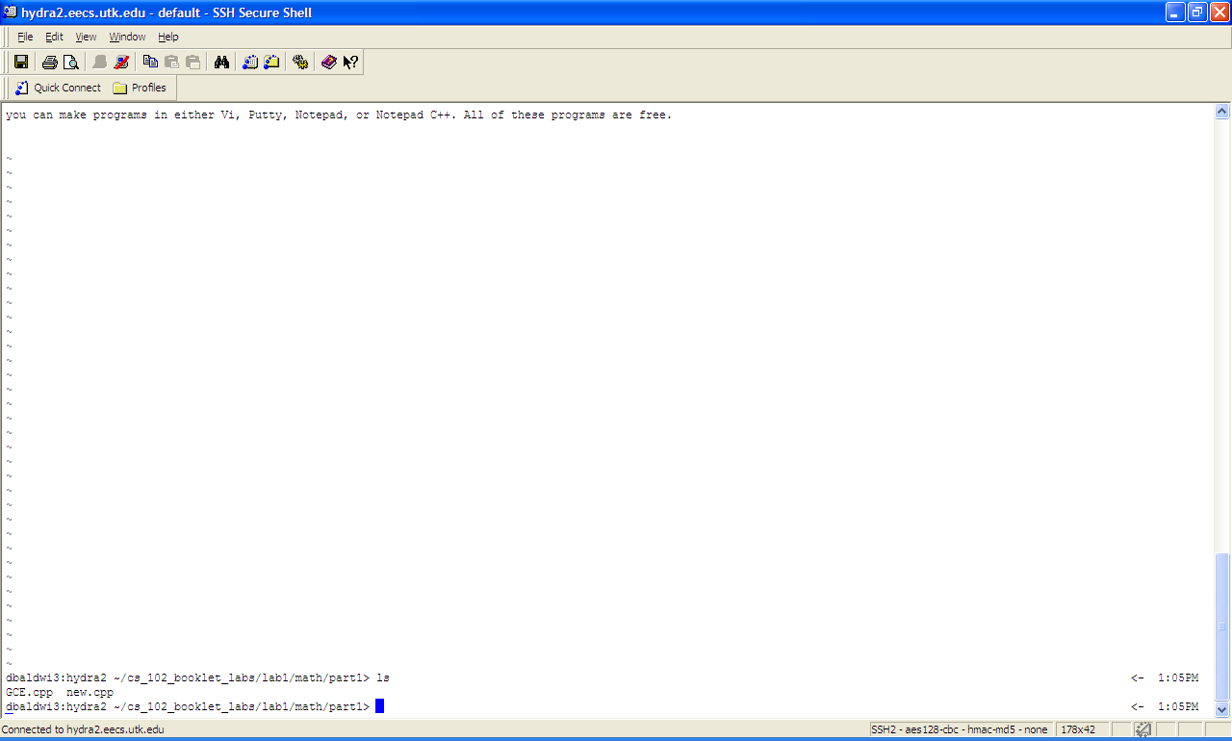

Type “y2y” (copies the current line and the next line that the cursor is on and above). The “y” stands for “yank” and the “2” represents the number of lines that are yanked. The last y confirms that you want to “yank” two lines. If at anytime you want to terminate a yank, you can do so my hitting the “esc” key. The yank is confirmed by “vi” stating “2 lines yanked” (bottom left corner).
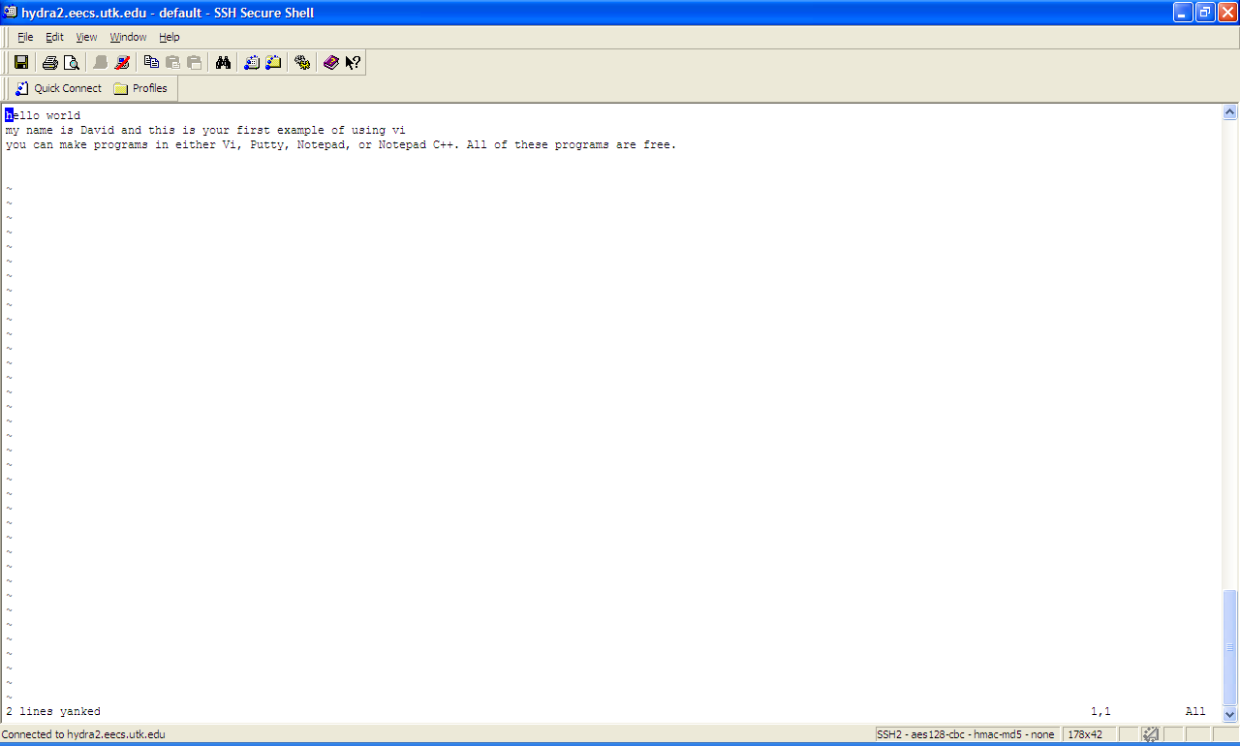

Now lets go and paste this lines that copied at a new location in the file. Move the cursor to the current location as show below.
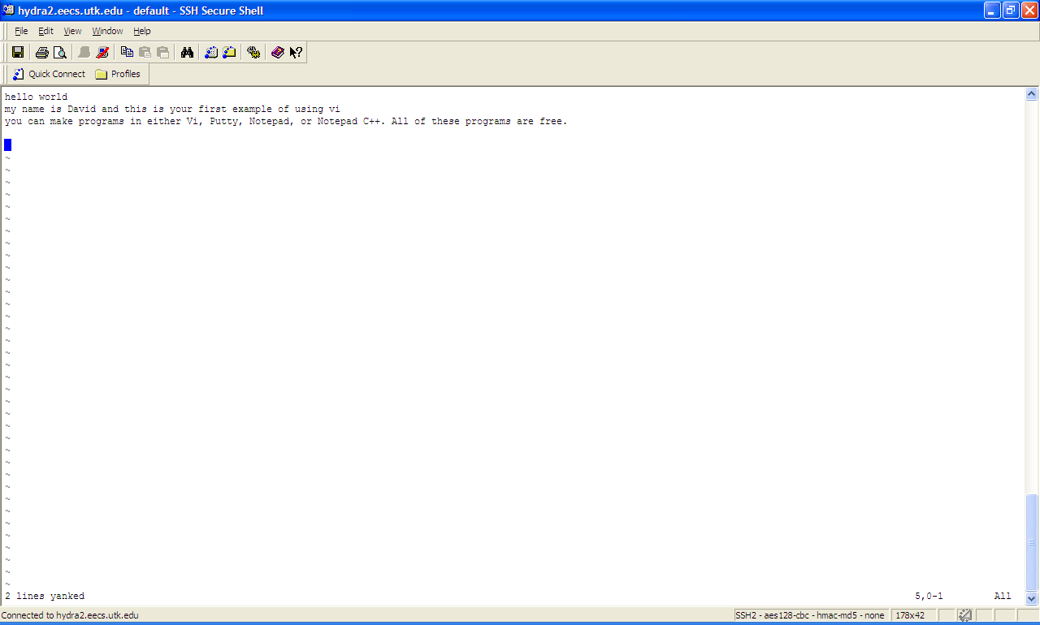

Now press “p” on the keyboard. A paste is confirmed when “vi” says “2 more lines” (besides the fact that you should obviously see the new lines).
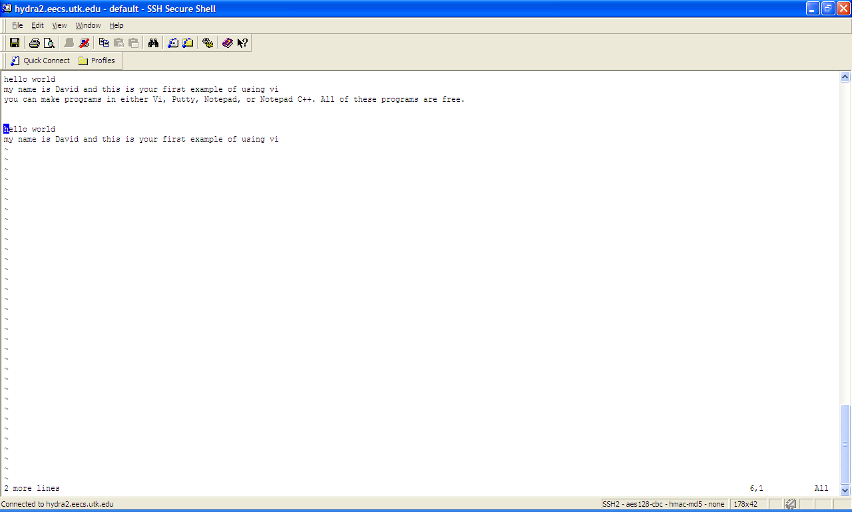

Now lets delete the two lines we have just added. To do this we hit “esc” key once and type “d2d” (delete the currently line and the next line below the cursor). “d” represents “delete”, but what it really is doing is “cutting” the two lines of out of the file. If you have never used “cut” before in windows, you will enjoy this technique. A successful cut is confirmed by the VI program stating “2 fewer lines”.
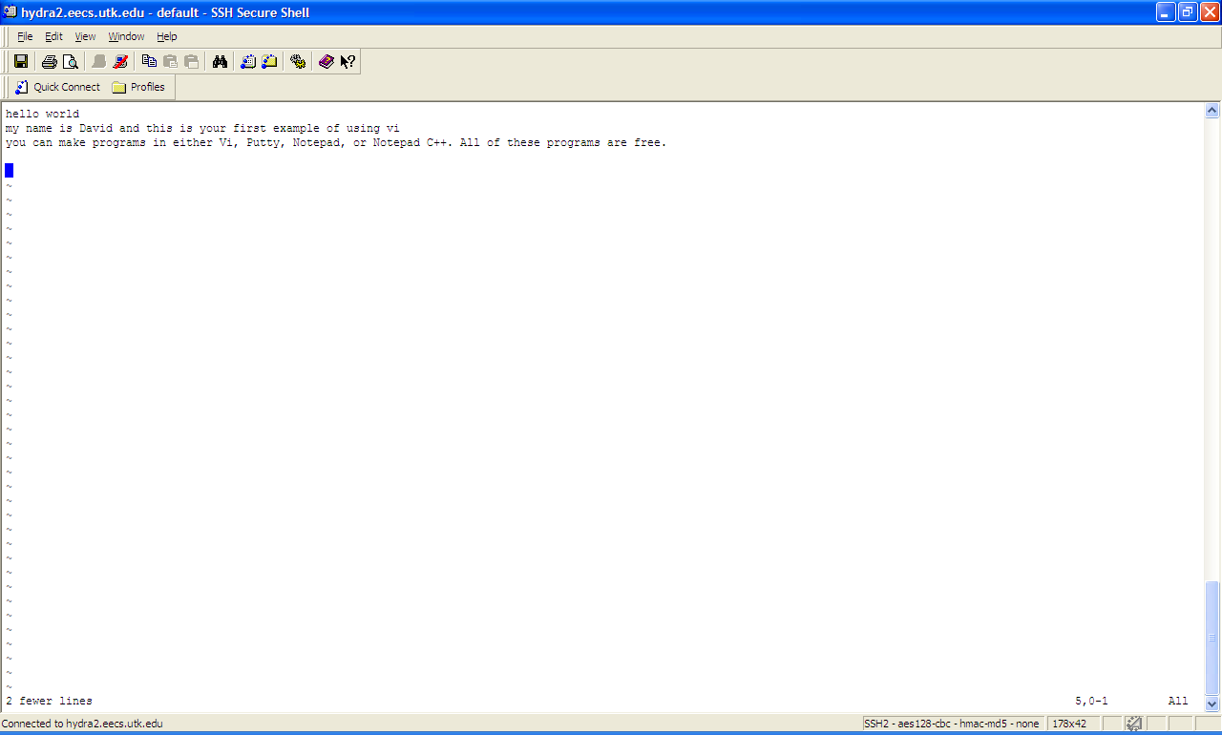

Now press “p” and magically the lines that I had previously deleted are back in place.
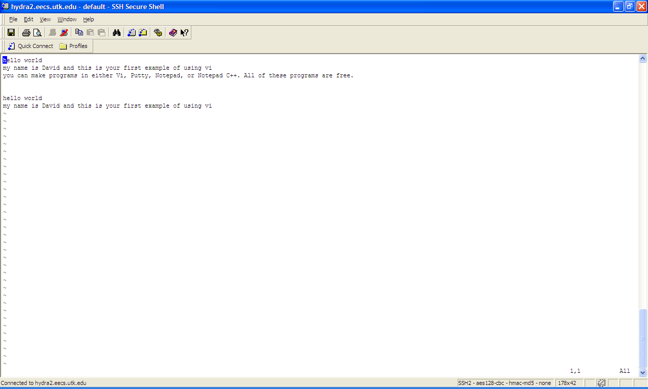

Now what if I make a mistake while coding? Oops I typed “d5d” (delete the current line and 4 lines below the cursor)
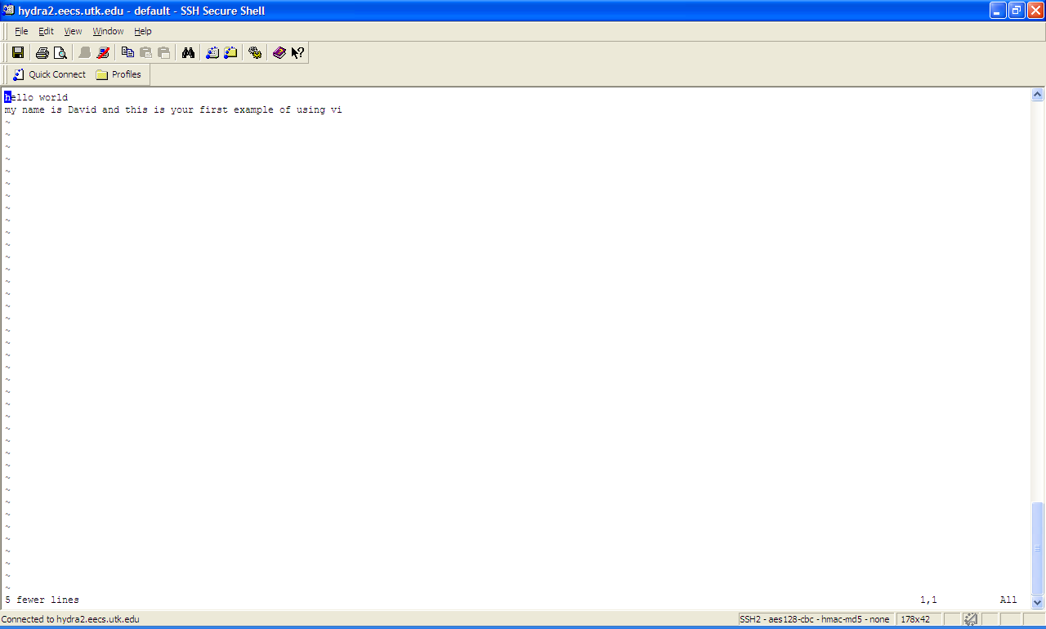

That’s ok because you can undo anything you have done (accident or on purpose) by hitting “esc” key and then typing “u”. “u” obviously stands for “undo”.
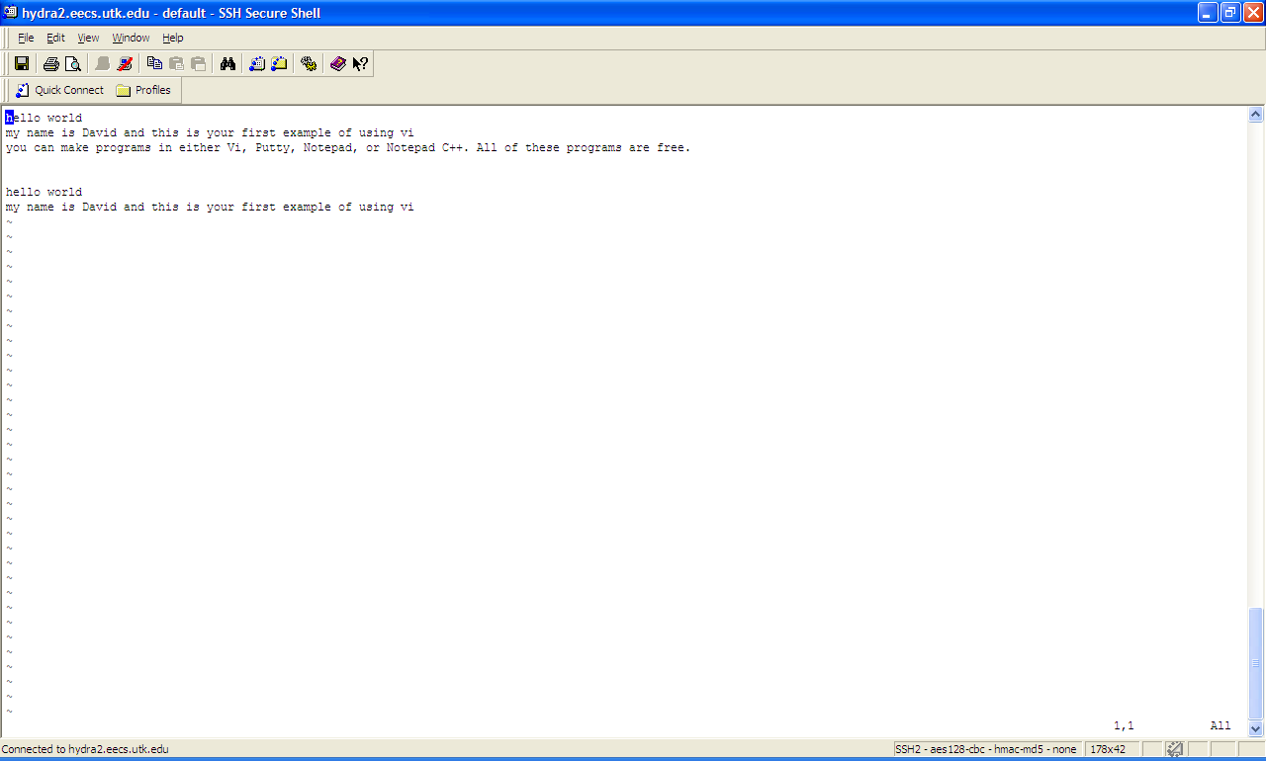

….nice
Now you can save and exit the VI Editor simply by pressing the “esc” key and then “:wq” as shown below.
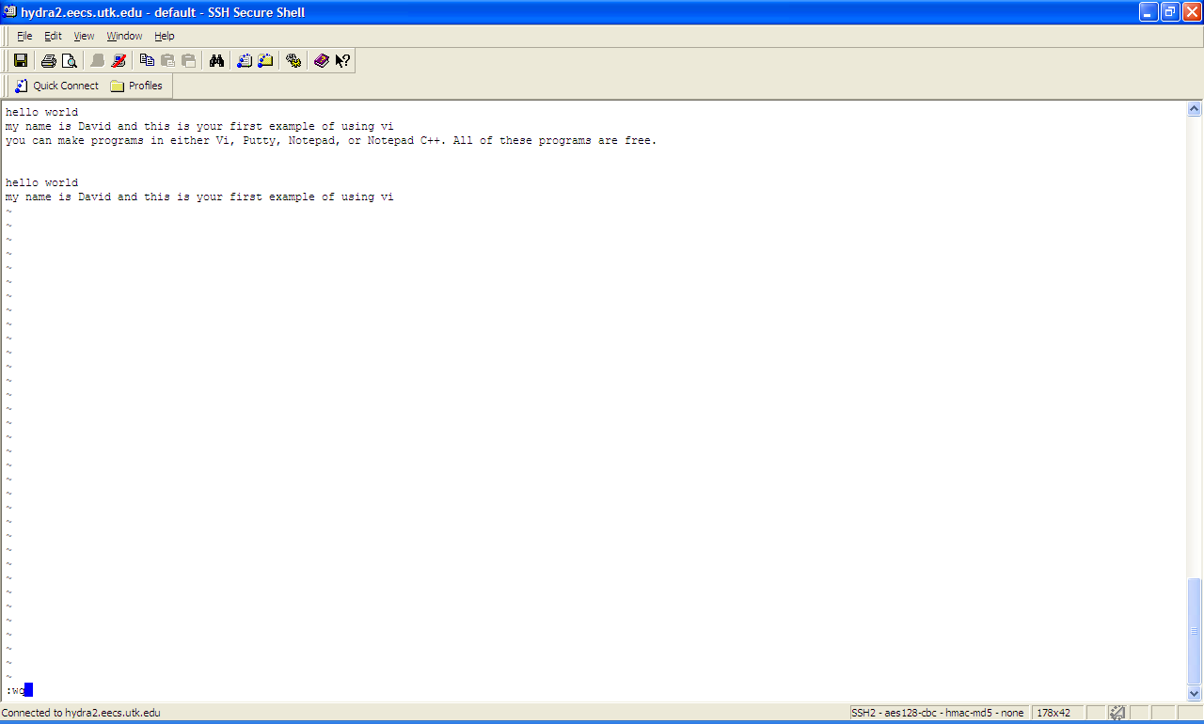

Now you make skip this section on Valgrind if you choose. Valgrind is virtual pointless to do at this level of C++ programming. Why? Because Valgrind tells the program if the program he has created is leaking. What do I mean by leaking? Well, a program is said to be “leaking” if it does not free up all the memory that it used. If you design programs that do not free up all the memory they use then your program will crash. And I do not know about you, but a program that constantly crashes is not fun to play or use. So why is this not important at the CS 102 level, because C++ automatically handles for freeing up all the memory a program will use. But I digress, lets find a program to check for leaks on.
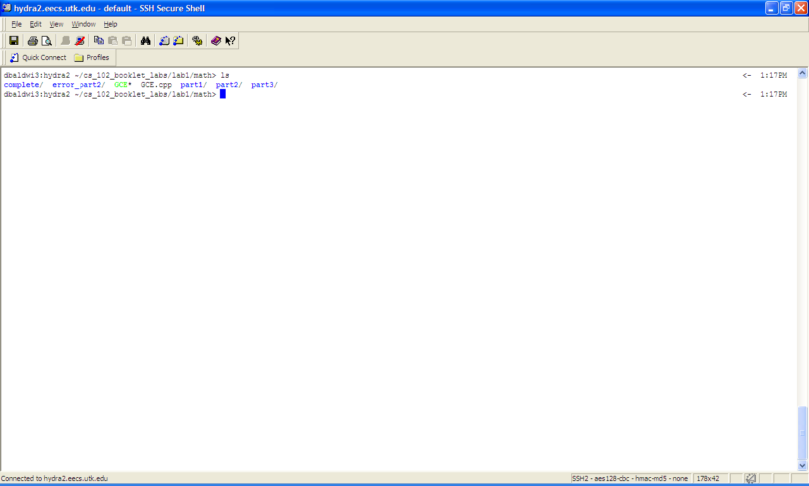

Once you have found a program you want to use Valgrind one type the following format:
valgrind ./[program name]

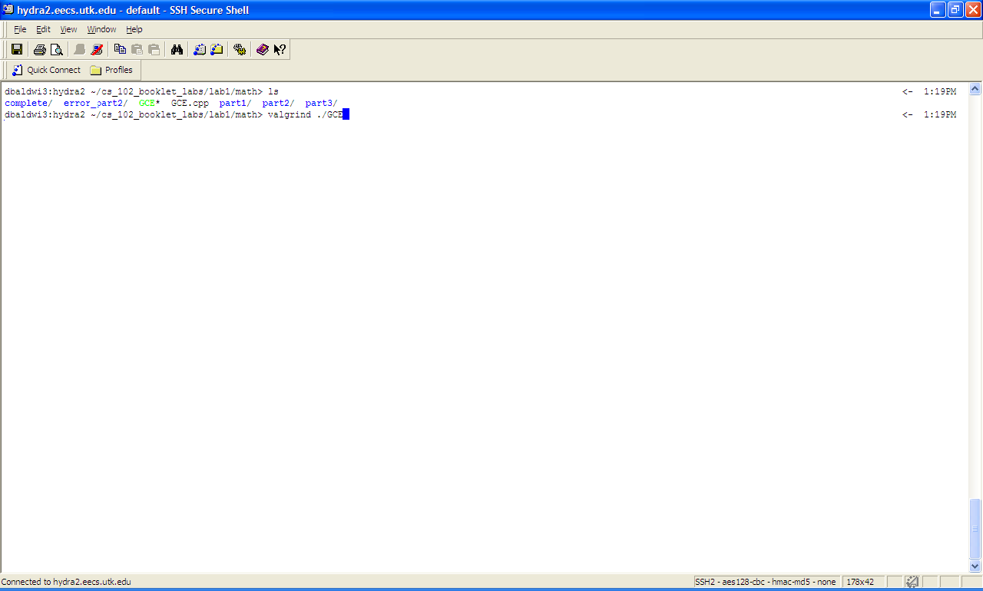
Valgrind begins to run. In the case of this program, it expects input from the user. This particular program takes longitude and latitude coordinates of two places on earth and returns the distance between the two points. You will later create such a program.

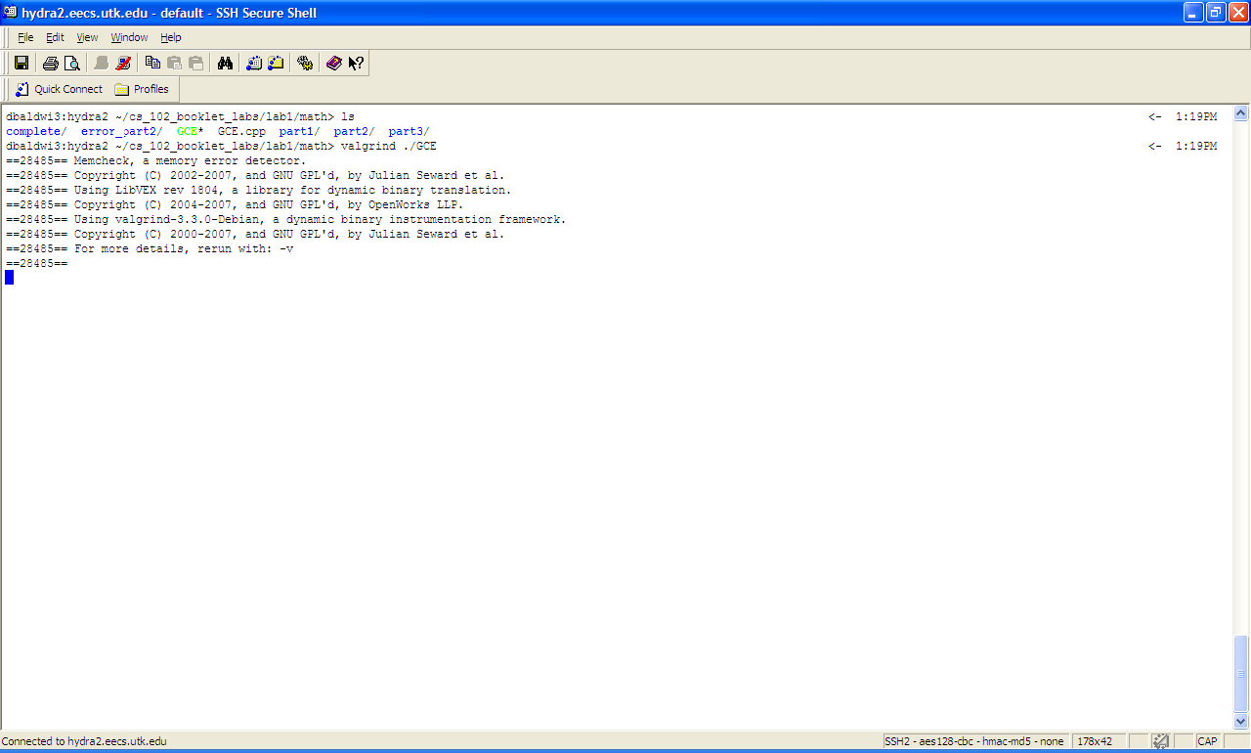

I go ahead and give it the information is expecting. Basically you run the program as if you were not even using valgrind.
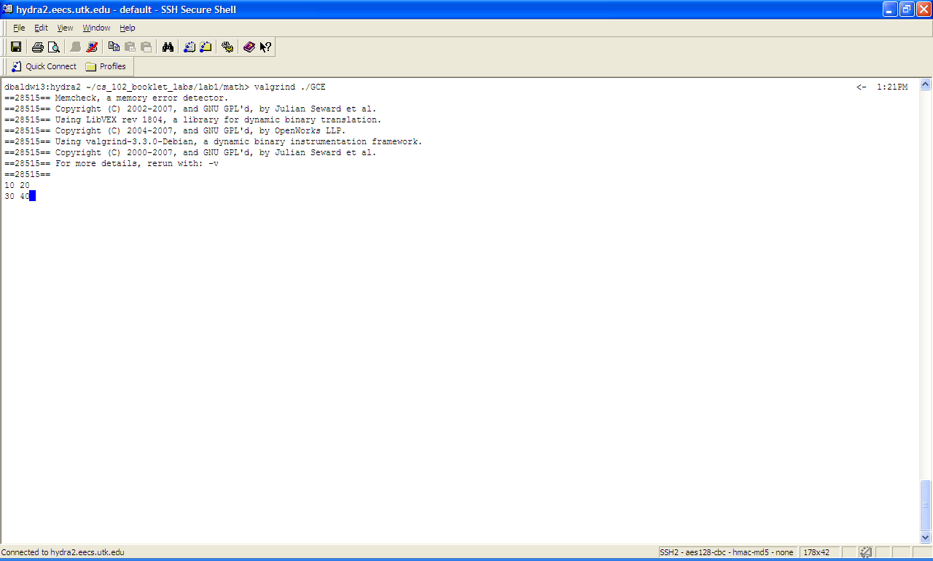
Now read the information valid grind returns carefully.
Error Summary found no errors. Also it reports “All heap blocks freed” and “ no leaks are possible”. That is the most relevant information for the CS 102 and 140 level students.
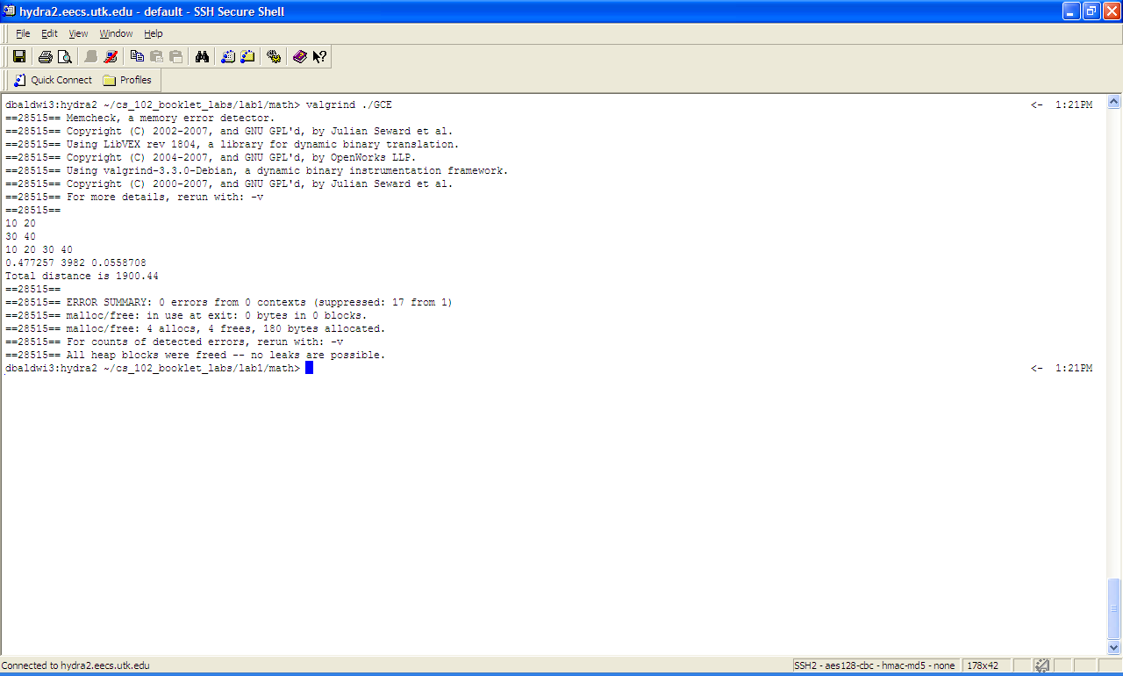

Now that we are finished playing with Valgrind, we can check out the “dir” command. The “dir” command list all the folders in a particular directory. To do this simply type “dir” then hit enter as shown below:

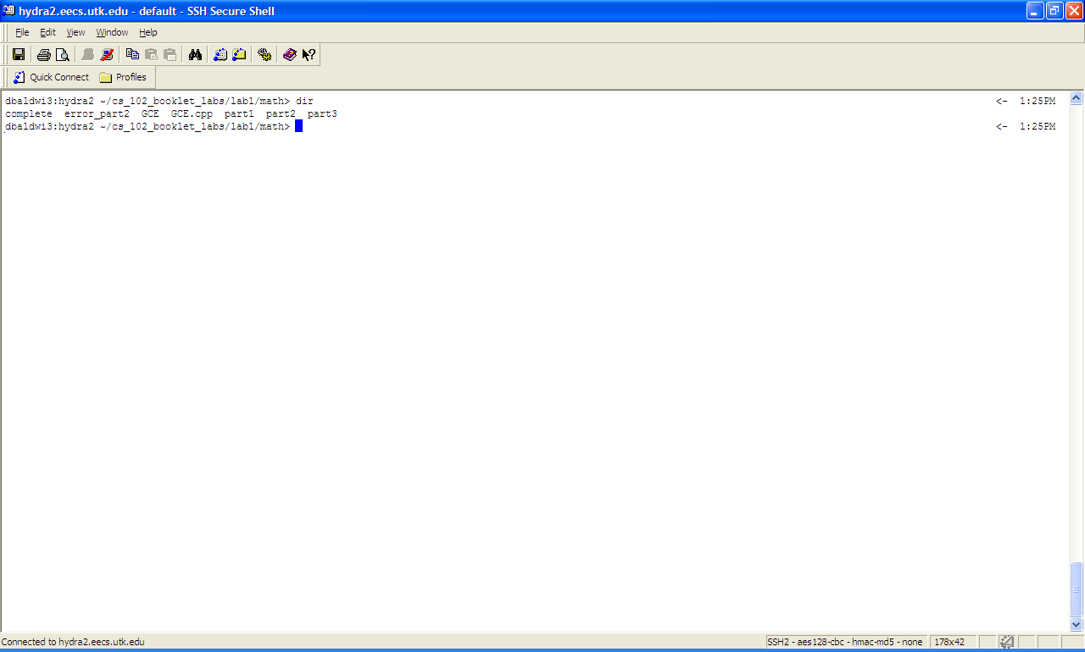

Now lets try and compile our first program. There are two methods of doing this:
Method 1:
Simply type “g++” then the file that you want to compile.

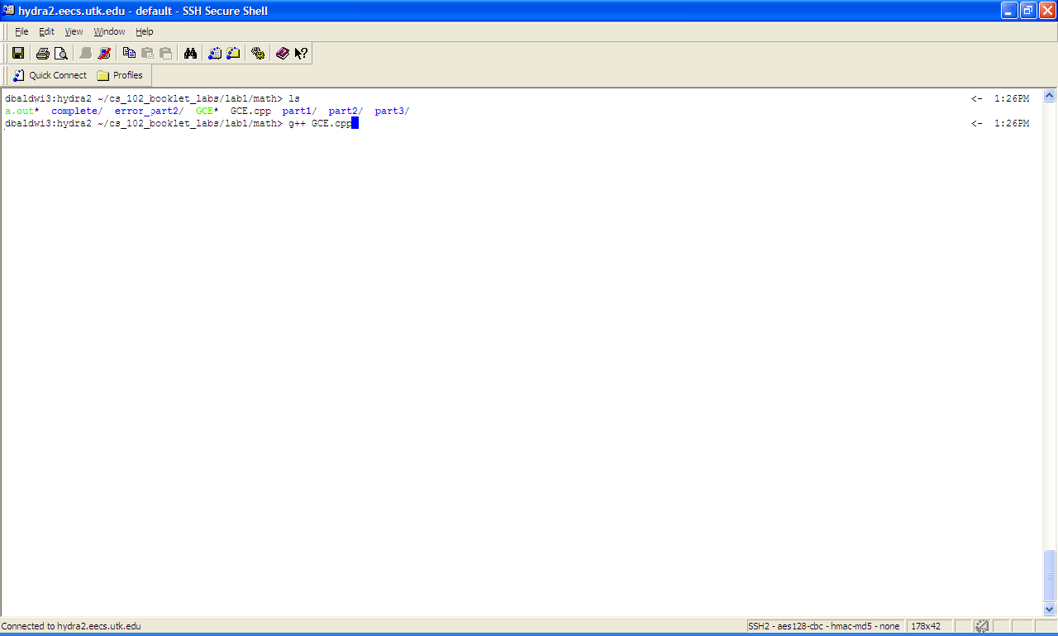
What happens? Well the file “a.out” is created. a.out is the program that is created when I compiled GCE.cpp.
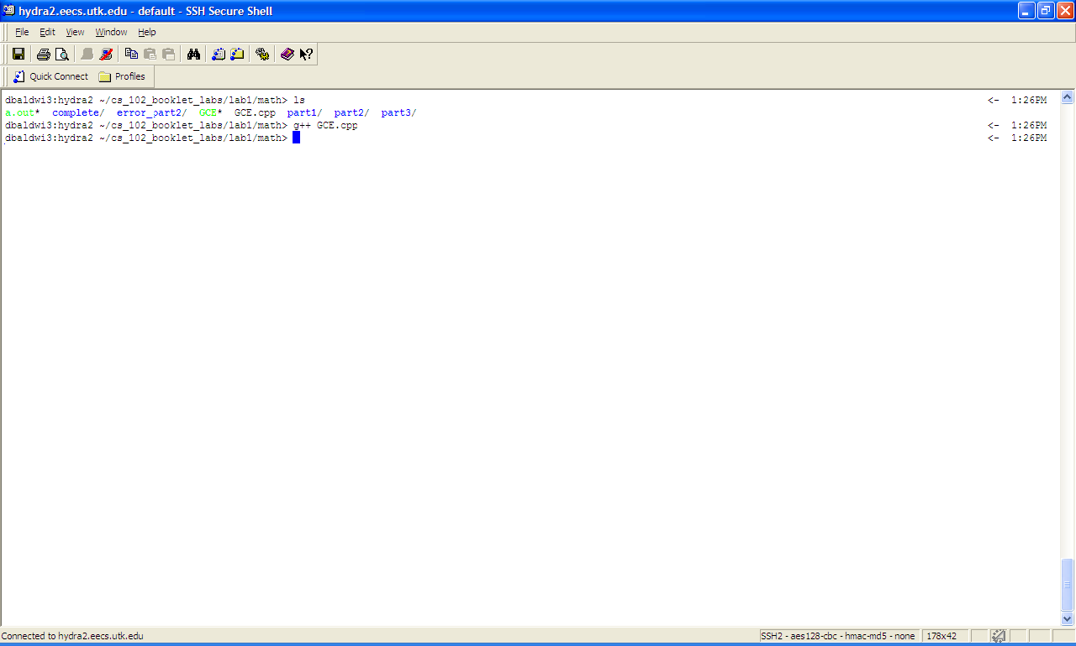

Now the second method is the one that is the best method. It allows you the ability to give your program a specific name other than a.out.
To use this method, you simply type “g++ -o” then the file name you want to give your program (in this case GCE2) and the file that you are going to compile (GCE.cpp). Therefore the format for using this method is: g++ -o [program name] [file to be compiled]

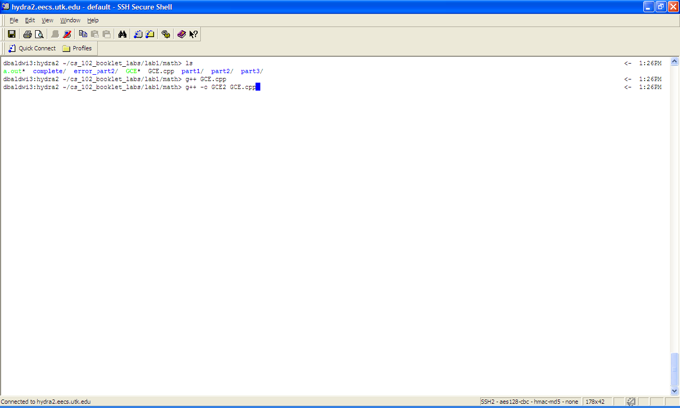
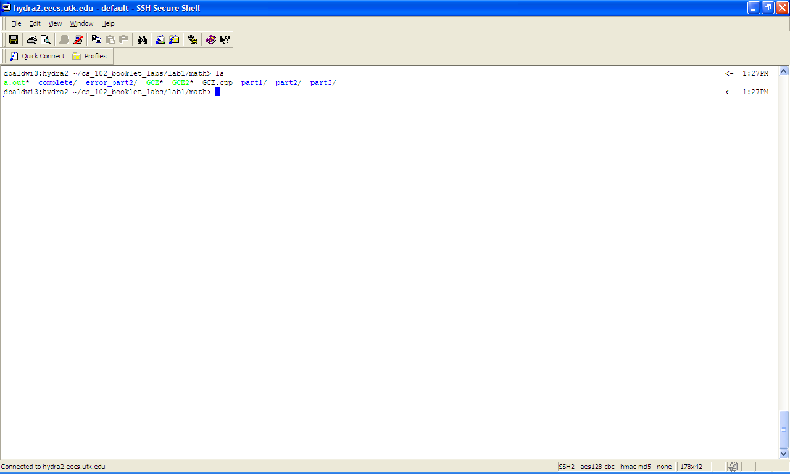
Now lets play with the rm command. The rm command allows you to remove a file or directory. To use the rm command simply type “rm” then type the file you want to remove. Thus the format for “rm” command is: rm [file to be removed]

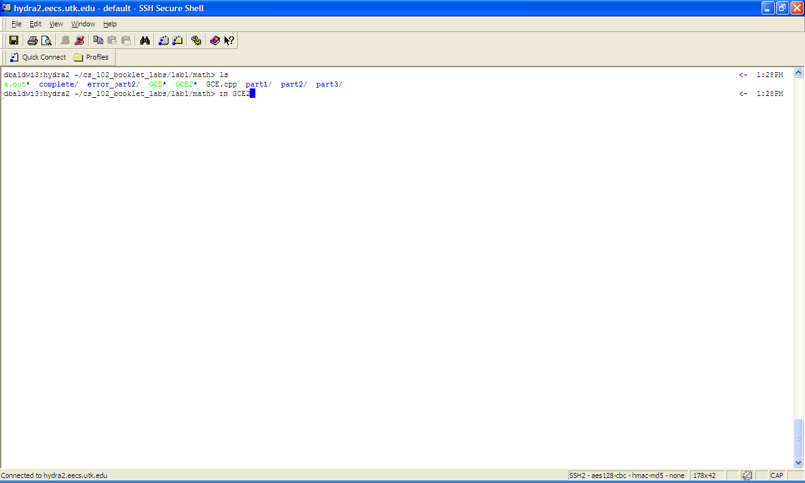
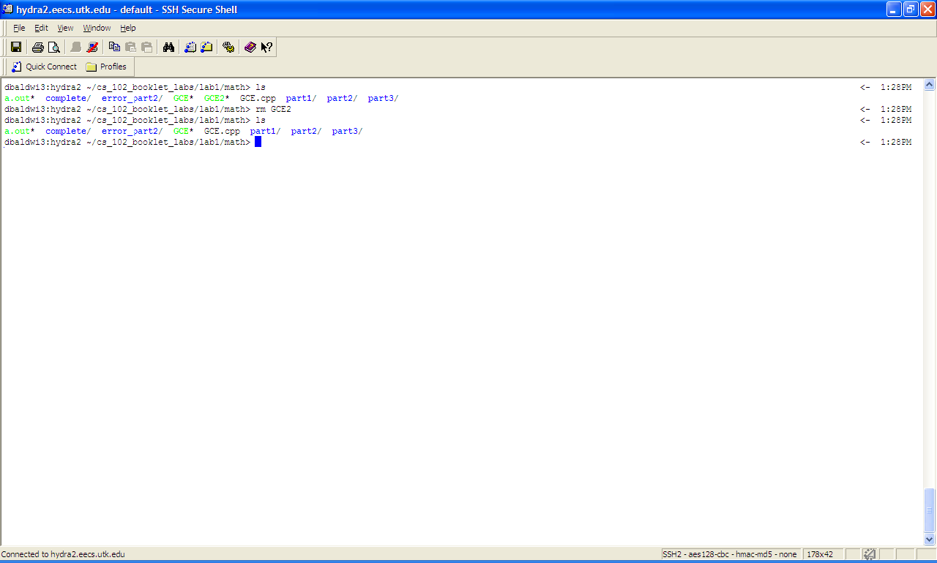
Now lets assume you want to remove a copy a file, type “cp” then the file you want to copy from and then the new file you want to create. Therefore the format for copying a file is : cp [source file] [destination file]

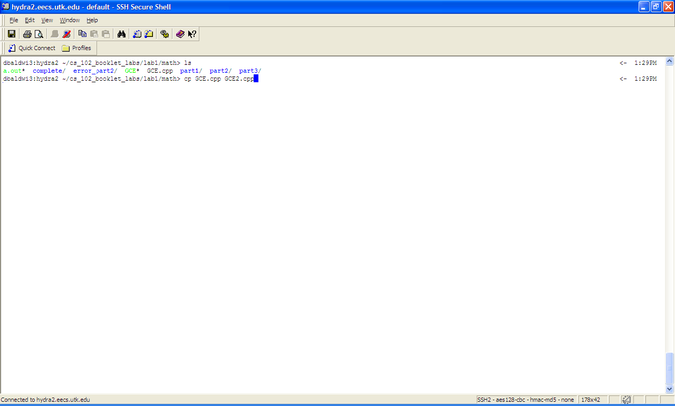

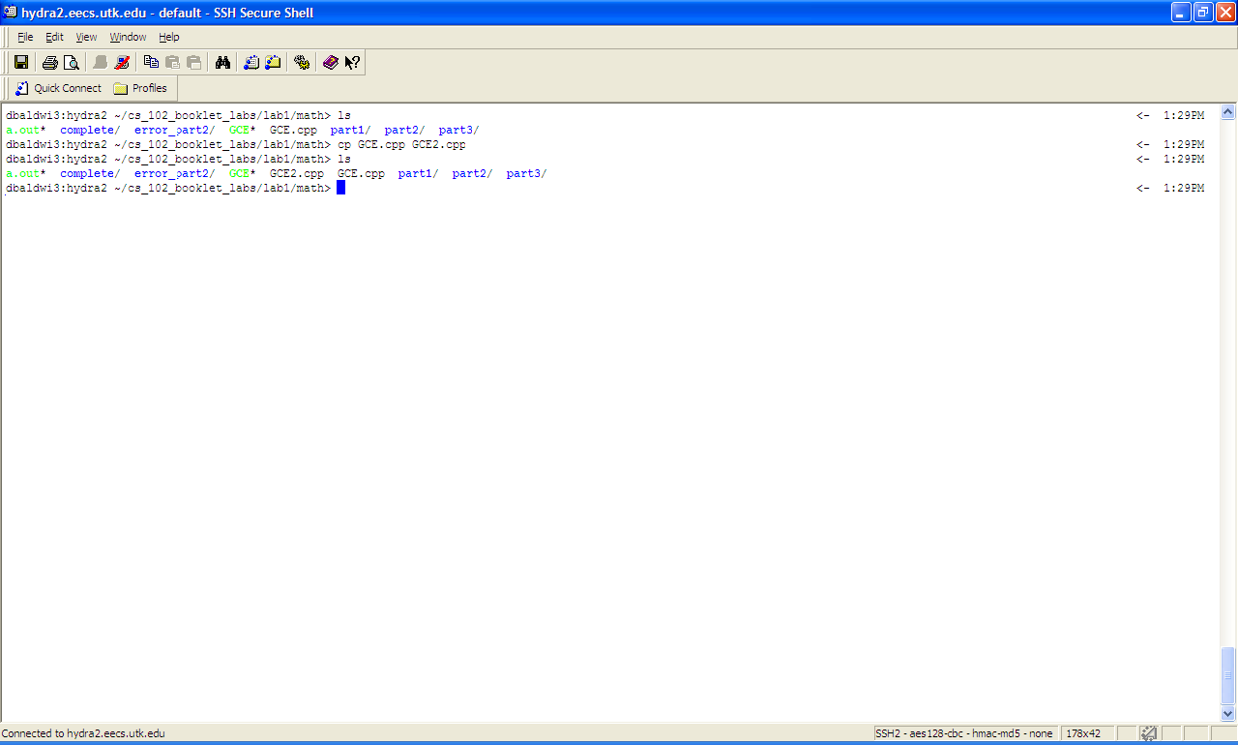

Now what if you want to create a directory? To create a directory, you simply type “mkdir”, as shown below.

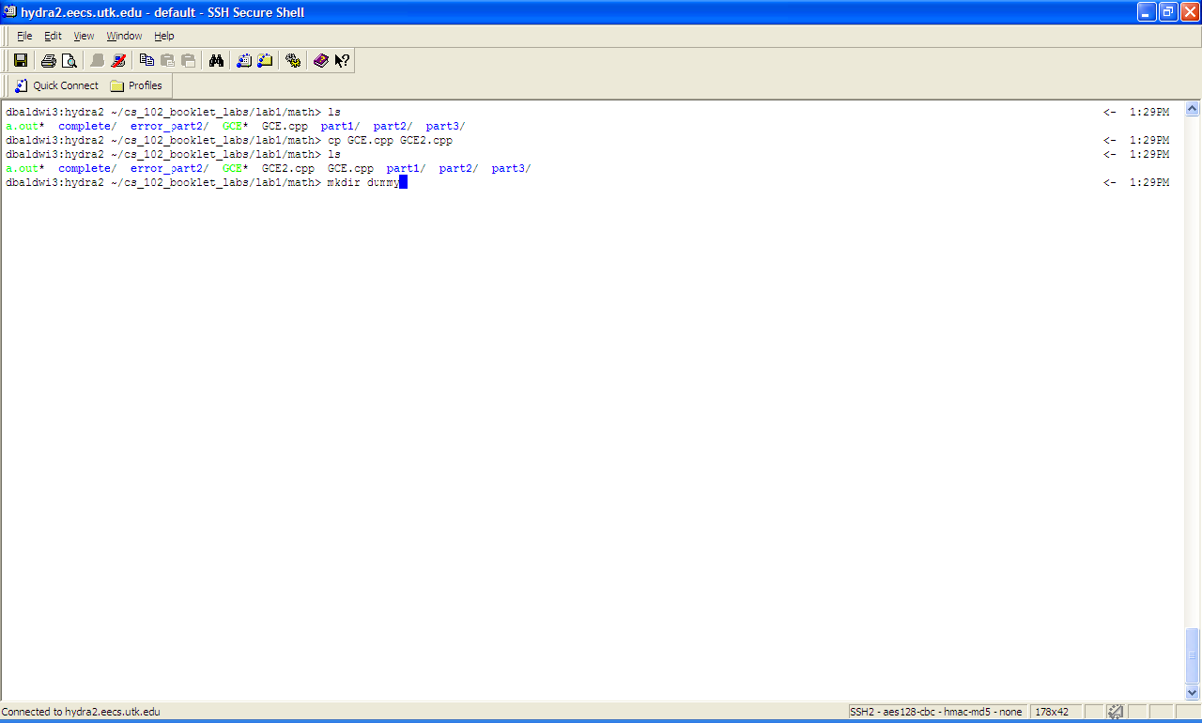

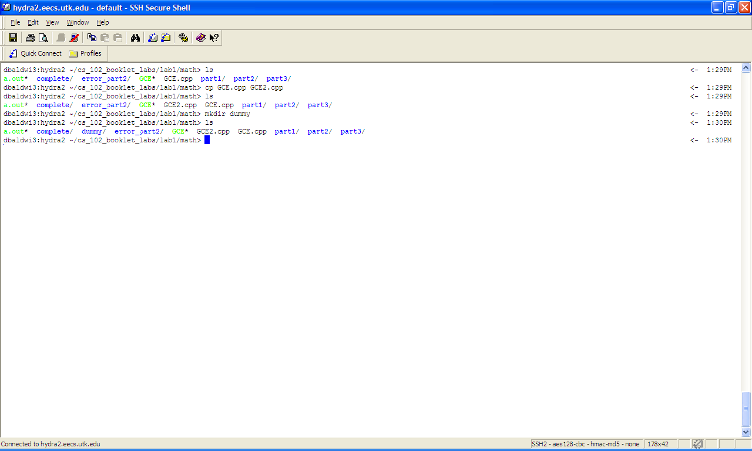

Now what if I wanted to delete this directory? It cannot be deleted! Why? The reason is simple. The rm command has a safeguard. It needs a special flag (-r) to authorize the removable of a directory.
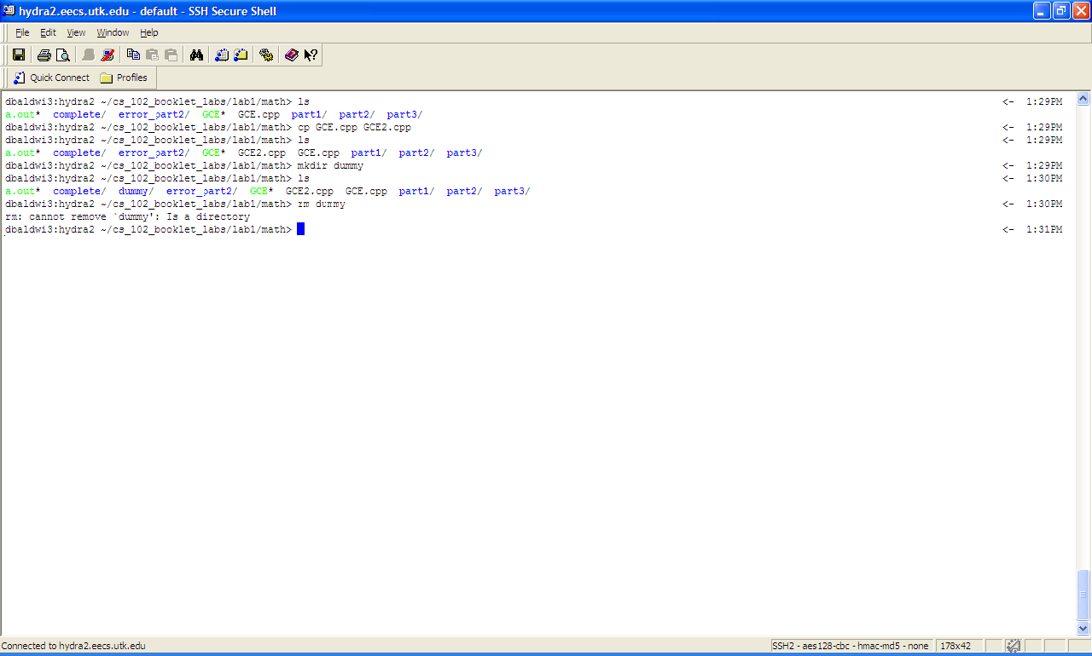

To remove a directory type “rm –r [directory name]”
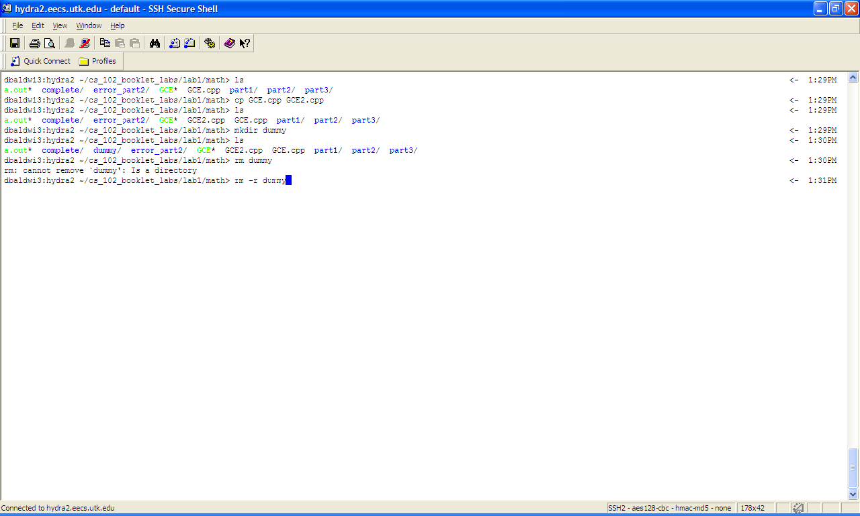

Now as you can tell the directory no longer exists! Cool

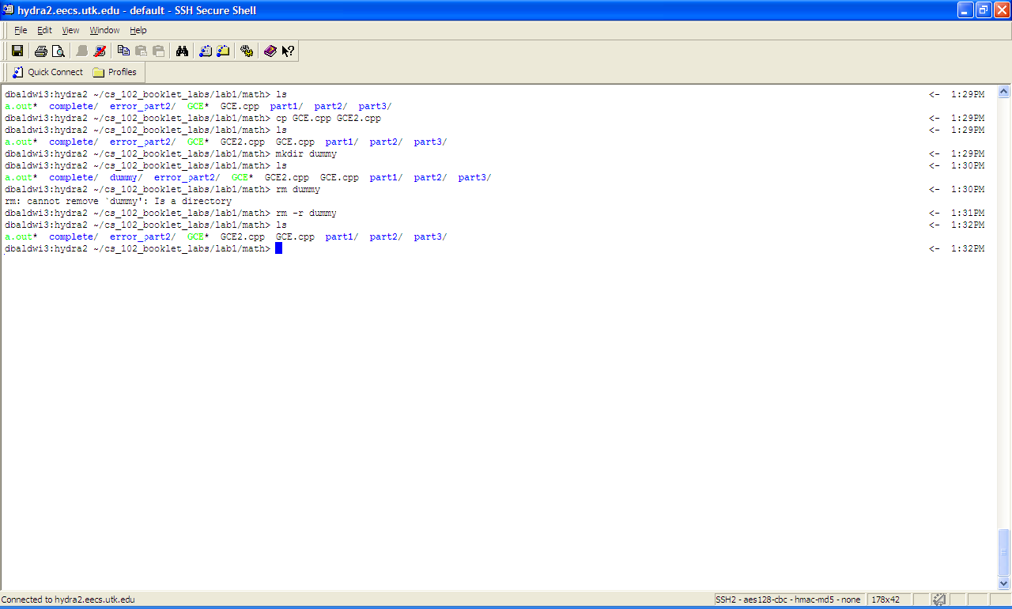

This concludes your tutorial section on using VI.

