~/cs_102_booklet_labs/if-else/example1/part1_error
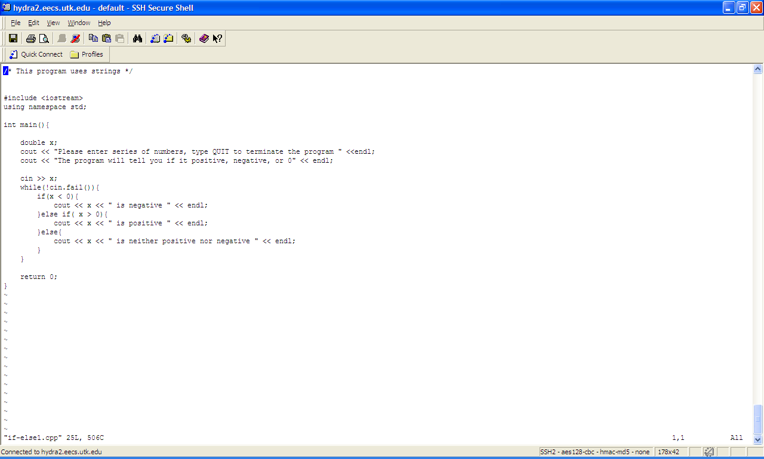

~/cs_102_booklet_labs/if-else/example1/part1/
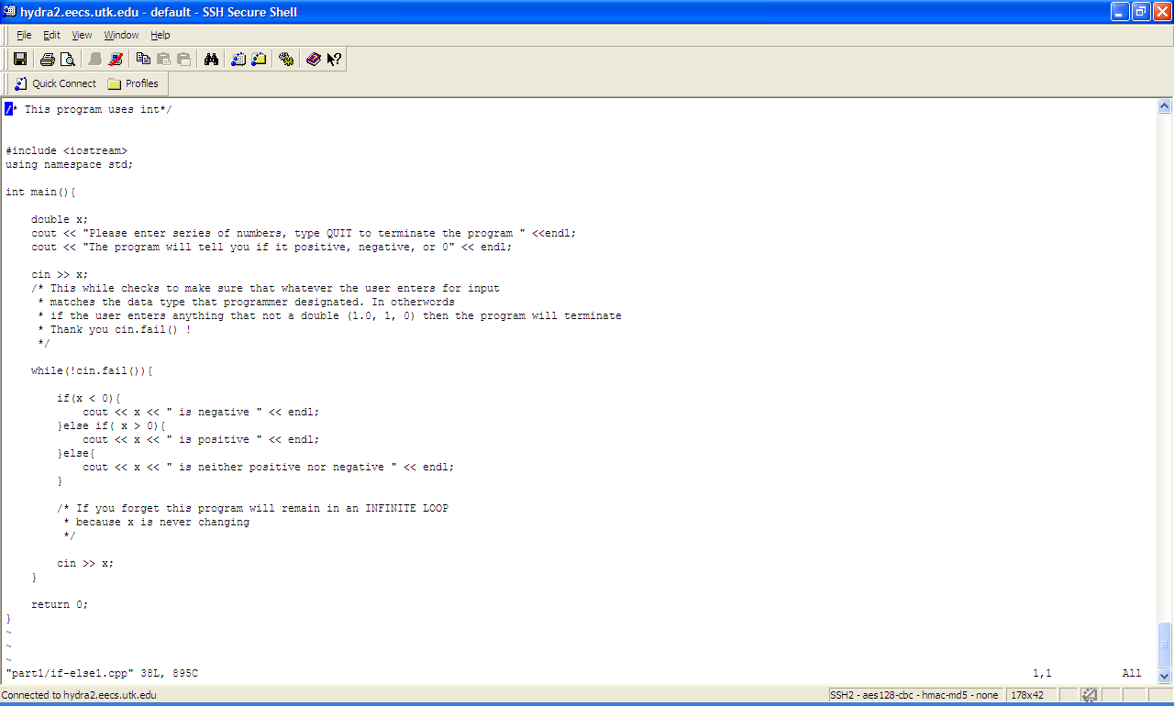
~/cs_102_booklet_labs/if-else/example1/complete/if-else1.cpp
