~/cs_102_booklet_labs/if-else/example3/lab1_error
Page1
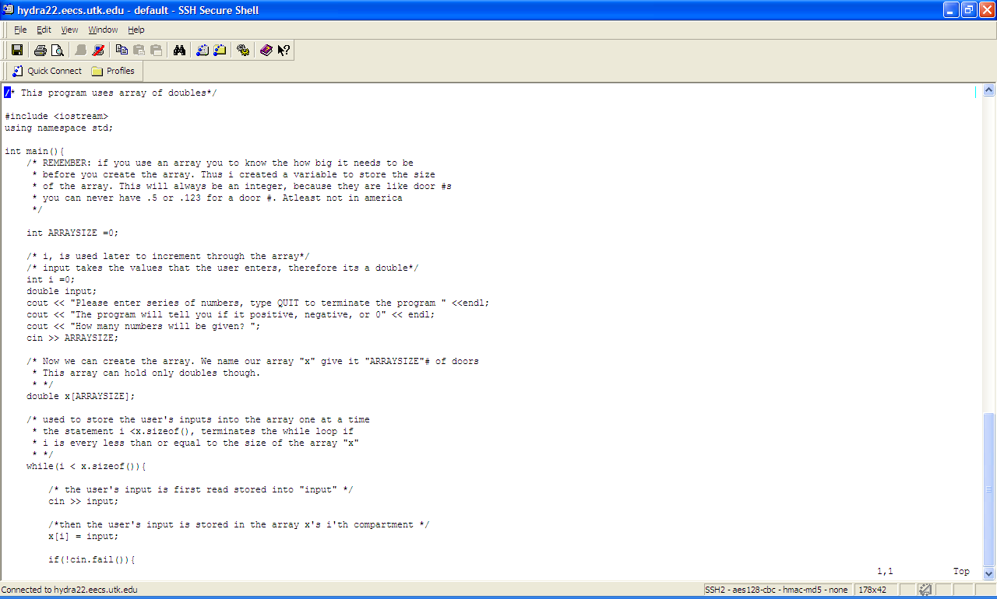

~/cs_102_booklet_labs/if-else/example3/lab1_error
Page2
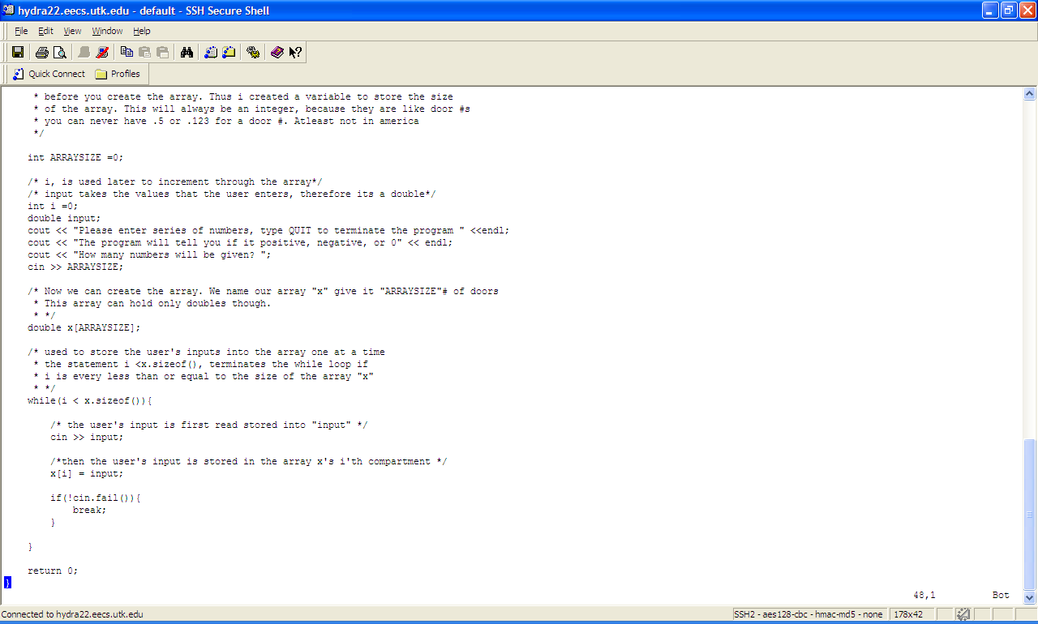
~/cs_102_booklet_labs/if-else/example3/lab2_error
Page1
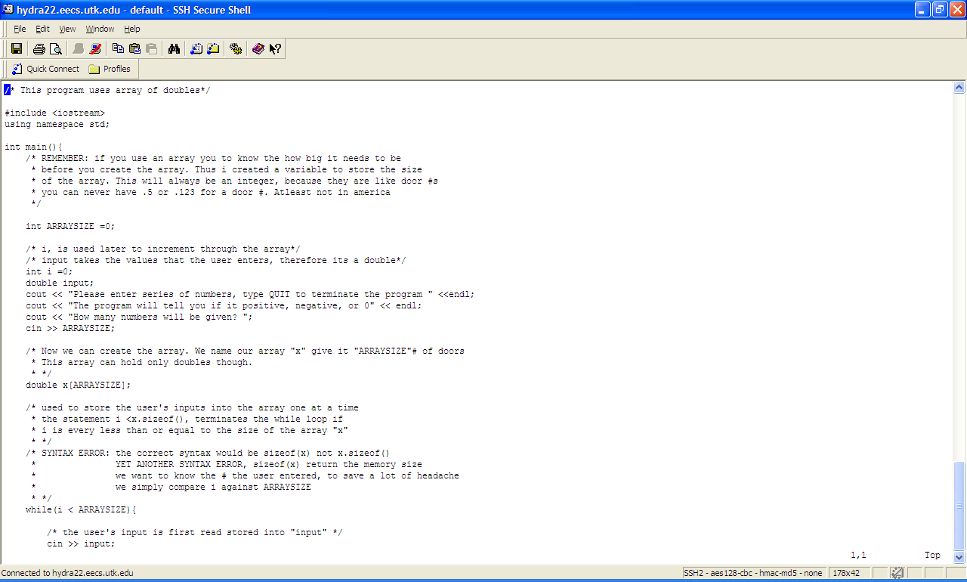

~/cs_102_booklet_labs/if-else/example3/lab2_error
Page2
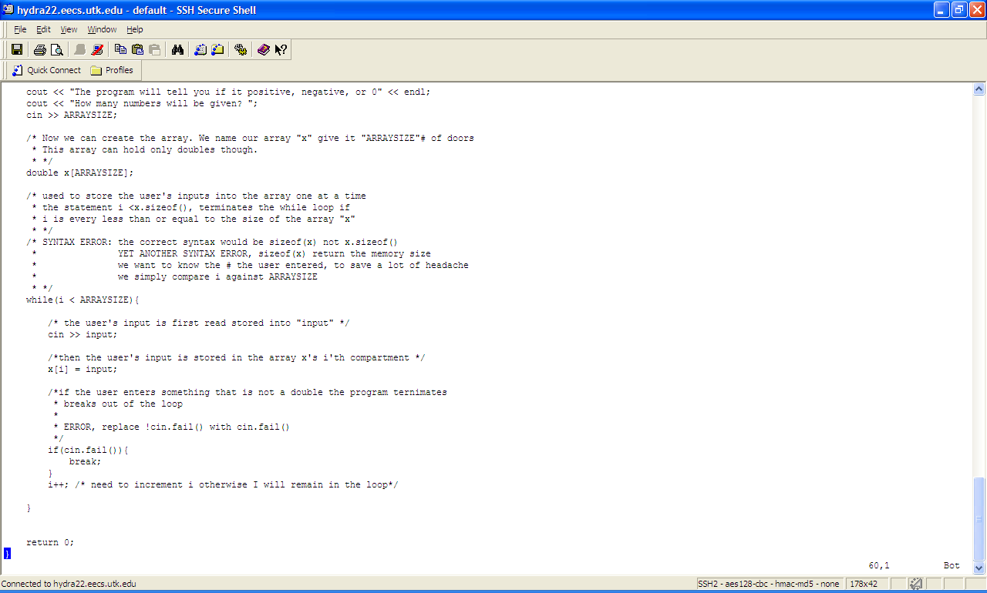

~/cs_102_booklet_labs/if-else/example3/part2_error
Page1
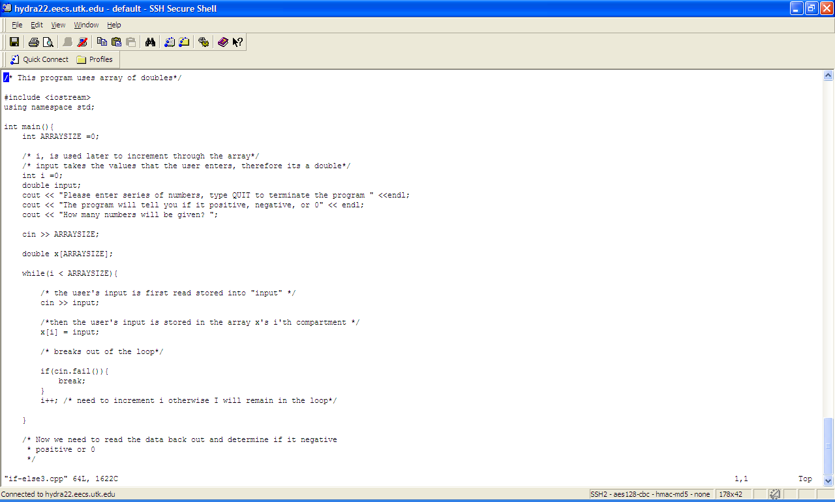

~/cs_102_booklet_labs/if-else/example3/part2_error
Part2
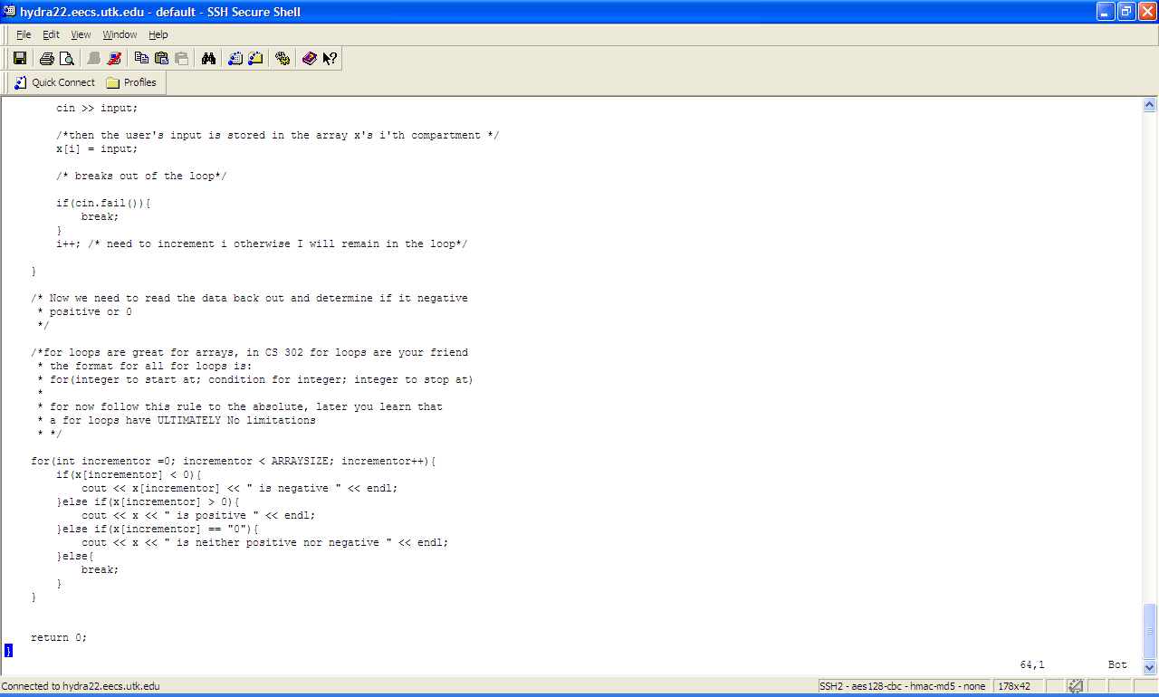
~/cs_102_booklet_labs/if-else/example3/part2_error2
Part1
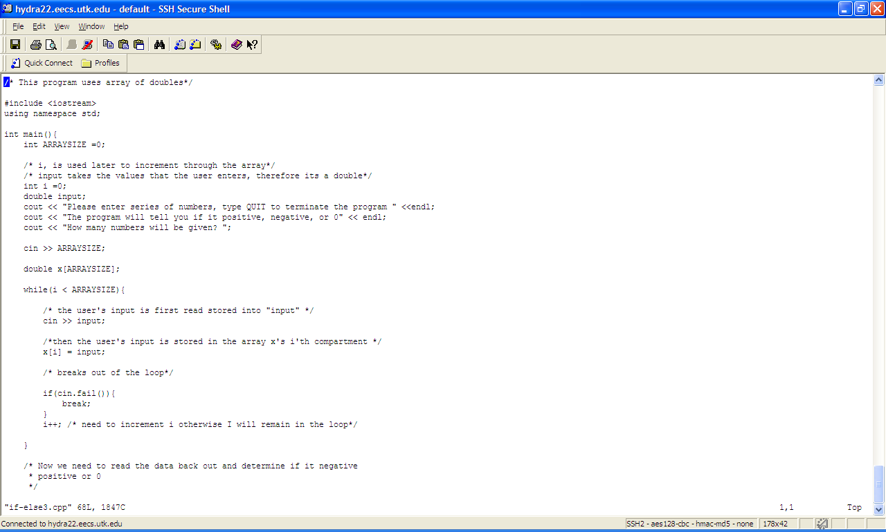

~/cs_102_booklet_labs/if-else/example3/part2_error2
Part2
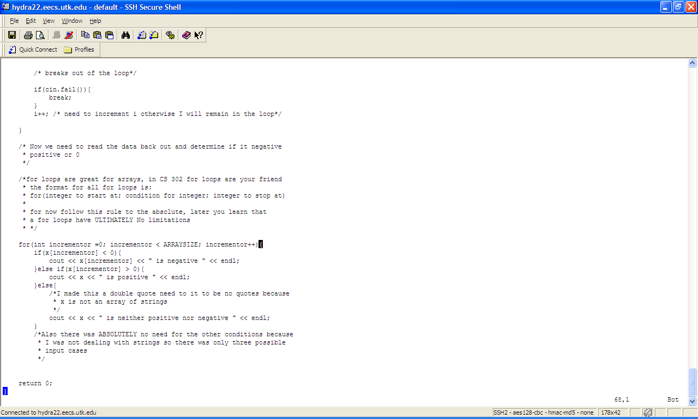
~/cs_102_booklet_labs/if-else/example3/part2
Part1
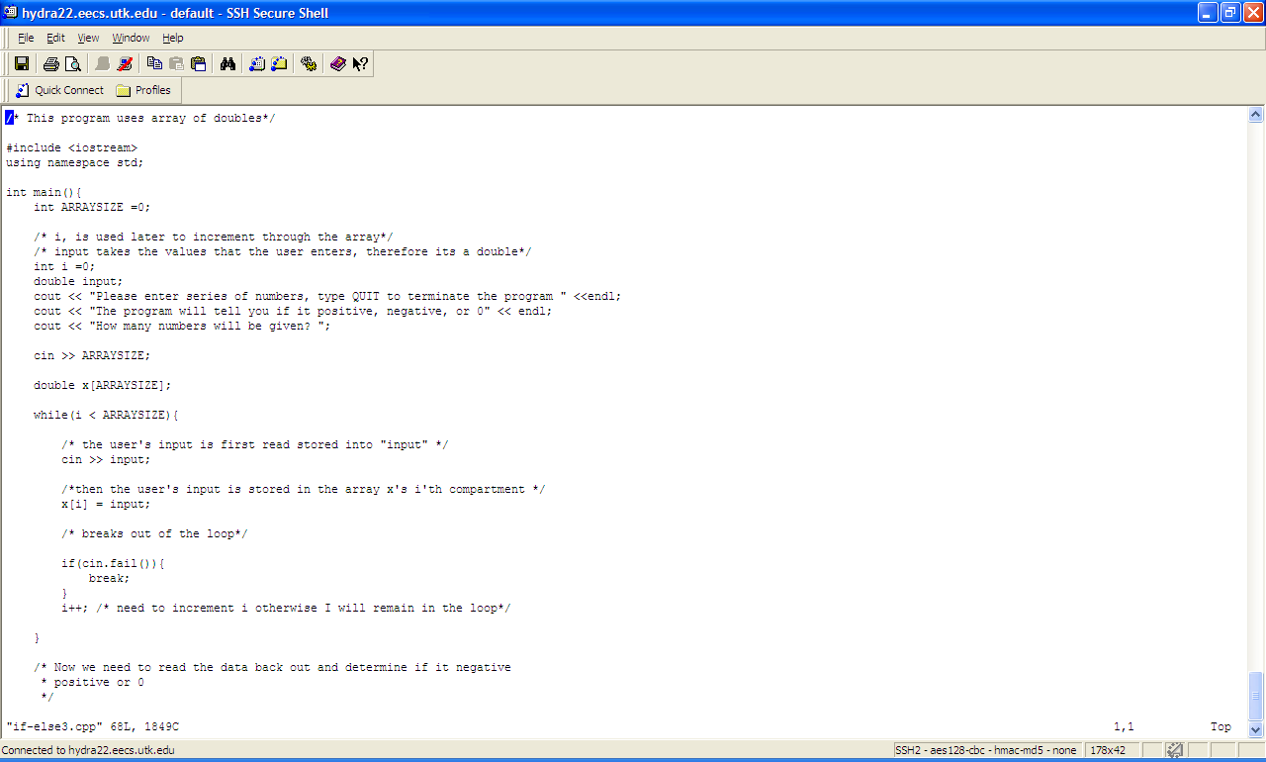
~/cs_102_booklet_labs/if-else/example3/part2
Part2
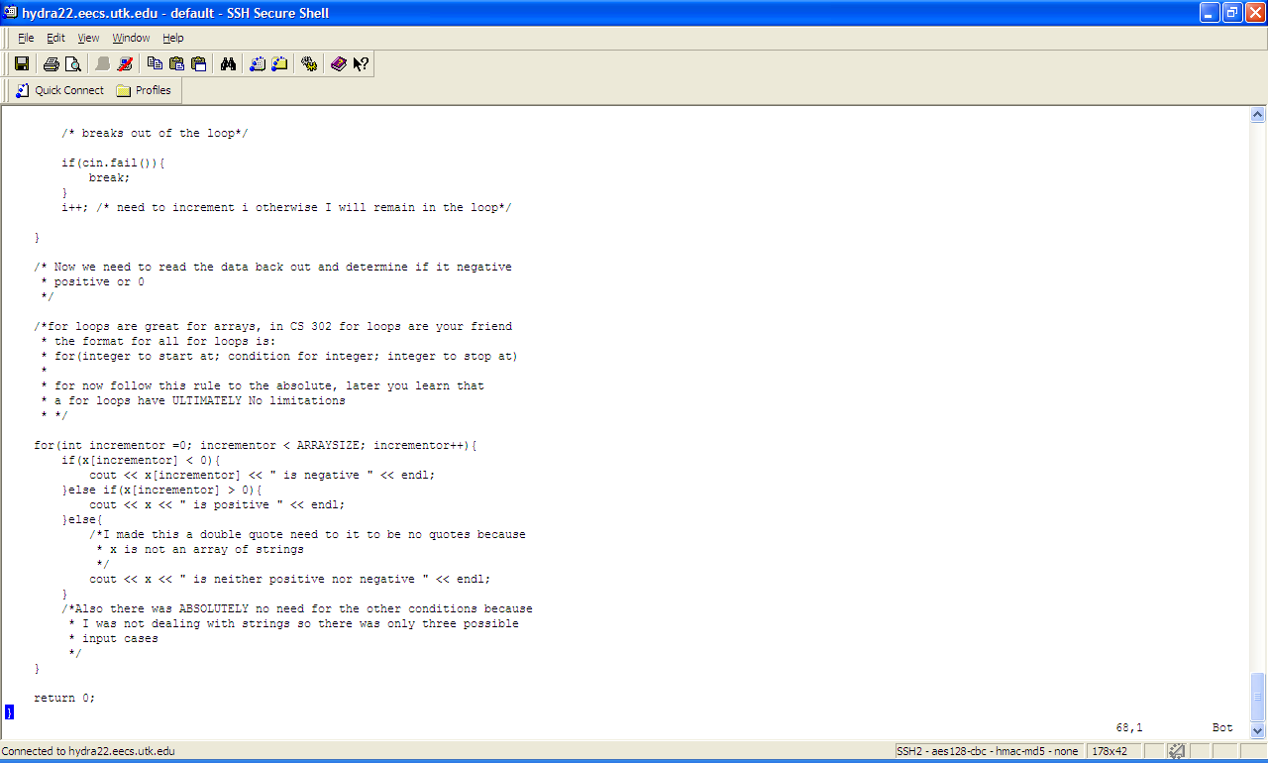

~/cs_102_booklet_labs/if-else/example3/part3
Part1
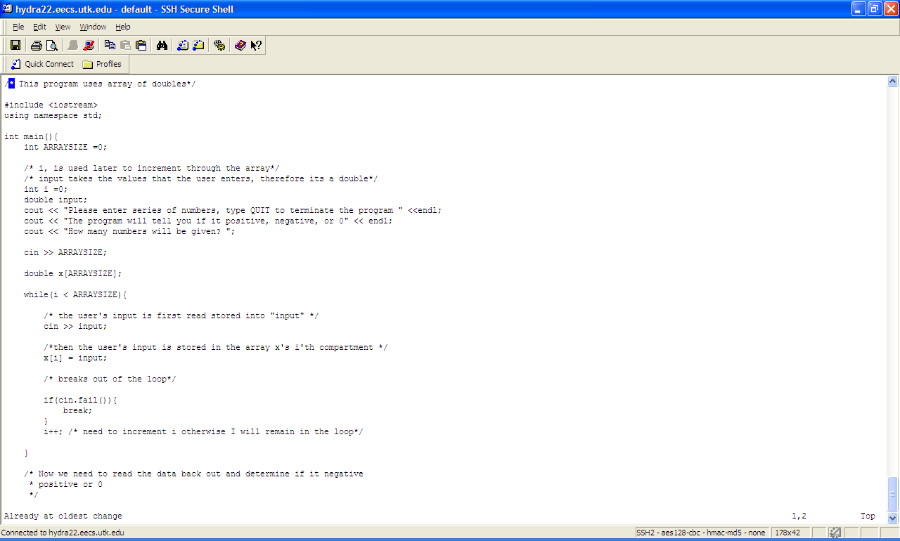

~/cs_102_booklet_labs/if-else/example3/part3
Part2

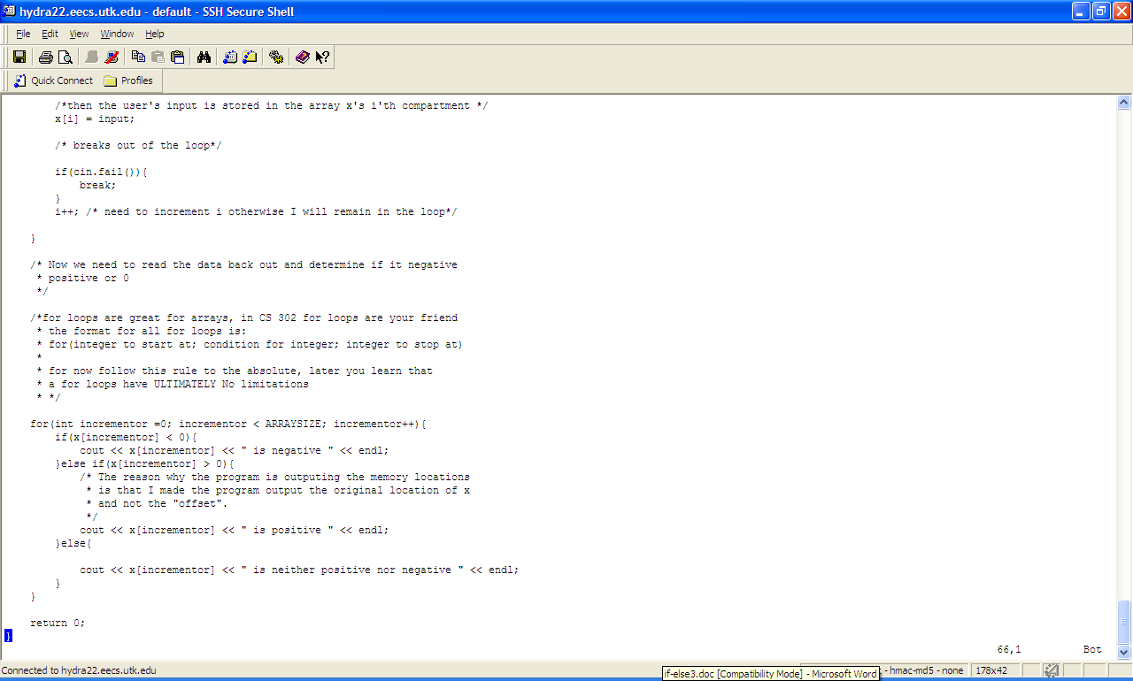

COMPLETE!
