# Ryan Timbrook

## **Applied Data Science**

## **IST687 Intro to Data Science**, Spring 2019

## **Due Date:** 05/14/2019

## **Homework:** 6

### NetID: RTIMBROO

### SUID: 386792749

## #R Code - unexecuted

## Homework Week 6: Vizualization - Air Quality Analysis

#---Preprocess Steps:----------------------------------------------------------------------

### Clear objects from Memory

rm(list=ls())

### Clear Console:

cat("\014")

### Set Working Directory

setwd("C:\\workspaces\\ms_datascience_su\\IST687-IntroDataScience\\R_workspace\\hw")

#---- Global Variable Assignments --------------------------------------------

#---- Load Required Packages -------------------------------------------------

if(!require("ggplot2")){install.packages("ggplot2")}

if(!require("dplyr")) {install.packages("dplyr")}

if(!require("reshape2")) {install.packages("reshape2")}

#----Step 1: Load the data ---------------------------------------------------

air <- airquality

#----Step 2: Clean the data --------------------------------------------------

### Replace NA with column means

na.2.mean <- function(x){

replace(x, is.na(x), mean(x, na.rm = TRUE))

}

cleanDataSet <- function(ds){

#Make all empty cells equal to NA

ds[ds==""] <- NA

#Clean NA Columns from Dataframe

ds <- ds[ ,!apply(ds,2,function(x) all(is.na(x)))]

#Clean empty Rows from Dataframe

ds <- ds[!apply(ds,1,function(x) all(is.na(x))),]

# replace NA's in Ozone col with mean of col (where NA is discarded when calculating the mean)

ds$Ozone[is.na(ds$Ozone)] <- mean(ds$Ozone,na.rm=TRUE)

ds$Ozone <- round(ds$Ozone)

ds$Solar.R[is.na(ds$Solar.R)] <- mean(ds$Solar.R,na.rm=TRUE)

ds$Solar.R <- round(ds$Solar.R)

return(ds)

}

clean.air <- cleanDataSet(air)

#----Step 3: Understand the data ---------------------------------------------

str(clean.air)

summary(clean.air)

head(clean.air)

#----Step 3.1: Visualizations --------------------------------------------------

## Step 3.1.1: Histograms for each of the variables

#colnames(clean.air)

## Ozone

summary(clean.air$Ozone)

ggplot(data=clean.air, aes(x=Ozone)) +

geom_histogram(bins=10, color="black", fill="white", boundary=2) +

ggtitle('Histogram of Ozone')

ggsave(filename='Histogram_of_Ozone.jpg', width = 6, height = 6)

## Solar.R

summary(clean.air$Solar.R)

ggplot(data=clean.air, aes(x=Solar.R)) +

geom_histogram(bins=10, color="black", fill="white", boundary=2) +

ggtitle('Histogram of Solar.R')

ggsave(filename='Histogram_of_Solar.R.jpg', width = 6, height = 6)

## Wind

summary(clean.air$Wind)

ggplot(data=clean.air, aes(x=Wind)) +

geom_histogram(bins=10, color="black", fill="white", boundary=2) +

ggtitle('Histogram of Wind')

ggsave(filename="Histogram_of_Wind.jpg", width = 6, height = 6)

## Temp

summary(clean.air$Temp)

ggplot(data=clean.air, aes(x=Temp)) +

geom_histogram(bins=10, color="black", fill="white", boundary=2) +

ggtitle('Histogram of Temp')

ggsave(filename="Histogram_of_Temp.jpg", width = 6, height = 6)

## Month

summary(clean.air$Month)

ggplot(data=clean.air, aes(x=Month)) +

geom_histogram(bins=10, color="black", fill="white", boundary=2) +

ggtitle('Histogram of Month')

ggsave(filename="Histogram_of_Month.jpg", width = 6, height = 6)

## Day

summary(clean.air$Day)

ggplot(data=clean.air, aes(x=Day)) +

geom_histogram(bins=10, color="black", fill="white", boundary=2) +

ggtitle('Histogram of Day')

ggsave(filename="Histogram_of_Day.jpg", width = 6, height = 6)

## Step 3.1.2: Boxplot for Ozone

summary(clean.air$Ozone)

ggplot(data=clean.air, aes(x=factor(0), y=Ozone)) +

geom_boxplot() + ylab('Ozone') + xlab('Count') +

ggtitle('Boxplot of Ozone')

ggsave(filename="Boxplot_of_Ozone.jpg", width = 6, height = 6)

## Step 3.1.2: Boxplot for wind values (rounded)

summary(round(clean.air$Wind))

ggplot(data=clean.air, aes(x=factor(0), y=round(Wind))) +

geom_boxplot() +

ylab("Wind") + xlab("Count") +

ggtitle('Boxplot of Wind')

ggsave(filename="Boxplot_of_Wind.jpg", width = 6, height = 6)

#----Step 3.2: Explore how the data changes over time ------------------------

## Step 3.2.1: Create dates

clean.air$Date <- paste("1973",clean.air$Month,clean.air$Day,sep='-')

clean.air$Date <- as.Date(clean.air$Date,'%Y-%m-%d')

str(clean.air$Date)

## Step 3.2.2: Create Line Charts

## Ozone

ggplot(data=clean.air, aes(x=Date, y=Ozone)) +

theme_classic(base_size = 8) +

geom_line(color='Black') +

ggtitle("Ozone Line Chart over Date Range")

ggsave("Ozone_Line_Chart_over_Date_Range.jpg", width = 6, height = 6)

## Wind

ggplot(data=clean.air, aes(x=Date, y=round(Wind))) +

theme_classic(base_size = 8) +

geom_line(color='Blue') +

ggtitle("Wind Line Chart over Date Range")

ggsave("Wind_Line_Chart_over_Date_Range.jpg", width = 6, height = 6)

## Temp

ggplot(data=clean.air, aes(x=Date, y=round(Temp))) +

theme_classic(base_size = 8) +

geom_line(color='Red') +

ggtitle("Temp Line Chart over Date Range")

ggsave("Temp_Line_Chart_over_Date_Range.jpg", width = 6, height = 6)

## Solar.R

ggplot(data=clean.air, aes(x=Date, y=round(Solar.R))) +

theme_classic(base_size = 8) +

geom_line(color='Green4') +

ggtitle("Solar.R Line Chart over Date Range")

ggsave("Solar.R_Line_Chart_over_Date_Range.jpg", width = 6, height = 6)

## Grouped Line Chart of all four attributes on one chart

ggplot(data=clean.air, aes(x=Date)) +

geom_line(aes(y=Ozone, color="Ozone")) +

geom_line(aes(y=Temp, color="Temp")) +

geom_line(aes(y=Wind, color="Wind")) +

geom_line(aes(y=Solar.R, color="Solar.R")) +

scale_color_manual(values=c("Black","Blue","Red","Green4")) +

theme(plot.title = element_text(hjust=.5)) +

labs(title="Ozone - Temp - Wind - Solar.R -- over Date Range") +

xlab("Date Range") + ylab("Values")

ggsave("Ozone_Temp_Wind_Solar.R_over_Date_Range.jpg", width = 6, height = 6)

## Using Melt

clean.air.reshape <- melt(clean.air[,-c(5,6)], id="Date")

#clean.air.reshape[order(clean.air.reshape$Date),]

ggplot(data=clean.air.reshape, aes(x=Date, y=value, color=variable)) +

geom_line() +

ggtitle("Ozone - Temp - Wind - Solar.R -- over Date Range")

ggsave("Melt_Ozone_Temp_Wind_Solar.R_over_Date_Range.jpg", width = 6, height = 6)

#----Step 4: Look at all the data via a Heatmap ------------------------------

## Each Day along the x-axis and Ozone, Temp, Wind, and Solar.R along y-axis and days as rows along the y-axis

## Create the heatmap using geom_tile

## **Show the relative change equally acroos all the variables

ggplot(data=clean.air.reshape, aes(x=Date, y=variable)) +

geom_tile(aes(fill=value)) +

scale_fill_gradient(low = "white", high="red") +

ggtitle("Heatmap of: Ozone - Temp - Wind - Solar.R")

ggsave("Heatmap_Ozone_Temp_Wind_Solar.R.jpg", width = 6, height = 6)

#----Step 5: Look at all the data via a Scatter Chart ------------------------

## Use geom_point, with the x-axis representing the Wind, the y-axis representing the Temp

# the size of each dot representing the Ozone and the color representing the Solar.R

ggplot(data=clean.air, aes(x=Wind, y=Temp, size=Ozone, color=Solar.R)) +

geom_point() +

ggtitle("Scatter Chart of: Wind - Temp - Ozone - Solar.R")

ggsave("Scatter_Chart_of_Wind_Temp_Ozone_Solar.R.jpg", width = 6, height = 6)

# Create a Scatter Chart with a smoother depicting standard error

ggplot(data=clean.air, aes(x=Wind, y=Temp, size=Ozone, color=Solar.R)) +

geom_smooth() +

geom_point(alpha=1/2) +

ggtitle("Scatter Chart with Smooth Line Fitting of: Wind - Temp - Ozone - Solar.R")

ggsave("Scatter_Chart_with_Smooth_Line_Fitting_of_Wind_Temp_Ozone_Solar.R.jpg", width = 6, height = 6)

#----Step 6: Final Alaysis ---------------------------------------------------

## What patterns immerged from the data?

## What was the most useful visualization?

## #R Code – executed

> ### Set Working Directory

> setwd("C:\\workspaces\\ms_datascience_su\\IST687-IntroDataScience\\R_workspace\\hw")

>

> #---- Global Variable Assignments --------------------------------------------

>

>

> #---- Load Required Packages -------------------------------------------------

> if(!require("ggplot2")){install.packages("ggplot2")}

> if(!require("dplyr")) {install.packages("dplyr")}

> if(!require("reshape2")) {install.packages("reshape2")}

>

> #----Step 1: Load the data ---------------------------------------------------

> air <- airquality

>

> #----Step 2: Clean the data --------------------------------------------------

>

> ### Replace NA with column means

> na.2.mean <- function(x){

+ replace(x, is.na(x), mean(x, na.rm = TRUE))

+ }

>

> cleanDataSet <- function(ds){

+ #Make all empty cells equal to NA

+ ds[ds==""] <- NA

+

+ #Clean NA Columns from Dataframe

+ ds <- ds[ ,!apply(ds,2,function(x) all(is.na(x)))]

+

+ #Clean empty Rows from Dataframe

+ ds <- ds[!apply(ds,1,function(x) all(is.na(x))),]

+

+ # replace NA's in Ozone col with mean of col (where NA is discarded when calculating the mean)

+ ds$Ozone[is.na(ds$Ozone)] <- mean(ds$Ozone,na.rm=TRUE)

+ ds$Ozone <- round(ds$Ozone)

+ ds$Solar.R[is.na(ds$Solar.R)] <- mean(ds$Solar.R,na.rm=TRUE)

+ ds$Solar.R <- round(ds$Solar.R)

+

+ return(ds)

+ }

>

>

> clean.air <- cleanDataSet(air)

>

> #----Step 3: Understand the data ---------------------------------------------

> str(clean.air)

'data.frame': 153 obs. of 6 variables:

$ Ozone : num 41 36 12 18 42 28 23 19 8 42 ...

$ Solar.R: num 190 118 149 313 186 186 299 99 19 194 ...

$ Wind : num 7.4 8 12.6 11.5 14.3 14.9 8.6 13.8 20.1 8.6 ...

$ Temp : int 67 72 74 62 56 66 65 59 61 69 ...

$ Month : int 5 5 5 5 5 5 5 5 5 5 ...

$ Day : int 1 2 3 4 5 6 7 8 9 10 ...

> summary(clean.air)

Ozone Solar.R Wind Temp Month Day

Min. : 1.0 Min. : 7.0 Min. : 1.700 Min. :56.00 Min. :5.000 Min. : 1.0

1st Qu.: 21.0 1st Qu.:120.0 1st Qu.: 7.400 1st Qu.:72.00 1st Qu.:6.000 1st Qu.: 8.0

Median : 42.0 Median :194.0 Median : 9.700 Median :79.00 Median :7.000 Median :16.0

Mean : 42.1 Mean :185.9 Mean : 9.958 Mean :77.88 Mean :6.993 Mean :15.8

3rd Qu.: 46.0 3rd Qu.:256.0 3rd Qu.:11.500 3rd Qu.:85.00 3rd Qu.:8.000 3rd Qu.:23.0

Max. :168.0 Max. :334.0 Max. :20.700 Max. :97.00 Max. :9.000 Max. :31.0

> head(clean.air)

Ozone Solar.R Wind Temp Month Day

1 41 190 7.4 67 5 1

2 36 118 8.0 72 5 2

3 12 149 12.6 74 5 3

4 18 313 11.5 62 5 4

5 42 186 14.3 56 5 5

6 28 186 14.9 66 5 6

>

> #----Step 3.1: Visualizations --------------------------------------------------

> ## Step 3.1.1: Histograms for each of the variables

>

> #colnames(clean.air)

> ## Ozone

> summary(clean.air$Ozone)

Min. 1st Qu. Median Mean 3rd Qu. Max.

1.0 21.0 42.0 42.1 46.0 168.0

> ggplot(data=clean.air, aes(x=Ozone)) +

+ geom_histogram(bins=10, color="black", fill="white", boundary=2) +

+ ggtitle('Histogram of Ozone')

> ggsave(filename='Histogram_of_Ozone.jpg', width = 6, height = 6)

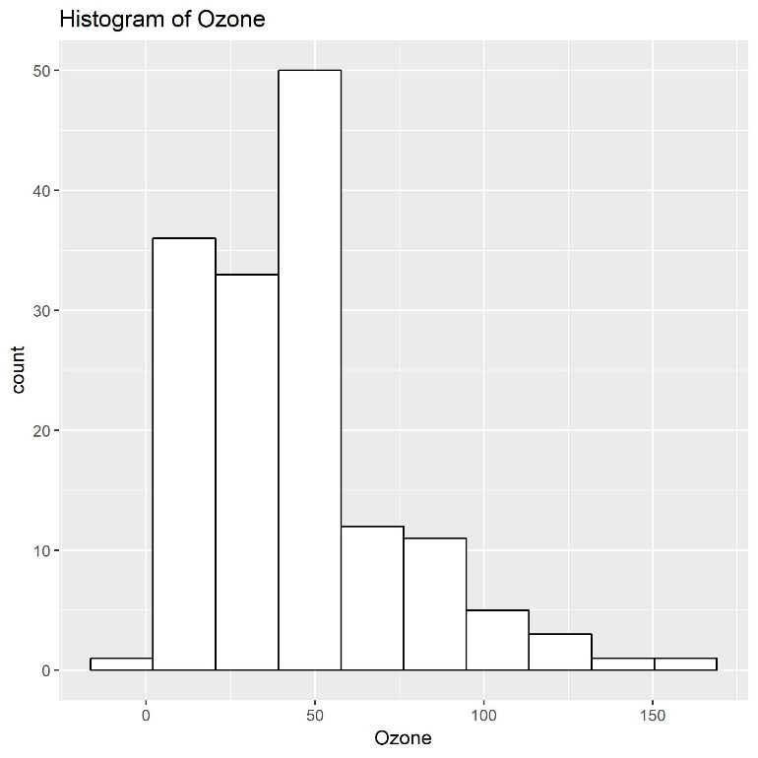

> ## Solar.R

> summary(clean.air$Solar.R)

Min. 1st Qu. Median Mean 3rd Qu. Max.

7.0 120.0 194.0 185.9 256.0 334.0

> ggplot(data=clean.air, aes(x=Solar.R)) +

+ geom_histogram(bins=10, color="black", fill="white", boundary=2) +

+ ggtitle('Histogram of Solar.R')

> ggsave(filename='Histogram_of_Solar.R.jpg', width = 6, height = 6)

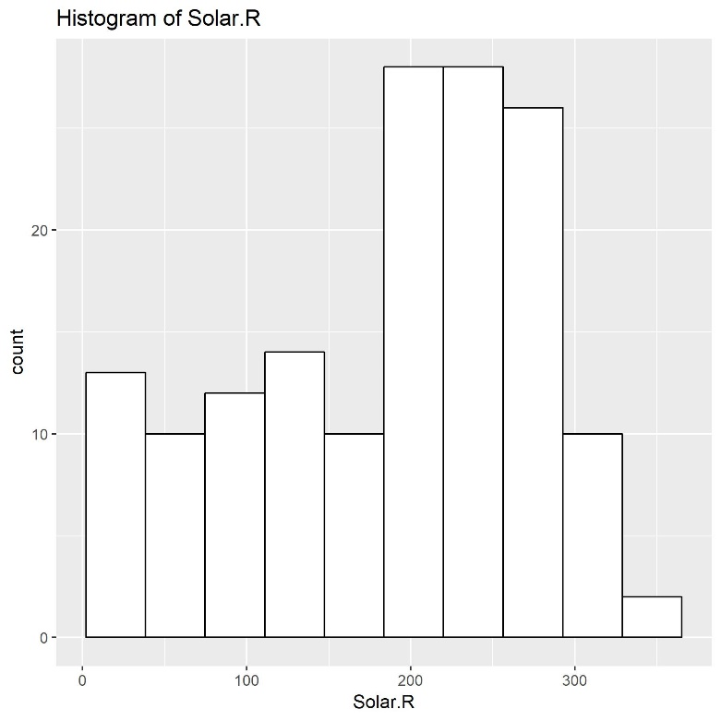

> ## Wind

> summary(clean.air$Wind)

Min. 1st Qu. Median Mean 3rd Qu. Max.

1.700 7.400 9.700 9.958 11.500 20.700

> ggplot(data=clean.air, aes(x=Wind)) +

+ geom_histogram(bins=10, color="black", fill="white", boundary=2) +

+ ggtitle('Histogram of Wind')

> ggsave(filename="Histogram_of_Wind.jpg", width = 6, height = 6)

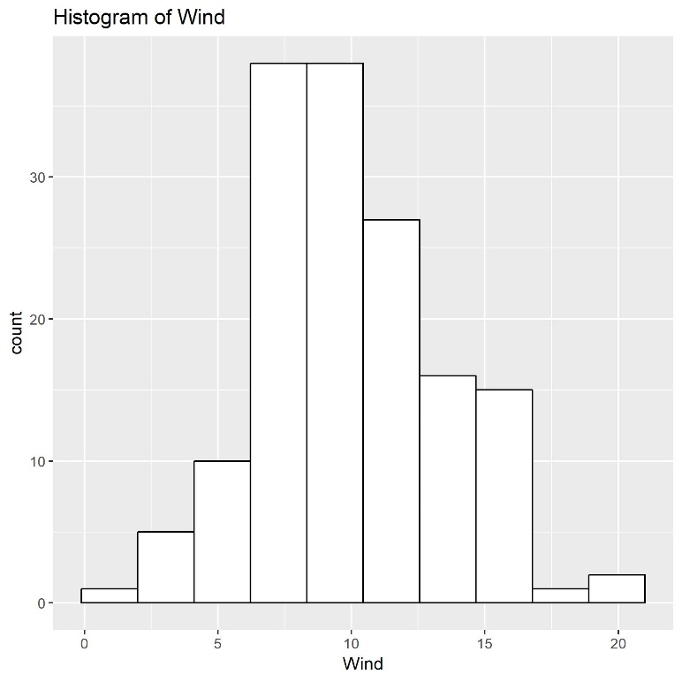

> ## Temp

> summary(clean.air$Temp)

Min. 1st Qu. Median Mean 3rd Qu. Max.

56.00 72.00 79.00 77.88 85.00 97.00

> ggplot(data=clean.air, aes(x=Temp)) +

+ geom_histogram(bins=10, color="black", fill="white", boundary=2) +

+ ggtitle('Histogram of Temp')

> ggsave(filename="Histogram_of_Temp.jpg", width = 6, height = 6)

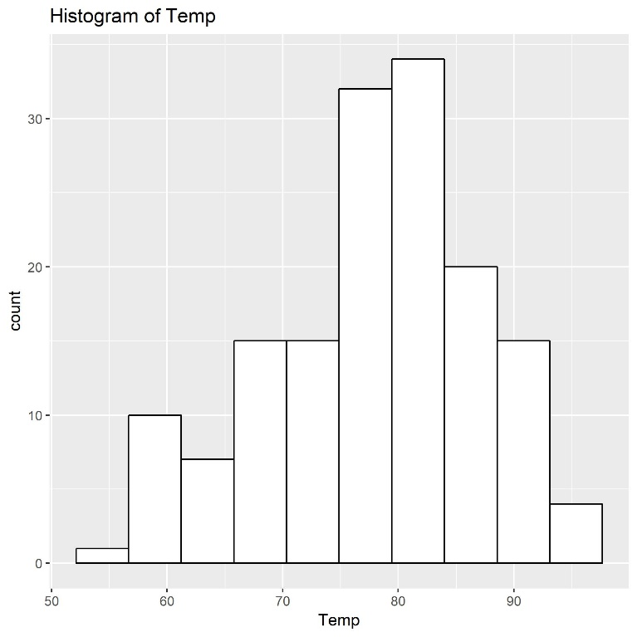

> ## Month

> summary(clean.air$Month)

Min. 1st Qu. Median Mean 3rd Qu. Max.

5.000 6.000 7.000 6.993 8.000 9.000

> ggplot(data=clean.air, aes(x=Month)) +

+ geom_histogram(bins=10, color="black", fill="white", boundary=2) +

+ ggtitle('Histogram of Month')

> ggsave(filename="Histogram_of_Month.jpg", width = 6, height = 6)

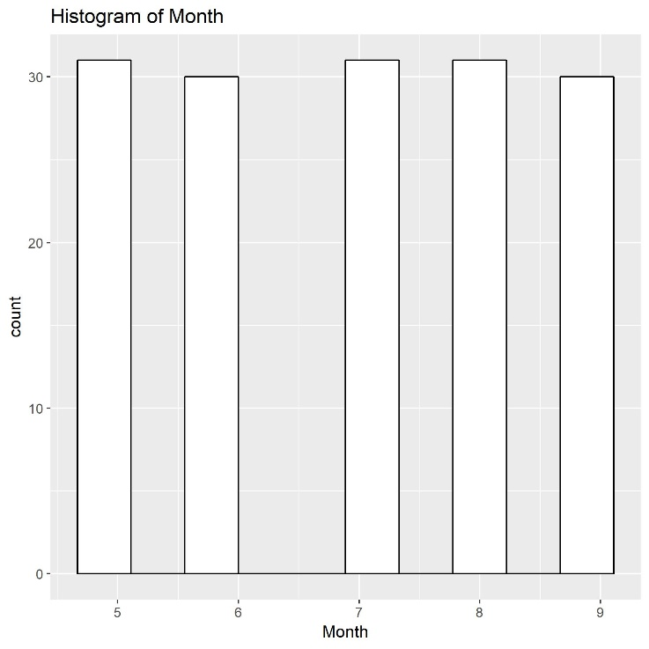

> ## Day

> summary(clean.air$Day)

Min. 1st Qu. Median Mean 3rd Qu. Max.

1.0 8.0 16.0 15.8 23.0 31.0

> ggplot(data=clean.air, aes(x=Day)) +

+ geom_histogram(bins=10, color="black", fill="white", boundary=2) +

+ ggtitle('Histogram of Day')

> ggsave(filename="Histogram_of_Day.jpg", width = 6, height = 6)

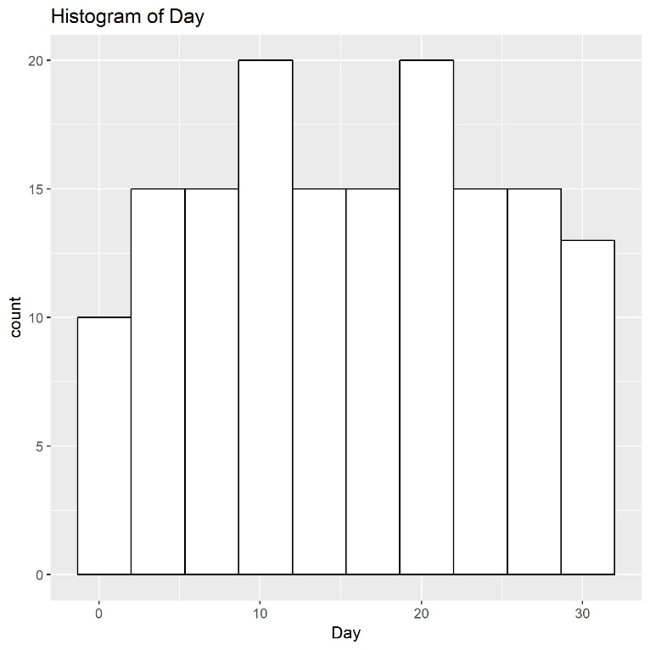

>

> ## Step 3.1.2: Boxplot for Ozone

> summary(clean.air$Ozone)

Min. 1st Qu. Median Mean 3rd Qu. Max.

1.0 21.0 42.0 42.1 46.0 168.0

> ggplot(data=clean.air, aes(x=factor(0), y=Ozone)) +

+ geom_boxplot() + ylab('Ozone') + xlab('Count') +

+ ggtitle('Boxplot of Ozone')

> ggsave(filename="Boxplot_of_Ozone.jpg", width = 6, height = 6)

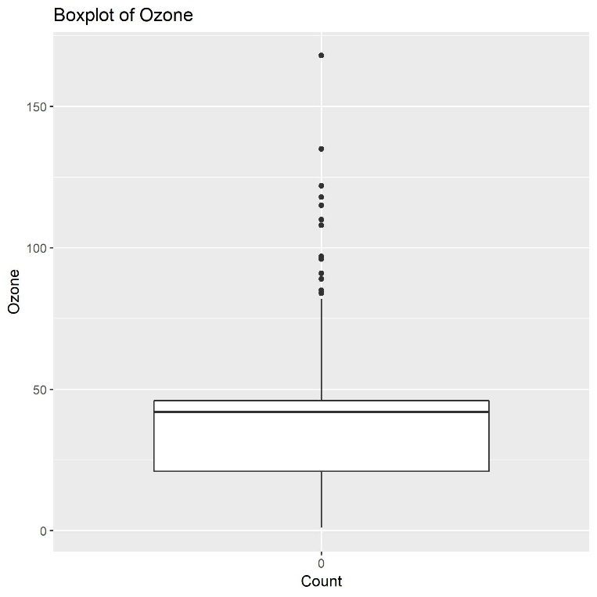

> ## Step 3.1.2: Boxplot for wind values (rounded)

> summary(round(clean.air$Wind))

Min. 1st Qu. Median Mean 3rd Qu. Max.

2.00 7.00 10.00 10.02 12.00 21.00

> ggplot(data=clean.air, aes(x=factor(0), y=round(Wind))) +

+ geom_boxplot() +

+ ylab("Wind") + xlab("Count") +

+ ggtitle('Boxplot of Wind')

> ggsave(filename="Boxplot_of_Wind.jpg", width = 6, height = 6)

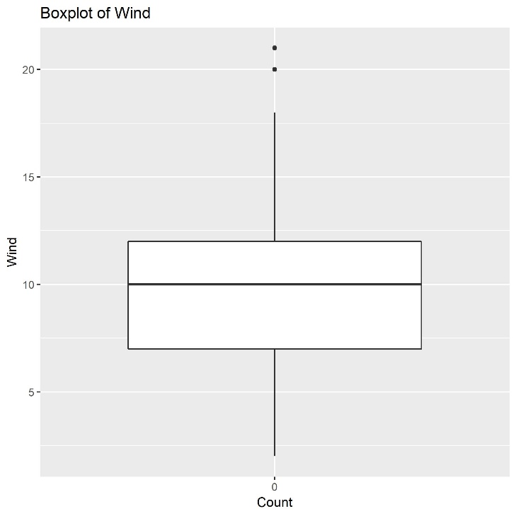

>

> #----Step 3.2: Explore how the data changes over time ------------------------

> ## Step 3.2.1: Create dates

> clean.air$Date <- paste("1973",clean.air$Month,clean.air$Day,sep='-')

> clean.air$Date <- as.Date(clean.air$Date,'%Y-%m-%d')

> str(clean.air$Date)

Date[1:153], format: "1973-05-01" "1973-05-02" "1973-05-03" "1973-05-04" "1973-05-05" "1973-05-06" "1973-05-07" "1973-05-08" "1973-05-09" ...

>

> ## Step 3.2.2: Create Line Charts

> ## Ozone

> ggplot(data=clean.air, aes(x=Date, y=Ozone)) +

+ theme_classic(base_size = 8) +

+ geom_line(color='Black') +

+ ggtitle("Ozone Line Chart over Date Range")

> ggsave("Ozone_Line_Chart_over_Date_Range.jpg", width = 6, height = 6)

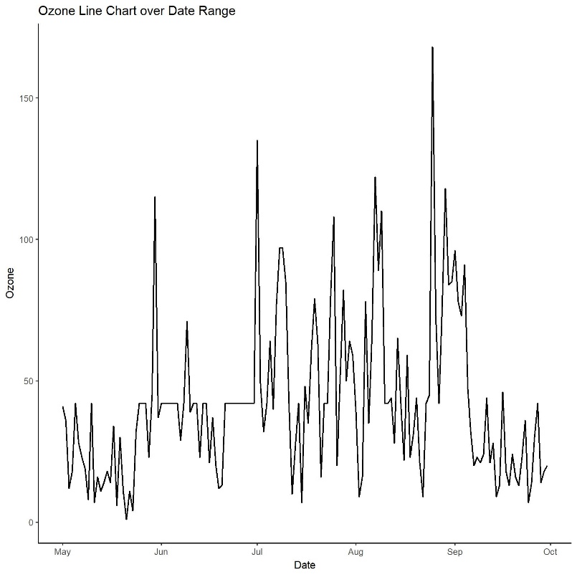

> ## Wind

> ggplot(data=clean.air, aes(x=Date, y=round(Wind))) +

+ theme_classic(base_size = 8) +

+ geom_line(color='Blue') +

+ ggtitle("Wind Line Chart over Date Range")

> ggsave("Wind_Line_Chart_over_Date_Range.jpg", width = 6, height = 6)

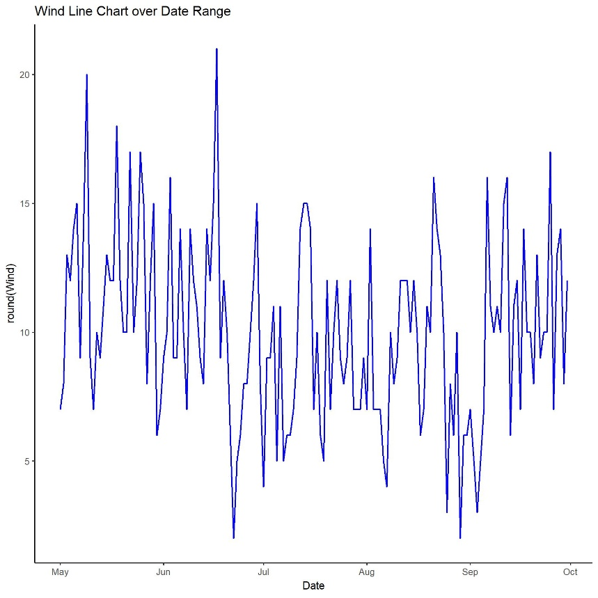

> ## Temp

> ggplot(data=clean.air, aes(x=Date, y=round(Temp))) +

+ theme_classic(base_size = 8) +

+ geom_line(color='Red') +

+ ggtitle("Temp Line Chart over Date Range")

> ggsave("Temp_Line_Chart_over_Date_Range.jpg", width = 6, height = 6)

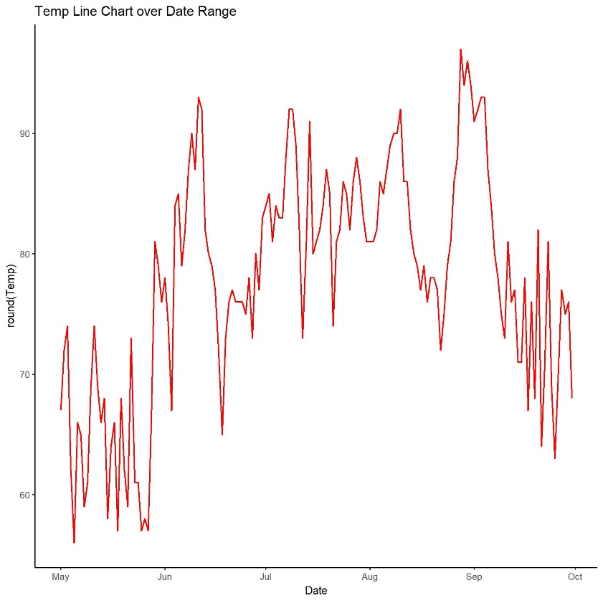

> ## Solar.R

> ggplot(data=clean.air, aes(x=Date, y=round(Solar.R))) +

+ theme_classic(base_size = 8) +

+ geom_line(color='Green4') +

+ ggtitle("Solar.R Line Chart over Date Range")

> ggsave("Solar.R_Line_Chart_over_Date_Range.jpg", width = 6, height = 6)

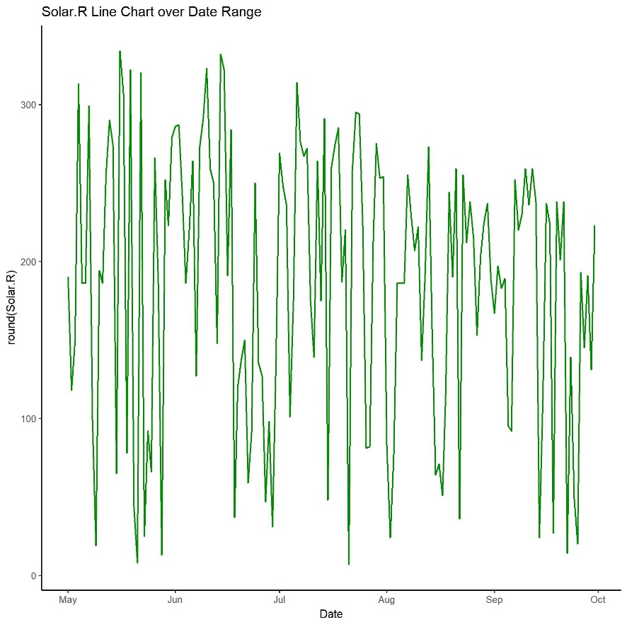

> ## Grouped Line Chart of all four attributes on one chart

> ggplot(data=clean.air, aes(x=Date)) +

+ geom_line(aes(y=Ozone, color="Ozone")) +

+ geom_line(aes(y=Temp, color="Temp")) +

+ geom_line(aes(y=Wind, color="Wind")) +

+ geom_line(aes(y=Solar.R, color="Solar.R")) +

+ scale_color_manual(values=c("Black","Blue","Red","Green4")) +

+ theme(plot.title = element_text(hjust=.5)) +

+ labs(title="Ozone - Temp - Wind - Solar.R -- over Date Range") +

+ xlab("Date Range") + ylab("Values")

> ggsave("Ozone_Temp_Wind_Solar.R_over_Date_Range.jpg", width = 6, height = 6)

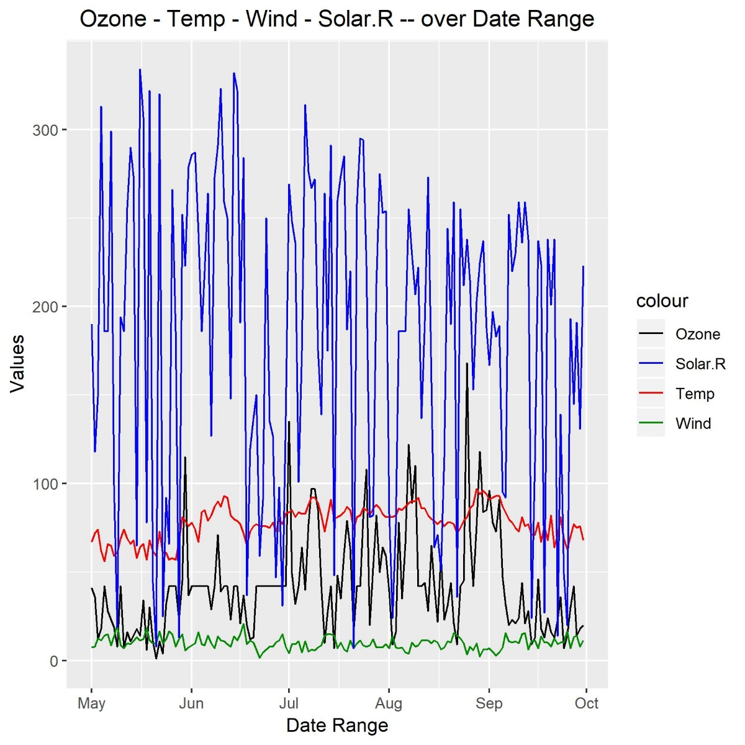

> ## Using Melt

> clean.air.reshape <- melt(clean.air[,-c(5,6)], id="Date")

> #clean.air.reshape[order(clean.air.reshape$Date),]

> ggplot(data=clean.air.reshape, aes(x=Date, y=value, color=variable)) +

+ geom_line() +

+ ggtitle("Ozone - Temp - Wind - Solar.R -- over Date Range")

> ggsave("Melt_Ozone_Temp_Wind_Solar.R_over_Date_Range.jpg", width = 6, height = 6)

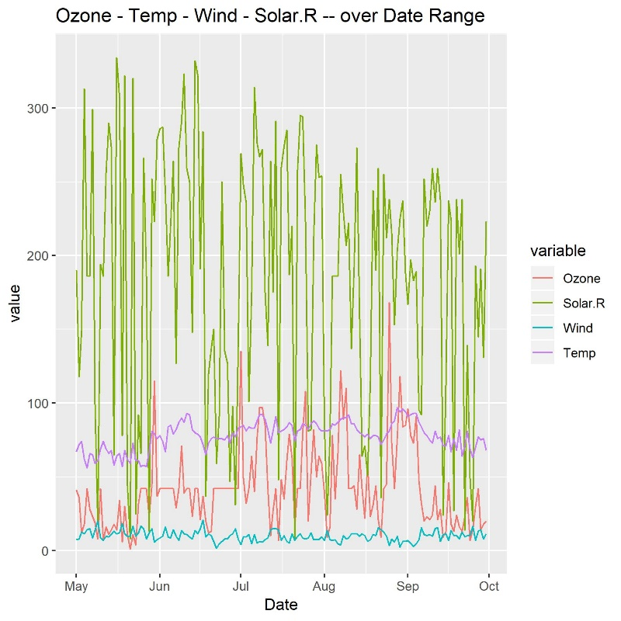

> #----Step 4: Look at all the data via a Heatmap ------------------------------

> ## Each Day along the x-axis and Ozone, Temp, Wind, and Solar.R along y-axis and days as rows along the y-axis

> ## Create the heatmap using geom_tile

> ## **Show the relative change equally acroos all the variables

> ggplot(data=clean.air.reshape, aes(x=Date, y=variable)) +

+ geom_tile(aes(fill=value)) +

+ scale_fill_gradient(low = "white", high="red") +

+ ggtitle("Heatmap of: Ozone - Temp - Wind - Solar.R")

> ggsave("Heatmap_Ozone_Temp_Wind_Solar.R.jpg", width = 6, height = 6)

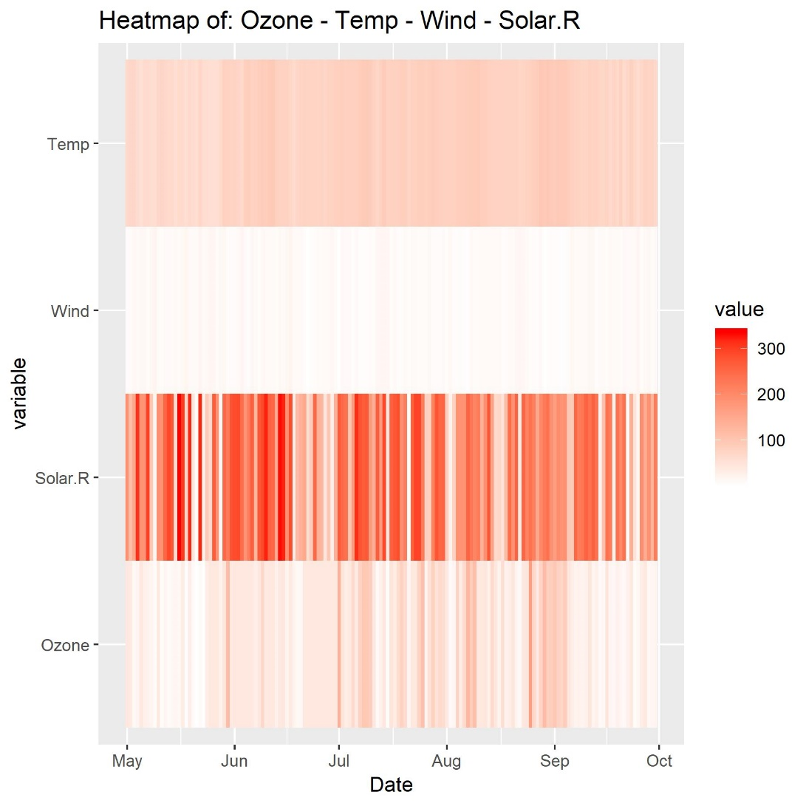

> #----Step 5: Look at all the data via a Scatter Chart ------------------------

> ## Use geom_point, with the x-axis representing the Wind, the y-axis representing the Temp

> # the size of each dot representing the Ozone and the color representing the Solar.R

> ggplot(data=clean.air, aes(x=Wind, y=Temp, size=Ozone, color=Solar.R)) +

+ geom_point() +

+ ggtitle("Scatter Chart of: Wind - Temp - Ozone - Solar.R")

> ggsave("Scatter_Chart_of_Wind_Temp_Ozone_Solar.R.jpg", width = 6, height = 6)

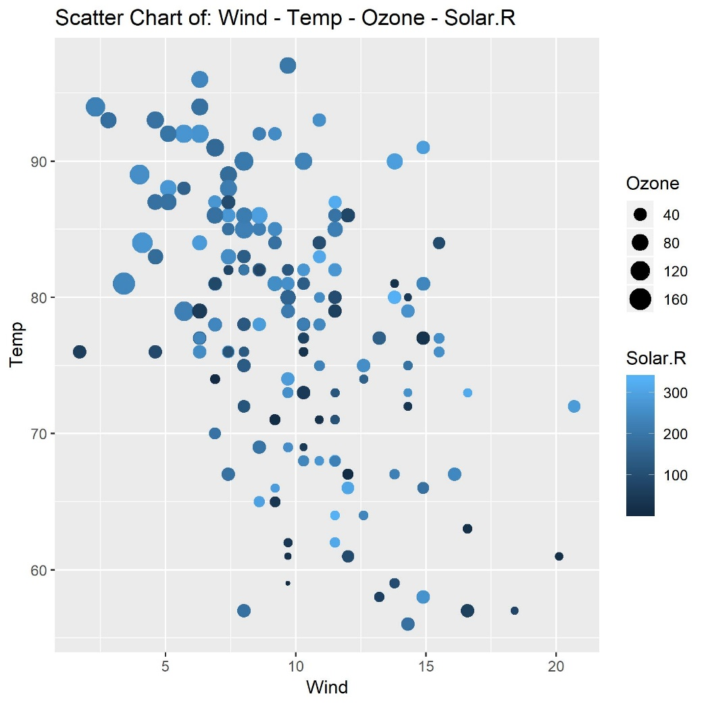

> ggplot(data=clean.air, aes(x=Wind, y=Temp, size=Ozone, color=Solar.R)) +

+ geom_smooth() +

+ geom_point(alpha=1/2) +

+ ggtitle("Scatter Chart with Smooth Line Fitting of: Wind - Temp - Ozone - Solar.R")

`geom_smooth()` using method = 'loess' and formula 'y ~ x'

> ggsave("Scatter_Chart_with_Smooth_Line_Fitting_of_Wind_Temp_Ozone_Solar.R.jpg", width = 6, height = 6)

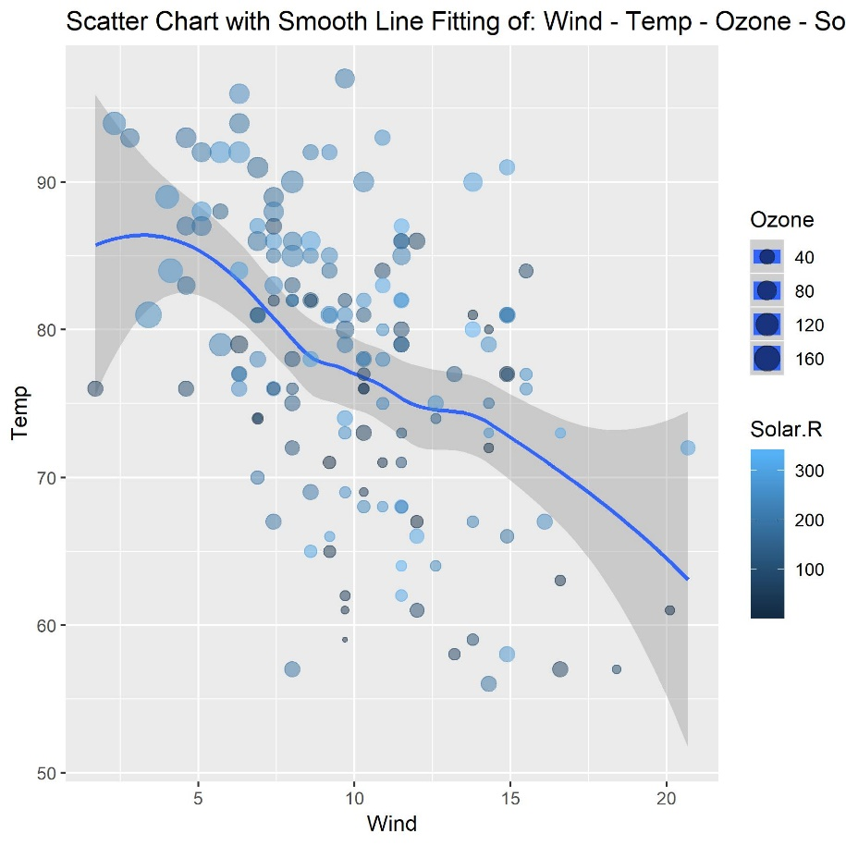

> #----Step 6: Final Alaysis ---------------------------------------------------

> ## What patterns immerged from the data?

As Wind increases, it’s observed that Temp decreases.

As Temp rises, it’s observed that Ozone levels rise.

> ## What was the most useful visualization?

I found the Scatter Chart to be the most useful in uncovering data patterns among the four core attributes, Wind, Temp, Ozone and Solar.R