# Ryan Timbrook

## **Applied Data Science**

## **IST687 Intro to Data Science**, Spring 2019

## **Due Date:** 05/28/2019

## **Homework:** 8

### NetID: RTIMBROO

### SUID: 386792749

## #R Code - unexecuted

## Homework Week 8: Viz Map HW: Making Predictions - Explore Antelope Populations

#--- Data Details -------------------------------------------------------------------

# 4 columns, 8 years of observations (n=8)

# 1st Column: Number of fawn in a given spring

# 2nd Column: Population of adult antelope

# 3rd column: Annual precipitation that year

# 4th column: value representing how bad the winter was during that year

#

#--- Preprocess Steps: ----------------------------------------------------------------------

### Clear objects from Memory

rm(list=ls())

### Clear Console:

cat("\014")

### Set Working Directory

setwd("C:\\workspaces\\ms_datascience_su\\IST687-IntroDataScience\\R_workspace\\hw")

#---- Global Variable Assignments --------------------------------------------

antelopeDataSetURL <- "http://college.cengage.com/mathematics/brase/understandable_statistics/7e/students/datasets/mlr/excel/mlr01.xls"

# Path to local Perl Interpreter - Needed to gdata package for read.xls()

perlPath <- "C:\\Strawberry\\perl\\bin\\perl"

#---- Load Required Packages -------------------------------------------------

if(!require("devtools")) {install.packages("devtools")}

if(!require("RCurl")) {install.packages("RCurl")}

if(!require("gdata")) {install.packages("gdata")}

if(!require("ggplot2")) {install.packages("ggplot2")}

if(!require("MASS")) {install.packages("MASS")}

#if(!require("tidyverse")) {install.packages("tidyverse")}

# ---- Step 1: Load the data -----------------------------------------------------------------------------

## 1.1: Read the data:

readDataSetasXLSX <- function(dsURL,locPerlPath){

df <- read.xls(dsURL, perl=locPerlPath)

return(data.frame(df))

}

antelopeDf <- readDataSetasXLSX(antelopeDataSetURL,perlPath)

# ---- Step 2: Explore the data -----------------------------------------------------------------------------

str(antelopeDf)

# ---- Step 3: Clean the data -----------------------------------------------------------------------------

# Rename Column Headings

newColumnNames <- c('Fawn_Cnt','Adult_Antelope_Pop','Annual_Percipitation','Bad_Winter_Scale')

colnames(antelopeDf) <- newColumnNames

# ---- Step 4: Create bivariate plots -----------------------------------------------------------------------------

#

# Create bivariate plots of number of baby fawns versus adult antelope population,

# the precipitation that year, and the severity of the winter. Your code should produce

# three separate plots. Make sure the Y-axis and X-axis are labeled. Keeping in mind

# that the number of fawns is the outcome (or dependent) variable, which axis should

# it go on in your plots?

# Attribute Type:

# - Precipitation: Independent / Numeric:Continuous

# - Severity of Winter: Independent / Categorical (Scale[1-5])

# - Baby Count: Dependent / Numeric:Continuous

# - Adult Population: Independent / Numeric:Continuous

## Plots - Focus is on the dependent variable, Baby Fawn Count

# Plot 1: Number of baby fawns versus adult antelope population

# x-axis: Adult_Antelope_Pop

# y-axis: Fawn_Cnt

g.fawn.adult <- ggplot(antelopeDf, aes(x=Adult_Antelope_Pop, y=Fawn_Cnt)) +

geom_point() +

stat_smooth(method='lm',col='red') +

labs(title="Bivariate Plot: \nNumber of baby fawns born \n versus \nAdult antelope population", x="Annual Adult Antelope Population", y="Number of Fawns born in Spring")

g.fawn.adult

ggsave("Bivariate_Plot_Baby_Fawns_Adult_Population.jpg", width = 6, height = 6)

# Plot 2: Number of baby fawns given the precipitation that year

# x-axis: Annual_Percipitation

# y-axis: Fawn_Cnt

g.fawn.percipitation <- ggplot(antelopeDf, aes(x=Annual_Percipitation, y=Fawn_Cnt)) +

geom_point() +

stat_smooth(method='lm',col='red') +

labs(title="Bivariate Plot: \nNumber of baby fawns born \n versus \nAnnual percipitation", x="Annual Percipitation", y="Number of Fawns born in Spring")

g.fawn.percipitation

ggsave("Bivariate_Plot_Baby_Fawns_Precipitation.jpg", width = 6, height = 6)

# Plot 3: Number of baby fawns given the severity of the winter

# x-axis: Bad_Winter_Scale

# y-axis: Fawn_Cnt

g.fawn.winter <- ggplot(antelopeDf, aes(x=Bad_Winter_Scale, y=Fawn_Cnt)) +

geom_point() +

stat_smooth(method='lm',col='red') +

labs(title="Bivariate Plot: ", x="Winter Severity Rating", y="Number of Fawns born in Spring")

g.fawn.winter

ggsave("Bivariate_Plot_Baby_Fawns_Bad_Weather_Rating.jpg", width = 6, height = 6)

# ---- Step 5: Create regression models -----------------------------------------------------------------------------

#

# Create three regression models of increasing complexity using lm().

# Step 5.1: Predict the number of fawns from the severity of the winter

# Output: Multiple R-squared = 0.5459 | p-value = 0.03626

fawn.winter.lm <- lm(Fawn_Cnt ~ Bad_Winter_Scale, data=antelopeDf)

sum.f.w <- summary(fawn.winter.lm)

sum.f.w

range(antelopeDf$Bad_Winter_Scale)

newWinterData <- data.frame(Bad_Winter_Scale=3)

predict(fawn.winter.lm,newWinterData,type="response")

# Step 5.2: Predict the number of fawns from two variables (one should be the severity of the winter)

# Output: Adjusted R-squared = 0.8439 | p-value = 0.004152

fawn.AntelopePop.Winter.lm <- lm(Fawn_Cnt ~ Adult_Antelope_Pop+Bad_Winter_Scale, data=antelopeDf)

sum.f.a.w <- summary(fawn.AntelopePop.Winter.lm)

sum.f.a.w

range(antelopeDf$Adult_Antelope_Pop)

newAntelopeWinterData <- data.frame(Adult_Antelope_Pop=9, Bad_Winter_Scale=1)

predict(fawn.AntelopePop.Winter.lm,newAntelopeWinterData,type='response')

# Step 5.3: Predict the number of fawns from the three other variables

# Output: Adjusted R-squared = 0.955 | p-value = 0.001229

fawn.AntelopePop.Percipitation.Winter.lm <- lm(Fawn_Cnt ~ Adult_Antelope_Pop+Annual_Percipitation+Bad_Winter_Scale, data=antelopeDf)

sum.f.a.p.w <- summary(fawn.AntelopePop.Percipitation.Winter.lm)

sum.f.a.p.w

range(antelopeDf$Annual_Percipitation)

newAntelopePopPercipitationWinterData <- data.frame(Adult_Antelope_Pop=5, Annual_Percipitation=14 ,Bad_Winter_Scale=4)

predict(fawn.AntelopePop.Percipitation.Winter.lm, newAntelopePopPercipitationWinterData, type='response')

# Step 5.4: Questions to Answer

# Question 5.4.1: Which model works best?

# The third model, fawn.AntelopePop.Percipitation.Winter.lm, it has an Adjust R-squared score of 0.955 and p-value of 0.001 (statistically significant)

paste("Adjusted R-squared:",sum.f.a.p.w$adj.r.squared)

paste("P-Value:")

sum.f.a.p.w$coefficients[,4]

# Question 5.4.2: Which of the predictors are statistically significant in each model?

# Model 1: Number of fawns from the severity of the winter

# Answer: Bad Winter Rating has a predictor confidence of 55% accuracy

paste("Multiple R-squared:",sum.f.w$r.squared)

paste("P-Value:")

sum.f.w$coefficients[,4]

# Model 2: Number of fawns from the Adult Antelope Population and Bad Winter Rating

# Answer: Adult Antelope Population has a prediction confidence accuracy of 84%, Bad Winter is not statistically significant in this model

paste("Adjusted R-squared:",sum.f.a.w$adj.r.squared)

paste("P-Value:")

sum.f.a.w$coefficients[,4]

# Model 3: number of fawns from the Adult Antelope Population, Annual Percipitation and Bad Winter Rating

# Answer: Adult Antelope Population, Annual Percipitation and Bad Winter Rating are all statistically significant

# and combined have a prediction confidence accuracy of 95%

paste("Adjusted R-squared:",sum.f.a.p.w$adj.r.squared)

paste("P-Value:")

sum.f.a.p.w$coefficients[,4]

# Question 5.4.3: If you wanted to create the most parsimonious model (i.e.,

# the one that did the best job with the fewest predictors), what would it contain?

# Answer:

# Analysis of Deviance Table

# Initial Model:

# Fawn_Cnt ~ Adult_Antelope_Pop + Annual_Percipitation + Bad_Winter_Scale

# Final Model:

# Fawn_Cnt ~ Adult_Antelope_Pop + Annual_Percipitation + Bad_Winter_Scale

# Apply Stepwise regression analysis, find best combination of variables for best prediction output

lm.step <- stepAIC(fawn.AntelopePop.Percipitation.Winter.lm,direction="both")

lm.step$anova

summary(lm.step)

plot(lm.step)

## Other individual attribute tests

# Output: Multiple R-squared = 0.8813 | p-value = 0.0005471

fawn.apop <- lm(Fawn_Cnt ~ Adult_Antelope_Pop, data=antelopeDf)

sum.fawn.apop <- summary(fawn.apop)

sum.fawn.apop

# Output: Multiple R-squared = 0.8536 | p-value = 0.001039

fawn.aperc <- lm(Fawn_Cnt ~ Annual_Percipitation, data=antelopeDf)

sum.fawn.aperc <- summary(fawn.aperc)

sum.fawn.aperc

## #R Code – executed

> ### Set Working Directory

> setwd("C:\\workspaces\\ms_datascience_su\\IST687-IntroDataScience\\R_workspace\\hw")

>

> #---- Global Variable Assignments --------------------------------------------

> antelopeDataSetURL <- "http://college.cengage.com/mathematics/brase/understandable_statistics/7e/students/datasets/mlr/excel/mlr01.xls"

> # Path to local Perl Interpreter - Needed to gdata package for read.xls()

> perlPath <- "C:\\Strawberry\\perl\\bin\\perl"

>

> #---- Load Required Packages -------------------------------------------------

> if(!require("devtools")) {install.packages("devtools")}

> if(!require("RCurl")) {install.packages("RCurl")}

> if(!require("gdata")) {install.packages("gdata")}

> if(!require("ggplot2")) {install.packages("ggplot2")}

> if(!require("MASS")) {install.packages("MASS")}

> #if(!require("tidyverse")) {install.packages("tidyverse")}

>

> # ---- Step 1: Load the data -----------------------------------------------------------------------------

> ## 1.1: Read the data:

> readDataSetasXLSX <- function(dsURL,locPerlPath){

+

+ df <- read.xls(dsURL, perl=locPerlPath)

+

+ return(data.frame(df))

+ }

>

> antelopeDf <- readDataSetasXLSX(antelopeDataSetURL,perlPath)

trying URL 'http://college.cengage.com/mathematics/brase/understandable_statistics/7e/students/datasets/mlr/excel/mlr01.xls'

Content type 'application/vnd.ms-excel' length 5632 bytes

downloaded 5632 bytes

>

> # ---- Step 2: Explore the data -----------------------------------------------------------------------------

> str(antelopeDf)

'data.frame': 8 obs. of 4 variables:

$ X1: num 2.9 2.4 2 2.3 3.2 ...

$ X2: num 9.2 8.7 7.2 8.5 9.6 ...

$ X3: num 13.2 11.5 10.8 12.3 12.6 ...

$ X4: int 2 3 4 2 3 5 1 3

>

> # ---- Step 3: Clean the data -----------------------------------------------------------------------------

> # Rename Column Headings

> newColumnNames <- c('Fawn_Cnt','Adult_Antelope_Pop','Annual_Percipitation','Bad_Winter_Scale')

> colnames(antelopeDf) <- newColumnNames

>

> # ---- Step 4: Create bivariate plots -----------------------------------------------------------------------------

> #

> # Create bivariate plots of number of baby fawns versus adult antelope population,

> # the precipitation that year, and the severity of the winter. Your code should produce

> # three separate plots. Make sure the Y-axis and X-axis are labeled. Keeping in mind

> # that the number of fawns is the outcome (or dependent) variable, which axis should

> # it go on in your plots?

> # Attribute Type:

> # - Precipitation: Independent / Numeric:Continuous

> # - Severity of Winter: Independent / Categorical (Scale[1-5])

> # - Baby Count: Dependent / Numeric:Continuous

> # - Adult Population: Independent / Numeric:Continuous

>

>

> ## Plots - Focus is on the dependent variable, Baby Fawn Count

>

> # Plot 1: Number of baby fawns versus adult antelope population

> # x-axis: Adult_Antelope_Pop

> # y-axis: Fawn_Cnt

> g.fawn.adult <- ggplot(antelopeDf, aes(x=Adult_Antelope_Pop, y=Fawn_Cnt)) +

+ geom_point() +

+ stat_smooth(method='lm',col='red') +

+ labs(title="Bivariate Plot: \nNumber of baby fawns born \n versus \nAdult antelope population", x="Annual Adult Antelope Population", y="Number of Fawns born in Spring")

> g.fawn.adult

> ggsave("Bivariate_Plot_Baby_Fawns_Adult_Population.jpg", width = 6, height = 6)

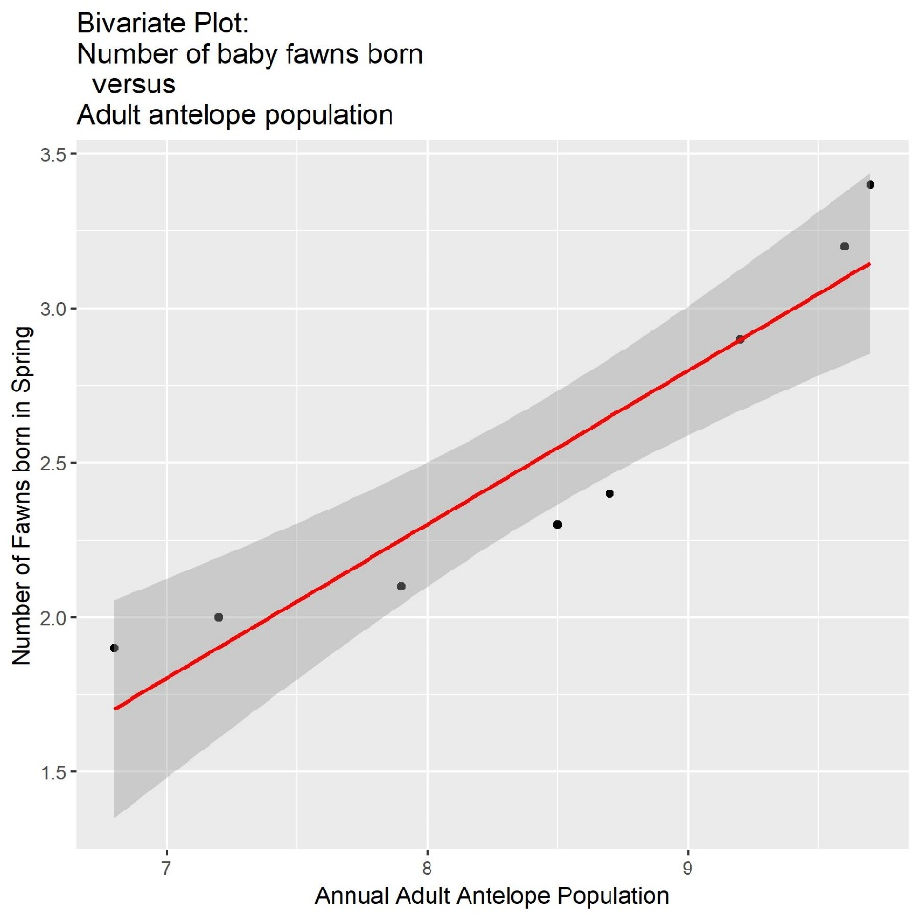

> # Plot 2: Number of baby fawns given the precipitation that year

> # x-axis: Annual_Percipitation

> # y-axis: Fawn_Cnt

> g.fawn.percipitation <- ggplot(antelopeDf, aes(x=Annual_Percipitation, y=Fawn_Cnt)) +

+ geom_point() +

+ stat_smooth(method='lm',col='red') +

+ labs(title="Bivariate Plot: \nNumber of baby fawns born \n versus \nAnnual percipitation", x="Annual Percipitation", y="Number of Fawns born in Spring")

> g.fawn.percipitation

> ggsave("Bivariate_Plot_Baby_Fawns_Precipitation.jpg", width = 6, height = 6)

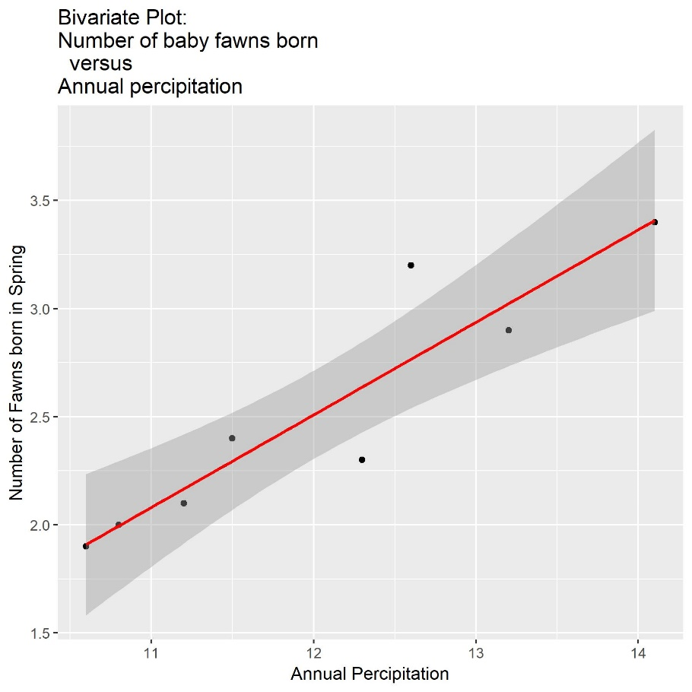

> # Plot 3: Number of baby fawns given the severity of the winter

> # x-axis: Bad_Winter_Scale

> # y-axis: Fawn_Cnt

> g.fawn.winter <- ggplot(antelopeDf, aes(x=Bad_Winter_Scale, y=Fawn_Cnt)) +

+ geom_point() +

+ stat_smooth(method='lm',col='red') +

+ labs(title="Bivariate Plot: ", x="Winter Severity Rating", y="Number of Fawns born in Spring")

> g.fawn.winter

> ggsave("Bivariate_Plot_Baby_Fawns_Bad_Weather_Rating.jpg", width = 6, height = 6)

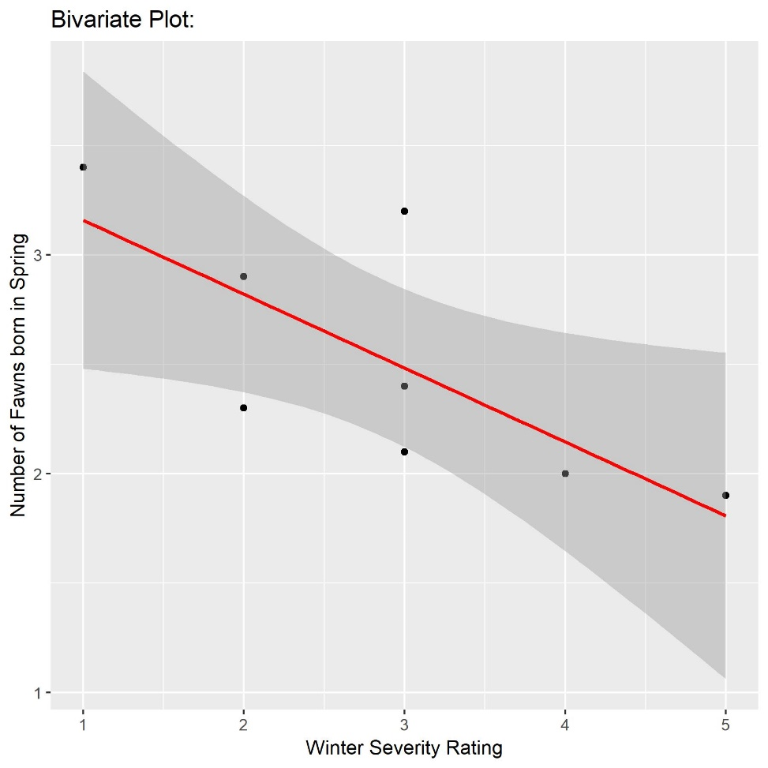

> # ---- Step 5: Create regression models -----------------------------------------------------------------------------

> #

> # Create three regression models of increasing complexity using lm().

>

> # Step 5.1: Predict the number of fawns from the severity of the winter

> # Output: Multiple R-squared = 0.5459 | p-value = 0.03626

> fawn.winter.lm <- lm(Fawn_Cnt ~ Bad_Winter_Scale, data=antelopeDf)

> sum.f.w <- summary(fawn.winter.lm)

> sum.f.w

Call:

lm(formula = Fawn_Cnt ~ Bad_Winter_Scale, data = antelopeDf)

Residuals:

Min 1Q Median 3Q Max

-0.52069 -0.20431 -0.00172 0.13017 0.71724

Coefficients:

Estimate Std. Error t value Pr(>|t|)

(Intercept) 3.4966 0.3904 8.957 0.000108 ***

Bad_Winter_Scale -0.3379 0.1258 -2.686 0.036263 *

---

Signif. codes: 0 ‘***’ 0.001 ‘**’ 0.01 ‘*’ 0.05 ‘.’ 0.1 ‘ ’ 1

Residual standard error: 0.415 on 6 degrees of freedom

Multiple R-squared: 0.5459, Adjusted R-squared: 0.4702

F-statistic: 7.213 on 1 and 6 DF, p-value: 0.03626

> range(antelopeDf$Bad_Winter_Scale)

[1] 1 5

> newWinterData <- data.frame(Bad_Winter_Scale=3)

> predict(fawn.winter.lm,newWinterData,type="response")

1

2.482759

>

> # Step 5.2: Predict the number of fawns from two variables (one should be the severity of the winter)

> # Output: Adjusted R-squared = 0.8439 | p-value = 0.004152

> fawn.AntelopePop.Winter.lm <- lm(Fawn_Cnt ~ Adult_Antelope_Pop+Bad_Winter_Scale, data=antelopeDf)

> sum.f.a.w <- summary(fawn.AntelopePop.Winter.lm)

> sum.f.a.w

Call:

lm(formula = Fawn_Cnt ~ Adult_Antelope_Pop + Bad_Winter_Scale,

data = antelopeDf)

Residuals:

1 2 3 4 5 6 7 8

0.01231 -0.27531 0.10301 -0.19154 0.01535 0.15880 0.29992 -0.12256

Coefficients:

Estimate Std. Error t value Pr(>|t|)

(Intercept) -2.46009 1.53443 -1.603 0.1698

Adult_Antelope_Pop 0.56594 0.14439 3.920 0.0112 *

Bad_Winter_Scale 0.07058 0.12461 0.566 0.5956

---

Signif. codes: 0 ‘***’ 0.001 ‘**’ 0.01 ‘*’ 0.05 ‘.’ 0.1 ‘ ’ 1

Residual standard error: 0.2252 on 5 degrees of freedom

Multiple R-squared: 0.8885, Adjusted R-squared: 0.8439

F-statistic: 19.92 on 2 and 5 DF, p-value: 0.004152

> range(antelopeDf$Adult_Antelope_Pop)

[1] 6.8 9.7

> newAntelopeWinterData <- data.frame(Adult_Antelope_Pop=9, Bad_Winter_Scale=1)

> predict(fawn.AntelopePop.Winter.lm,newAntelopeWinterData,type='response')

1

2.70392

>

> # Step 5.3: Predict the number of fawns from the three other variables

> # Output: Adjusted R-squared = 0.955 | p-value = 0.001229

> fawn.AntelopePop.Percipitation.Winter.lm <- lm(Fawn_Cnt ~ Adult_Antelope_Pop+Annual_Percipitation+Bad_Winter_Scale, data=antelopeDf)

> sum.f.a.p.w <- summary(fawn.AntelopePop.Percipitation.Winter.lm)

> sum.f.a.p.w

Call:

lm(formula = Fawn_Cnt ~ Adult_Antelope_Pop + Annual_Percipitation +

Bad_Winter_Scale, data = antelopeDf)

Residuals:

1 2 3 4 5 6 7 8

-0.11533 -0.02661 0.09882 -0.11723 0.02734 -0.04854 0.11715 0.06441

Coefficients:

Estimate Std. Error t value Pr(>|t|)

(Intercept) -5.92201 1.25562 -4.716 0.0092 **

Adult_Antelope_Pop 0.33822 0.09947 3.400 0.0273 *

Annual_Percipitation 0.40150 0.10990 3.653 0.0217 *

Bad_Winter_Scale 0.26295 0.08514 3.089 0.0366 *

---

Signif. codes: 0 ‘***’ 0.001 ‘**’ 0.01 ‘*’ 0.05 ‘.’ 0.1 ‘ ’ 1

Residual standard error: 0.1209 on 4 degrees of freedom

Multiple R-squared: 0.9743, Adjusted R-squared: 0.955

F-statistic: 50.52 on 3 and 4 DF, p-value: 0.001229

> range(antelopeDf$Annual_Percipitation)

[1] 10.6 14.1

> newAntelopePopPercipitationWinterData <- data.frame(Adult_Antelope_Pop=5, Annual_Percipitation=14 ,Bad_Winter_Scale=4)

> predict(fawn.AntelopePop.Percipitation.Winter.lm, newAntelopePopPercipitationWinterData, type='response')

1

2.441915

>

> # Step 5.4: Questions to Answer

> # Question 5.4.1: Which model works best?

> # The third model, fawn.AntelopePop.Percipitation.Winter.lm, it has an Adjust R-squared score of 0.955 and p-value of 0.001 (statistically significant)

> paste("Adjusted R-squared:",sum.f.a.p.w$adj.r.squared)

[1] "Adjusted R-squared: 0.955004704934087"

> paste("P-Value:")

[1] "P-Value:"

> sum.f.a.p.w$coefficients[,4]

(Intercept) Adult_Antelope_Pop Annual_Percipitation Bad_Winter_Scale

0.009196072 0.027272444 0.021707219 0.036626174

>

> # Question 5.4.2: Which of the predictors are statistically significant in each model?

> # Model 1: Number of fawns from the severity of the winter

> # Answer: Bad Winter Rating has a predictor confidence of 55% accuracy

> paste("Multiple R-squared:",sum.f.w$r.squared)

[1] "Multiple R-squared: 0.545888574072554"

> paste("P-Value:")

[1] "P-Value:"

> sum.f.w$coefficients[,4]

(Intercept) Bad_Winter_Scale

0.000108158 0.036263036

>

> # Model 2: Number of fawns from the Adult Antelope Population and Bad Winter Rating

> # Answer: Adult Antelope Population has a prediction confidence accuracy of 84%, Bad Winter is not statistically significant in this model

> paste("Adjusted R-squared:",sum.f.a.w$adj.r.squared)

[1] "Adjusted R-squared: 0.84389367311556"

> paste("P-Value:")

[1] "P-Value:"

> sum.f.a.w$coefficients[,4]

(Intercept) Adult_Antelope_Pop Bad_Winter_Scale

0.16977988 0.01118699 0.59557987

>

> # Model 3: number of fawns from the Adult Antelope Population, Annual Percipitation and Bad Winter Rating

> # Answer: Adult Antelope Population, Annual Precipitation and Bad Winter Rating are all statistically significant

> # and combined have a prediction confidence accuracy of 95%

> paste("Adjusted R-squared:",sum.f.a.p.w$adj.r.squared)

[1] "Adjusted R-squared: 0.955004704934087"

> paste("P-Value:")

[1] "P-Value:"

> sum.f.a.p.w$coefficients[,4]

(Intercept) Adult_Antelope_Pop Annual_Percipitation Bad_Winter_Scale

0.009196072 0.027272444 0.021707219 0.036626174

|  |
| --- |
| # Question 5.4.3: If you wanted to create the most parsimonious model (i.e.,  > # the one that did the best job with the fewest predictors), what would it contain?  > # Answer:  > # Analysis of Deviance Table  > # Initial Model:  > # Fawn_Cnt ~ Adult_Antelope_Pop + Annual_Percipitation + Bad_Winter_Scale  > # Final Model:  > # Fawn_Cnt ~ Adult_Antelope_Pop + Annual_Percipitation + Bad_Winter_Scale  >  > # Apply Stepwise regression analysis, find best combination of variables for best prediction output  > lm.step <- stepAIC(fawn.AntelopePop.Percipitation.Winter.lm,direction="both")  Start: AIC=-31.35  Fawn_Cnt ~ Adult_Antelope_Pop + Annual_Percipitation + Bad_Winter_Scale  Df Sum of Sq RSS AIC  <none> 0.058494 -31.346  - Bad_Winter_Scale 1 0.13950 0.197989 -23.592  - Adult_Antelope_Pop 1 0.16907 0.227561 -22.478  - Annual_Percipitation 1 0.19518 0.253673 -21.609  > lm.step$anova  Stepwise Model Path  Analysis of Deviance Table  Initial Model:  Fawn_Cnt ~ Adult_Antelope_Pop + Annual_Percipitation + Bad_Winter_Scale  Final Model:  Fawn_Cnt ~ Adult_Antelope_Pop + Annual_Percipitation + Bad_Winter_Scale  Step Df Deviance Resid. Df Resid. Dev AIC  1 4 0.05849389 -31.3462  > summary(lm.step)  Call:  lm(formula = Fawn_Cnt ~ Adult_Antelope_Pop + Annual_Percipitation +  Bad_Winter_Scale, data = antelopeDf)  Residuals:  1 2 3 4 5 6 7 8  -0.11533 -0.02661 0.09882 -0.11723 0.02734 -0.04854 0.11715 0.06441  Coefficients:  Estimate Std. Error t value Pr(>|t|)  (Intercept) -5.92201 1.25562 -4.716 0.0092 **  Adult_Antelope_Pop 0.33822 0.09947 3.400 0.0273 *  Annual_Percipitation 0.40150 0.10990 3.653 0.0217 *  Bad_Winter_Scale 0.26295 0.08514 3.089 0.0366 *  ---  Signif. codes: 0 ‘***’ 0.001 ‘**’ 0.01 ‘*’ 0.05 ‘.’ 0.1 ‘ ’ 1  Residual standard error: 0.1209 on 4 degrees of freedom  Multiple R-squared: 0.9743, Adjusted R-squared: 0.955  F-statistic: 50.52 on 3 and 4 DF, p-value: 0.001229  > plot(lm.step)          ## Other individual attribute tests  > # Output: Multiple R-squared = 0.8813 | p-value = 0.0005471  > fawn.apop <- lm(Fawn_Cnt ~ Adult_Antelope_Pop, data=antelopeDf)  > sum.fawn.apop <- summary(fawn.apop)  > sum.fawn.apop  Call:  lm(formula = Fawn_Cnt ~ Adult_Antelope_Pop, data = antelopeDf)  Residuals:  Min 1Q Median 3Q Max  -0.24988 -0.17586 0.04938 0.12611 0.25309  Coefficients:  Estimate Std. Error t value Pr(>|t|)  (Intercept) -1.67914 0.63422 -2.648 0.038152 *  Adult_Antelope_Pop 0.49753 0.07453 6.676 0.000547 ***  ---  Signif. codes: 0 ‘***’ 0.001 ‘**’ 0.01 ‘*’ 0.05 ‘.’ 0.1 ‘ ’ 1  Residual standard error: 0.2121 on 6 degrees of freedom  Multiple R-squared: 0.8813, Adjusted R-squared: 0.8616  F-statistic: 44.56 on 1 and 6 DF, p-value: 0.0005471  > # Output: Multiple R-squared = 0.8536 | p-value = 0.001039  > fawn.aperc <- lm(Fawn_Cnt ~ Annual_Percipitation, data=antelopeDf)  > sum.fawn.aperc <- summary(fawn.aperc)  > sum.fawn.aperc  Call:  lm(formula = Fawn_Cnt ~ Annual_Percipitation, data = antelopeDf)  Residuals:  Min 1Q Median 3Q Max  -0.33747 -0.08040 -0.00889 0.03023 0.43399  Coefficients:  Estimate Std. Error t value Pr(>|t|)  (Intercept) -2.63251 0.87591 -3.005 0.02384 *  Annual_Percipitation 0.42845 0.07244 5.915 0.00104 **  ---  Signif. codes: 0 ‘***’ 0.001 ‘**’ 0.01 ‘*’ 0.05 ‘.’ 0.1 ‘ ’ 1  Residual standard error: 0.2356 on 6 degrees of freedom  Multiple R-squared: 0.8536, Adjusted R-squared: 0.8292  F-statistic: 34.99 on 1 and 6 DF, p-value: 0.001039 |
|  |
| |  | | --- | | > | |