Ryan Timbrook

NetID: RTIMBROO
Course: IST 707 Data Analytics
Term: Summer, 2019
Due Date: 7/17/19

Table of Contents
1 Introduction 3
2 Analysis and Models 4
2.1 About the Data 4
2.1.1 Dataset Info 4
2.1.2 Data Exploration & Cleaning 5
2.1.3 Data Transformations 6
3 Conclusions 14

Introduction

Five schools (A, B, C, D and E) have implemented the same math course, with 35 lessons, for the current school term. The semester is approaching the 75%-waymark. The school district would like to get a sense of how each school is progressing in completing all 35 lessons and if there are any early warning indicators that could be understood.

For each section of this course, collected over the five schools, records were taken, counting the number of students who were in one of six groupings: Very Ahead (more than 5 lessons ahead), Middling (5 lessons ahead to 0 lessons ahead), Behind (1 to 5 lessons behind), More Behind (6 to 10 lessons behind), Very Behind (more than 10 lessons behind) and Completed (finished with the course)

Based on the data, and time left in the term, are there indicators that can show how one school is performing over another? What stories does the data reveal?

Analysis and Models

About the Data
The data set contains 30 records of 8 variables. It’s made up of one Factor variable, the School, and seven numeric continuous variables, six of which are the counts of students grouped into a lessons progress categorization. The six lesson progress categorizations are: Very.Ahead..5, Middling..0, Behind..1.5, More.Behind..6.10, Very.Behind..11, Completed. The Section numeric variable represents a school’s section number for this Math course. Each school, due to its student class size has a different number of sections.

There were no missing values from the original dataset. In the initial cleaning, some column headings were altered for readability purposes.

Original Column Name | New Column Name
Very.Ahead..5 | VeryAhead
Middling..0 | Middling
Behind..1.5 | Behind
More.Behind..6.10 | MoreBehind
Very.Behind..11 | VeryBehind

Dataset Info
Each of 5 schools (A, B, C, D and E) have the same math course for the current semester,
with 35 lessons. There are 30 sections total.

Each section has a count of students who are:
- very ahead (more than 5 lessons ahead)
- middling (5 lessons ahead to 0 lessons ahead)
- behind (1 to 5 lessons behind)
- more behind (6 to 10 lessons behind)
- very behind (more than 10 lessons behind)
- completed (finished with the course)

Attribute | Data Type | Preview
School | Factor w/5 levels | ‘A’,’B’,’C’,’D’,’E’,…
Section | Int | 1 2 3 4 5 6 7 8 9 10 …
VeryAhead | Int | 0 0 0 0 0 0 0 0 0 0 0 …
Middling | Int | 5 8 9 14 9 7 19 3 6 13 …
Behind | Int | 54 40 35 44 42 29 22 …
MoreBehind | Int | 3 10 12 5 2 3 5 11 8 5 …
VeryBehind | Int | 9 16 13 12 24 10 14 18 …
Completed | int | 10 6 11 10 8 9 19 5 10 …

Data Exploration & Cleaning

- View of the head of the dataset to get a sense of how the data looks.

Table 2.0: Preview (head) of Schools Dataset
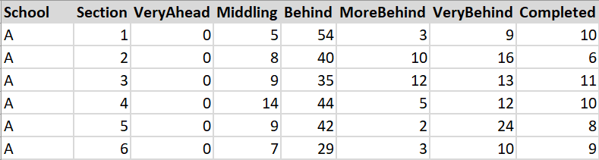

- View of the summary statistics of the school dataset as it was obtained.

The school variable shows a disproportionate number of records per school. This represents the number of math course sections in a given school. It’s reflective of the overall number of students proportional to the schools. (i.e., More students in a school, more sections their will be.) The VeryAhead attribute is 0 for all schools, this attribute can be removed from most analysis. Most of the means and medians are close representing a normal distribution, except for ‘Behind’, where it shows a higher mean value, skewing the dataset distribution to the right.
Table 2.1: Summary Table of Schools Dataset
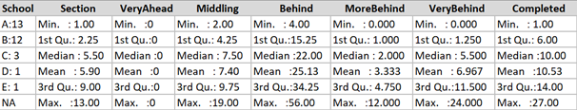

- Describe of the data
Table 2.2: Describe Table of School Dataset
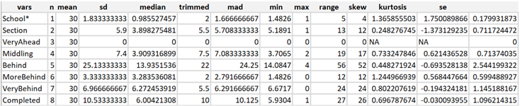

- No cleaning Necessary, there were no incomplete data records

Data Transformations
- Dimensionality Reduction:
  - Section attribute was removed from most analysis. It was found to be proportional to the number of students enrolled in the math course for a given school. Each of the schools having a disproportional number of students to one another.
  - VeryAhead attribute was found to be 0 for all sections of each school. It was removed from most analysis and visualizations.
- Aggregation: Total student counts summed by school

Summation of progress groups by school along with adding a new attribute, ‘Totals’, to the dataset.
The graph below, ‘Count of Student Lessons Reports by School’, visualize the distribution of students across the five schools.
Table 2.3: Total counts of student lessons distributed across schools
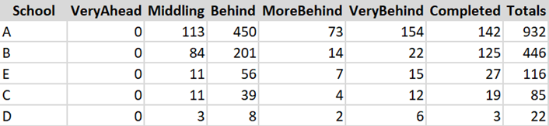 | 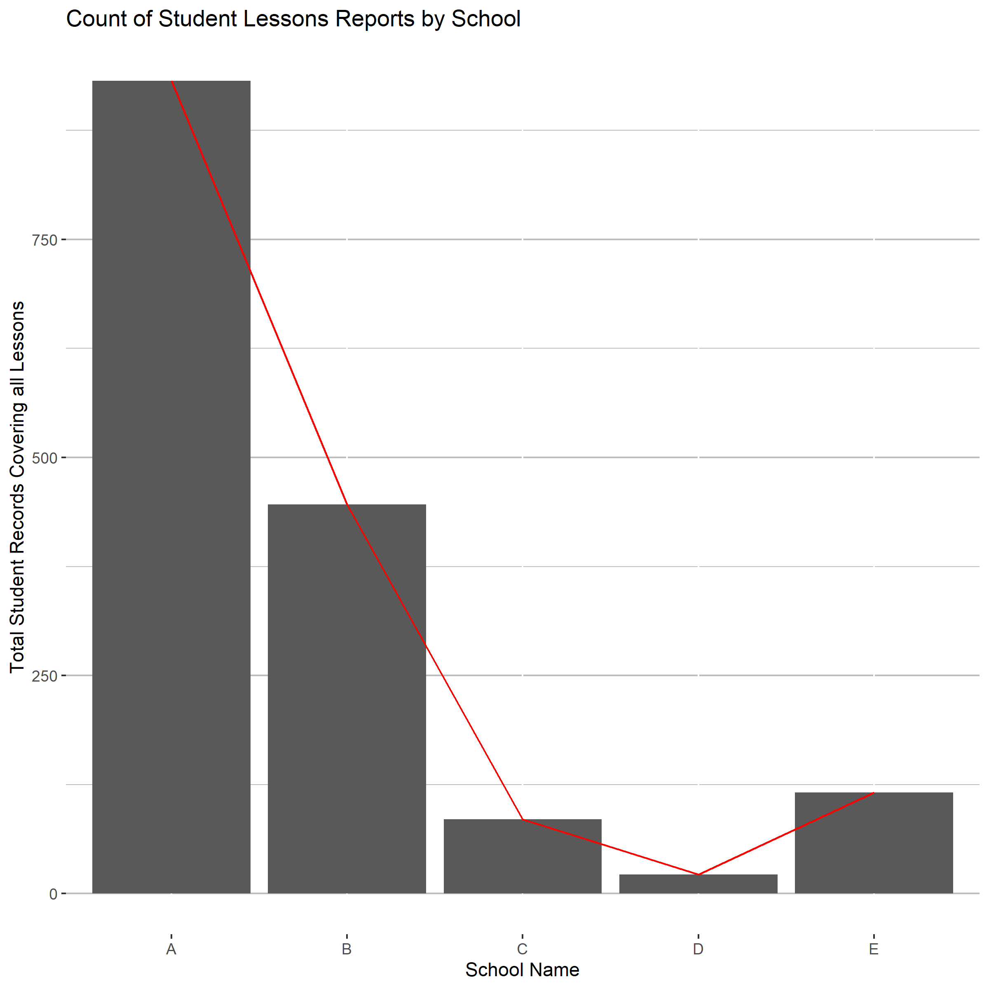

- Normalization: Proportion’s of Students at each School to total population

The table 2.4 below represents the overall proportion of students at each school to the total number all students enrolled in the same math course at each of the five schools. The graph, ‘Proportion of All Students Records by School’, helps to visualize the school’s student populations inequalities.
Table 2.4: Proportion of students to each School
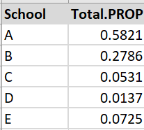 | 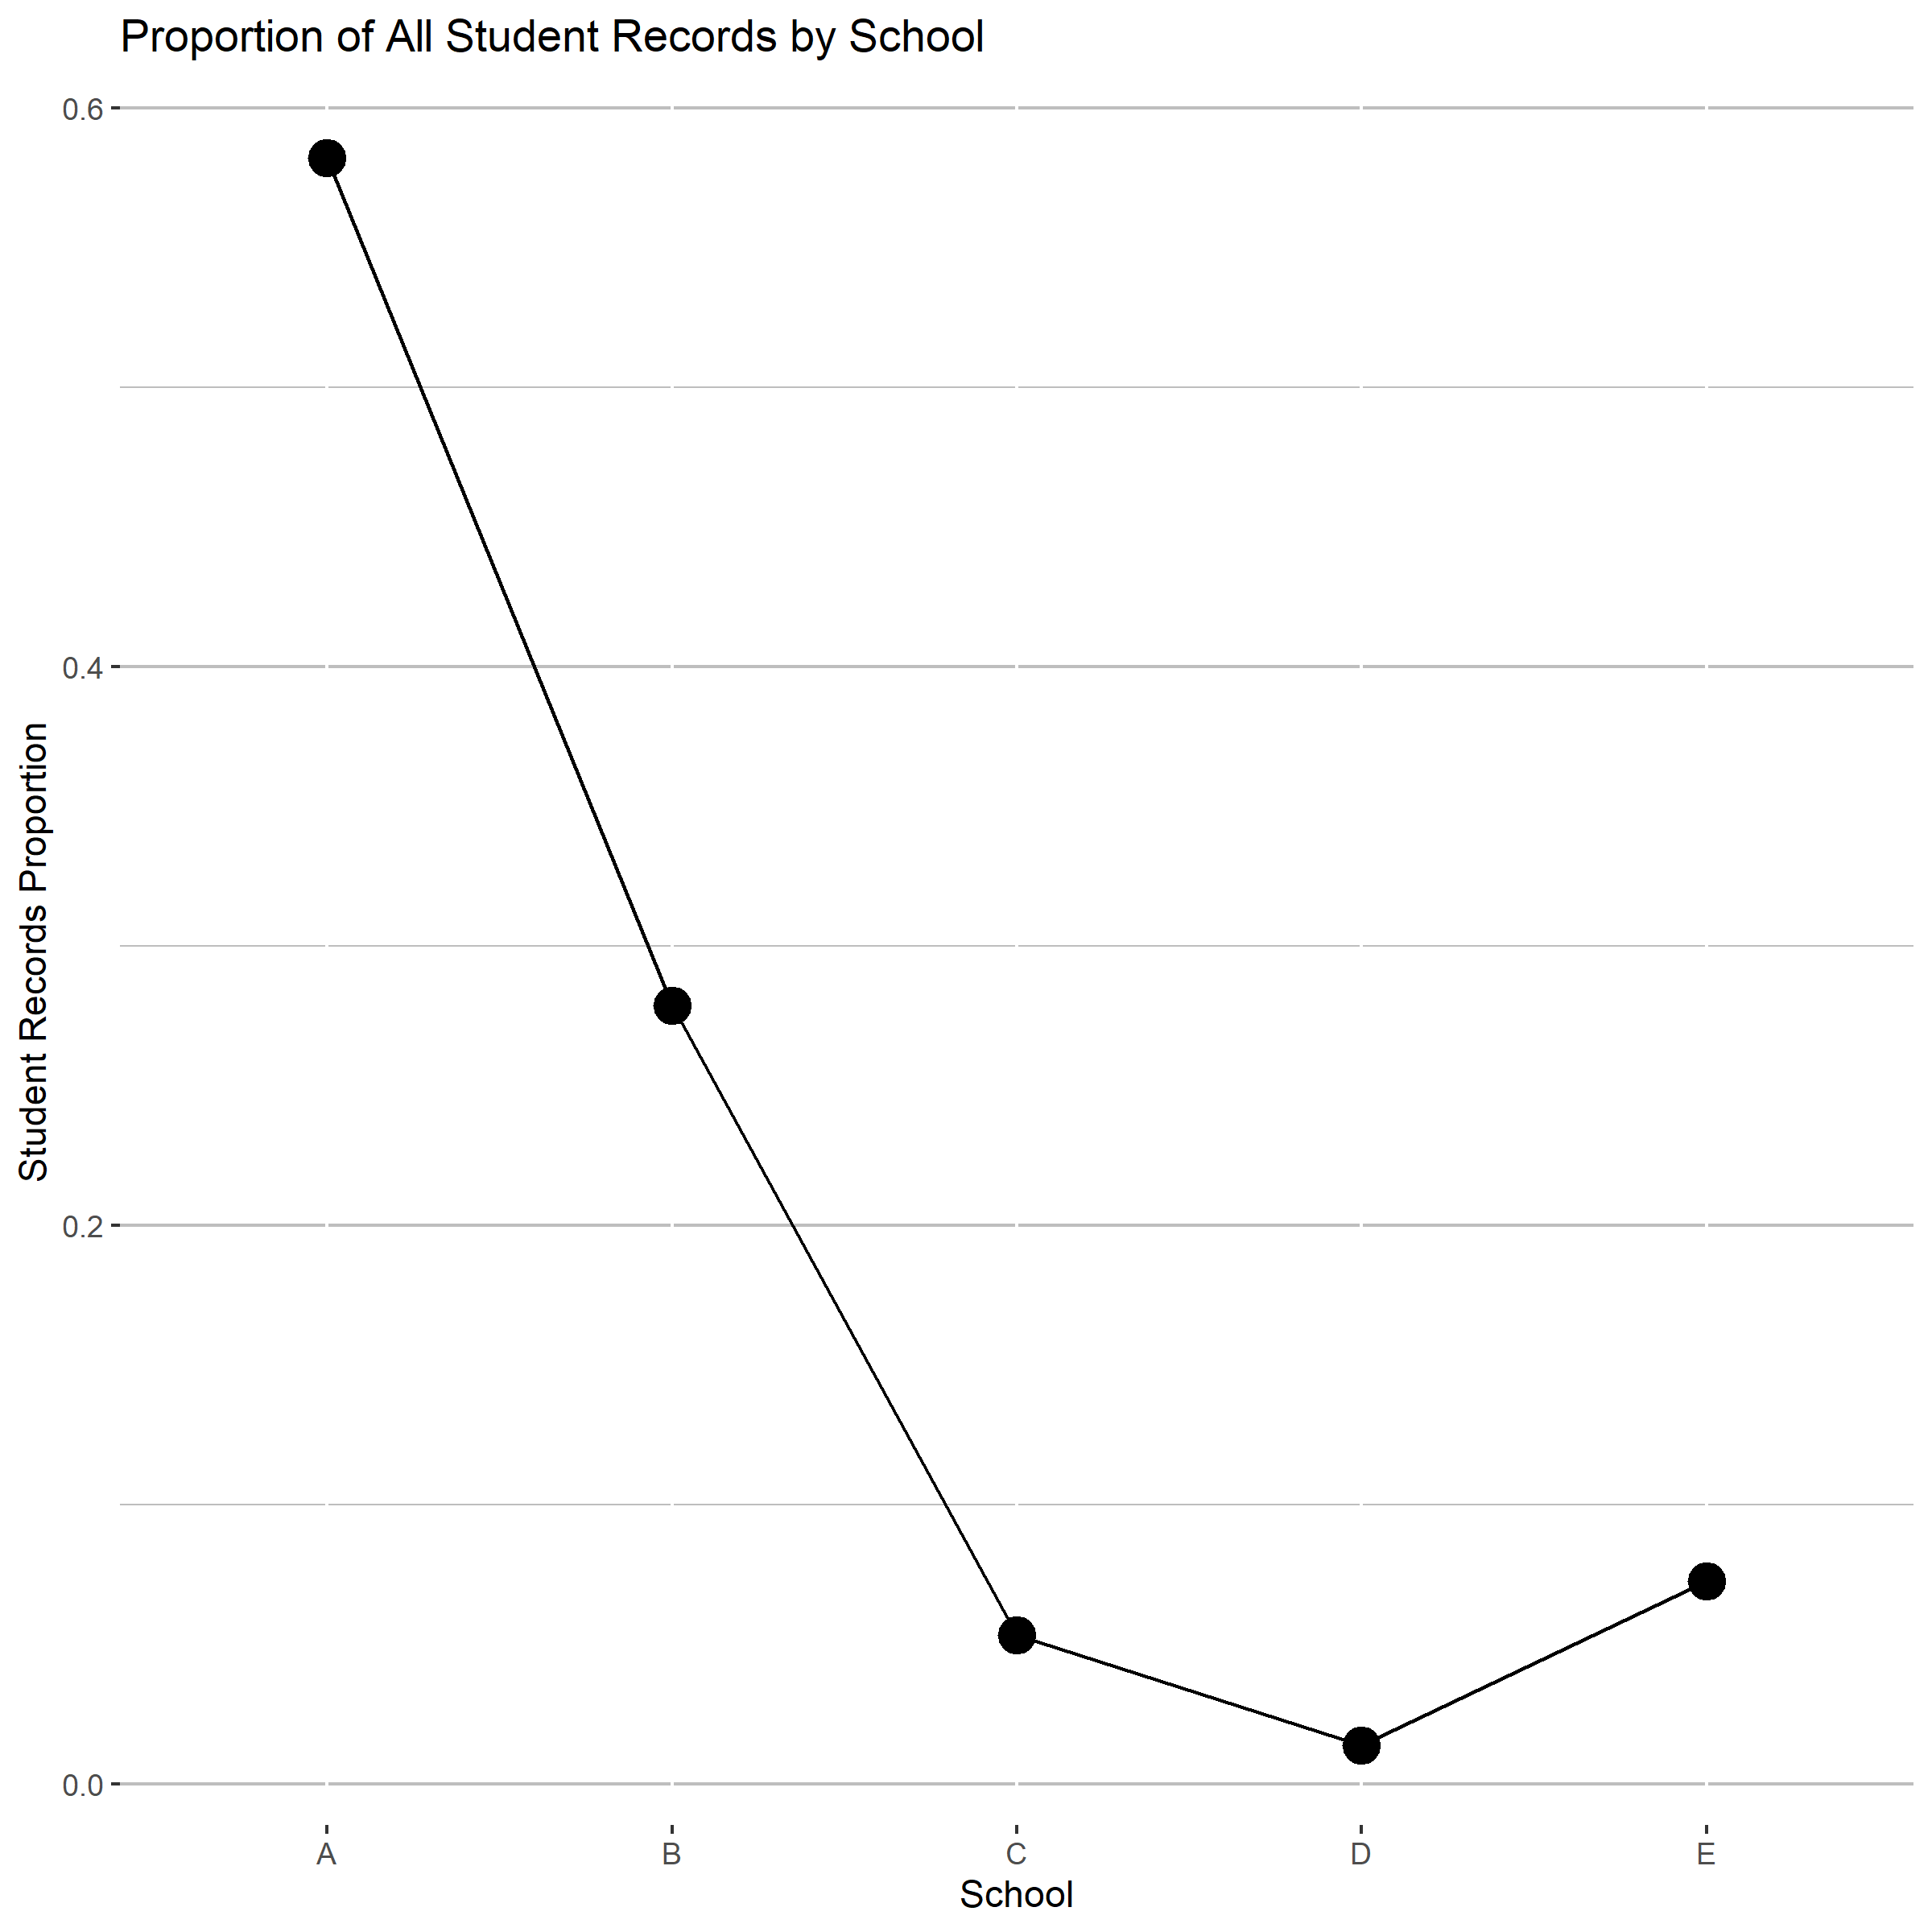

- Aggregation: Total lesson progress counts by grouping of all schools

Summing each of the lessons progress groupings and visualizing them to represent overall distribution of students in each of these categories shows that ‘Behind’ has more than twice the number of students than its closest category, Completed. And more than three times ‘Middling’, ‘MoreBehind’ and ‘VeryBehind’.

Table 2.5: Progress Categories Counts
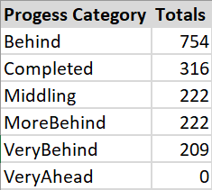 | 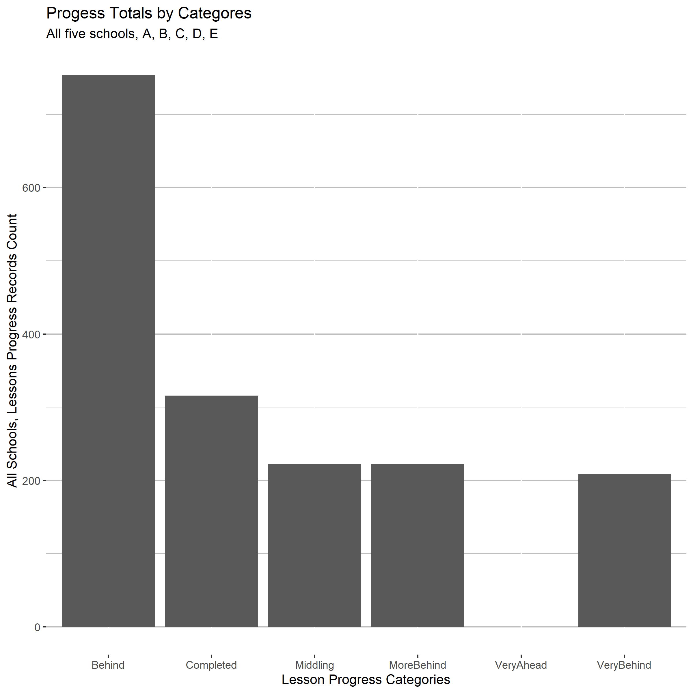

- Normalized Dataset to Proportions of total students by School

An approach of normalizing each school’s student lesson progress distribution was taken in order to compare the school’s performance to each other. Each grouping’s value is a proportion of students in that group to the total population of the given school. Equally distributing, or ranking, based on the number of students enrolled in the match course at that school.
Table 2.6 below is a view of the new, proportions based, school dataset. It also has three new attributes, (GREEN, YELLOW, RED), used for alert levels that will be described in another section.

Shown in Graph 2.6.1, ‘Normalized relationships of progress groupings by school’, is a layered visualization that shows how each school is performing for a given lessons progress grouping in relation to all other schools.

In Graph 2.6.2 below, each lesson progress grouping is broken out into its own visualization that incorporates the overall average distribution. This visual helps to show how far or close to the norm a school is for that topic. As an example, for ‘VeryBehind’, school’s B and D show the greatest distance from the average and each other. School B is only 5% VeryBehind, where school D is 27% VeryBehind.

Table 2.6: Table view of school dataset as proportions to student count by school
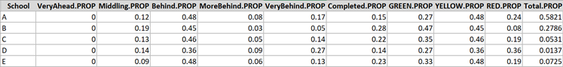

Graph 2.6.1: Normalized relationship of progress groupings by school
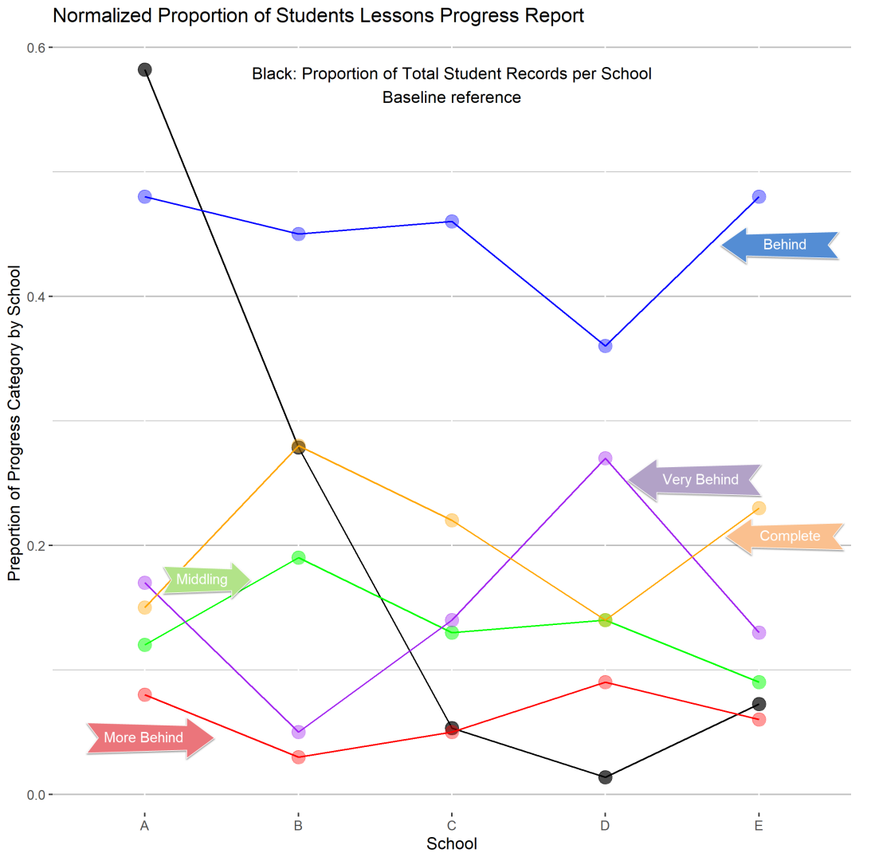

Graph 2.6.2: Normalized progress grouping by School with Average represented
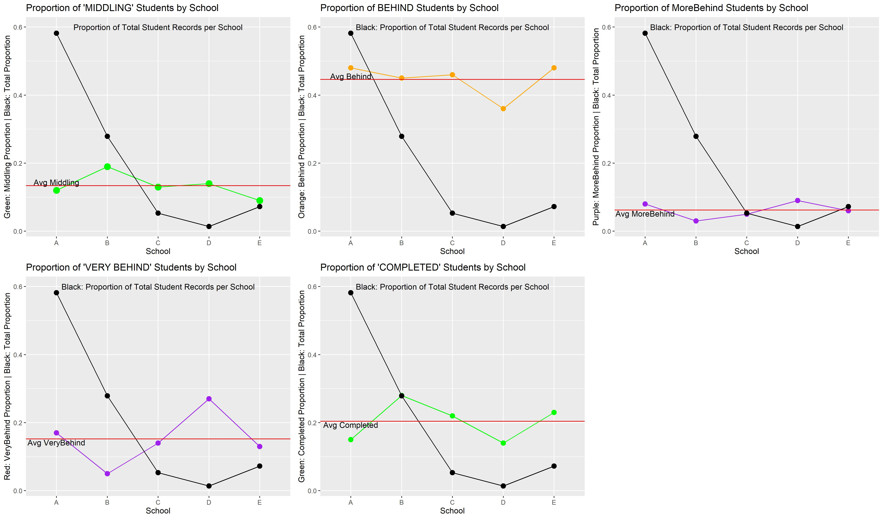

- Discretization (change of scale) : Applying categories alerting by progress by school (count of students)
  - Schools at risk of students not completing their lessons:
    - Groups: GREEN, YELLOW, RED
      - GREEN: Completed, Very Ahead, Middling
      - YELLOW: Behind
      - RED: More Behind, Very Behind

A new scale grouping was added to the proportion’s dataset to further narrow down the feature set and group schools into categories that would indicate if they had a large population of students at risk of not completing all the lessons for the term.

Based on proportion of students, Graph 2.8.1 below visualizes how school ‘D’ has the highest proportion of its students at risk of not completing their lessons, while school ‘B’ has the lowest proportion. Whereas in contrast, Graph 2.8.2 blow, which visualizes alerts by total count of Students in the grouping per School, shows that School ‘A’ has the highest number of Students at risk of not completing their math lessons this term with School ‘D’ being the least.

Table 2.8: Table view of school dataset as proportions to student count by school

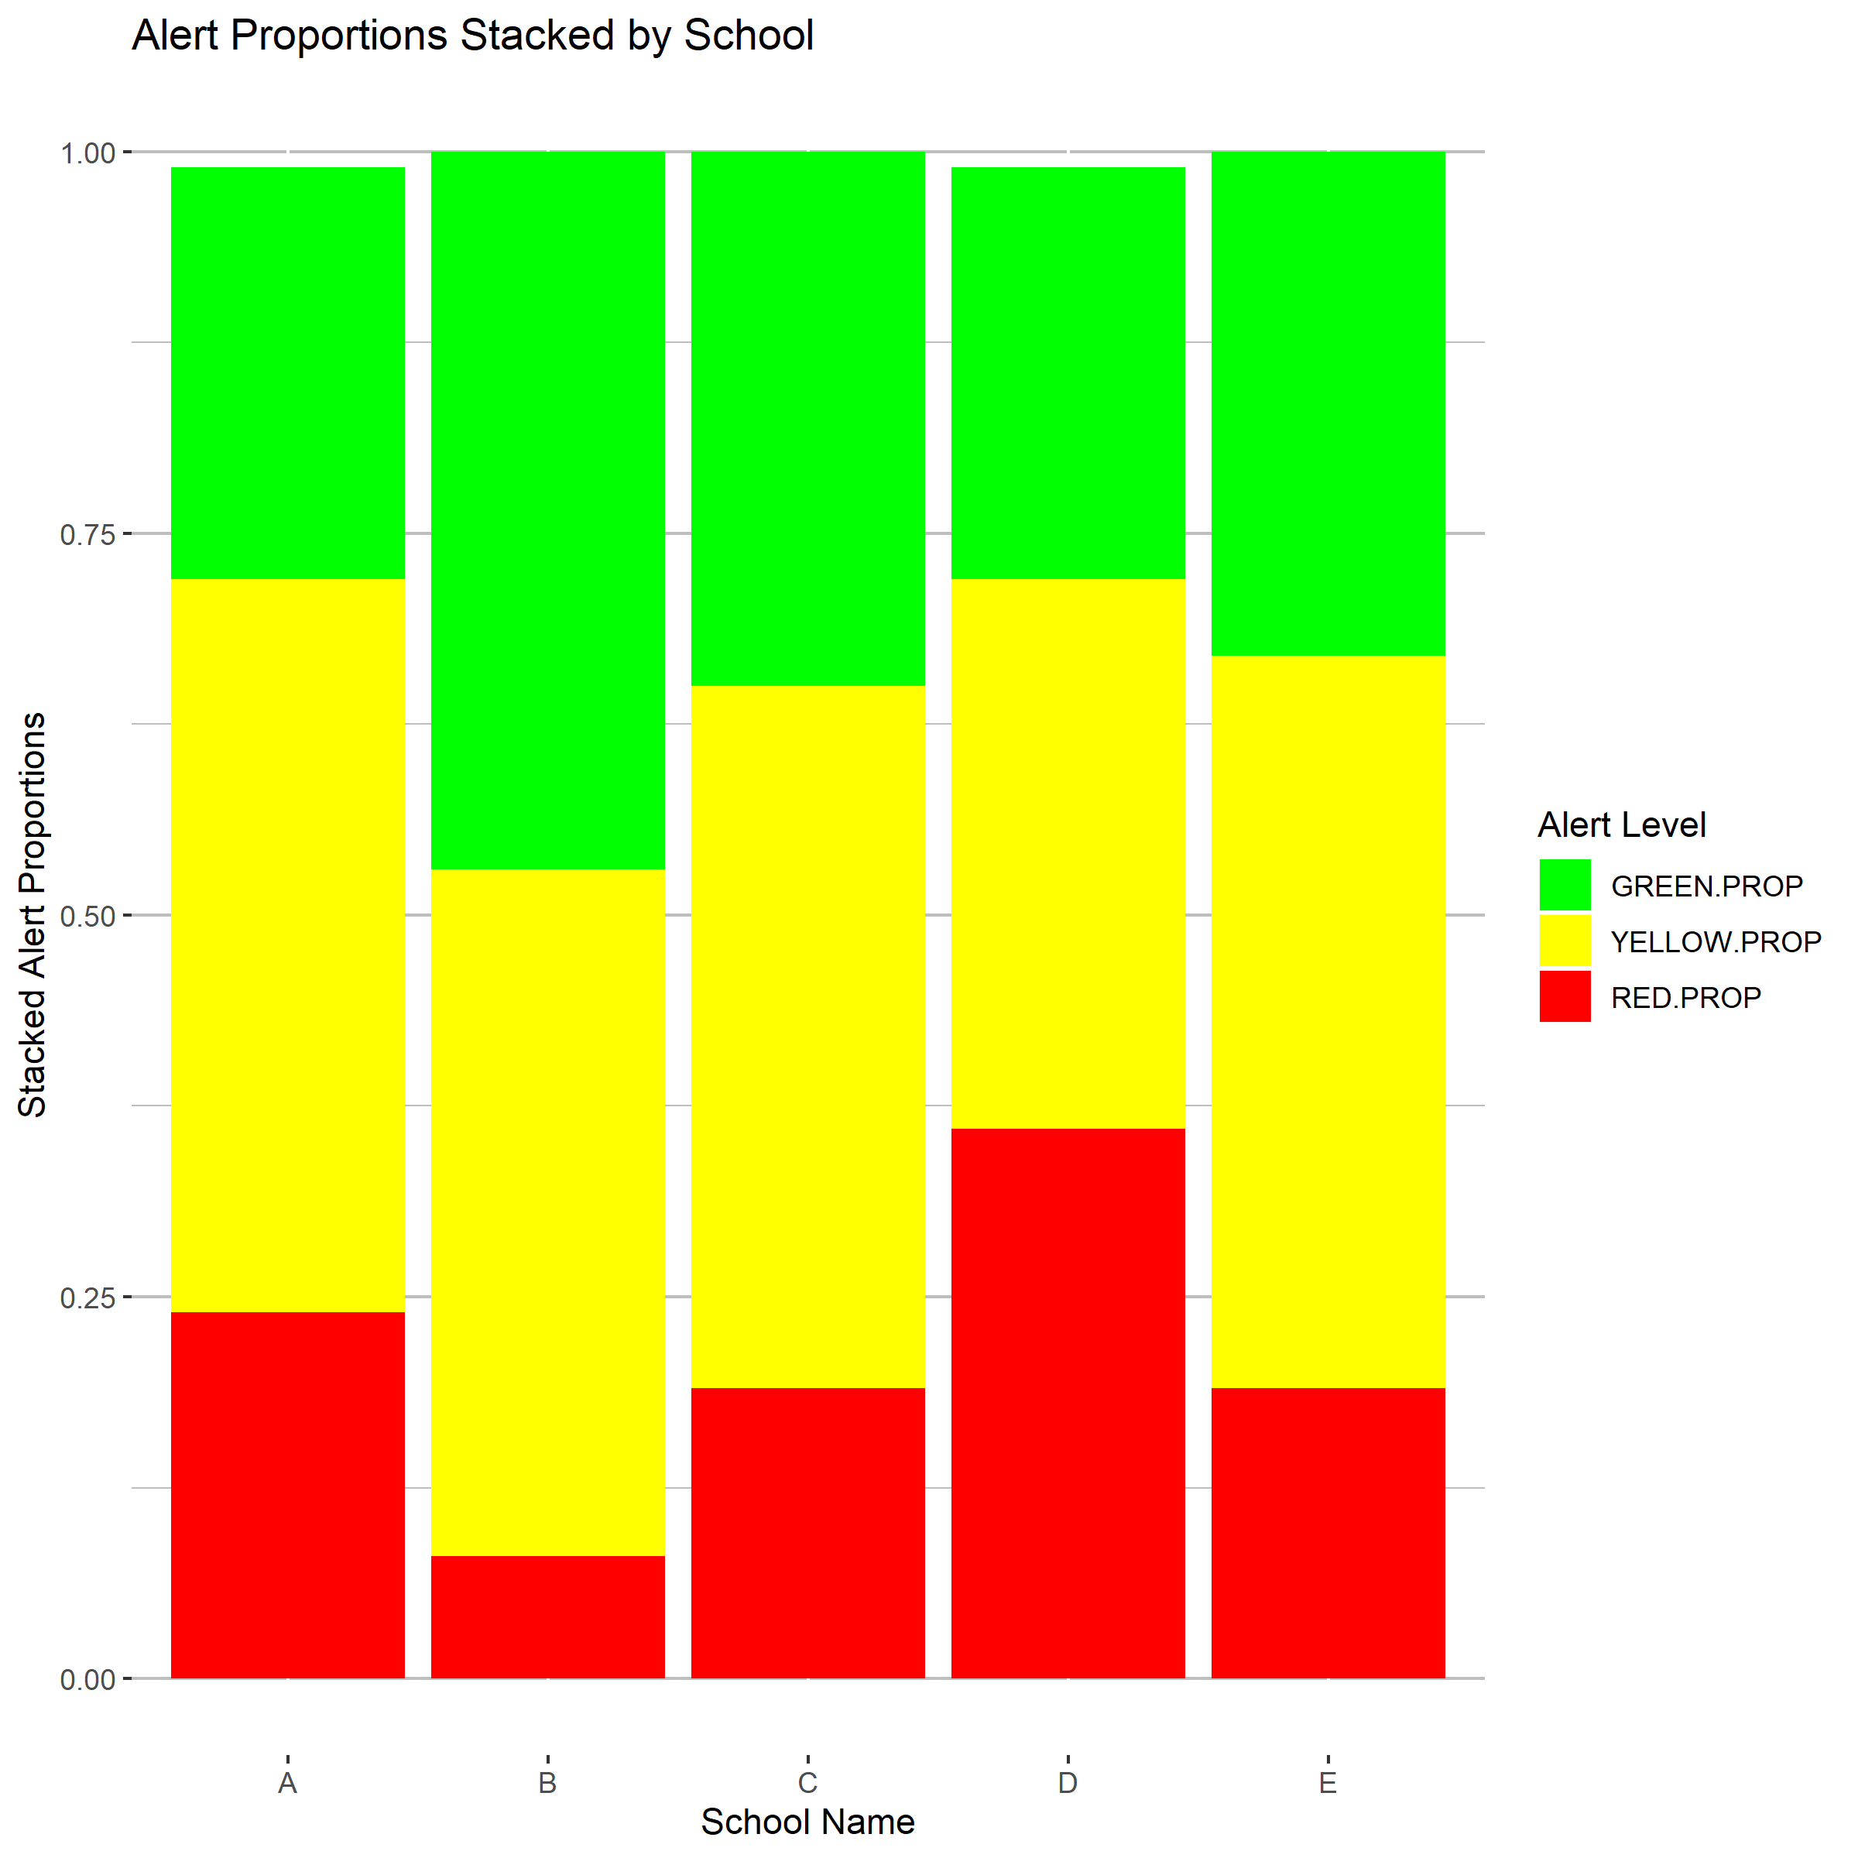  Graph 2.8.1: Progress Alerts as a Proportion by School | 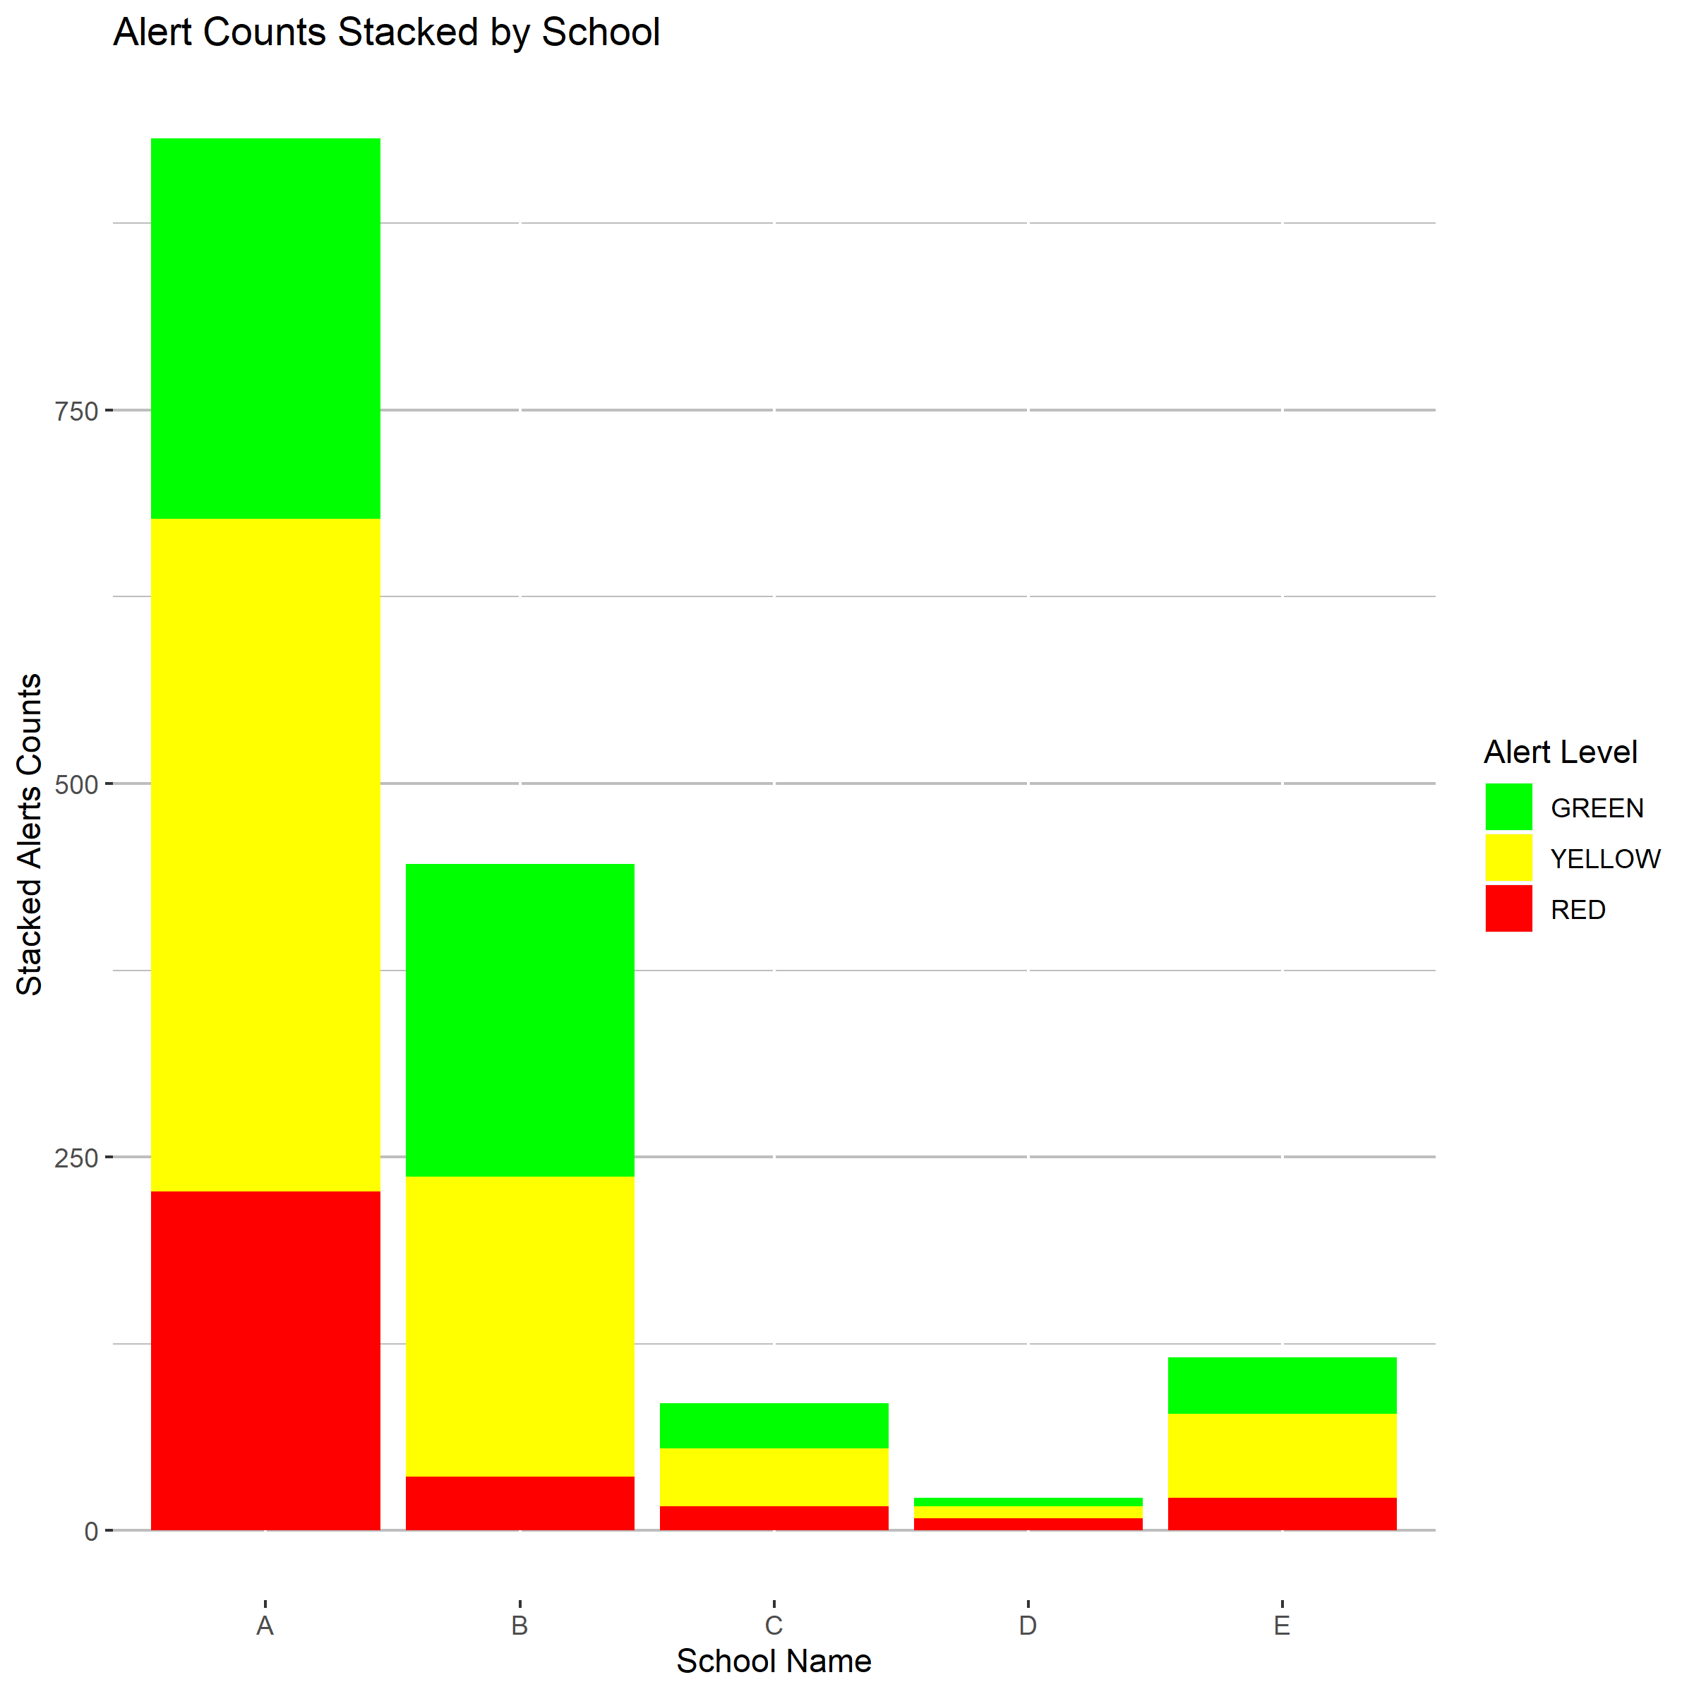  Graph 2.8.2: Progess Alerts by Total Count by School

Table 2.9: Summary Table of School dataset as proportions
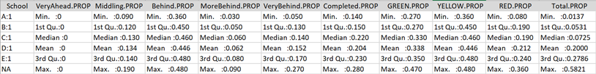
Graph 2.9.1: Boxplot representation of each progress category
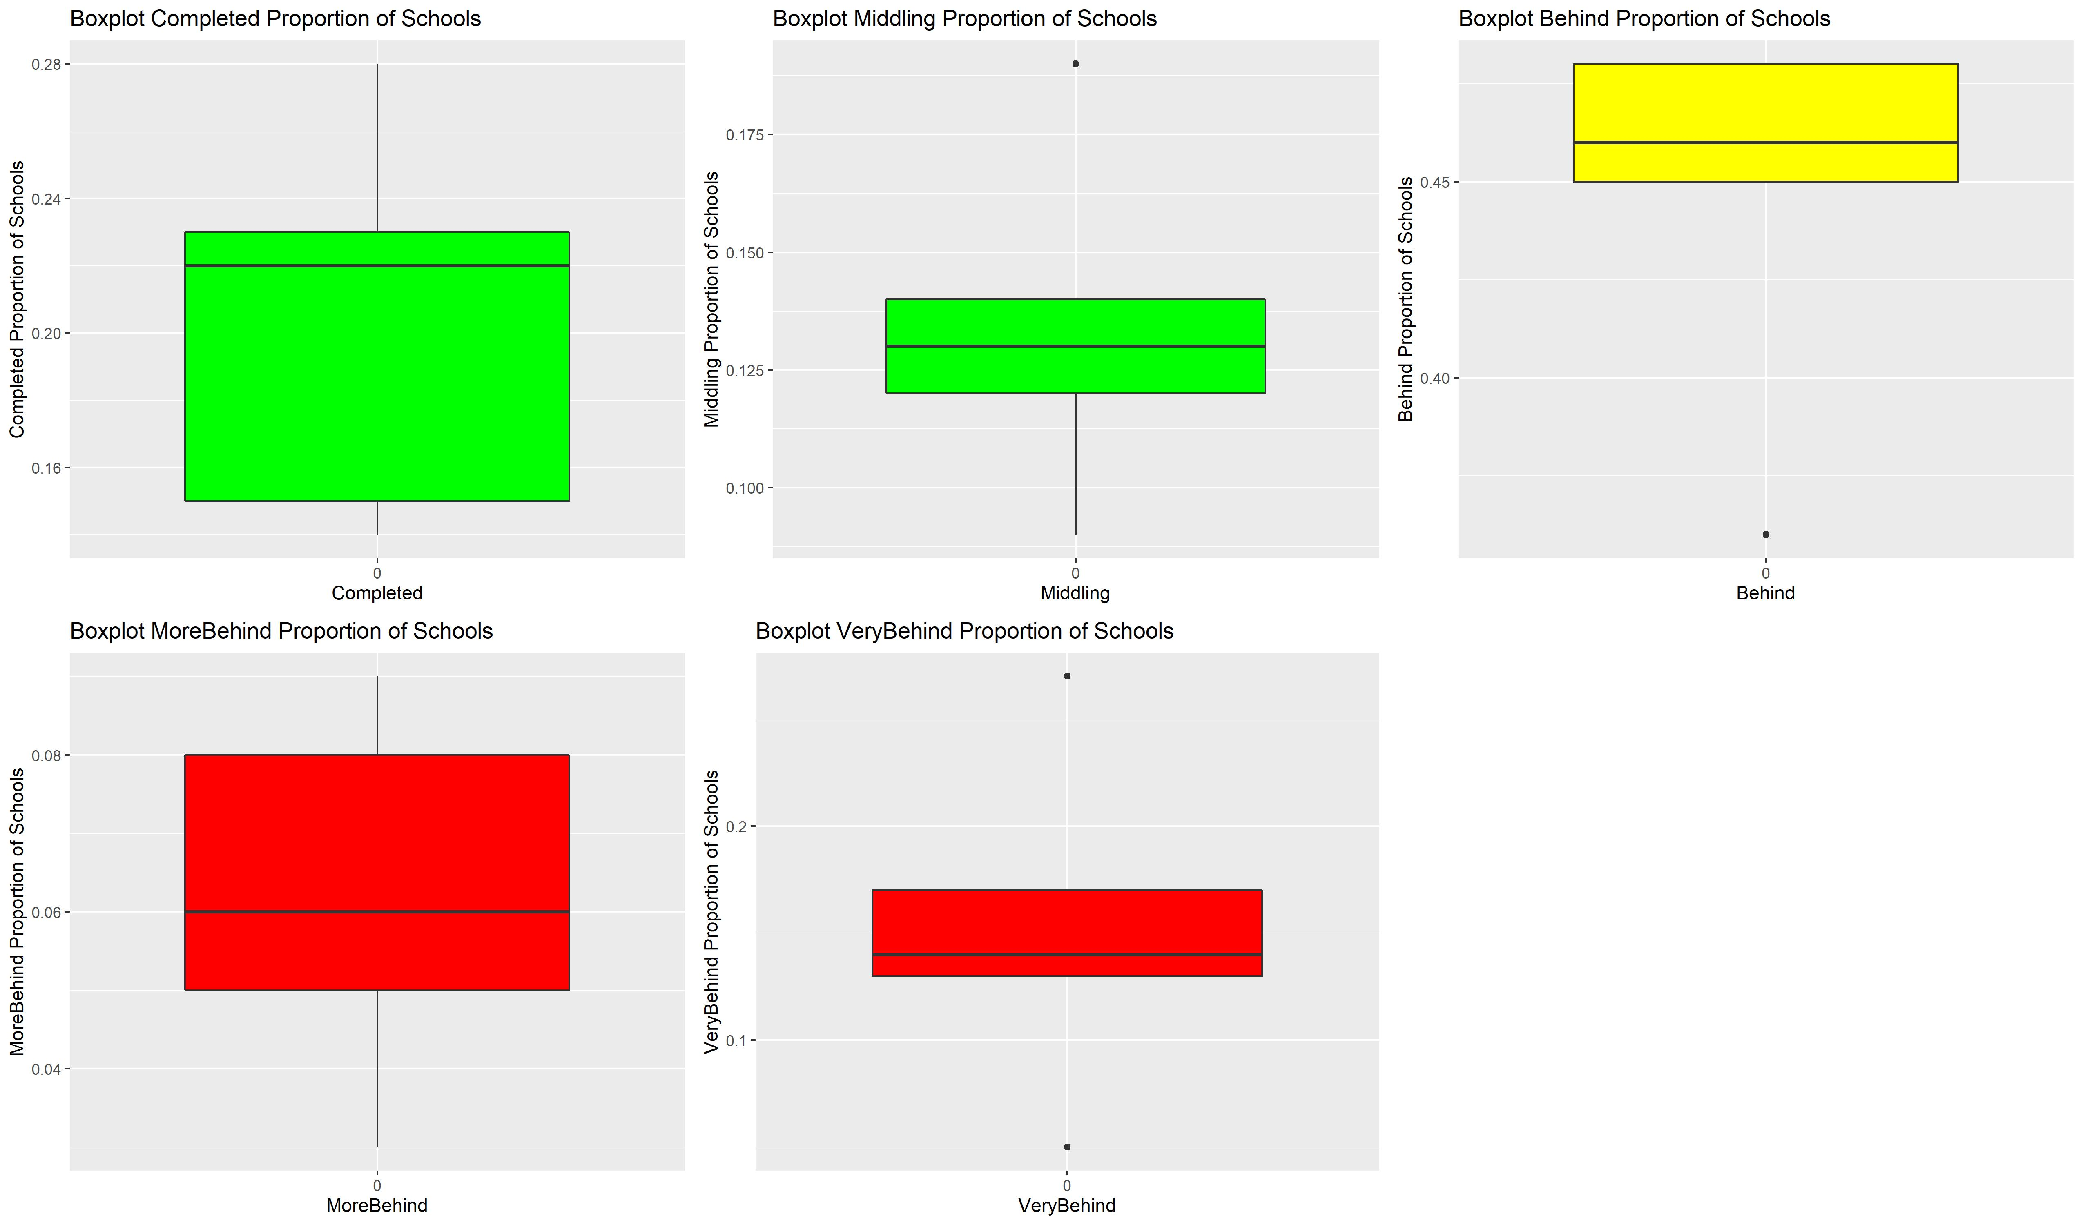

Conclusions
Based on proportion of students, shown in Graph 2.8.1 that visualizes how school ‘D’ has the highest proportion of its students at risk of not completing their lessons, while school ‘B’ has the lowest proportion;
The data can be used to rank these five school’s performances in relation to each other as:
- 1st Rank: School B
- 2nd Rank: School C
- 3rd Rank: School E
- 4th Rank: School A
- 5th Rank: School D

Keeping in mind however, this ranking is strictly based on proportion of students to the given school and does not represent the number of students who are impacted by these performance gaps directly. Assessing for overall impacts to student success rate of not completing the math lessons for the term would focus on school ‘A’ over all others. School ‘A’ has 60% of the overall student population, having just under 250 students at risk of not completing the course.

