Group 3:
- Ryan Timbrook
- Steve Skeels
- Tim Konze

Term: Winter, 2020
Date: 1/27/2020
Topic: Segmentation at Sticks Kebob Shop

Table of Contents
1 Introduction 3
1.1 Purpose 3
1.2 Scope 3
2 Results 4
2.1 Q1: How people choose a fast food restaurant 4
2.1.1 How do they choose - what's important 5
2.2 Q2: Customers & Motivation 5
2.2.1 Customers 5
2.2.2 Motivation 6
2.3 Q3: Survey Differences - Customers and Noncustomers 6
2.3.1 Use of Coupon Differences: 6
2.3.2 Business Profession Differences 7
2.4 Q4: Survey Questions to Identify Customer Segments 7
2.5 Q5: Number of Customer Segments 9
3 Appendix 11
3.1 Demographic Profile Table 11

Introduction

Purpose
Provide a recommendation for the location of the next Sticks Kebob Shop based on the segmentation analysis and the demographic profiles of the locations in table 6.1 Demographic Profile Table.

(Hint: Consider differences in the set restaurants visited for lunch/dinner by Sticks customers and noncustomers.)

Scope
Answer the following questions from the Sticks Kebob Data Spreadsheet:
- How do people choose a fast food restaurant to visit?
  - What is important: location, price, assortment, or cuisine?
- Who do you think are Sticks’ customers, and what are their motivations for visiting Sticks?
- What does the survey data tell us about differences between customers and noncustomers?
- What survey questions would you use to identify the customer segments?
- How many customer segments can you estimate from the survey data?
  - What are the profiles of the customer segments?
  - Which customer segments should Sticks target?

Results

Q1: How people choose a fast food restaurant
How do people choose a fast food restaurant to visit? And What is important: location, price, assortment, or cuisine?
Rating Scale:
1-Very Important, 2-Somewhat Important, 3-Indifferent, 4-Somewhat unimportant, 5-Not Important at all, 6-Don't know
Question ID Key Map:
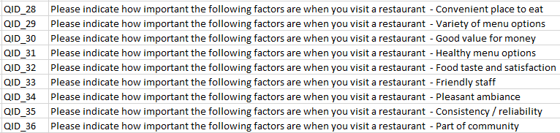
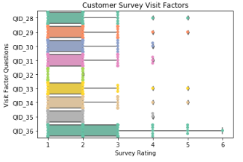 | 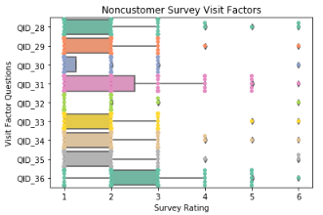
Median Customer Survey Visiting Factors:  QID_28 1.0  QID_29 2.0  QID_30 1.0  QID_31 1.0  QID_32 1.0  QID_33 2.0  QID_34 2.0  QID_35 1.0  QID_36 2.0  Average Customer Survey Visiting Factors:  QID_28 1.4895  QID_29 1.6862  QID_30 1.3333  QID_31 1.4762  QID_32 1.0691  QID_33 1.5979  QID_34 1.7513  QID_35 1.2751  QID_36 2.123 | Median Noncustomer Survey Visiting Factors:  QID_28 2.0  QID_29 2.0  QID_30 1.0  QID_31 2.0  QID_32 1.0  QID_33 1.0  QID_34 2.0  QID_35 1.0  QID_36 2.0  Average Noncustomer Survey Visiting Factors:  QID_28 1.7308  QID_29 1.6169  QID_30 1.3141  QID_31 2.0452  QID_32 1.1987  QID_33 1.5677  QID_34 1.7372  QID_35 1.4679  QID_36 2.375

How do they choose - what's important
Customers of Sticks Kebob, on average, say that convienence, variety, good value, taste and satisfaction, and consistency are very important to them when choosing a fast food restaurant.
Nocustomers of Stick Kebob, on average, say that good value, taste and satisfaction, a friendly staff, and consistency are very important to them when choosing a fast food restaurant.

Q2: Customers & Motivation
Who are Sticks customers, and what are their motivations for visiting Sticks?

Customers
Sticks Kebob's customer base is predominately composed of Business Professionals at 58% (114 or 195) and Educators at 22% (43 of 195), making up 80% of those customers surveyed by Sticks Kebob.
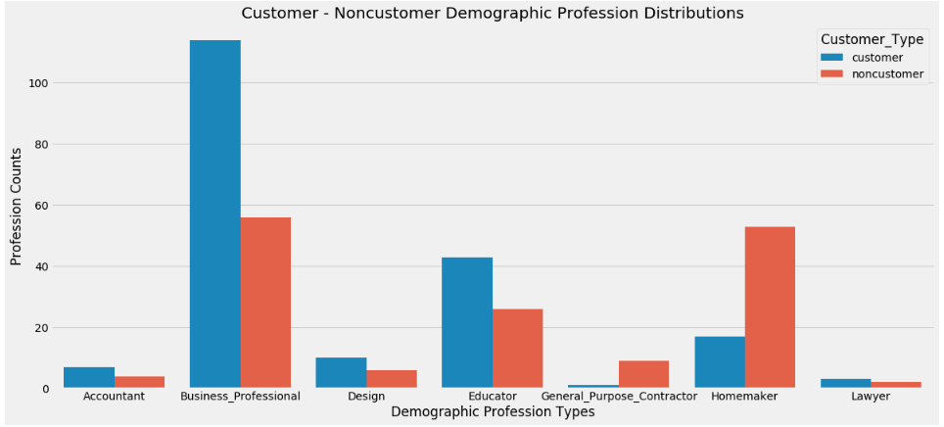
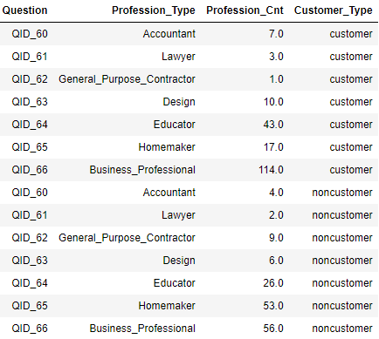

Motivation
Sticks Kebob's Business Professional customers tend to visit more frequently when it's an event, either a Sticks event or After work or sports event. Second to that they visit more frequently during the week for lunch.
Sticks Kebob's Education Professionals customers tend to visit more frequently when it's an event, either a Sticks event or after work or sports event. They visit least frequently during the weekends for lunch.
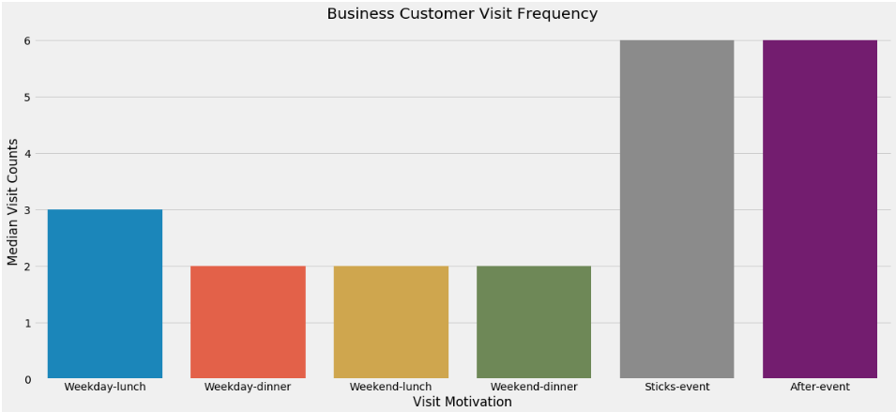
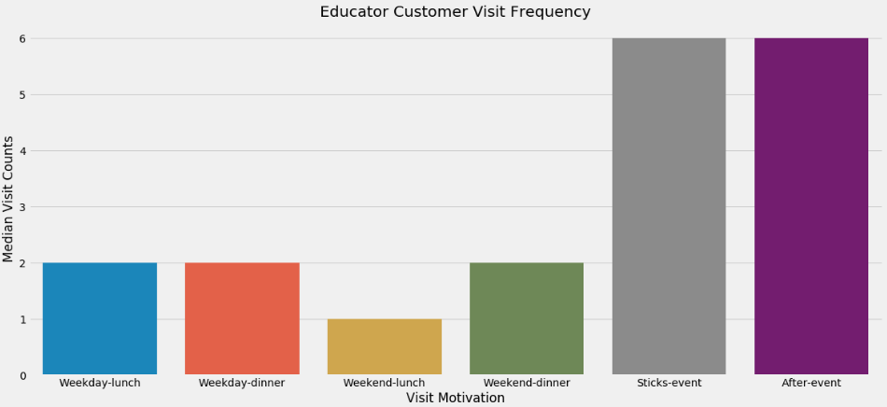
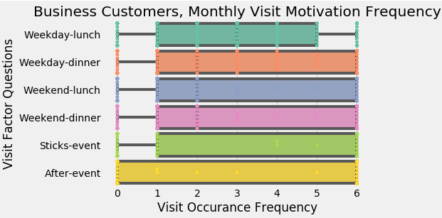
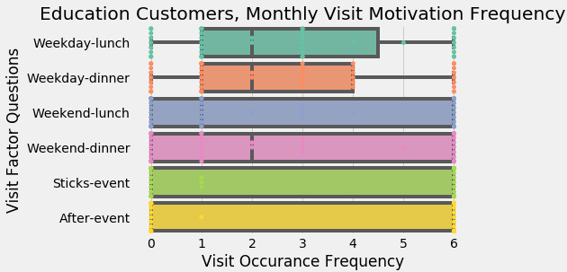

Q3: Survey Differences - Customers and Noncustomers
What does the survey data tell us about differences between customers and noncustomers?

Use of Coupon Differences:
Sticks Kebob's customers use coupons much more than their non-customers surveyed. Noteable coupon channels Sticks kebob should focus on for customer retention are: customer-loyalty at 4x that of noncustomers, store-receipts at 2x that of noncustomers, and social-daily-deals at 2.5x that of noncustomers.
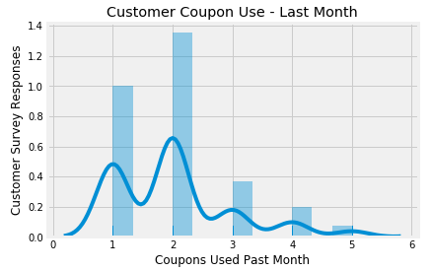
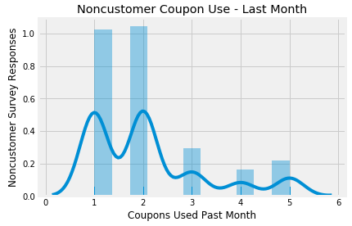

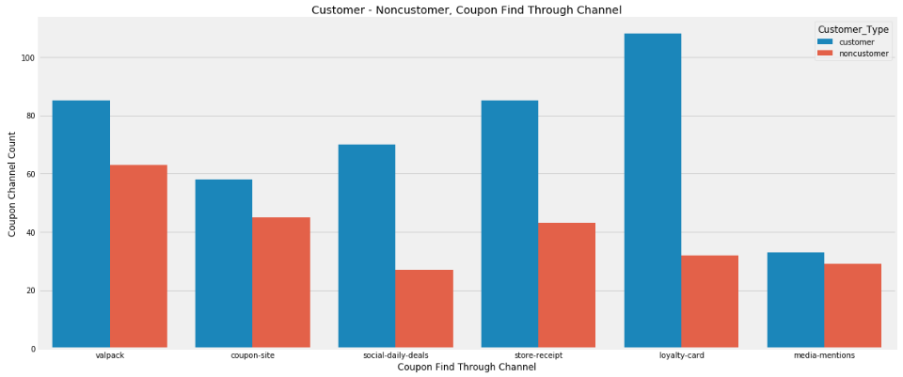
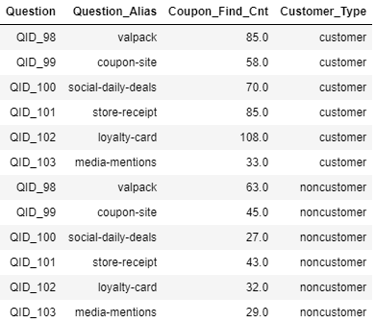

Business Profession Differences
Sticks Kebob's Business customers are 2x of noncustomers, and Educators are 1.5x of noncustomers.
Noncustomers Homemaker's are 2.5x of Sticks Kebobs Customers.

Q4: Survey Questions to Identify Customer Segments
What survey questions would you use to identify the customer segments?
Survey Questions:
- food_consumption_habbit
- visit_occasion
- visit_factors
- visit_compare
- demographic
- behavioral_profile
- behavioral_profile_activity
- coupons_savings
- food_consumption_habbit: (frequency count)
  - QID_2 - QID_6:
    - Make and eat lunch at home
    - Bring own lunch to work
    - Buy lunch at workplace (e.g., cafeteria)
    - Buy lunch at a restaurant / food court / food truck
    - Skipped lunch / ate a small snack item
- visit_occasion: (frequency count)
  - QID_21 - QID_26
    - Weekday lunch
    - Weekday dinner
    - Weekend lunch
    - Weekend dinner
    - Sticks event ( catering at work, food festival)
    - After school snack or after sports practice / event
- visit_compare (factor - rating)
  - QID_38 - QID_46
    - Convenient place to eat
    - Variety of menu options
    - Good value for money
    - Healthy menu options
    - Food taste and satisfaction
    - Friendly staff
    - Pleasant ambiance
    - Consistency / reliability
    - Part of community
- demographic: (factor - categorical)
  - QID_48 - QID_50
    - gender
    - age
    - average household income
  - QID_51 - QID_54
    - household type
    - children less than 12
    - children 12 - 17
    - children 18 and older
  - Profession: QID_60 - QID_66 (1 - 7)
    - Accountant
    - Lawyer
    - General purpose contractor
    - Design
    - Educator
    - Homemaker
    - Business professional
- behavioral_profile (factor - categorical)
  - QID_55 - QID_58
    - plan carefully
    - trouble controlling spending
    - important made locally
    - careful consider health benefitds
- behavioral_profile_active (factor - categorical)
  - QID_79 - QID_95
    - volunteer
    - tennis
    - swimming
    - skiing / snowboarding
    - running
    - hiking
    - golf
    - gardening
    - fishing
    - camping
    - bicycling
    - yoga
    - book club
    - eating out
    - attending local sports events
    - visting meseums
    - kids activities
- visit_factors
  - QID_28 - QID_36
    - convenience
    - variety
    - good value
    - healthy options
    - food taste and satisfaction
    - friendly staff
    - pleasant ambiance
    - consistency
    - part of community

Q5: Number of Customer Segments
How many customer segments can you estimate from the survey data?
  - What are the profiles of the customer segments?
  - Which customer segments should Sticks target?
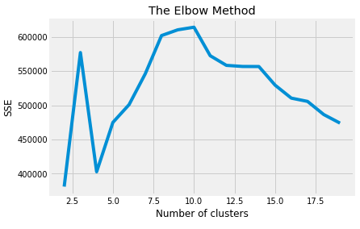
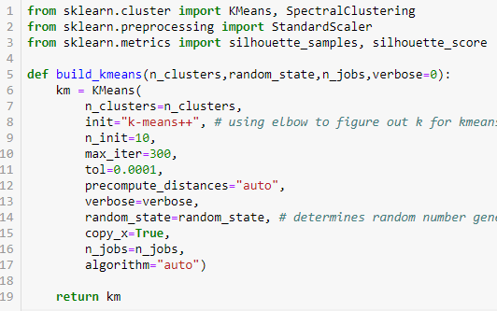

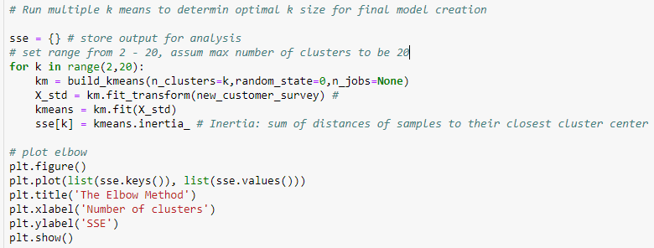

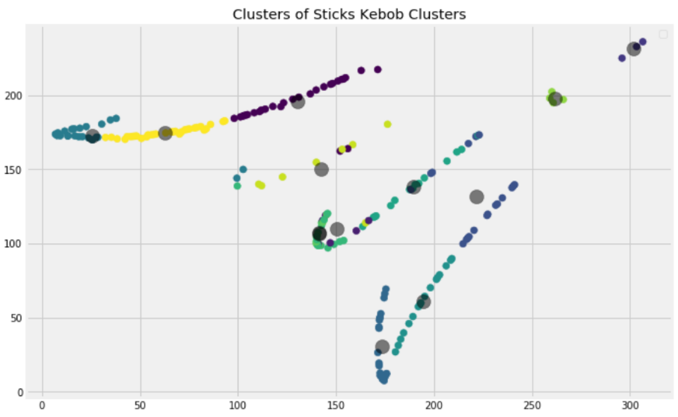

Estimated number of customer segments: 13
This group segmentation count comes from runnig an elbow test on the updated dataset.
Multiple k means test were ran to determin optimal k size referenced above for final model creation.

Customer segment profiles:
- Location C
- Brite Lites, Li'l City, Family Thrifts, Up-and-Comers, Upward Bound, White Picket Fences
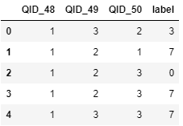
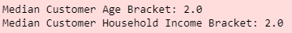

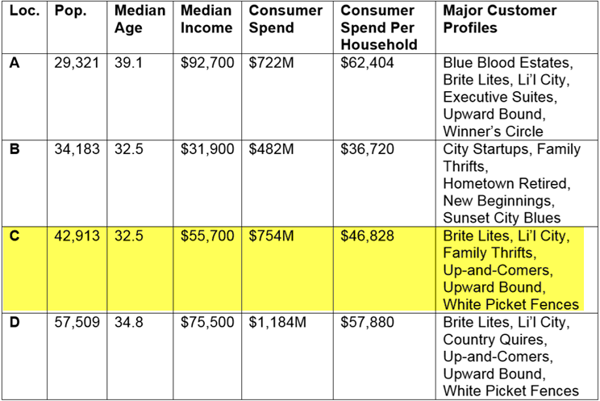

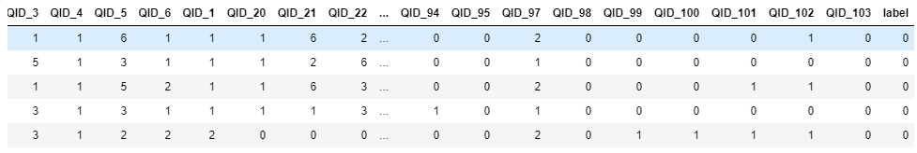

Appendix

Demographic Profile Table
