Ryan Timbrook

Data Science 350 – Homework Assignment 6

Assignment:

Probability of texting. – You are asked to compute the probability that the driver of a car is texting at a specific intersection. – Nationally the cumulative probability that a driver is texting is:

> P = 0.5, at x = 0.1

> P = 0.75 at x = 0.3

– You observe cars at a location three times and note the number of texting drivers:

1. 2 texting out of 20 drivers

2. 4 texting out of 20 drivers

3. 1 texting out of 20 drivers

> Given these data

– Compute the Beta prior, and report the coefficients

– Plot the prior, likelihood and posterior three times as you update your belief based on collecting more data

– Simulate the final posterior distribution and do the following:

> Plot the posterior with the 90% HDI shown

> Report the upper and lower limits of the 90% HDI

> Of the next hundred drivers what are the number of texting drivers in the 90% HDI?

> Are the drivers in this area better or worse that the national figures indicate?

Observations:

* As more observations occur and are added to the modal, the posterior distribution moves closer to the likelihood as expected. This is reflected in Table 1’s Bay’s Triplots graphs below.
* The final posterior distribution’s 90% HDI’s upper and lower limits are:
  + Lower Limits: **5%** 0.0589697266018973
  + Upper Limits: **95%** 0.192268807963088

These observations are reflected in Table 2 below.

* There are 17 drivers of the next 100 that are texting in the 90% HDI. This is reflected in Table 3.1 below.
* The drivers in this area appear to be on par with the national average indicated above. This is reflected in Table 3.2 below.

Table 1: Plots of the prior, likelihood and posterior for each observation

|  |  |  |
| --- | --- | --- |
| 1.1: Prior & 1st Posterior Observation | 1.2: Priors & 2nd Posterior Observations | 1.2: Priors & 3rd Posterior Observations |

Table 2: Simulation of the final posterior distribution, plotted at 90% HDI

|  |  |
| --- | --- |
| 2.1: Plot of posterior distribution with 90% HDI    Lower Limit: **5%** 0.0589697266018973  Upper Limit: **95%** 0.192268807963088 | 2.2: Model Test |

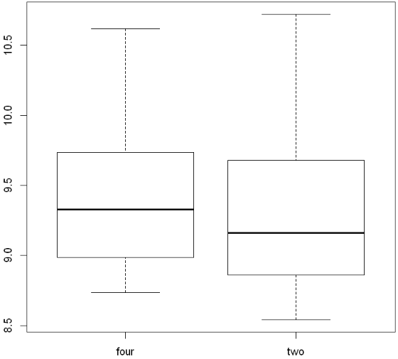Table 3: Next hundred drivers texting in the 90% HDI

|  |  |
| --- | --- |
| 3.1: Next 100 Drivers  17 drivers are texting in the 90% HDI | 3.2: National Average as prior and Next Hundred as posterior    These drivers appear to be in par with the national average |