PHASE 2 – LOGICAL DESIGN

By: Lucas Gullo, Geoffrey Splendorio, Randi Tinney

COMP 4410 Database Management

Mahmood Hossain

October 14, 2018

Relational Schema

**Entertainment (eid, title, release_date, genre, num_in_stock)**

* “eid” is a Primary Key
* “title” is NOT NULL
* “genre” is NOT NULL
* “num_in_stock” is NOT NULL

**Movies (eid, awards_won, sequal_id)**

* “eid” is a Primary Key
* “eid” is a Foreign Key to Entertainment (ON DELETE/UPDATE CASCADE)
* “sequal_id” Foreign Key to Movies

**Games (eid, platform, version)**

* “eid” is a Primary Key
* “eid” is a Foreign Key to Entertainment (ON DELETE/UPDATE CASCADE)
* “platform” is NOT NULL
* “version” is NOT NULL

**Rent_History (rid, eid, uid, time_rented, time_returned)**

* “rid” is a Primary Key
* “eid” is a Foreign Key to Entertainment
* “uid” is a Foreign Key to User
* “time_rented” is NOT NULL

**Users (email, name, pass, phone, aid, is_admin, level_id)**

* “email” is PRIMARY KEY
* “level_id” is a FOREIGN KEY to Sub_Plan Table (NOT NULL)
* “aid” is a FOREIGN KEY to Address Table (NOT NULL)
* “name” is NOT NULL
* “pass” is NOT NULL

**Sub_Plan (level_id, total_quota)**

* “level_id” is a Primary Key
* “total_quota” is NOT NULL

**Cast (cid, name, aid, is_director)**

* “cid” is a Primary Key
* “name” is NOT NULL
* “aid” is a Foreign Key to Address Table (NOT NULL)
* “is_director” is NOT NULL

**Worked_In (cid, eid)**

* “cid” and “eid” make a composite Primary Key
* “cid” is a Foreign Key to Cast (NOT NULL) (ON DELETE/UPDATE CASCADE)
* “eid” is a Foreign Key to Movies (NOT NULL) (ON DELETE/UPDATE CASCADE)

**Address (aid, state, city, street, zip)**

* “aid” is a Primary Key
* “state” is NOT NULL
* “city” is NOT NULL
* “street” is NOT NULL
* “zip” is NOT NULL

Updated ER Diagram

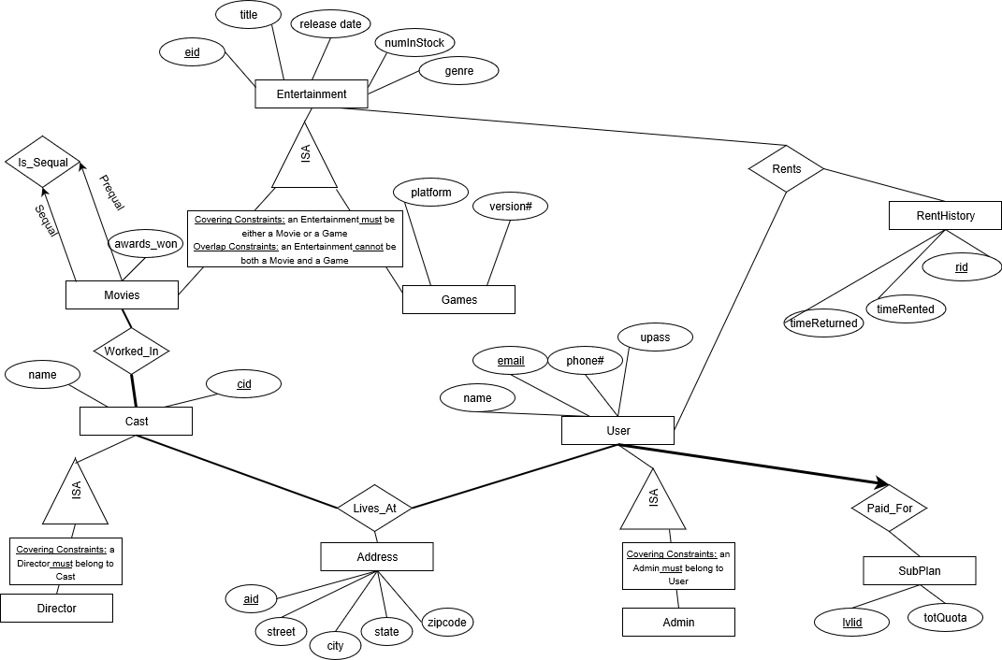

SQL Queries for Table Creations

|  |  |
| --- | --- |
| CREATE TABLE Entertainment( | eid INTEGER PRIMARY KEY, |
|  | title VARCHAR(64) NOT NULL, |
|  | release_date TIMESTAMP, |
|  | genre VARCHAR(64) NOT NULL, |
|  | num_in_stock INTEGER NOT NULL); |
|  |  |
|  |  |
|  |  |
| CREATE TABLE Address( | aid INTEGER PRIMARY KEY, |
|  | state VARCHAR(2) NOT NULL, |
|  | city VARCHAR(32) NOT NULL, |
|  | street VARCHAR(64) NOT NULL, |
|  | zip INTEGER NOT NULL); |
|  |  |
|  |  |
|  |  |
| CREATE TABLE Sub_Plan( | level_id INTEGER PRIMARY KEY, |
|  | total_quota INTEGER NOT NULL); |
|  |  |
|  |  |
|  |  |
| CREATE TABLE Movies( | eid INTEGER PRIMARY KEY, |
|  | awards_won INTEGER, |
|  | sequal_id INTEGER, |
|  | FOREIGN KEY (eid) REFERENCES Entertainment(eid) ON DELETE CASCADE); |
|  |  |
|  |  |
|  |  |
| CREATE TABLE Games( | eid INTEGER PRIMARY KEY, |
|  | platform VARCHAR(64) NOT NULL, |
|  | version FLOAT, |
|  | FOREIGN KEY (eid) REFERENCES Entertainment(eid) ON DELETE CASCADE); |
|  |  |
|  |  |
|  |  |
| CREATE TABLE Users( | user_email VARCHAR(128) PRIMARY KEY, |
|  | name VARCHAR(32) NOT NULL, |
|  | pass VARCHAR(32) NOT NULL, |
|  | phone INTEGER, |
|  | aid INTEGER NOT NULL, |
|  | is_admin BOOLEAN NOT NULL, |
|  | level_id INTEGER NOT NULL, |
|  | FOREIGN KEY (aid) REFERENCES Address(aid), |
|  | FOREIGN KEY (level_id) REFERENCES Sub_Plan(level_id) ); |
|  |  |
|  |  |
|  |  |
|  |  |
|  |  |
|  |  |
|  |  |
|  |  |
|  |  |
|  |  |
|  |  |
|  |  |
|  |  |
|  |  |
| CREATE TABLE Rent_History( | rid INTEGER PRIMARY KEY, |
|  | eid INTEGER NOT NULL, |
|  | user_email VARCHAR(128) NOT NULL, |
|  | time_rented TIMESTAMP NOT NULL, |
|  | time_returned TIMESTAMP, |
|  | FOREIGN KEY (eid) REFERENCES Entertainment(eid) ON DELETE NO ACTION, |
|  | FOREIGN KEY (user_email) REFERENCES Users(user_email) ON DELETE NO ACTION); |
|  |  |
|  |  |
|  |  |
| CREATE TABLE Cast_Member( | cid INTEGER PRIMARY KEY, |
|  | name VARCHAR(32) NOT NULL, |
|  | aid INTEGER NOT NULL, |
|  | is_director BOOLEAN NOT NULL, |
|  | FOREIGN KEY (aid) REFERENCES Address(aid) ); |
|  |  |
|  |  |
|  |  |
| CREATE TABLE Worked_In( | cid INTEGER, |
|  | eid INTEGER, |
|  | PRIMARY KEY(cid,eid), |
|  | FOREIGN KEY (cid) REFERENCES Cast_Member(cid) ON DELETE CASCADE, |
|  | FOREIGN KEY (eid) REFERENCES Movies(eid) ON DELETE CASCADE); |
|  |  |

Screenshot of Successful Table Creations

