Understanding Data Science Salaries

Executive Summary
The aim of this analysis is to utilize the job posting information aggregated by the website indeed.com to determine appropriate salaries for a Data Scientist. Salary, job description, job title, and company name were scraped from indeed.com for various locations across the United States. We found that location wast the strongest indicator of the salary, in particular cost of living index. Other important features were words like ‘python’, ‘senior’, and ‘manager’ in the job descriptions and titles. When determining what salary a person should have the most important factor to consider is what the cost of living in that region is, and after taking that into account, consider what key words the position entails.

Introduction
Our company is growing rapidly and there is a growing need for qualified data scientists. We want to be able to create job postings that are competitive with other data science jobs across the country. Additionally, we don not want to over pay for talent. The intent of this report is the guide the job posting creation process.

Methods
Information from the indeed.com was scraped using a python script that utilized the Beautiful Soup package. We creating a list of over 60 cities to query the indeed.com site. We queried the site for job postings including the key phrase ‘Data Science’ as well as had salaries of over $20,000. Many of the job postings did not have salaries listed, these results were cleaned from our data set and only postings with valid yearly salaries were used to train our model.
Our model was a Random Forest classifier that attempted to predict whether a salary would be above or below the national median. We created features that searched for key words in the description and job titles, as well as dummy variables for various search locations. We cross validated our model to ensure we had a valid predictor, and looked at the accuracy and auc-roc score to see how strong of a predictor we had. We then looked at the feature importances of the resulting model.

Results
Our model was able to predict if a job posting was offering a salary above or below the median salary for the nation with an accuracy of 0.71. Giving that we chose to predict above or below the median, our base line accuracy was 0.5 and 0.21 improvement. Below is the confusion matrix resulting from our testing sample.
 | Actual Above | Actual Below
Predicted Above | 76 | 25
Predicted Below | 33 | 69
Table 1: Confusion Matrix of Classifying against the Median Salary

Discussion
The accuracy of our model is promising. We were able to out perform the baseline score meaning that we have a statistically significant way of predicting what a salary should be compared to the national median. This can be utilized in a number of ways. For one, we can continue to add key words to our model to try to improve accuracy, but more importantly determine their impact on predicting salary. We can work on creating a pipeline that allows a job description created by our staffing team to be fed into our model and determine an approximate salary for that description to be competitive nationally.
Secondly, we can use our model to predict which locations across the country have the most amount of jobs that are below/above the national median. As mentioned above most job postings on indeed.com do not have salaries posted, but with our model we can predict if a job is above or below the national median. From there we can look at major cities across the US that have a disproportional amount jobs below the national median. There is a plot in the appendix of this report visualizing this relationship. From that, we can see New York City as a place to potentially target recruitment of underpaid Data Scientist.

Conclusion
We successfully were able to predict whether a salary for a position should be above or below the national median. The accuracy of our model could be improved by adding additional features for various words, but our current model is sufficient enough to make high level conclusions. We can write job descriptions for our open positions and then use our model to determine what kind of salary we should offer with the job. We can also look at other job postings across the country and attempt to recruit new data scientists from regions that appear to be under represented.

Appendix
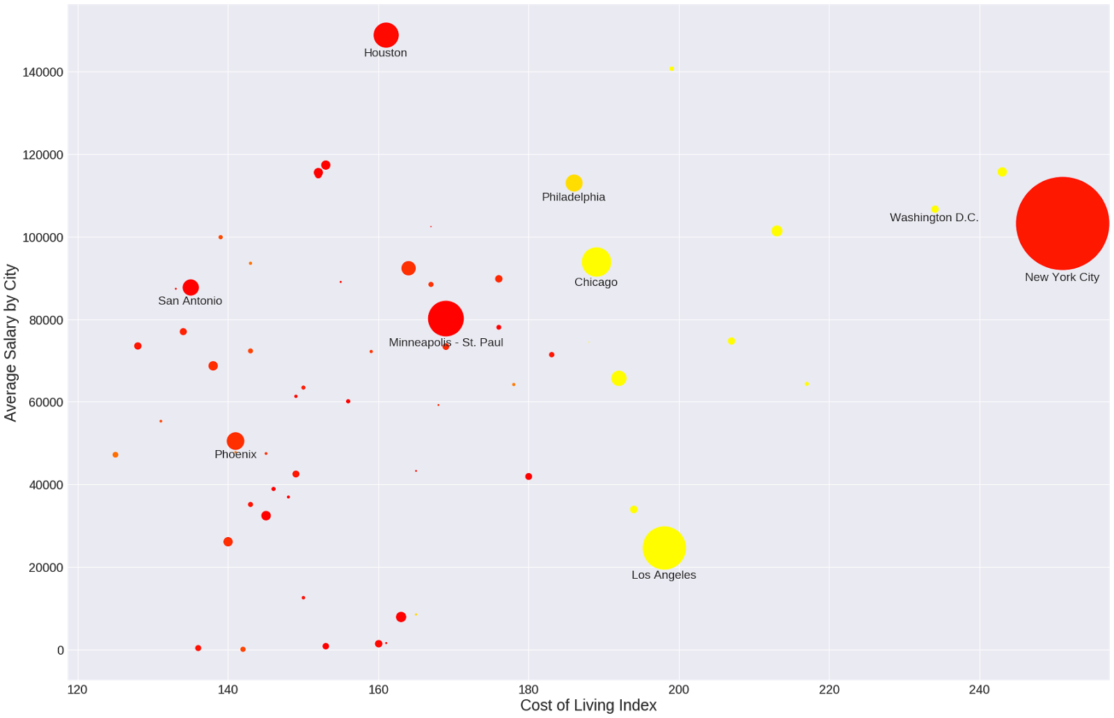Illustration 1: This plot visualizes the distribution of jobs in a city by color and shows the average salary of jobs in that city vs the cost of living. Red means most jobs are below the median, and yellow means most jobs are above the median.

