Operating System
4th Semester, Academic Year 2025
Date:16-03-2025
Name: Rithvik Rajesh Matta | SRN:PES2UG23CS485 | Section  H

Mini Project-Jackfruit Problem

Part 1:The first part of the project involves creating and inserting (load and unload) a module into the Linux kernel. The contents of the kernel log buffer are checked using dmesg to ensure everything is working properly.
#include <linux/init.h>
#include <linux/kernel.h>
#include <linux/module.h>

static int __init simple2_init(void)
{
printk(KERN_INFO "Loading Module simple2\n");
return 0;
}

static void __exit simple2_exit(void)
{
printk(KERN_INFO "Removing Module simple2\n");
}

module_init(simple2_init);
module_exit(simple2_exit);

MODULE_LICENSE("GPL");
MODULE_DESCRIPTION("Simple Kernel Module 2");
MODULE_AUTHOR("SGG");

MAKEFILE:
obj-m += simple2.o

all:
make -C /lib/modules/$(shell uname -r)/build M=$(PWD) modules

clean:
make -C /lib/modules/$(shell uname -r)/build M=$(PWD) clean

OUTPUT:
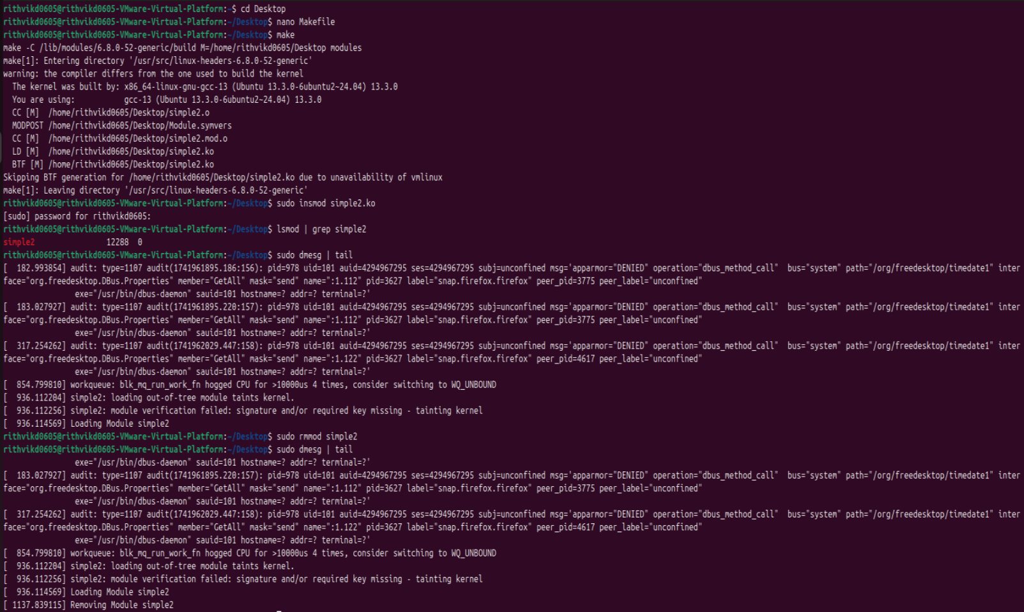

PART 2:
The second part of this project consists of modifying the kernel module structure. In the module entry point, create a linked list containing five struct birthday elements. Traverse the linked list and output its contents to the kernel log buffer. Invoke the dmesg command to ensure the list is properly constructed once the kernel module has been loaded. In the module exit point, delete the elements from the linked list and return the free memory back to the kernel. Again, invoke the dmesg command to check that the list has been removed once the kernel module has been unloaded.
CODE:
#include <linux/init.h>
#include <linux/kernel.h>
#include <linux/module.h>
#include <linux/list.h>
#include <linux/slab.h>

struct d {
int y;
int z;
int x;
struct list_head f;
};

static LIST_HEAD(e);

int simple_init(void)
{
struct d *q;
int i;

printk(KERN_INFO "Loading Module: Creating Linked List\n");

for (i = 0; i < 5; i++) {
q = kmalloc(sizeof(*q), GFP_KERNEL);
if (!q) {
printk(KERN_ERR "Memory allocation failed\n");
return -ENOMEM;
}

q->y = i + 1;
q->z = i + 2;
q->x = i + 3;

INIT_LIST_HEAD(&q->f);
list_add_tail(&q->f, &e);

printk(KERN_INFO "Added: %d-%d-%d\n", q->y, q->z, q->x);
}

printk(KERN_INFO "Traversing the linked list:\n");

struct d *u;

list_for_each_entry(u, &e, f) {
printk(KERN_INFO "Birthday: %d-%d-%d\n", u->y, u->z, u->x);
}

return 0;
}

void h(void)
{
struct d *u, *next;

printk(KERN_INFO "Removing Module: Deleting Linked List\n");

list_for_each_entry_safe(u, next, &e, f) {
printk(KERN_INFO "Removing: %d-%d-%d\n", u->y, u->z, u->x);
list_del(&u->f);
kfree(u);
}

printk(KERN_INFO "Linked List Successfully Removed\n");
}

module_init(simple_init);
module_exit(h);

MODULE_LICENSE("GPL");
MODULE_DESCRIPTION("Kernel Module with Linked List");
MODULE_AUTHOR("SGG");
MAKEFILE:
obj-m += birthday_list.o

all:
make -C /lib/modules/$(shell uname -r)/build M=$(PWD) modules

clean:
make -C /lib/modules/$(shell uname -r)/build M=$(PWD) clean
OUTPUT:
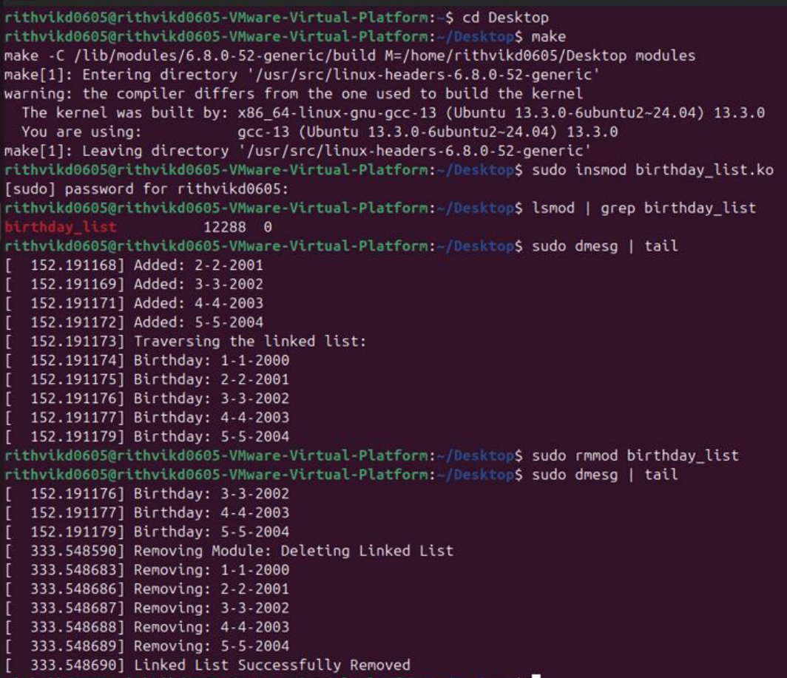

If found plagiarized, I will abide with the disciplinary action of the University.
Signature: Rithvik
Name: Rithvik Rajesh Matta
SRN: PES2UG23CS485
Section: 4H
Date:16/03/2025

