
B.TECH. (CSE)
SEMESTER: IV SECTION: H
UE23CS252B – COMPUTER NETWORKS LABORATORY PROJECT REPORT ON
NETWORK ATTACK & INTRUSION DETECTION SYSTEM
SUBMITTED BY
NAME SRN
1. Rithvik Rajesh Matta PES2UG23CS485
2. Rohan J Jogi PES2UG23CS489
JANUARY – MAY 2025
DEPARTMENT OF COMPUTER SCIENCE & ENGINEERING
ELECTRONIC CITY CAMPUS,
BENGALURU – 560100, KARNATAKA, INDIA
Date: 24-04-2025
Problem Statement: Multiuser chat room with raw sockets

Abstract
This project is a multi-room chat server with encrypted communication via SSL. The system consists of a server and client components that enable secure text-based communication. Key features include:
- Encrypted connections using SSL certificates for secure communication
- Multiple chat rooms with the ability to create new rooms and switch between them
- User management with admin privileges (kick, ban, mute users)
- Emoji parsing to convert text codes into actual emoji characters
- Message logging to a SQLite database for chat history
- Command system with various utilities (/help, /join, /list, etc.)
- Proper error handling and connection management
- Thread-based client handling for concurrent connections
- System notifications for user events (joining/leaving)
- Simple database utility for viewing chat logs
The architecture follows a client-server model where each client connection is handled in a separate thread, allowing multiple users to communicate simultaneously across different chat rooms.

File Heirarchy
chatroom_project/
├── __pycache__/
├── database/
│ └── chat_logs.db
├── ssl_cert/
│ ├── server.crt
│ ├── server.csr
│ └── server.key
├── chatroom.py
├── client.py
├── db.py
└── server.py

Code:

server.py
import socket
import threading
import ssl
import sqlite3
import time
import os
from chatroom import ChatRoom

ADMIN_USERS = ["admin"] # Example: hardcoded admin username
EMOJIS = {":smile:": "ðŸ˜Š", ":sad:": "ðŸ˜ž", ":laugh:": "ðŸ˜‚", ":heart:": "â¤ï¸", ":thumbsup:": "ðŸ‘"}

class ChatServer:
def __init__(self, host='10.1.5.6', port=5555):
self.host = host
self.port = port
self.server_socket = None
self.running = False

# Create SSL context
self.context = ssl.create_default_context(ssl.Purpose.CLIENT_AUTH)
self.context.load_cert_chain(certfile="ssl_cert/server.crt", keyfile="ssl_cert/server.key")

self.chatrooms = {}
self.client_usernames = {} # socket -> username
self.client_chatroom = {} # socket -> chatroom
self.muted_users = set() # usernames
self.banned_users = set() # usernames
self.typing_users = set() # currently typing users
self.clients = [] # all connected clients

# Make sure database directory exists
os.makedirs("database", exist_ok=True)

self.conn = sqlite3.connect("database/chat_logs.db", check_same_thread=False)
self.cursor = self.conn.cursor()
self.cursor.execute("""
CREATE TABLE IF NOT EXISTS logs (
username TEXT, room TEXT, message TEXT, timestamp DATETIME DEFAULT CURRENT_TIMESTAMP
)
""")
self.conn.commit()

def initialize_socket(self):
# Create a new socket
self.server_socket = socket.socket(socket.AF_INET, socket.SOCK_STREAM)
self.server_socket.setsockopt(socket.SOL_SOCKET, socket.SO_REUSEADDR, 1)

# Wrap with SSL
self.server_socket = self.context.wrap_socket(self.server_socket, server_side=True)

def start_server(self):
# Initialize default rooms
for name in ["general", "tech", "fun"]:
self.chatrooms[name] = ChatRoom(name)

max_retries = 5
retry_count = 0
retry_delay = 2 # seconds

while retry_count < max_retries:
try:
self.initialize_socket()
self.server_socket.bind((self.host, self.port))
self.server_socket.listen(5)
print(f"Server started on {self.host}:{self.port}")
self.running = True
break
except socket.error as e:
if e.errno == 98: # Address already in use
print(f"Port {self.port} is already in use. Retrying in {retry_delay} seconds...")
retry_count += 1
time.sleep(retry_delay)

# Try with a different port if needed
if retry_count >= 3:
self.port += 1
print(f"Trying with port {self.port}")
else:
print(f"Error binding socket: {e}")
break

if not self.running:
print("Failed to start server after multiple attempts")
return

self.accept_connections()

def accept_connections(self):
"""Handle incoming connections in a loop"""
while self.running:
try:
client_socket, addr = self.server_socket.accept()
print(f"[LOG] Connection from {addr}")
self.clients.append(client_socket)
client_thread = threading.Thread(target=self.handle_client, args=(client_socket,))
client_thread.daemon = True
client_thread.start()
except Exception as e:
if self.running: # Only show error if we're supposed to be running
print(f"Error accepting connection: {e}")

def handle_client(self, client_socket):
"""Handle a single client connection"""
username = None
try:
client_socket.send(b"Enter your username: ")
username = client_socket.recv(1024).decode().strip()

if not username:
client_socket.send(b"Invalid username. Disconnecting.\n")
return

if username in self.banned_users:
client_socket.send(b"You are banned from this server.\n")
return

self.client_usernames[client_socket] = username

welcome = f"\n[Welcome {username}]\nYou have joined the chatroom!\nType /help for commands.\n"
client_socket.send(welcome.encode())
self.join_chatroom("general", client_socket)

# Notify everyone that a new user has joined
self.chatrooms["general"].broadcast(f"[System] {username} has joined the server!", sender_socket=client_socket)

while True:
try:
msg = client_socket.recv(1024).decode().strip()
if not msg:
break

if msg.startswith("/"):
if msg.lower() == "/quit":
client_socket.send(b"Goodbye!\n")
break
self.handle_command(msg, client_socket)
else:
username = self.client_usernames[client_socket]
if username in self.muted_users:
client_socket.send(b"You are muted and cannot send messages.\n")
continue

room = self.client_chatroom[client_socket].name
message = self.parse_emoji(f"[User: {username}] {msg}")
self.client_chatroom[client_socket].broadcast(message, sender_socket=client_socket)

# Log the message to database
self.cursor.execute("INSERT INTO logs (username, room, message) VALUES (?, ?, ?)",
(username, room, msg)) # Store original message, not the emoji-parsed one
self.conn.commit()
except ConnectionResetError:
print(f"[LOG] Connection reset by {username}")
break
except Exception as e:
print(f"Error receiving message from {username}: {e}")
break
except Exception as e:
print(f"Error handling client: {e}")
finally:
self.disconnect_client(client_socket)

def handle_command(self, msg, client_socket):
cmd = msg.split(" ")
username = self.client_usernames[client_socket]
current_room = self.client_chatroom.get(client_socket)

if cmd[0] == "/help":
help_msg = """
Available commands:
/help Show this message
/quit Exit chat
/join <room> Join existing room
/create <room> Create and join a new room
/list List users in your room
/rooms List all available rooms
/kick <username> (Admin) Kick a user
/ban <username> (Admin) Ban a user
/mute <username> (Admin) Mute a user
/unmute <username> (Admin) Unmute a user
"""
client_socket.send(help_msg.encode())

elif cmd[0] == "/quit":
# This will be handled in the main loop
pass

elif cmd[0] == "/create" and len(cmd) == 2:
roomname = cmd[1]
if roomname not in self.chatrooms:
self.chatrooms[roomname] = ChatRoom(roomname)
client_socket.send(f"Room '{roomname}' created.\n".encode())
self.join_chatroom(roomname, client_socket)

elif cmd[0] == "/join" and len(cmd) == 2:
roomname = cmd[1]
if roomname in self.chatrooms:
self.join_chatroom(roomname, client_socket)
else:
client_socket.send(f"Room '{roomname}' does not exist. Use /create {roomname} to create it.\n".encode())

elif cmd[0] == "/list":
if current_room:
users = current_room.list_users()
client_socket.send(f"Users in {current_room.name}: {', '.join(users)}\n".encode())
else:
client_socket.send(b"You are not in any room.\n")

elif cmd[0] == "/rooms":
rooms = ", ".join(self.chatrooms.keys())
client_socket.send(f"Available rooms: {rooms}\n".encode())

elif cmd[0] == "/kick" and len(cmd) == 2:
if username in ADMIN_USERS:
target = cmd[1]
self.kick_user(target, reason="Kicked by admin")
client_socket.send(f"User {target} kicked.\n".encode())
else:
client_socket.send(b"Permission denied. Admin privileges required.\n")

elif cmd[0] == "/ban" and len(cmd) == 2:
if username in ADMIN_USERS:
target = cmd[1]
self.ban_user(target)
client_socket.send(f"User {target} banned.\n".encode())
else:
client_socket.send(b"Permission denied. Admin privileges required.\n")

elif cmd[0] == "/mute" and len(cmd) == 2:
if username in ADMIN_USERS:
self.muted_users.add(cmd[1])
client_socket.send(f"User {cmd[1]} muted.\n".encode())
else:
client_socket.send(b"Permission denied. Admin privileges required.\n")

elif cmd[0] == "/unmute" and len(cmd) == 2:
if username in ADMIN_USERS:
if cmd[1] in self.muted_users:
self.muted_users.discard(cmd[1])
client_socket.send(f"User {cmd[1]} unmuted.\n".encode())
else:
client_socket.send(f"User {cmd[1]} is not muted.\n".encode())
else:
client_socket.send(b"Permission denied. Admin privileges required.\n")

else:
client_socket.send(b"Invalid command. Type /help for available commands.\n")

def kick_user(self, target_username, reason="You have been kicked from the server."):
"""Kick a user from the server"""
for sock, name in list(self.client_usernames.items()):
if name == target_username:
sock.send(f"{reason}\n".encode())
self.disconnect_client(sock)
return True
return False

def ban_user(self, target_username):
"""Ban a user from the server"""
self.banned_users.add(target_username)
return self.kick_user(target_username, reason="You have been banned from the server.")

def join_chatroom(self, roomname, client_socket):
"""Join a user to a chatroom"""
current = self.client_chatroom.get(client_socket)
username = self.client_usernames.get(client_socket, "Unknown")

if current:
current.broadcast(f"[System] {username} left room '{current.name}'.", sender_socket=None)
current.remove_client(client_socket)

self.chatrooms[roomname].add_client(client_socket)
self.client_chatroom[client_socket] = self.chatrooms[roomname]
client_socket.send(f"You joined room '{roomname}'.\n".encode())

def disconnect_client(self, client_socket):
"""Handle client disconnection"""
try:
username = self.client_usernames.get(client_socket, "Unknown")
print(f"[LOG] {username} disconnected")

# Remove from chatroom
room = self.client_chatroom.get(client_socket)
if room:
room.remove_client(client_socket)
room.broadcast(f"[System] {username} left the chat.")

# Clean up dictionaries
self.client_usernames.pop(client_socket, None)
self.client_chatroom.pop(client_socket, None)

if client_socket in self.clients:
self.clients.remove(client_socket)

# Close socket
client_socket.close()
except Exception as e:
print(f"Error during client disconnect: {e}")

def parse_emoji(self, message):
"""Replace emoji codes with actual emojis"""
for emoji_code, emoji in EMOJIS.items():
message = message.replace(emoji_code, emoji)
return message

def shutdown(self):
"""Shut down the server properly"""
self.running = False

# Notify and disconnect all clients
for client in list(self.clients):
try:
client.send(b"Server is shutting down. Goodbye!\n")
client.close()
except:
pass

# Close server socket
if self.server_socket:
self.server_socket.close()

# Close database connection
self.conn.close()
print("Server shut down.")

if __name__ == "__main__":
try:
server = ChatServer()
server.start_server()
except KeyboardInterrupt:
print("\nShutting down server...")
server.shutdown()
except Exception as e:
print(f"Fatal error: {e}")

client.py
import socket
import ssl
import threading
import time
import sys

def receive_messages(client_socket):
"""Continuously receive and display messages from the server"""
try:
buffer = ""
while True:
try:
data = client_socket.recv(1024).decode('utf-8')
if not data:
print("Server closed the connection.")
break

buffer += data

# Process complete messages (in case we get multiple at once)
lines = buffer.split('\n')
# Keep the last line if it's incomplete
buffer = lines.pop() if lines and not data.endswith('\n') else ""

# Print each complete line
for line in lines:
if line.strip(): # Only print non-empty lines
print(line)

except ssl.SSLError as e:
if e.errno == ssl.SSL_ERROR_WANT_READ:
# Non-blocking SSL socket needs more data, just continue
continue
else:
print(f"SSL Error: {e}")
break
except Exception as e:
print(f"Error in receive: {e}")
break
except Exception as e:
print(f"Receive thread error: {e}")
finally:
print("Disconnected from server")

def start_client():
"""Connect to the server and handle user input"""
client_socket = None
try:
# Create socket
client_socket = socket.socket(socket.AF_INET, socket.SOCK_STREAM)

# Connect first, then wrap with SSL
print("Connecting to server...")
client_socket.connect(('10.1.5.6', 5555))

# Set up SSL context
context = ssl.create_default_context()
context.check_hostname = False
context.verify_mode = ssl.CERT_NONE # For development only, not secure for production

# Wrap the socket with SSL
client_socket = context.wrap_socket(client_socket, server_hostname="10.1.5.6")
print("Connected to server.")

# Handle initial username prompt
username_prompt = client_socket.recv(1024).decode('utf-8')
username = input(username_prompt)
client_socket.send(username.encode('utf-8'))

# Start the receive thread
receive_thread = threading.Thread(target=receive_messages, args=(client_socket,))
receive_thread.daemon = True
receive_thread.start()

print("\nStart typing messages (type /quit to exit):")
while True:
try:
message = input()
if message.lower() == "/quit":
client_socket.send(message.encode('utf-8'))
print("Goodbye!")
time.sleep(1) # Give time for server to process quit command
break
else:
client_socket.send(message.encode('utf-8'))
except BrokenPipeError:
print("Connection to server lost.")
break
except ConnectionResetError:
print("Connection reset by server.")
break
except Exception as e:
print(f"Error sending message: {e}")
break

except ConnectionRefusedError:
print("Connection refused. Is the server running?")
except Exception as e:
print(f"Error: {e}")
finally:
if client_socket:
try:
client_socket.shutdown(socket.SHUT_RDWR)
client_socket.close()
except:
pass
print("Client terminated.")

if __name__ == "__main__":
start_client()

chatroom.py
class ChatRoom:
def __init__(self, name):
self.name = name
self.clients = []

def add_client(self, client_socket):
"""Add a client to the chatroom"""
if client_socket not in self.clients:
self.clients.append(client_socket)

def remove_client(self, client_socket):
"""Remove a client from the chatroom"""
if client_socket in self.clients:
self.clients.remove(client_socket)

def broadcast(self, message, sender_socket=None):
"""Send a message to all clients in the room except the sender"""
# Ensure the message ends with a newline for proper display
if not message.endswith('\n'):
message += '\n'

message_bytes = message.encode('utf-8')

# Make a copy of the clients list to avoid modification during iteration
clients_copy = self.clients.copy()

for client in clients_copy:
# Don't send back to the sender
if client != sender_socket:
try:
client.send(message_bytes)
except Exception as e:
print(f"Error broadcasting to client: {e}")
# Don't remove here, let the server handle disconnects

def list_users(self):
"""Return a list of usernames in the room"""
# This needs to be implemented by the server since it has the username mapping
# We'll return client socket identifiers here, and the server will translate
return [str(client.getpeername()) for client in self.clients]

db.py
import sqlite3

# Connect to the database
conn = sqlite3.connect("database/chat_logs.db")
cursor = conn.cursor()

# Query all data from logs table
cursor.execute("SELECT * FROM logs")
rows = cursor.fetchall()

# Print the data
print("Username | Room | Message | Timestamp")
print("-" * 60)
for row in rows:
print(f"{row[0]} | {row[1]} | {row[2]} | {row[3]}")

# Close connection
conn.close()

Output screenshots:

Server
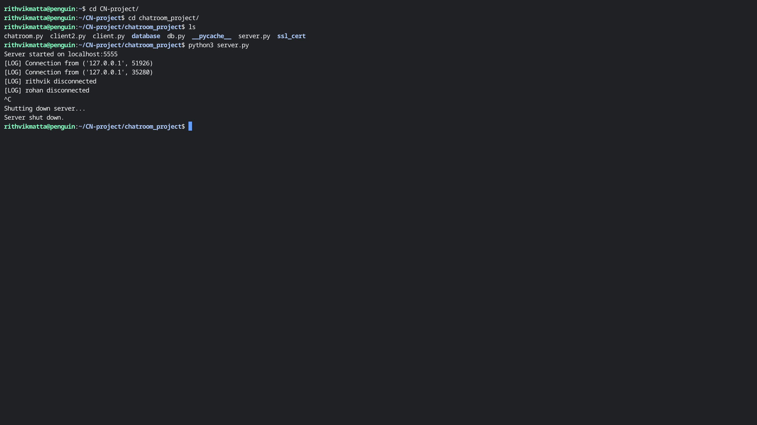

Client 1
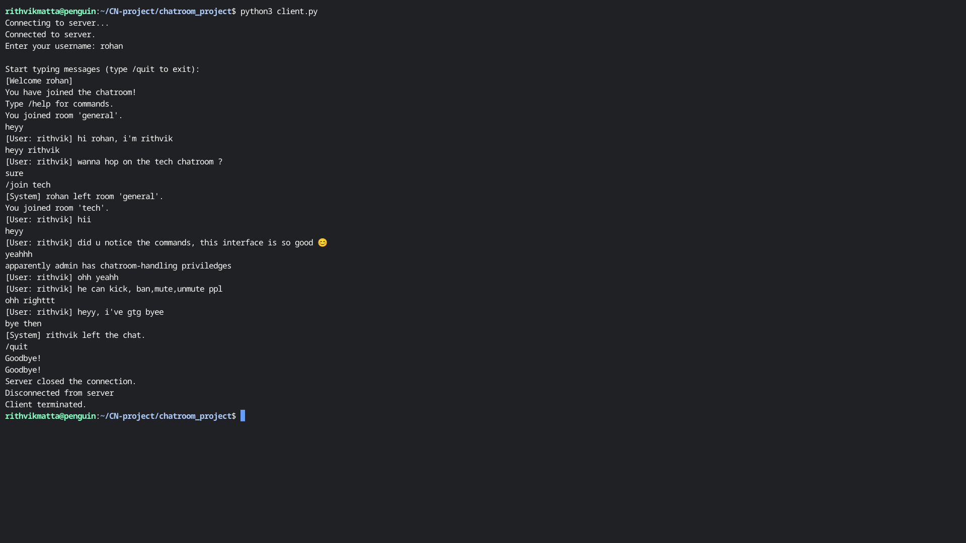

Client 2

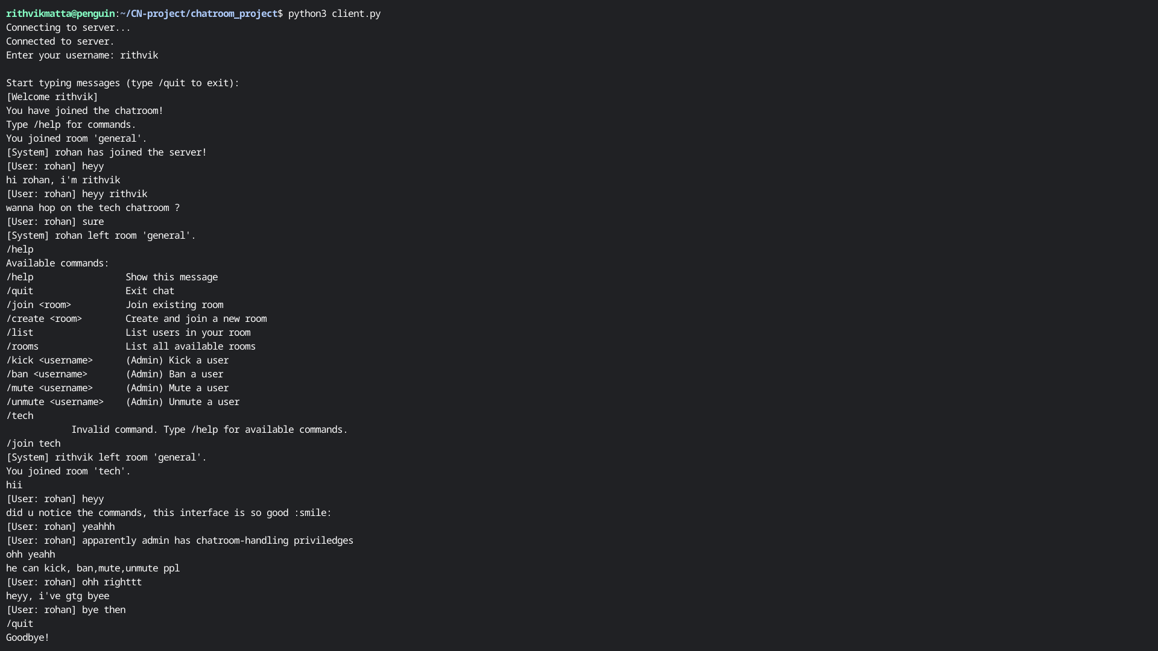

Database (containing chatlog)
