Lab 5: Static Code Analysis

Objective
To enhance Python code quality, security, and style by utilizing static analysis tools (Pylint, Bandit, and Flake8) to detect and rectify common programming issues.

Duration:
90 minutes

Software Requirements
- GitHub Account
- Web Browser (for GitHub Codespaces)
- inventory_system.py (provided file, which will be within your Codespaces environment)

Learning Outcomes
By the end of this lab, you will be able to:
- Understand the purpose and scope of static code analysis.
- Identify and resolve common Python programming issues, including mutable default arguments, overly broad exceptions, and insecure coding patterns.
- Effectively use Pylint, Bandit, and Flake8 to analyze Python code.
- Interpret static analysis reports and apply fixes based on issue severity.
- Reflect on the contribution of static analysis to overall code quality and maintainability.

Note: Students may be randomly called for a presentation after completing the lab. Please be prepared to discuss your code, bugs you found, and how you fixed them.

Introduction
In modern software development, ensuring code quality, security, and maintainability is paramount. Static code analysis is a crucial technique that involves examining source code without executing it to find potential bugs, vulnerabilities, and style violations. This lab will guide you through using three industry-standard Python static analysis tools:
- Pylint: Your "strict code reviewer" for code quality and logical errors. It flags issues like unused variables, poor practices, and potential design flaws.
- Flake8: Your "grammar checker" for Python code, enforcing PEP 8 style guidelines. It combines checks for formatting, whitespace, line length, and syntax issues.
- Bandit: Your "app's security guard" for Python, identifying common security vulnerabilities. It detects dangerous functions and insecure coding patterns.
You'll perform this lab entirely within GitHub Codespaces, a cloud-based development environment that provides all necessary tools without local setup.

Deliverables
You will use Pylint, Bandit, and Flake8 to analyze a provided Python program, inventory_system.py. Your task is to identify, document, and fix a minimum of four issues found by these tools, prioritizing high and medium severity findings. Finally, you will reflect on your experience with static analysis.
- A cleaned and updated version of inventory_system.py with at least four issues fixed.
- A filled-out table documenting the identified issues and how they were addressed.
- Answers to reflection questions provided in the lab.

Steps:

Step 1: Setup Your GitHub Codespaces Environment (15 minutes)
- Access the Lab Repository:
- Navigate to the GitHub repository provided for this lab (your instructor will provide this link).
- Click the green "Code" button.
- Select the "Codespaces" tab.
- Click "Create codespace on main" (or similar option if a specific branch is indicated).
- Wait for your Codespace to initialize. This may take a minute or two as it sets up a virtual development environment for you.
- Inspect inventory_system.py:
- Once your Codespace loads, you'll see a file explorer on the left. Locate and open inventory_system.py.
- Familiarize yourself with the code's structure and functionality.
- Run the program from the terminal within Codespaces to observe its initial behavior:
python inventory_system.py

- Install Static Analysis Tools:
- The Codespace environment should have pip pre-installed. In the Codespace terminal, install the required tools:
pip install flake8 bandit pylint
- Confirm Tool Installation:
- Verify that each tool is correctly installed by checking its version:
pylint --version
bandit --version
flake8 --version

Step 2: Run Static Analysis Tools (20 minutes)
Now that your environment is set up, run each analysis tool against inventory_system.py. The output will be redirected to text files for easier review.
- Run Pylint: pylint inventory_system.py > pylint_report.txt
- Run Bandit: bandit -r inventory_system.py > bandit_report.txt
- Run Flake8: flake8 inventory_system.py > flake8_report.txt
- You should now see pylint_report.txt, bandit_report.txt, and flake8_report.txt in your file explorer. Open them to view the reports.

Step 3: Identify and Document Issues (15 minutes)
Review the generated reports and cross-reference them with the common issues outlined for each tool. Use the provided table structure to document your findings. You may need to refer to the official documentation for Pylint, Bandit, and Flake8 if you need more context on specific error codes or warnings.
Example Known Issue Table:
Issue | Type | Line(s) | Description | Fix Approach
Mutable default arg | Bug | 12 | logs=[] shared across calls | Change default to None and initialize in method
... (Your findings) | ... | ... | ... | ...

Step 4: Fix Issues (30 minutes)
Based on your documented issues, begin fixing the problems in inventory_system.py.
- Prioritize: Focus on high and medium severity issues first.
- Fix at least 4 issues from your identified list.
- Suggested fixes to consider:
- Replace except: with specific exception types.
- Use f-strings for cleaner logging/output.
- Implement input validation for functions that take user input.
- Properly configure logging in the main execution block.
- Verify Fixes: After making changes, rerun the static analysis tools (as in Step 2) and check the new reports (pylint_report.txt, bandit_report.txt, flake8_report.txt) to confirm that the issues you've addressed no longer appear. Repeat this process until your fixes are verified.
- Pro Tip: An extra 2 marks will be awarded for fixing ALL issues reported by the tools!

Reflection (10 minutes)
Answer the following questions concisely (using paragraphs or bullet points) based on your experience during this lab. Add your answers to a new file named reflection.md in your Codespace.
- Which issues were the easiest to fix, and which were the hardest? Why?
- Did the static analysis tools report any false positives? If so, describe one example.
- How would you integrate static analysis tools into your actual software development workflow? Consider continuous integration (CI) or local development practices.
- What tangible improvements did you observe in the code quality, readability, or potential robustness after applying the fixes?

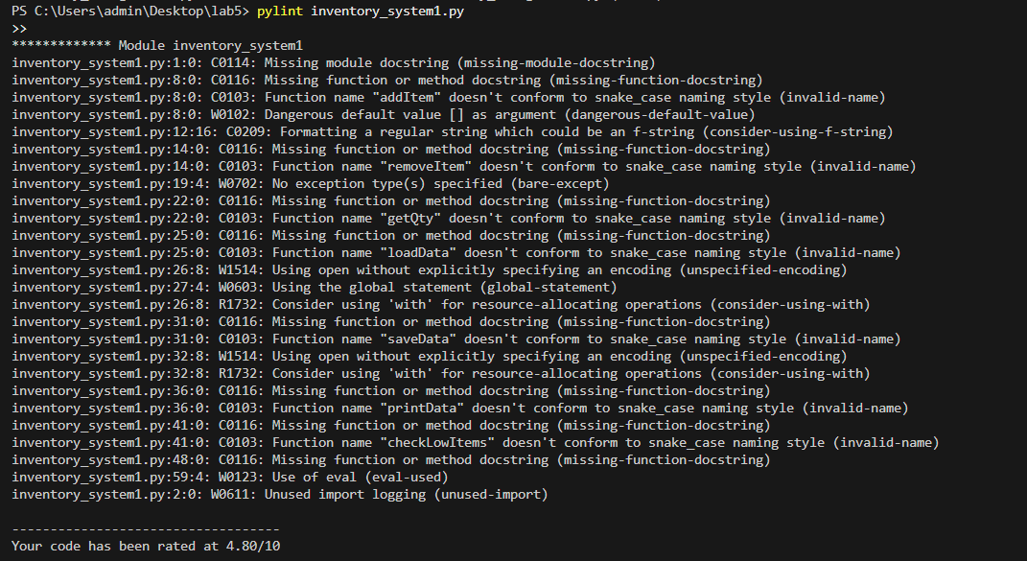
Screenshots:
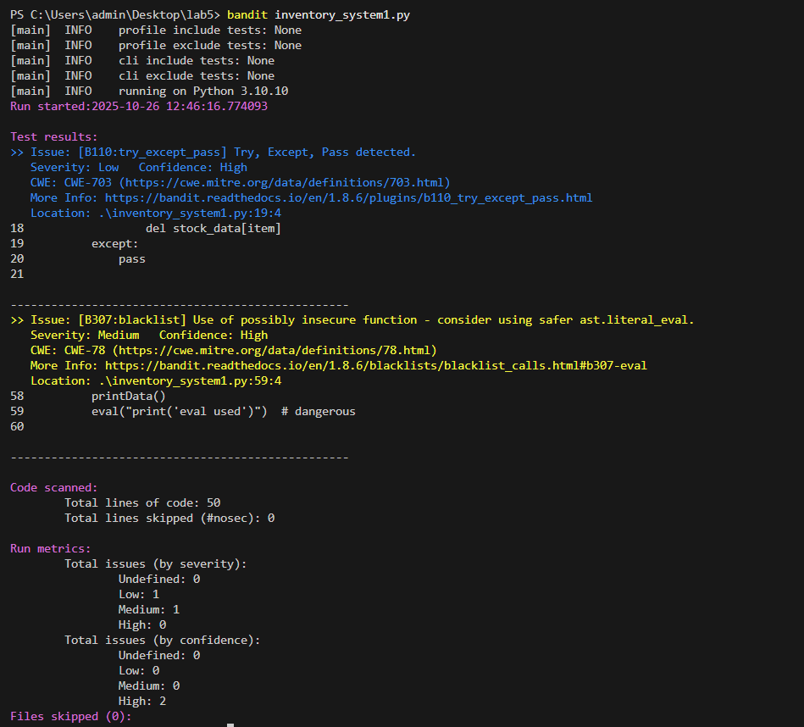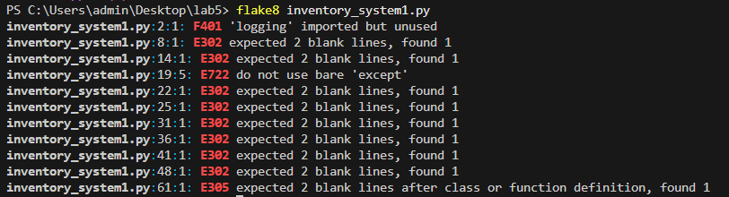

Table:

Issue | Type | Line(s) | Description | Fix Approach
Missing Module and Function Docstrings | C0114 | 1 | The module is missing a top-level docstring explaining its purpose. | Add a docstring at the top of the file to describe the module's purpose.
Bare except Clause | W0702 (Pylint), E722 (flake8), [B110:try_except_pass] (Bandit) | 19 | A bare except: is used, which can catch unexpected exceptions and make debugging harder. | Specify the type of exception you want to catch.
Use of eval() | [B307:blacklist] (Bandit) | 59 | The use of eval() is considered unsafe because it can execute arbitrary code, leading to potential security risks. | Replace eval() with ast.literal_eval() for evaluating string literals safely.
Function Naming Style (snake_case) | C0103 | 8, 14, 22, 25, 31, 36, 41, 48 | Function names like addItem, removeItem, and getQty do not follow the Python convention of using snake_case. | Rename the functions to use snake_case (e.g., add_item, remove_item).

After fixing:
import json
import logging
from datetime import datetime

# Global variable
stock_data = {}

# Log setup
logging.basicConfig(level=logging.INFO)

class Inventory:
"""
A class that represents an inventory system for managing stock.
"""

def __init__(self):
"""Initializes the inventory system."""
self.stock_data = {}

def add_item(self, item="default", qty=0):
"""Adds an item to the stock with the specified quantity."""
if not item or not isinstance(qty, int) or qty < 0:
logging.warning("Invalid input: item=%s, qty=%d", item, qty)
return
self.stock_data[item] = self.stock_data.get(item, 0) + qty
logging.info("Added %d of %s", qty, item)

def remove_item(self, item, qty):
"""Removes the specified quantity of an item from the stock."""
try:
if item not in self.stock_data:
logging.warning("Item %s not found in stock.", item)
return
self.stock_data[item] -= qty
if self.stock_data[item] <= 0:
del self.stock_data[item]
logging.info("Removed %d of %s", qty, item)
except KeyError as e:
logging.error("KeyError: %s", e)
except Exception as e:
logging.error("Unexpected error: %s", e)

def get_qty(self, item):
"""Returns the quantity of an item in stock."""
return self.stock_data.get(item, 0)

def load_data(self, file="inventory.json"):
"""Loads stock data from a JSON file."""
try:
with open(file, "r", encoding='utf-8') as f:
self.stock_data = json.load(f)
logging.info("Data loaded from %s", file)
except FileNotFoundError:
logging.warning("%s not found. Using empty inventory.", file)
except json.JSONDecodeError:
logging.error("Error decoding JSON from %s", file)
except Exception as e:
logging.error("Unexpected error loading data: %s", e)

def save_data(self, file="inventory.json"):
"""Saves stock data to a JSON file."""
try:
with open(file, "w", encoding='utf-8') as f:
json.dump(self.stock_data, f, indent=4)
logging.info("Data saved to %s", file)
except Exception as e:
logging.error("Error saving data to %s: %s", file, e)

def print_data(self):
"""Prints out the inventory data."""
print("Items Report")
for item, qty in self.stock_data.items():
print(f"{item} -> {qty}")

def check_low_items(self, threshold=5):
"""Returns a list of items that are below the specified threshold."""
return [item for item, qty in self.stock_data.items() if qty < threshold]

def main():
"""Main function to run the inventory system."""
inventory = Inventory() # Create an instance of the Inventory class
inventory.add_item("apple", 10)
inventory.add_item("banana", -2)
inventory.add_item(123, "ten")
inventory.remove_item("apple", 3)
inventory.remove_item("orange", 1)
print("Apple stock:", inventory.get_qty("apple"))
print("Low items:", inventory.check_low_items())
inventory.save_data()
inventory.load_data()
inventory.print_data()

if __name__ == "__main__":
main()

