# Query Options

Query Option are used to to filter or manipulate the search results. Query Options are defined using blocks within EPiServer. One or more blocks can be added to the query options section to build up the search query. The following blocks are available under Query Options

* Filter Query Block
* Boost Query Block
* Advance Query Options Block

## Filter Query Block

The Filter Query is used to filter the search results by a field within the search index. The Filter Query Block consists of the following properties

### 

### Filter Field

A drop down list used to select the field to filter the search results by. The drop down list contains a list of fields available in the search index. By default the following fields are available to filter by.

* Category – The EPiServer category assigned to a page.
* CMS Path – The path to the page within the EPiServer CMS. The path is in the following format (ex. /Root/Start Page/Press Release) which matches the page tree path in the CMS.
* Page Type – The EPiServer Page Type Name.
* Hostname – The website hosting the page.
* Language – The language the page is written in.

### Filter Condition

A drop down list used to define the condition to filter by. Available options are

* Equals – Filter search results where field equals value
* NotEquals – Filter search results where field does not equal value
* Contains - Filter results where field contains value. (Note: The “Contains” condition will not work with field values containing “AND” or “OR”.)

### Filter Value

A case-sensitive value used to filter the search results. One or more values can be defined within this field. Values should be separated by an “AND” or “OR”

Example 1: Filter results where field value equals “High Society”



Example 2: Filter results where field value equals “High” or “Society”



Example 3: Filter results where field value equals “High” and “Society”



### Example Filter Queries

**Ex 1. Filter by Category Name**

Filter results to return all pages assigned to the category “Biosolids”

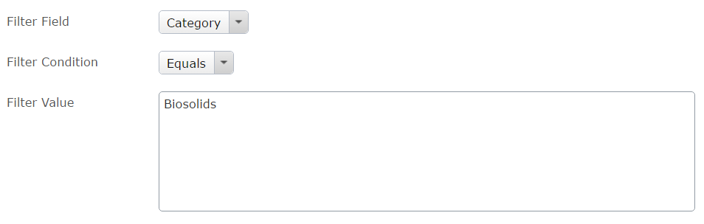

**Ex 2. Filter by EPiServer Page Type**

Filters results to return all pages of type General Page or Article Page

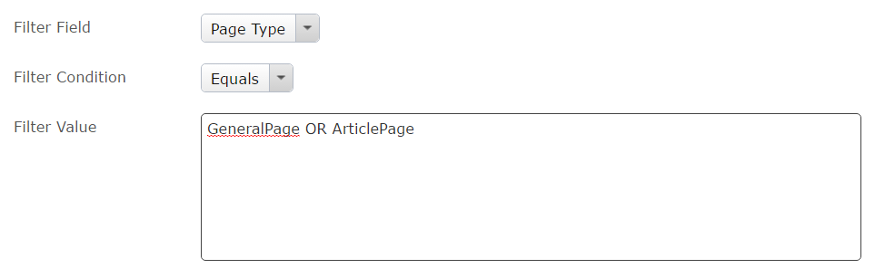

**Ex3. Filter by EPiServer Container Page**

Filter results to return all pages directly under another page.

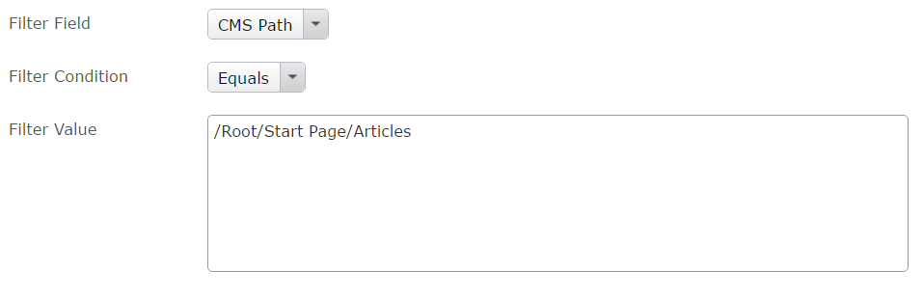

**Ex 4. Filter by EPiServer Container Page (and all sub container pages)**

Filter results to return all pages under the another page

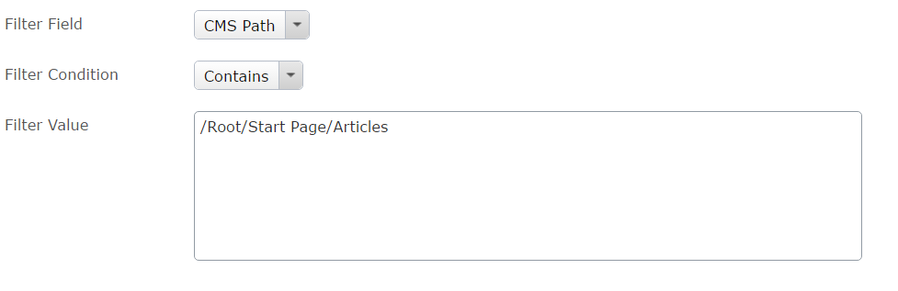

**Ex 5. Filter by Multiple Categories**

Filter results to return all pages assigned to the categories “Article” or “Press Release” and that are also assigned to “High Priority”

## 

## Boost Query Block

Boosting is used to increase/decrease the relevance of certain content in the search results. Query Boosting is based on values assigned to fields in the search index. Query Boosting is configured using the Boost Query Block consisting of the following properties:

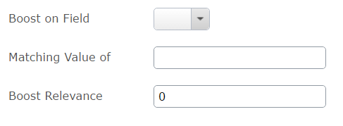

### Boost on Field

A drop down list used to select the field to boost on.

### Matching Value of

A single case-sensitive value used to trigger boosting. Boosting is added to all content where field matches value. Note: the Boost Query Block does not support multiple values or using conditional “And/Or”.

### Boost Relevance

A decimal number used to increase/decrease the relevance of content matching the value. The higher the number the more likely matching content will appear at the top of the search results. Use a negative number to decrease the relevance of matching content over other content.

### Example Boost Queries

**Ex 1. Boost by Category**

Boost the relevance all content assigned to the “High Priority” category

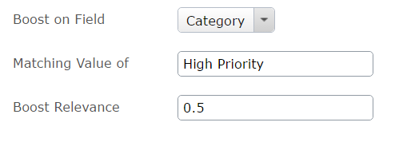

## Advanced Query Options Block

The Advanced Query Option Block allows for additional tuning of the search query. The block consists of the following properties:

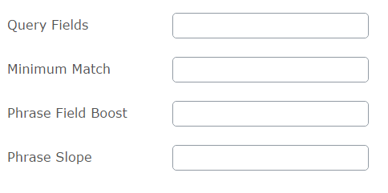

### Query Fields

The Query Fields property is used to define the fields searched on. The following are examples of some of fields within the search index that can be searched.

* _text_ - (This is the default field used by search if no other field is defined. This field contains content from all other fields).
* title – the content title or EPiServer page name
* summary – the content summary

Example 1: Query just the title field



Example 2: Query the title and summary fields



Example 3: Query the title and _text_ fields and boost the relevancy of matches on the title field



### Minimum Match

The Minimum Match property is a positive whole number used to define the minimum number of term matches required for content to be returned in the search results. For example if the minimum match value is set to “2” then searching on “James Cagney” will only return content that contains both terms.

### Phrase Slope

The Phrase Slope property is a numeric value used to define the proximity of terms in the search results. This can be useful for full name searches. For example searching on James Cagney could also return

### Phrase Field Boost

# Facets

Facets are a list of terms used to filter the search results on the search page. Facets are created from terms assigned to a given field in the search index. The facets displayed on the search page is determine by the search results,

In most cases facets are display on the search page as a checkbox list, or in some cases a dropdown list.

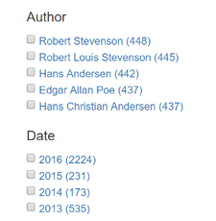

Facets are defined using blocks within EPiServer. One or more facet blocks can be added to the search page. The following facet blocks are available:

* Field Facet Block
* Date Range Facet Block
* Range Facet Block

## Field Facet Block

Use the Field Facet Block to configure a basic Facet to display on the search page. The Field Facet Block consists of the following properties:

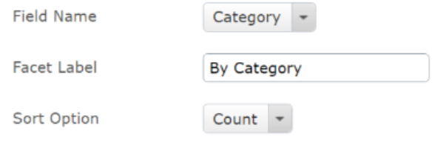

### Field Name

This property defines the search index field to use as a facet. The Field Name drop down list displays a list of search index fields that can be used as a facet.

### Facet Label

This property defines the facet heading label displayed on the search page.

### Sort Option

This property defines the sort order of facets item displayed on the search page.

* Count – Sort facet items by the number of page hits per item
* Name – Sort facet items by the facet item name

## Date Range Facet Block

Use the Date Range Facet Block to display a facet for a date field in the search index. The Date Range Facet Block consists of the following properties:

