System Documentation

IRAD Portal
System Description and System Flow
Technology Stack, Logical Architecture, and Data Movement

DOCUMENT SCOPE
This document presents a logical description of the IRAD Portal. It intentionally excludes environment-specific hostnames, IP addresses, credentials, network zones, and other sensitive deployment details.

Prepared for client review

1. Executive Summary
The IRAD Portal is a web-based application that provides a centralized interface for managing personnel, positions, candidates, workflows, notifications, support functions, reporting, and administrative configuration. The system uses a modern client/server web architecture in which users access the portal through a standard web browser, while server-side application logic controls authorization, validation, workflow processing, and access to persistent data.
The portal is implemented as one integrated application rather than a collection of separate user-facing systems. Vue.js provides the interactive browser interface, Laravel provides the server-side application framework, Inertia.js connects the two layers, and a relational database provides persistent storage. Role- and permission-based controls determine which capabilities and records each user can access.

2. System Description
Users access IRAD through a supported web browser over HTTPS. The hosting environment provides the authenticated user identity, which IRAD resolves to the appropriate application user. The application then evaluates roles and permissions before processing protected operations.
For each user action, Laravel receives the request, validates the submitted information, applies authorization and business rules, performs the required database operation, and prepares response data. Inertia.js carries the resulting page data to the Vue interface, allowing the browser to update the user experience without operating a separate stand-alone front-end API application.
Administrative functions use the same core application architecture as user-facing functions. Access is controlled through server-side roles and permissions. Configurable settings, custom fields, help content, portal features, and workflow-related options allow installations to adapt the portal without requiring source-code changes for routine configuration.

3. Technology Stack
Technology / Tool | Role in the Portal | Primary Responsibilities
Laravel 13 | Server-side application framework | Routing, application logic, authorization, validation, workflows, services, data access, exports, notifications, and administrative functions.
PHP 8.4 | Server-side runtime | Executes Laravel and application business logic on the application server.
Vue.js 3 | Browser-based user interface | Dashboards, forms, tables, navigation, search, filtering, dialogs, alerts, workflows, and administrative interfaces.
TypeScript | Front-end development language | Adds type checking and improves reliability of browser-side application code.
Inertia.js | Laravel-to-Vue communication layer | Allows Laravel to return page data directly to Vue without requiring a separate stand-alone REST application for normal page interactions.
Vite | Build and packaging tool | Compiles and packages Vue, TypeScript, CSS, and other browser resources during development and deployment.
Tailwind CSS | Styling framework | Provides responsive layouts, typography, spacing, visual states, and consistent interface styling.
shadcn-vue | Reusable interface component foundation | Provides standardized buttons, forms, dialogs, dropdowns, tables, tabs, cards, inputs, and related components.
Lucide Icons | Interface icon set | Provides standardized icons for navigation, actions, and status indicators.
Relational Database | Persistent data storage | Stores users, people, positions, candidates, job titles, workflows, notes, custom fields, alerts, tickets, settings, roles, permissions, help content, and related operational data.
Enterprise Identity Environment | User identity source | Provides the authenticated identity used by IRAD to resolve the current application user.
Email / Notification Service | Optional external delivery service | Receives application-generated messages or notifications when these functions are enabled and configured.

4. Major Application Functions

Identity and User Resolution
IRAD resolves the authenticated identity supplied by the hosting environment to the appropriate application user and, where applicable, the associated person record.

Roles and Permissions
Server-side authorization determines whether a user may view, create, update, delete, administer, or otherwise act on application data. Interface controls may also hide unavailable actions, but security enforcement occurs on the server.

Application Services
Reusable service-layer components centralize business processes such as workflow processing, current-user resolution, search, notifications, exports, feature configuration, and site settings.

Administrative Configuration
Authorized administrators can manage portal settings, users, permissions, custom fields, help content, feature availability, and other configurable functions.

Accessibility
The portal is designed to support keyboard navigation, visible focus, proper form labeling, semantic structure, accessible dialogs and menus, screen-reader compatibility, and consistent status/error messaging.

5. Logical System Architecture / Network Flow
The diagram below presents the logical relationship among the browser, identity environment, application layers, data store, and optional external services. It is intentionally not a physical network topology and does not identify deployment-specific servers, addresses, ports, firewalls, or network zones.
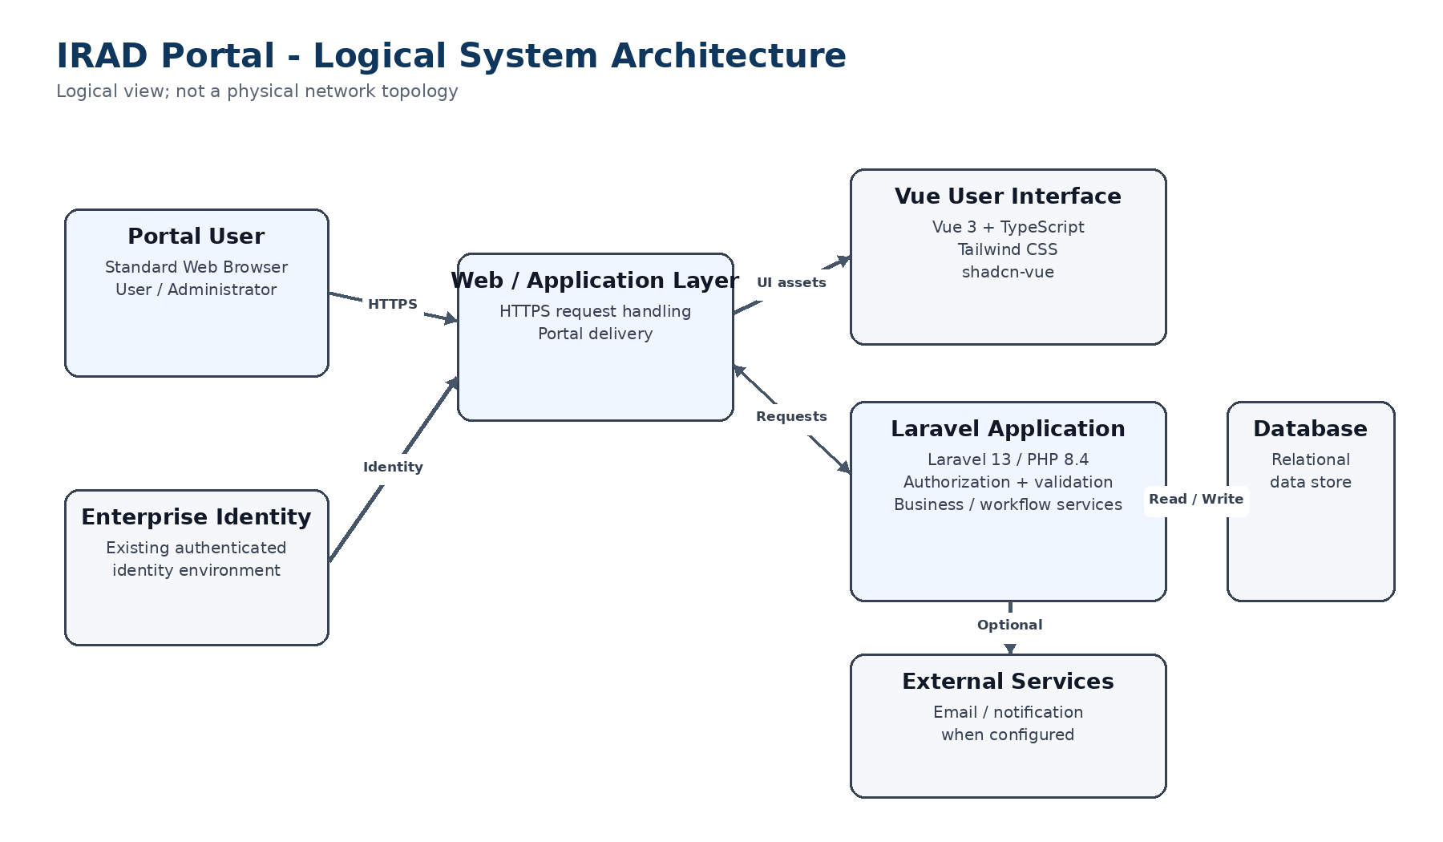
Figure 1. IRAD logical system architecture. Communication between the user and portal occurs over HTTPS. The application layer controls authorization, validation, business processing, and data access.

6. Application Data Flow
A typical request moves through the portal in the sequence shown below. The same general flow applies to viewing, creating, updating, searching, and administering portal information.
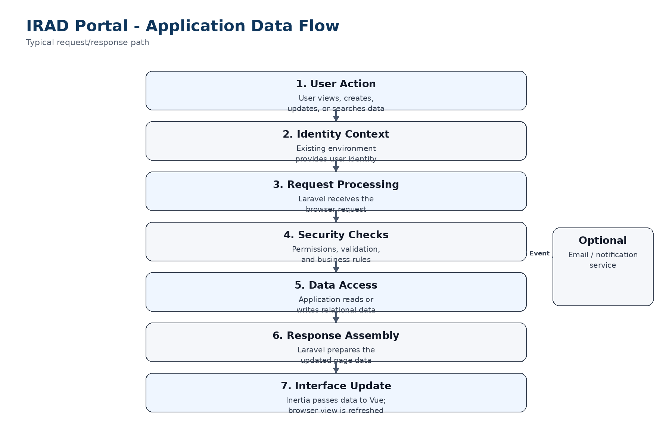
Figure 2. Typical IRAD request and response flow.

7. Data Movement Narrative
1. User action: A user performs an action in the browser, such as opening a page, searching for a record, editing a position, or submitting a form.
2. Identity context: The existing hosting or enterprise identity environment provides the authenticated identity. IRAD resolves that identity to the correct application user.
3. Request processing: The browser request is received by the Laravel application. The request contains the operation being performed and any user-entered data required for that operation.
4. Security and validation: Laravel verifies that the user is authorized to perform the requested action and validates submitted data before application logic is executed.
5. Business processing and data access: Application services apply workflow or business rules and read from or write to the relational database as required.
6. Optional external communication: If the action requires a notification or email, the application prepares the message and passes it to the configured external delivery service.
7. Response generation: Laravel prepares the resulting page data. Inertia.js transfers that data to the Vue application.
8. User interface update: Vue updates the browser interface to display the current data, status, confirmation, validation message, or resulting workflow state.

8. Example Transaction: Updating a Position
When an authorized user updates a Position, the browser submits the requested changes to IRAD. Laravel resolves the current user, confirms that the user has permission to modify the Position, validates the submitted values, and applies the applicable business rules. The application then updates the relational database. Laravel prepares the updated page data, Inertia.js transfers that data to Vue, and the browser refreshes the displayed Position information. If the action triggers an enabled notification, the application also passes the notification to the configured delivery service.

9. Documentation Scope
This document describes IRAD at a logical application level. The following information is intentionally excluded and should be maintained, if required, in the appropriate controlled deployment or security documentation:
- Production or test server names and IP addresses
- Network segments, VLANs, firewall rules, and routing details
- Credentials, secrets, API keys, certificates, or connection strings
- Environment-specific identity-provider configuration
- Database account information or privileged administrative access details
- Detailed security controls whose disclosure is restricted by the hosting organization

10. Architecture Summary
Logical processing path: Web Browser → Web/Application Layer → Laravel Application → Application Services → Relational Database → Laravel/Inertia Response → Vue User Interface.
External identity and messaging systems integrate with this path only where required. The architecture separates presentation, application logic, authorization, and persistent data storage while maintaining a single integrated portal that can be extended as requirements evolve.

