Fabricated and inaccurate citations generated by large language models for biomedical topics: a systematic review and meta-analysis
Review 2 of the Cochrane-style clinical AI meta-analysis series.
Author: Raphael Malikian. Independent researcher, Palmdale, California, USA. Healthcare founder and operator who bootstrapped and ran a direct primary care clinic as CEO, now building clinical AI. No industry affiliation.
ORCID: 0009-0008-4326-4205. Email: rtmalikian@gmail.com. GitHub: rtmalikian.
Protocol version 1.0, 22 October 2026 (protocol.md, this series). Registration: no PROSPERO registration number was issued before analysis. A PROSPERO-ready form was prepared before screening (prospero-form.md) and an OSF record is the transparent parallel route. No registration is backdated or implied anywhere in this review.
Methods standard: Cochrane Handbook for Systematic Reviews of Interventions, version 6.5 (2024), followed in spirit and structure. Reporting follows PRISMA 2020 and PRISMA-S. This is a Cochrane level review. It is not a Cochrane review and was not submitted to Cochrane, because Cochrane requires at least two authors and this is a single author review with LLM assistance under human accountability, reported in full in the declarations and the team log.
Scope note: this review covers evidence synthesis and research integrity only. It makes no clinical recommendation and no medication recommendation, and it gives no advice for the care of any individual patient.

Abstract
Rationale. Large language models produce reference lists that look sound. A share of the references do not exist, and a further share contain errors that stop a reader finding the source. Primary studies have reported these rates study by study, with different models, topics and definitions. No published synthesis pools them on their shared denominator, references generated.
Objectives. To estimate, from generation experiments, the proportion of LLM generated biomedical references that are completely fabricated, the proportion with any major inaccuracy, and the proportion fully accurate, and to examine how those proportions vary by model family, retrieval use, publication type and study level pooling.
Search methods. PubMed, Europe PMC, OpenAIRE, Crossref and an OpenAlex test page were searched on 22 October 2026, with exact strings, dates and hit counts in the search log. arXiv and Semantic Scholar were attempted and blocked by rate limits and are logged as blocked. Embase, Scopus and Web of Science strings were prepared and are marked run pending access. No language limit was applied at search.
Eligibility criteria. Primary studies that prompted one or more LLMs to generate references on a biomedical or clinical topic, reported the number generated, and verified each reference against a named source. Large scale audits of the published literature were eligible as a separate stratum and were never pooled with generation experiments. Editorials, reviews with no original experiment, detection tools, citation screening studies and reports with no denominator were excluded.
Outcomes. Critical: proportion completely fabricated; proportion with any major inaccuracy including fabricated; proportion fully accurate on all checked fields. Important: minor errors by field, non-resolving or wrong DOIs, error by list position where reported.
Risk of bias. An adapted tool specified before extraction (rob-forms.md), with eight domains covering topic and prompt sampling, model and prompt reporting, generation settings, verification source, verifier independence, duplicate or blinded verification, partial match handling and selective reporting.
Synthesis methods. Random effects meta-analysis of proportions in Python (numpy, scipy, pandas), logit transformation, REML tau squared, prediction intervals where 10 or more arms pooled. Model arms within studies were kept visible; a per study pool was run as a sensitivity check for every outcome.
Included studies. 15,985 records were screened. Twenty five generation experiments (69 model arms) and one published literature audit met the rules.
Results of syntheses. Completely fabricated: pooled 18.6 percent (95% CI 12.8 to 26.3), 51 arms, 18 studies, 12,828 references, I squared 97.7 percent, prediction interval 0.9 to 84.7 percent, GRADE very low. Fully accurate: pooled 29.4 percent (19.5 to 41.7), 42 arms, 13 studies, 12,002 references, I squared 98.5 percent, GRADE very low. Any major inaccuracy: pooled 36.0 percent (19.8 to 56.3), 9 arms, 5 studies, 1,537 references, I squared 96.1 percent, GRADE very low. Per study sensitivity pools gave 23.0 percent fabricated and 41.2 percent fully accurate. Arms with retrieval or browsing active pooled 5.0 percent fabricated against 25.1 percent for arms with retrieval off. The audit stratum, reported apart, found fabricated citations in published papers rising from about 1 in 2,828 papers in 2023 to about 1 in 277 in early 2026.
Authors' conclusions. In these experiments, roughly one generated biomedical reference in five did not exist, and fewer than one in three was fully accurate. The spread between models and setups was wider than any average, so the pooled figures describe a literature, not a property of a named product. Verification of every generated reference against a database is the only step in this literature that consistently separated usable lists from unusable ones. Certainty is very low throughout, mainly because verification conduct was poorly reported and heterogeneity stayed high after every pre-specified subgroup.
Funding. None. Registration. None issued before analysis; see the title page note.

Plain language summary
The plain language summary is filed as plain-language-summary.md and reproduced in the repository README. In short: of every 100 references a model generated in these experiments, about 19 did not exist and about 29 were fully accurate. Rates varied sharply by model and by whether web access was on. A separate audit found fabricated citations already sitting in published papers, and rising fast between 2023 and 2026. The quality of the underlying studies was weak enough that all main results carry very low certainty.

Summary of findings
GRADE, adapted for proportion and prevalence evidence as set out in the protocol, applied per critical outcome. Downgrade reasons were stated in the protocol before analysis.
Outcome | Arms | Studies | References checked | Pooled proportion (95% CI) | I squared | Certainty | Reasons
Completely fabricated | 51 | 18 | 12,828 | 18.6% (12.8 to 26.3) | 97.7% | Very low | Risk of bias down 1 (15 of 25 studies at high risk on the adapted tool, verification conduct often unreported); inconsistency down 1 (prediction interval 0.9 to 84.7%); indirectness down 1 (experimental lists stand in for real manuscript drafting)
Any major inaccuracy, including fabricated | 9 | 5 | 1,537 | 36.0% (19.8 to 56.3) | 96.1% | Very low | Risk of bias down 1; inconsistency down 1; imprecision down 1 (5 studies, wide interval)
Fully accurate on all checked fields | 42 | 13 | 12,002 | 29.4% (19.5 to 41.7) | 98.5% | Very low | Risk of bias down 1; inconsistency down 1 (prediction interval 1.1 to 93.8%); indirectness down 1
Outcomes with thinner data: minor errors by field and bad DOI counts were extracted where printed and are reported in the Results without pooling, because field level denominators differed between studies. Error by list position was reported by too few studies to pool and is described narratively.

Background

Description of the problem
A reference list does quiet work. It tells a reader that a claim rests on a paper that exists, that the paper says what the writer says it says, and that the reader can go and check. Large language models write reference lists that keep the shape of that promise and break its content. The authors are plausible because the model has seen thousands of real author names in the field. The journal is real. The year fits the topic. The paper does not exist, or it exists with a different title, or the DOI resolves to another article entirely.
This is not a rare glitch at the edge of the technology. When Chelli and colleagues asked GPT-3.5, GPT-4 and Bard for references for systematic reviews in 2024, the hallucinated shares were 39.6 percent, 28.6 percent and 91.4 percent. When researchers in 2026 asked six models for radiology references, 480 per model, fabrication ran from 3 percent for one model to 61 percent for another in the same study, on the same topics, with the same verification (Gunes 2026, extracted in this review). A tool that drafts a manuscript section and appends a bibliography is now a standard feature of the writing software researchers open every day. The bibliography is the part nobody retypes by hand, which is exactly why errors in it travel.
The published literature already carries the marks. Yin and colleagues audited about 111 million references across 2.5 million papers on arXiv, bioRxiv, SSRN and PubMed Central and estimated about 146,932 non-existent references in 2025 alone, with a sharp rise after mid 2024. Topaz and colleagues, in a 2026 Lancet letter, audited 2.5 million biomedical papers and found fabricated references rising from about 1 in 2,828 papers in 2023 to about 1 in 277 papers in the first weeks of 2026. Those audits measure what reached print. They cannot say which step produced the errors, because a published reference list mixes human error, copy editing error and model generation. The generation experiments can answer the narrower question, and until now nobody had pooled them.

Description of the intervention
There is no intervention in the clinical sense. The unit under study is a generation setup: a model, at a version, with stated or unstated settings, with or without web access or retrieval, given a prompt or a task that asks for references on a biomedical topic. The comparator, where one exists, is another setup in the same study run on the same topics. Most primary studies are bench experiments, not trials, and this review treats them that way.

Why it is important to do this review
Editors, reviewers and readers currently argue from single studies. One paper finds 7 percent fabrication from a current model on guideline topics (Bernstein 2026, 195 of 2,736) and the next finds 66 percent from another model in another specialty (UcarGundogar 2026, DeepSeek R1 arm, 98 of 149). Both can be accurate reports of their own setups. A pooled estimate with its heterogeneity stated, split by model family and by retrieval, gives the argument a shared set of numbers. It also gives the methods literature a target: if verification conduct is the weak point, the pooled result should show where the weakness sits. Review 1 of this series covered ambient AI scribes. The gap ranking behind the series placed LLM hallucination second, on the condition that a review take one task with one denominator. Citation generation is that task.

Objectives
To assess, from primary generation experiments, the proportions of LLM generated biomedical references that are completely fabricated, that carry any major inaccuracy, and that are fully accurate, and how those proportions vary by model family and generation, retrieval use, specialty and topic type, list length, publication type and model year.
Research questions: RQ1, what proportion of generated references are completely fabricated? RQ2, what proportion carry any major inaccuracy including fabrication? RQ3, what proportion are fully accurate on all checked fields? RQ4, how do these proportions differ by model family and generation? RQ5, how do they differ with retrieval, browsing or a reference database active against none? RQ6, how do they differ by specialty, established against emerging topic, and number of references requested? RQ7, what happens to generated errors after publication, as measured by the separate audit stratum?

Methods

1. Differences between protocol and review
Four differences, each logged with its reason. First, the strict second pass over abstracts was applied at the full text stage rather than before retrieval, because open access retrieval for all 122 stage 1 survivors was automated (Europe PMC then Unpaywall) and cost less than a separate pass; every retrieved report still received a full text decision with one exclusion reason. Second, analysis ran in Python rather than R, because no R installation was available in the working environment; the protocol named Python with a logit model as the stated fallback, and the code is published with the review. Third, the model year subgroup could not be run as specified: primary studies rarely printed a model year apart from the model version, so that subgroup is reported as not estimable rather than rebuilt from publication year, which would answer a different question. Fourth, list length subgrouping used references requested where a study printed it (17 of 42 fully accurate arms and 4 of 9 major inaccuracy arms carried a usable requested count); arms without a printed requested count sit in a not reported group and are not assigned a list length from their generated count. No outcome definition changed after extraction began. No eligibility rule changed.

2. Criteria for considering studies for this review
Types of studies: primary generation experiments of any design, and preprints of the same, with original data. Published literature audits formed a separate stratum under their own extraction section. Systematic reviews, editorials and commentaries were used for background and reference chasing only.
Types of participants: not applicable in the clinical sense. The sampled units are topics, prompts and reference lists in biomedical and clinical subject areas. Studies in other fields were included only where a biomedical subset could be extracted apart (Mugaanyi 2024, natural sciences subset). Cross disciplinary studies that reported only discipline level aggregates with no biomedical split were excluded (for example the Walters and Wilder experiment, captured in this search, reports by work type rather than topic).
Types of generation setups: any LLM or LLM based assistant asked to produce references or citations, with model, version, settings and retrieval status extracted where printed.
Outcomes and definitions: a reference was completely fabricated where no matching publication existed under the study's verification. A major inaccuracy was an error that prevents retrieval or misattributes the source, including fabricated references, a wrong DOI that resolves to a different paper, or a title or author error the study graded as major. A reference was fully accurate where every field the study checked was correct. Definitions were extracted as printed for every study; a study entered a pool only where its definition mapped exactly to the review definition, or where its printed components summed to the review definition, with the mapping logged per row in extraction.csv.

3. Outcome measures
Critical outcomes are the three proportions in the summary of findings. Important outcomes: minor error rate; minor errors by field (authors, title, journal, year, volume or pages, DOI); proportion with a DOI that does not resolve or resolves to a different paper (for example Athaluri 2023, 69 invalid DOIs among 178 generated references; Adiguzel 2026, DOI errors in 94 of 150 ChatGPT 5 references against 14 of 150 for Claude Sonnet 4.6); error by list position where a study printed it.

4. Search methods for identification of studies
Databases and sources searched on 22 October 2026: PubMed through NCBI E-utilities (372 retrieved), Europe PMC REST API with cursor paging (14,090 retrieved, string not restricted to title and abstract, a breadth decision that is logged and that screening absorbed), OpenAIRE (10), Crossref bibliographic and posted content queries (1,000 records retrieved from each; the total-results figures of 1,507,235 and 122,445 are relevance match counts and were never treated as result sets), and an OpenAlex test page (25 records; full retrieval not run). arXiv timed out and then returned HTTP 429; Semantic Scholar returned HTTP 429 on its test call. Both are logged as attempted and blocked. Embase, Scopus and Web of Science were not searched: no licensed access was available, and ready to run strings for each sit in search-appendix-pending.md, marked string prepared, run pending access. This review does not claim those databases were searched. Reference lists of included studies and of the existing hallucination reviews informed background checking; no additional eligible study entered through chasing that was not already in the search set. Full strings as run sit in search-log.md.

5. Data collection and analysis
Selection of studies. Two LLM screeners with different written rules (A strict, B sensitive) screened all 15,985 deduplicated titles and abstracts apart. Agreement was 94.29 percent; Cohen kappa was 0.13, a prevalence effect described in the team log. A coded adjudication rule passed 122 records to full text. Full texts were sought for all 122; 76 were retrieved open access and 46 were not retrieved and are listed in flagged-for-author.md. Full text decisions were made by extractors in three batches, with a fourth batch for re-retrieved records, each exclusion carrying one reason.
Data collection and management. Extraction followed extraction-form.md: 57 fields across identity, topic, per arm model and setup, verification, definitions as printed, counts as printed, funding and conflicts, plus a separate audit section. Percentages were never back calculated into counts unless the count was also printed, with one stated exception: where a paper printed integer percentages against a printed denominator of 100 references per model and the derived counts summed exactly to the paper's printed pooled totals (Seifi 2026), the derived counts were entered and flagged derived in every affected row. A verification pass then checked analysis totals against the extraction sheet by hand and checked named arms against their papers (details in llm-team-log.md).
Assessment of risk of bias. The adapted tool in rob-forms.md, specified before extraction, with eight domains. Two assessors judged all 25 generation studies apart (200 domain judgements, 56 disagreements). Judgements were adjudicated by taking the more cautious of the two per domain, a conservative rule stated here so a reader can rebuild the assessments from stage4/rob-assessor1.csv, stage4/rob-assessor2.csv and rob-assessments.csv. The tool is adapted; it is not RoB 2 and not QUADAS-2.
Measures of effect. Proportions per model arm, with the arm as the primary unit and the study as a clustering level handled by a per study sensitivity pool. No odds ratios or comparative effect measures apply, because most primary studies have no non-LLM comparator.
Synthesis methods. Random effects meta-analysis of proportions, logit transformation, REML estimate of tau squared, in Python (analysis.py; numpy, scipy, pandas). Prediction intervals are reported where 10 or more arms pool. Reporting bias tests were not run: funnel based tests behave badly for single proportions and the protocol limited them to pools of 10 or more units with care; given I squared above 95 percent in every main pool, a funnel plot would describe heterogeneity, not reporting bias, and none is presented as evidence either way.
Subgroup and sensitivity analyses. Pre-specified subgroups only: model family; retrieval, browsing or RAG against none, with not reported kept apart; specialty and topic type in narrative form where arms were too few to pool; list length by references requested, 10 or fewer against more than 10, where printed; peer reviewed against preprint; model year not estimable (see differences, above). Sensitivity analyses: per study pooling; peer reviewed reports only (preprints removed); leave one model family out; studies at low or some concerns risk of bias only. A strict against lenient fully accurate sensitivity could not be run because no included study printed both definitions for the same arms; that gap is reported rather than filled.
Certainty of the evidence. GRADE adapted for proportion evidence (protocol.md), per critical outcome, with downgrade reasons fixed in advance: risk of bias in verification, inconsistency where model and topic mix stays unexplained, indirectness where experimental lists stand in for real drafting, and imprecision.

6. Equity considerations
Two equity points arise. First, verification labour falls unevenly: a researcher with library support and database access can check a generated list in minutes per reference, while a researcher without that support carries the full cost, and fabricated references in print then mislead readers in settings with the least access to check them. Second, several included experiments found worse accuracy on emerging or low resource topics, the topics where local researchers most need drafting help. No included study reported results by author country or language of the prompt in a form that could be pooled, so both points are stated as context, not as findings of this review.

7. Consumer involvement
No patients or members of the public were involved. The stakeholders for this question are authors, editors, reviewers and librarians; the conference route for this review targets a library audience for that reason.

Results

Description of studies
Records identified: 16,497 retrieved across all runs. Duplicates removed: 512. Records screened: 15,985. Records excluded at title and abstract after dual screening and adjudication: 15,863. Reports sought: 122. Reports not retrieved: 46. Reports assessed at full text: 76. Reports excluded at full text: 48, with one reason each in fulltext-screening.csv; the largest groups were reviews and editorials with no original experiment, duplicate reports of an experiment already captured, retrieval or detection tools with no generation experiment, non-biomedical reports with no separable biomedical data, and four reports whose retrieved file did not correspond to the record and whose correct text could not be obtained. Reports included: 27 generation experiment reports covering 25 unique studies, and 1 audit report. The full flow sits in prisma-flow.md and prisma-flow-diagram.png.
The 25 generation studies ran from 2023 to 2026 and covered, among other fields, radiology, orthopaedics, endodontics, neurocritical care, psychiatry and mental health, ophthalmology, otolaryngology, physical therapy and general biomedical topics. Sixty nine model arms were extracted. Models included the GPT family (the largest group), Gemini, Claude, DeepSeek, Bard, Copilot and several research systems in one study of AI research agents (Shi 2026). Verification sources were PubMed most often, then Crossref, Google Scholar and publisher records, named per arm in extraction.csv. Funding and conflicts were extracted per study; vendor involvement in the primary studies was uncommon in print, and several studies declared nothing either way, which the extraction records as not reported rather than as none.

Risk of bias in included studies
Adjudicated overall judgements: high risk in 15 of 25 studies, some concerns in 10, low in none. Verification conduct drove most high judgements: studies that never said who verified the references, or whether verification was duplicated or blinded, could not score well on domains 5 and 6, and domain 6 carried the most no information judgements of any domain. Unversioned models with no generation date drove domain 2 high judgements in three early studies. Two single domain cases stand out: Chelli 2024 kept a prompt because it yielded the most results, and Bernstein 2026 defined hallucination to include real studies not indexed in PubMed, which can inflate a fabricated count. The full summary sits in rob-summary.md.

Synthesis of results
Completely fabricated. Fifty one arms from 18 studies carried a printed fabricated count, covering 12,828 generated references, of which 2,324 were fabricated (crude 18.1 percent). The random effects pooled proportion was 18.6 percent (95% CI 12.8 to 26.3), tau squared 2.47, I squared 97.7 percent, prediction interval 0.9 to 84.7 percent. The per study sensitivity pool gave 23.0 percent (13.3 to 36.8). Removing preprints gave 21.5 percent (13.6 to 32.4). Leave one family out pools sat between 17.8 and 21.4 percent, so no single family carries the result. In the low or some concerns sensitivity pool (25 arms, 7 studies) the estimate was 24.4 percent (14.6 to 37.9), which says the headline figure is not an artefact of the weakest studies.
Any major inaccuracy. Nine arms from 5 studies, 1,537 references, 522 with a major inaccuracy (crude 34.0 percent). Pooled 36.0 percent (19.8 to 56.3), tau squared 1.55, I squared 96.1 percent. The per study pool gave 43.1 percent (26.9 to 60.8). This pool is small because most studies graded errors on their own scales and only five printed a count that mapped exactly to the review definition. It should be read as an estimate from a thin slice of the literature, and the GRADE rating reflects that.
Fully accurate. Forty two arms from 13 studies, 12,002 references, 5,239 fully accurate (crude 43.7 percent). Pooled 29.4 percent (19.5 to 41.7), tau squared 3.10, I squared 98.5 percent, prediction interval 1.1 to 93.8 percent. The per study pool gave 41.2 percent (27.4 to 56.4), higher than the arm level pool because studies with many arms tended to include the weakest models. Removing preprints gave 30.3 percent (17.9 to 46.5). In the low or some concerns pool the estimate was 34.4 percent (22.3 to 48.8).
Subgroups. By model family, fabricated proportions pooled at 4.1 percent for Claude arms (5 arms, 1.4 to 11.9), 19.5 percent for GPT arms (26 arms, 12.5 to 29.0), 22.7 percent for Gemini arms (10 arms, 6.7 to 54.5) and 23.8 percent for DeepSeek arms (4 arms, 6.1 to 59.7). Fully accurate proportions by family were 74.6 percent for Claude (58.5 to 86.0), 24.5 percent for GPT (14.6 to 38.0) and 9.7 percent for Gemini (3.2 to 25.7). These family pools mix model generations and study topics, and the confidence intervals for Gemini and DeepSeek are wide; the family split is a description of this literature, not a league table of current products. By retrieval: arms with retrieval, browsing or database access active pooled 5.0 percent fabricated (5 arms, 1.4 to 16.4) against 25.1 percent for arms with retrieval off (30 arms, 16.0 to 37.1) and 15.1 percent where retrieval status was not reported (16 arms). Fully accurate with retrieval was 39.2 percent (13.0 to 73.6) against 21.8 percent with retrieval off (12.6 to 35.0). Only five retrieval arms exist in this literature, so the retrieval gap is the most interesting number in the review and the least settled. By publication type, fabricated pooled 21.5 percent in peer reviewed reports and 12.4 percent in preprints, a split that tracks model year more than editorial process and is not read as a quality signal. List length and model year subgroups are reported as not estimable in the Methods, with the arms that carried a printed requested count too few and too one sided (all above 10) to split.
Audit stratum, reported apart and never pooled. Yin 2026 audited about 111 million references in 2.5 million papers across arXiv, bioRxiv, SSRN and PubMed Central, and estimated about 146,932 non-existent references in 2025, with rates rising sharply after mid 2024. Within the search set, the Topaz 2026 Lancet audit was identified and used in the Background; it sits in the background list rather than the extracted audit stratum because this review's audit extraction was completed for one large scale audit. The stratum answers RQ7 in one direction: generation errors are not staying in the lab. What proportion of published fabrications came from LLMs, as against human error, cannot be read off either audit, and this review does not claim it.
Studies that could not enter a pool. Seven of the 25 studies contributed no arm to the fabricated pool, most often because they printed percentages without counts, graded accuracy on a composite score such as the Reference Hallucination Score without a whole reference fabricated count (Aljamaan 2024, Tas 2026, Metze 2024), or reported accuracy in a form that did not map to the review definitions. Their results are in extraction.csv and extraction-outcomes.csv and are described here so the pools are not mistaken for the whole included set.
Forest plots are printed after the references in this manuscript: one by-study plot per outcome (Figures 1 to 3), with the random-effects pooled proportion drawn as a diamond and the prediction interval as a capped line under it, and arm-level panels in the appendix figures. The plot files are forest-fabricated-bystudy.png, forest-fully_accurate-bystudy.png and forest-major_inaccuracy-bystudy.png for the by-study plots, and forest-fabricated-arms-1 to 3.png, forest-fully_accurate-arms-1 to 2.png and forest-major_inaccuracy-arms-1.png for the arm panels, all produced by forest_plots_v2.py. An earlier plot build (forest_plots.py, files forest-fabricated.png, forest-major_inaccuracy.png and forest-fully_accurate.png) drew no summary diamond and its images overflowed the page in the first PDF, so the major inaccuracy plot was also left out of that PDF; the fault and the fix are logged in llm-team-log.md, and the first-build files are kept in the repository for the record.

Discussion

Summary of main results
Across 51 model arms and 12,828 checked references, 18.6 percent of LLM generated biomedical references were completely fabricated (95% CI 12.8 to 26.3). Across 42 arms and 12,002 references, 29.4 percent were fully accurate (19.5 to 41.7). A reference list from a model in these studies was therefore more likely to contain an invented paper than to be clean throughout, and the middle ground, real papers with wrong details, held the largest share of all. The major inaccuracy pool, 36.0 percent across a thin set of five studies, points the same way.
The averages are the least useful part of those numbers, because the prediction interval for fabrication runs from 0.9 to 84.7 percent. Within a single study that held topic and verification constant and varied only the model, fabrication ran from 15 of 480 references to 291 of 480 (Gunes 2026). A purchasing decision, an editorial policy or a personal habit built on the pooled 18.6 percent would be built on a number that describes almost no actual setup. What the review can support is narrower and stronger: fabrication is a property of a setup, it changes by an order of magnitude between setups, and no setup in 69 arms was error free across a full list.
Retrieval is the one setup feature that separated cleanly, on thin data. Arms with browsing, retrieval or database access pooled 5.0 percent fabricated against 25.1 percent with retrieval off, and Pastucha 2026 shows the pattern inside one study, where turning web search on cut fabricated counts in the same model family from 82 of 396 and 103 of 530 to 7 of 296 and 4 of 301. Five retrieval arms cannot settle a claim of that size, and retrieval arms came from later studies with later models, so generation and retrieval effects are tangled. The claim the data carry is that the gap is large enough, and consistent enough across the few studies that tested it directly, that any future experiment which fails to state its retrieval status is wasting its readers' time. Sixteen of 51 fabricated arms did not report retrieval status at all.
The family split will be the part of this review that gets quoted, so it gets its caveat in the same paragraph as its numbers. Claude arms pooled 4.1 percent fabricated and 74.6 percent fully accurate; GPT arms 19.5 percent and 24.5 percent; Gemini arms 22.7 percent and 9.7 percent. The Claude arms are five, they cluster in later studies (Adiguzel 2026 found 1 fabricated reference in 150 for Claude Sonnet 4.6 and 1 in 150 for ChatGPT 5, with the gap sitting in partial accuracy and DOI errors rather than invention), and family pools mix generations that differ more from each other than families do. Anyone quoting the family figures without the arm counts and intervals is misusing the review.
The audit stratum turns a laboratory finding into a publishing problem. Yin 2026 estimated about 146,932 non-existent references across four large corpora in 2025, and Topaz 2026 counted fabricated references in about 1 in 277 published biomedical papers in early 2026, up from about 1 in 2,828 in 2023. Set against a pooled experimental fabrication rate of 18.6 percent per generated reference, the print rates look small, and they should: most published lists are human written or human checked, and peer review catches some invented entries. The direction is the point. The reservoir of generated, unchecked lists is large and growing, and the audits show the spill has started.

Limitations of the evidence included in the review
No included study sat at low risk of bias on the adapted tool, and 15 of 25 sat at high risk. The dominant weakness was not fraud or sloppiness in generation; it was silence about verification. A reader often cannot tell who checked the references, against what, with what rule for a near match, or whether a second checker ever saw them. Where verification is the outcome measure, that silence caps what any synthesis can claim, and it capped this one at very low certainty on all three critical outcomes. Heterogeneity stayed above 95 percent in every main pool and no pre-specified subgroup explained it away, because studies differed in topic difficulty, prompt design, list length and grading stringency at the same time as they differed in model. Definition drift is real: one study counted a reference as hallucinated where any two of title, first author and year were wrong (Chelli 2024), another counted fabricated and misrepresented together (Singh 2026), and Bernstein 2026 counted real papers outside PubMed as hallucinated. Each definition is defensible in its own paper. Pooled, they measure a family of related failures rather than one failure, and the manuscript says so wherever the numbers appear.

Limitations of the review process
This is a single author review built with LLM assistance, and its process limits are stated plainly. Screening used two LLM rule sets with a coded adjudicator, not two human screeners; agreement was high and kappa was low for prevalence reasons, and both figures are published. The search could not include Embase, Scopus or Web of Science, could not retrieve arXiv or Semantic Scholar past their rate limits, and took in a very broad Europe PMC set whose PMCID field proved unreliable for a number of records; that fault cost four reports their full text assessment and is reported in the team log rather than buried. Forty six reports that passed screening were never retrieved, and some of them are likely eligible; the included set is therefore the open access visible part of this literature, which may tilt it toward better reported studies. Risk of bias adjudication took the more cautious judgement wherever two assessors differed, which protects against optimism and may overstate risk for the five studies where overall judgements split. Extraction rested on printed counts; where a paper printed only percentages, its arms stayed out of the pools, which favours studies that reported completely.

Agreements and disagreements with other studies or reviews
No earlier synthesis pooled these experiments, so there is no direct comparator for the headline figures. The findings agree with the mitigation review of Basu and Huynh (44 studies), which found retrieval approaches cutting hallucinations by 30 to 50 percent in the studies it covered; this review's retrieval split, 5.0 against 25.1 percent fabricated, is larger than that range and rests on far fewer arms, so the agreement is in direction, not size. The findings sit uneasily with vendor facing claims that citation accuracy in current models is a solved problem: the best single arm in this set (Claude Sonnet 4.6 in Adiguzel 2026, 1 fabricated in 150) coexists with a 2026 arm at 98 fabricated in 149 (UcarGundogar 2026, DeepSeek R1), both in peer reviewed reports from the same year. The review also disagrees, in method, with any reading of the audits that treats print prevalence as a model property: the audits measure a pipeline that includes authors, co-authors, reviewers and editors, and the experiments measure the model step of that pipeline.

Authors' conclusions

Implications for practice
This review makes no clinical recommendation and nothing in it bears on the care of any patient. For the practice of writing, reviewing and editing research, the conclusions are these. A generated reference list should be treated as unverified text until every entry has been checked against a database, because 18.6 percent of generated references in these experiments did not exist and only 29.4 percent were fully accurate. Journals and institutions that ask authors to declare AI use could ask a sharper question at the same time: how was each AI assisted reference verified, and by whom. Librarians and research support staff are the group best placed to run that check at scale, which is why the journal route for this review targets their literature.

Implications for research
Four things would lift the next version of this evidence base out of very low certainty. First, report verification like a method, not an afterthought: who checked, against which sources, blind to model or not, with a stated rule for partial matches and a second checker on at least a sample. Second, print counts, not only percentages, per model arm, with the denominator, the prompt, the model version, the generation date and the retrieval status on the same page. Third, run retrieval as an experimental factor inside one study on shared topics, as Pastucha 2026 began to do, rather than leaving it as a between study comparison tangled with model year. Fourth, register these experiments and report every model and topic run, so the published record stops being a selection of the runs that finished. A repeat of this review in twelve months, on a literature that did those four things, could support a moderate certainty rating. On the current literature, it cannot.

Declarations
Funding: none. This review was carried out without funding from any source.
Conflicts of interest: none. The author has no industry affiliations of any kind and is fully independent.
Author contributions: Raphael Malikian set the question and the eligibility rules, settled flagged items, checked the numbers that entered the pools against their sources, and wrote and takes responsibility for the final text. Screening, extraction, risk of bias assessment, analysis and drafting support were carried out by an LLM team working under his direction, as described in llm-team-log.md.
AI assistance note: AI tools were used for literature searching, screening, data extraction, analysis and drafting support in the preparation of this review, under the direction of the author, who reviewed the full text and takes full responsibility for it. The use of AI inside the review process is reported in full in llm-team-log.md, including agreement statistics, disagreement counts and adjudication rules.
Data, code and other materials: the protocol, search log and results, screening files, extraction files, risk of bias assessments, analysis datasets (analysis-fabricated.csv, analysis-major_inaccuracy.csv, analysis-fully_accurate.csv), analysis code (analysis.py, forest_plots.py) and forest plots are published with this review in the GitHub repository and the Zenodo package. Licence: CC BY 4.0 for text and data, MIT for code.
Registration and protocol: protocol.md in this series, version 1.0, 22 October 2026. No PROSPERO number was issued before analysis; a PROSPERO-ready form (prospero-form.md) and an OSF record are the registration route, and neither is backdated.

References
Included generation studies (25): Adiguzel 2026 (endodontics); Aljamaan 2024 (Reference Hallucination Score); Athaluri 2023 (stem cell topics, Cureus); Bernstein 2026 (ChatGPT-5, AAOS guidelines); Chelli 2024 (systematic review references, JMIR); Civelekler 2026; Dhaimade 2026 (AAP in-service examination); Gravel 2023 (ChatGPT bibliography, psychiatry topics); Gunes 2026 (radiology); Hasnain 2025 (conjunctivitis); Hueber 2023 (rheumatology); Jedrzejczak 2024 (otolaryngology); Kutluay 2026 (ChatGPT-5.3, open fracture management); Linardon 2025 (mental health); Metze 2024 (ChatGPT-4 bibliographic research); Mugaanyi 2024 (cross disciplinary, biomedical subset); Nieves-Lopez 2026 (foot and ankle surgery examinations); Pastucha 2026; Sawamura 2024 (physical therapy); Seifi 2026 (neurocritical care); Shi 2026 (AI research systems); Singh 2026 (GPT-5, orthopaedic in-training examination); Tas 2026 (reference hallucination framework, large sample); Ucar 2026; UcarGundogar 2026 ( molar incisor hypomineralisation topics). Full citations, DOIs and record identifiers for every included study sit in extraction.csv and search-results.csv, which form part of this review's published data.
Audit stratum: Yin 2026, LLM hallucinations in the wild: large scale evidence from non-existent citations (analysis of about 111 million references in 2.5 million papers across arXiv, bioRxiv, SSRN and PubMed Central).
Other references: Topaz M et al. Fabricated citations: an audit across 2.5 million biomedical papers. The Lancet. 2026;407:1779-81. Zhao et al. 2025 (ambient scribe meta-analysis, series background). Basu S, Huynh B. Mitigating hallucinations in healthcare AI: a systematic review of evidence-based strategies. BMC Health Services Research. 2026. Cochrane Handbook for Systematic Reviews of Interventions, version 6.5, 2024. Page MJ et al. PRISMA 2020 statement. BMJ. 2021;372:n71. RAISE position statement on responsible AI use in evidence synthesis, Cochrane, Campbell, JBI and CEE, 2025.

Appendices
Appendix A: full search strings as run, in search-log.md. Appendix B: ready to run strings for sources pending access, in search-appendix-pending.md. Appendix C: characteristics of included studies, in extraction.csv and extraction-outcomes.csv. Appendix D: characteristics of excluded full text reports, with one reason each, in fulltext-screening.csv. Appendix E: PRISMA 2020 checklist, in journal-package/prisma-2020-checklist.md.

Forest plot: completely fabricated, by study
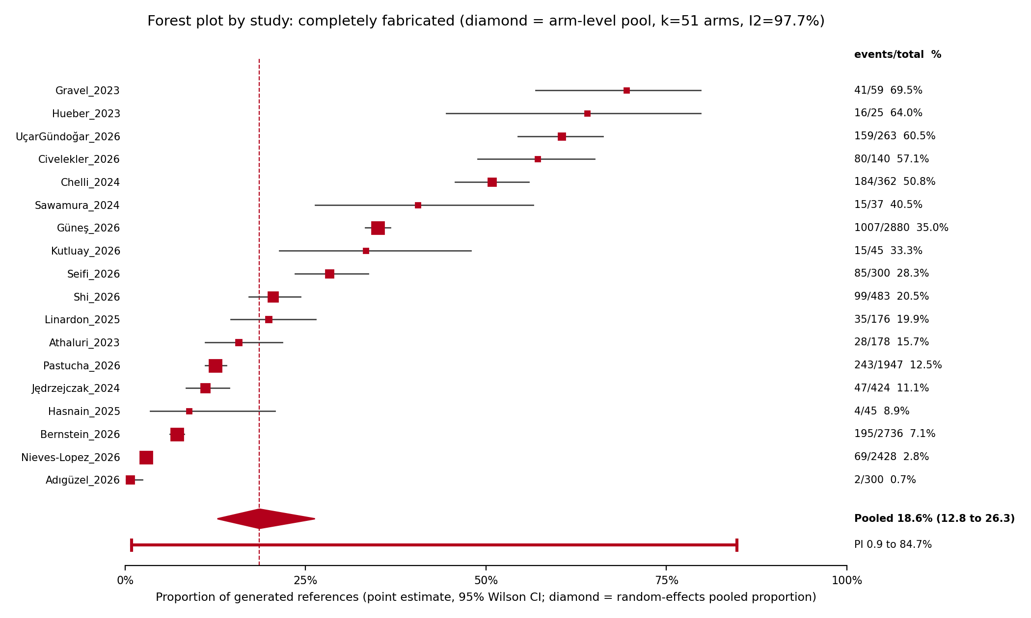
Figure 1. One row per study (study totals across its model arms). The diamond is the arm-level random-effects pooled proportion, 18.6% (95% CI 12.8 to 26.3); the capped line under it is the 95% prediction interval, 0.9 to 84.7%. The per-study sensitivity pool was 23.0%.

Forest plot: fully accurate, by study
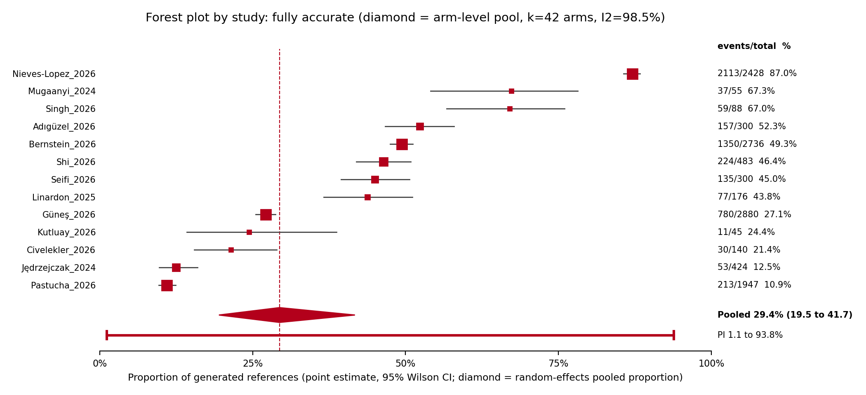
Figure 2. One row per study. Diamond: arm-level pooled proportion fully accurate, 29.4% (95% CI 19.5 to 41.7); capped line: 95% prediction interval. Per-study sensitivity pool 41.2%.

Forest plot: any major inaccuracy, by study
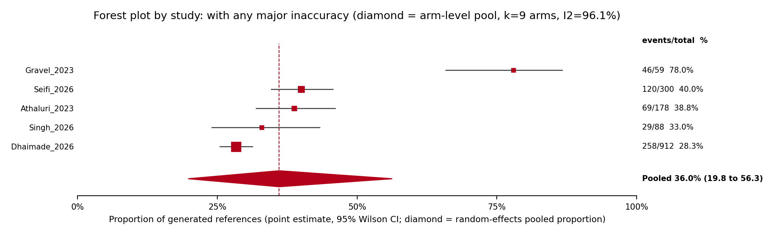
Figure 3. One row per study. Diamond: pooled proportion with any major inaccuracy including fabricated, 36.0% (95% CI 19.8 to 56.3), from 9 arms in 5 studies. This figure was missing from the first build and is restored here.

Appendix figures: forest plots by model arm

Fabricated, arms 1 of 3
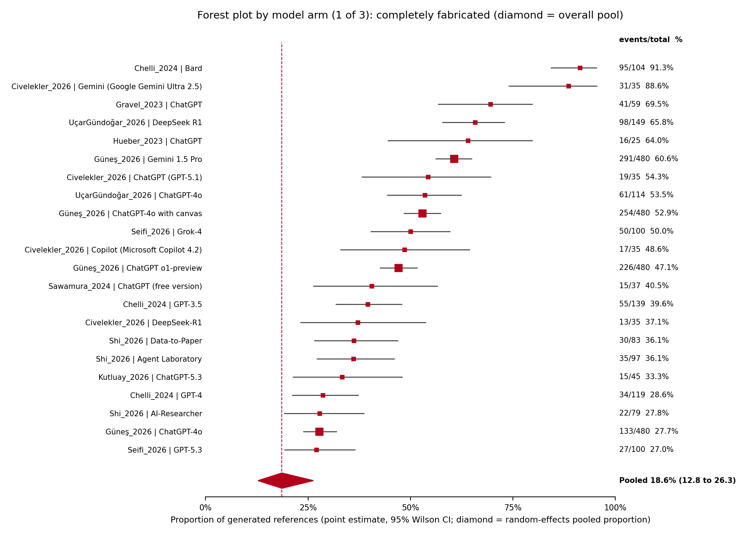
Fabricated, arms 1 of 3. The diamond on each panel is the overall arm-level pool.

Fabricated, arms 2 of 3
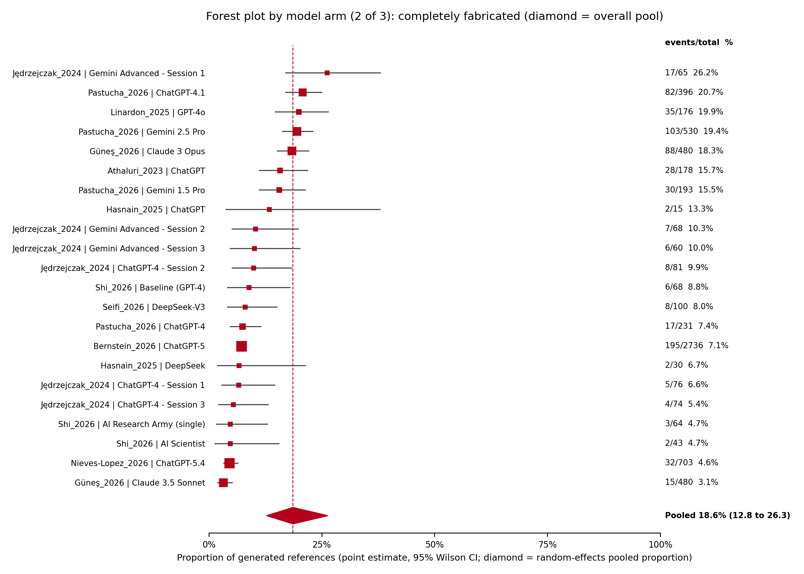
Fabricated, arms 2 of 3.

Fabricated, arms 3 of 3, with the prediction interval
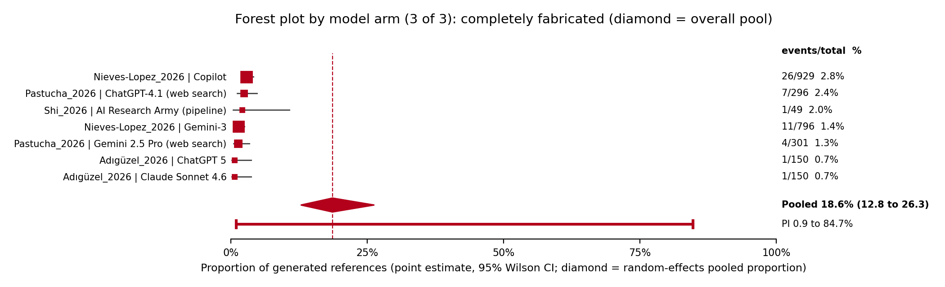
Fabricated, arms 3 of 3, with the prediction interval.

Fully accurate, arms 1 of 2
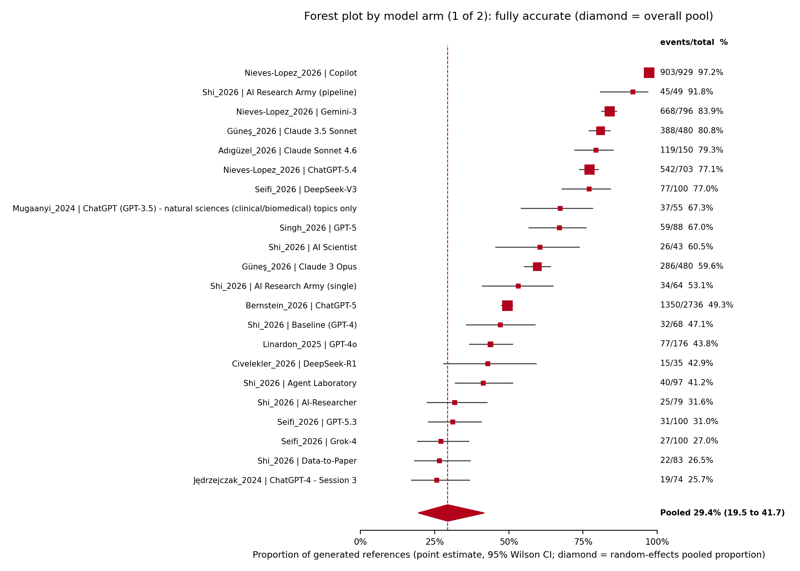
Fully accurate, arms 1 of 2.

Fully accurate, arms 2 of 2, with the prediction interval
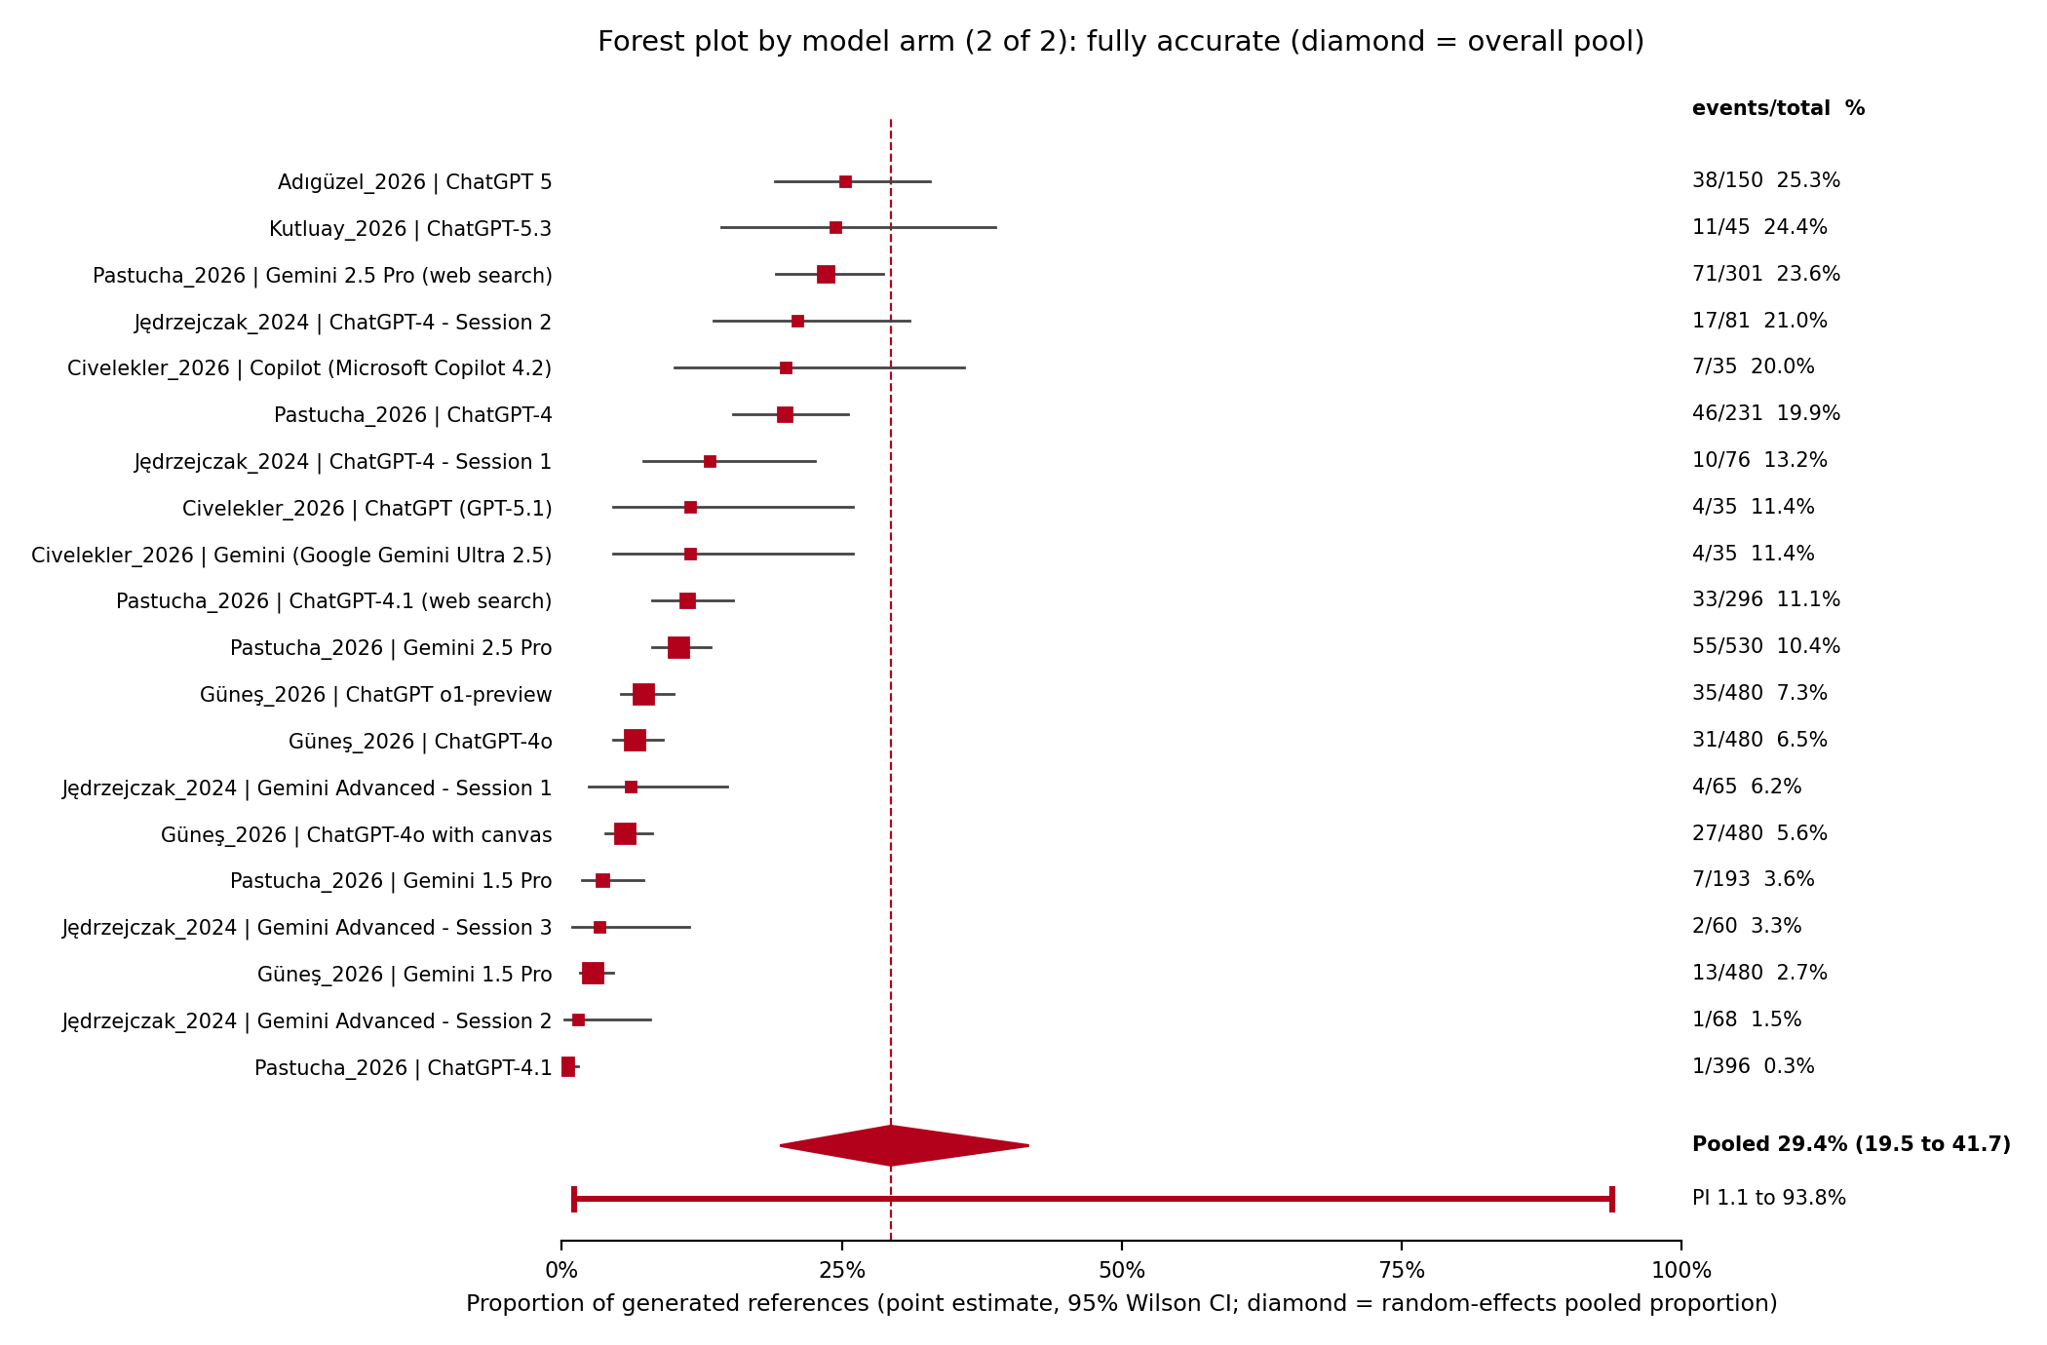
Fully accurate, arms 2 of 2, with the prediction interval.

Any major inaccuracy, all 9 arms
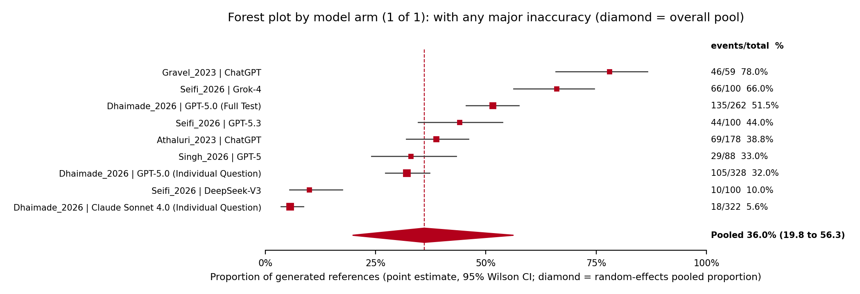
Any major inaccuracy, all 9 arms.

PRISMA flow diagram
