CPSC 479 Project 1: Introduction to HPC - Electing Two Leaders in a Ring Topology

This document contains the pseudo code for the implementation of the two leader election, the commands to run the program, the variables needed for the implementation, as well as the information about group members and screenshots of project execution.

Group Members:

Ryan McDonald - rtmcdonald96@csu.fullerton.edu

Set up Variables:

The algorithm that is executed in the project concurrently calculates the two leaders in our ring topology. This is done by first randomly generating an integer between 10-100 in each process. We take the value of 1 and concatenate it with this randomly generated number and then concatenate that with the rank of the process. For example if we have the process 5 which randomly generates the number 78. We would have the end value of 1785. To ensure each process generates a random number we seed the random number generator with the rank of the process and the time.

Along with the randomly generated value above we have two other integer values that are used to track the current highest even and highest odd value within our ring. Lastly we utilize a flag to determine if the randomly generated value is even or odd.

Algorithm Pseudocode:

random_value = randomly_generated_value  
 if random_value is even  
 flag = 1  
 else  
 flag = 0  
 highest_even = 0  
 highest_odd = 0  
 process rank 1-> n-1  
 receive highest even and odd value from (rank-1)%n  
 process rank 0 ->n-1  
 if random_value is even  
 if random_value > highest_even  
 highest_even = random_value  
 if random_value is odd  
 if random_value > highest_odd  
 highest_odd = random_value  
 send highest even and odd to (rank + 1) % size  
 process rank 0  
 receive highest even and odd from n-1  
 broadcast highest even and odd from process 0 to all processes  
 if random_value equals highest even  
 process is vice president  
 if random_value equals highest odd  
 process is president

Screenshots of Project Execution:

10 processes

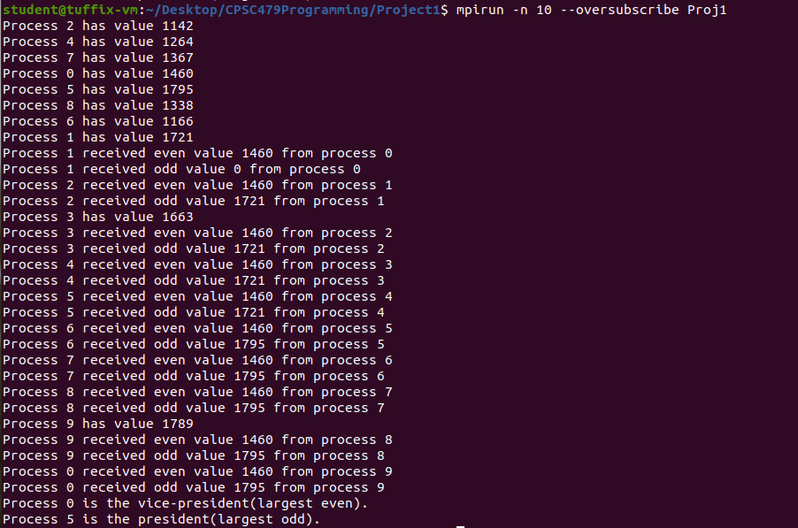

8 processes

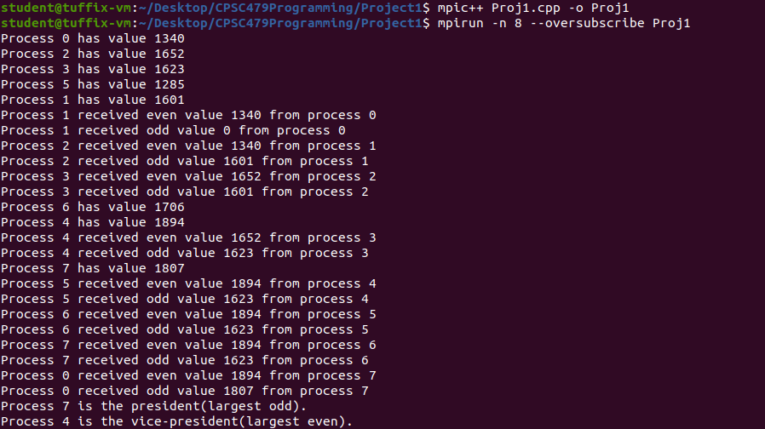

Screenshot of Group Members Information:

