Stored Cross-Site Scripting (XSS) vulnerability was found on the manage-employee.php page of the Kashipara Online Attendance Management System project V1.0. This vulnerability allows remote attackers to execute arbitrary scripts attack in /attendance/admin/manage-employee.php URL.

**Vulnerability Overview**

* **Official Website URL**

<https://www.kashipara.com/project/php/13168/online-attendance-management-system-php-project-source-code>

* **Affected Product Name: -** Online Attendance Management System

|  |  |
| --- | --- |
| **Affected Vendor** | Kashipara |
| **Affected Code File** | /attendance/admin/manage-employee.php |
| **Affected Parameter** | department |
| **Method** | POST |
| **Type** | Stored Cross-Site Scripting (XSS) |
| **Version** | V1.0 |

**Vulnerability Description**

A stored XSS vulnerability exists in Online Attendance Management System version V1.0, allowing an attacker to inject malicious scripts via the “**department**” field in the manage employee section of a Admin Panel. The malicious payload executes when the admin reviews the comments, potentially compromising the admin account and the underlying application.

**Steps to Reproduce**

1. **Access the Target application: -**

* Navigate to the admin account and their Dashboard <http://localhost/kasipara/attendance/admin/dashboard.php>
* Log in with **valid credentials**
* After accessing the dashboard, click on the **NO OF STAFF** area.

1. **Switch in the Manage Employee Section: -**

* When you click on the number of staff area, you will see the Manage Employees section as shown in your images.
* After this you have to click on the edit button as shown in the images.

1. **Navigate the Edit Page: -**

* Then you will see an edit employee page open.
* All the required fields must be filled in.

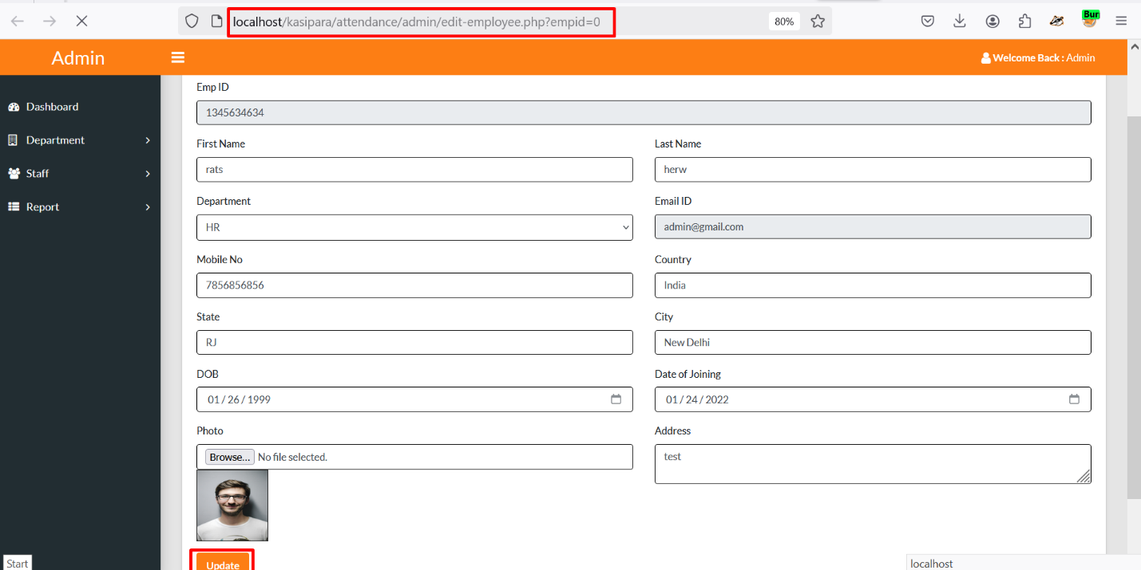

1. **Intercept the Request:**

* Enable Burp Suite and set up the browser to route traffic through it

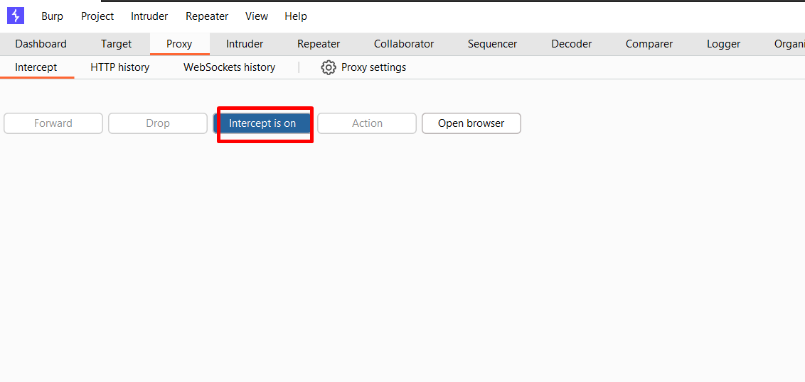

1. **Modify the Parameter:**

* Send the request to the Burp Suite Repeater and modify the “**department**” parameter with the following payload: **<script>alert(1)</script>**

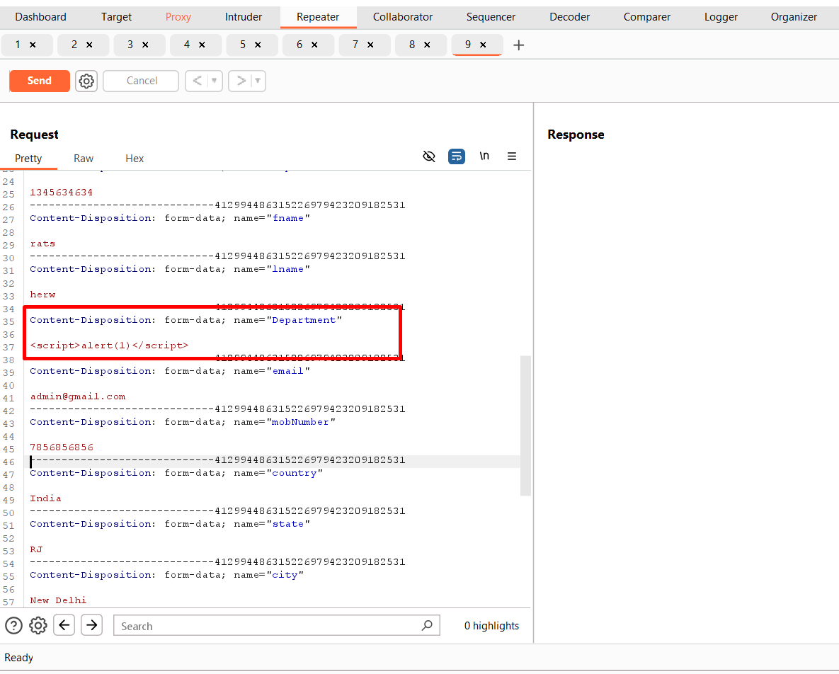

1. **Send the Modified Request:**

* Forward the modified request in the Burp Suite Repeater.
* Observe the delay in the response code.

1. **Trigger the Payload**: -

* Navigate to the “ACTION” section in the Manage Employee.
* Here you can see the payload has been stored in the “**department**” parameter.

* The payload will be executed as soon as the click view button is clicked.
* Observe the execution of the injected JavaScript payload.

**Impact**

* Execution of arbitrary JavaScript in the context of the admin's browser.
* Potential to steal admin cookies, hijack sessions, or perform actions on behalf of the admin.

**Recommendations**

* Input Validation: Enforce strict validation to block harmful scripts or tags.
* Output Encoding: Encode user inputs before rendering.
* Content Security Policy (CSP): Use a strong CSP to block unauthorized scripts.

**References**

OWASP XSS Prevention Cheat Sheet: <https://owasp.org>