Ryan Torelli

11481335

April 25, 2018

CptS 437: Homework #6

4. Principal Component Analysis

(a) The pca() function returns a principal component matrix and a reduced input matrix. The function determines the Singular Value Decomposition of the centered input matrix, truncates the left-hand matrix to a reduced number of principal components, and computes the product of the principal components and input matrix.

(b) The reconstruction() function computes the product of a principal component matrix and reduced data matrix and returns the transpose of that product matrix.

(c) The reconstruct_error() function computes Frobenius norm of the difference between initial and reconstructed matrix, returning the square of the norm.

(d) The reconstruction error approaches zero as the number of principal components approaches a full complement. For principal components, p = {10, 50, 100, 200}, the reconstruction error decreases as follows, {198843, 42323, 14733, 1401}. The reconstructed matrices, plotted as images, have greater resolution as principal components approach 256. Two images for each value of principal components are reproduced on the next page.

p = 10

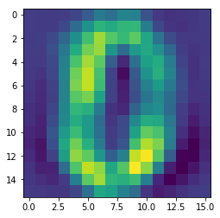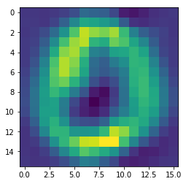

p = 50

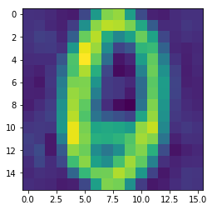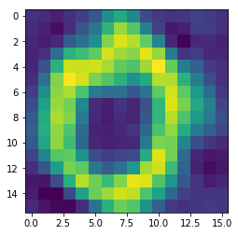

p = 100

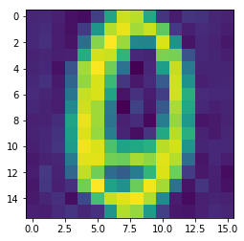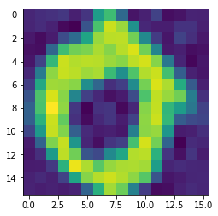

p = 200

