**https://link.springer.com/article/10.1007/s10967-007-0131-3**

**Experimental HPGe Coaxial Detector Response and Efficiency Compared to Monte Carlo Simulations (Nora):**

* BLUF: They only adjusted the dead layer thicknesses, and found that their were issues with matching high and low energy photons, along with poor matching at the detector edges, where the electric field in the crystal would become deteriorated. (doubled the inner dead layer thickness from 0.7mm to 1.4mm
* Adjusted just the detector dead layer, and the model improved, except near the rim of the detector
* The efficiency of the detector changes with age
* Model detector using specifications provided by the manufacturer, and compare them to the experimental results. Then simulations were repeated by adjusting parameters till the Full Energy peak efficiencies matched over a wide range of photon energies.
* The model had a bulletized Ge crystal with a density of 5.323 g/cm^3.
* No variance reduction technique was used.
* Only the dead layer thicknesses were altered.
* Center hole, will reduce efficiency for photon energies above 80 KeV
* A change of the internal dead layer thickness from 0.7mm to 1.4 mm
* Strongest disagreements, between the experimental and simulated results occurred near the edges. (More obvious for collimated scans)
* Some researchers have adjusted their dead layers on a photon energy case basis (Rodenas et al, 2003,2007).
  + Stating it is impossible to find an external dead-layer thickness that reproduces experimental results for all incident photon energies
* Concluded that just by changing the dead layer (and Ge crystal dimensions) the model will still not be sufficient

**Radiation Detection and Measurement (Glenn F. Knoll): Chapter 12**

* Surface dead layer: In reality, gamma rays of energies above 200 keV, can ignore the effects of the dead layer, in regards to attenuation. The dead layer, however, still reduces the active volume.
* The surface dead layer, on Ge detectors, may vary slowly over periods of time, because of the formation of surface channels. This is where the electric field and charge collection efficiency are reduced.
* Coaxial HPGe’s can be produced with larger active volumes, and the fillet edges help smooth out the charge collection flow, from interacting photons.
  + The closed end configuration helps lower leakeage currents on the front surface, along with providing a planar front surface where a special entrance window can be applied for lower energy/weakly penetrating radiation.
  + However, areas of reduced field strength occur in this configuration, compared to a true full coaxial crystal
* The main photon interactions in a Ge crystal are: Photoelectric effect (what we want), Compton scatter (scattering of a photon, before PE absorption), and pair production (produces .511 MeV peak). Figuer 12.17 in Knoll’s shows the fraction of FEP, for each type of interaction as a function of energy.
* It is important to account for secondary radiation ** as of now we are removing electrons from the model** but can easily add them back in.
* N-type detectors perform better at lower photon energies
  + Low energy photons below 150 keV tend to be absorbed/attenuated by the dead layer.
  + N-type detectors are able to take advantage of this 100keV region, where the PE effect dominates over Compton scatter
* Read page 485 for a possible experimental fit: equation 12.32
* Between 50 kev to 1.4 Mev it has been possible to construct an efficiency curve with an accuracy of bout 0.2% using monte Carlo models.
* Formula for Absolute Efficiency:

“The Institute of Electrical and Electronics Engineers (IEEE) 325-1996 specifies the counting efficiency using a 60Co point source placed 25 cm away from the front face of the detector, as: [3]

|  |  |
| --- | --- |
|  | Eq. 1 |

Where A is the total counts in the fitted full-energy peak, Ns is the total number of 1332.5 keV photons emitted by the source during the live time which is equal to:

|  |  |
| --- | --- |
|  | Eq. 2 |

Where A0 is the initial source activity (Becquerels), td is the age of the source (days), tL is the live time (seconds), t1/2 is the half-life (days), and γ is the photon yield (%). “(Egner,2017)

* **Absolute full-energy peak efficiency**, defined as the ratio of counts in the FEP divided by the number of gamma rays emitted by the source
* **Intrinsic efficiency** is defined as the number of full energy peak counts divided by the number of gamma rays incident on the detector (accounts for efficiency positional dependence (distance/angle from the source)
* **Relative Efficiency:** photo peak efficiency relative to a standard 3by3in NaI(Tl) scintillator, with a source-to-detector spacing of 25 cm for the 1.333 MeV gamma-ray photo peak from cobalt-60. (ANSI/IEEE Standard #325)
* Rule of Thumb/Estimate: The efficiency ration in percent is given by the detector volume in cm cubed, divided by a factor of 5.

[Experimental and Monte Carlo determination of Gamma Spectrometry Efficiency (Pavel Dryak,Petr Kovar):](http://www.nucleide.org/ICRM_GSWG/Workshop_2009/01_Monday_morning/05.%20HPGe%20MC_CMI.pdf)

* Created a model and performed X-rays, to verify manufacturers specifications, Canberra Detector
* Parameters checked experimentally:
  + Crystal Diameter and Height,
  + Inner hole diameter and height,
  + Distance between the detector cap and crystal
  + Cap material composition
  + Germanium crystal density
  + Aluminum density
  + Position of the crystal
  + Dead layer thicknesses (outer)
* Modeling Parameters adjusted:
  + Size of the contact pin – estimated/assumed contact pin material was brass
  + Densities of Ge and Al
    - Ge –p = 5.3233(5)g/cm3, published values of 5.323 and 5.35.
    - Al – p = 2.717(2) g/cm3
  + Radius of crystal
  + Dead Layer
* Electron motion adjustment (if we wanted to account for electrons)
  + Estep in material cards was increased from default(7) to 20, to improve more realistic electron motion:

c x--- Material Cards --------------------------------------x

m1 32000 -1.0 estep=30 $ Germanium ro=5.3255

m2 13000 -1.0 $ Aluminum ro=2.717

* + This lowered the high energy efficiency (in a better fitting manner)
  + Homogeneous dead layer assumption (0.5325(100) mm)
  + Their conclusion: “The exact description of the detector gives very good results of efficiencies.” And “MCNP method can be used for the Calibration of Ge detectors.”

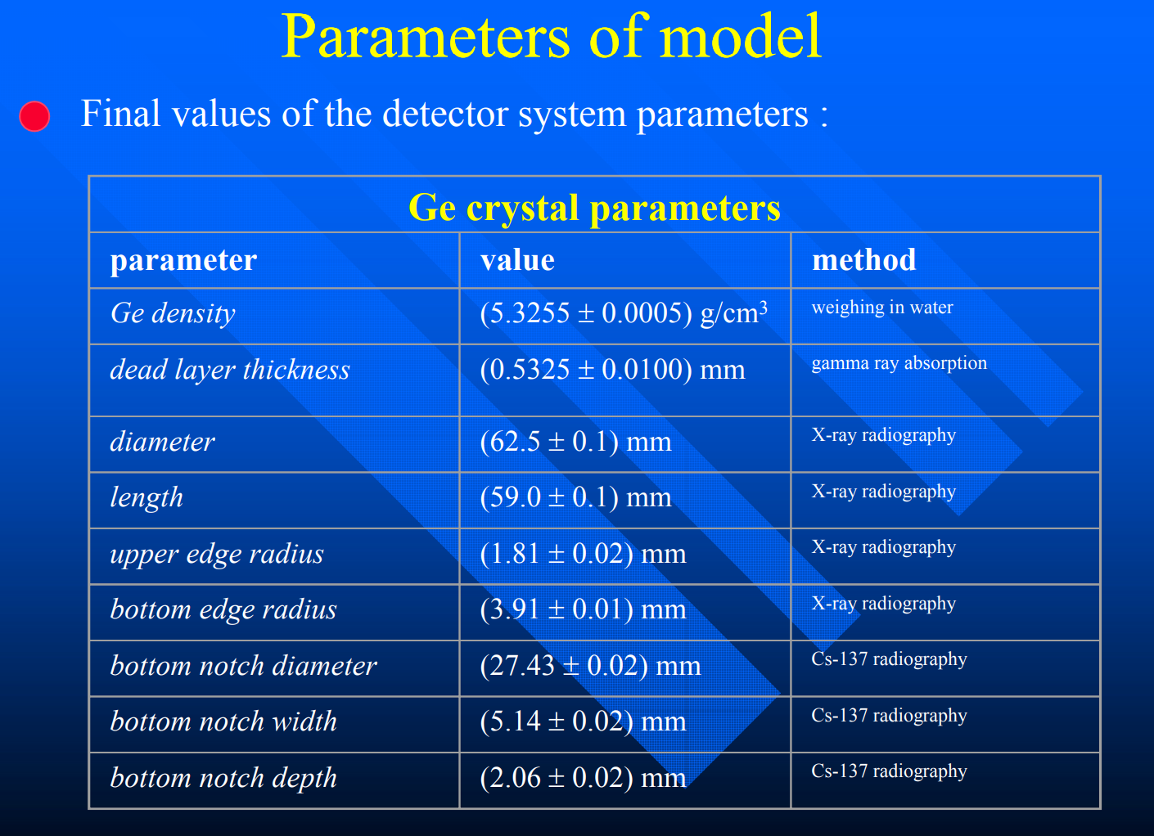

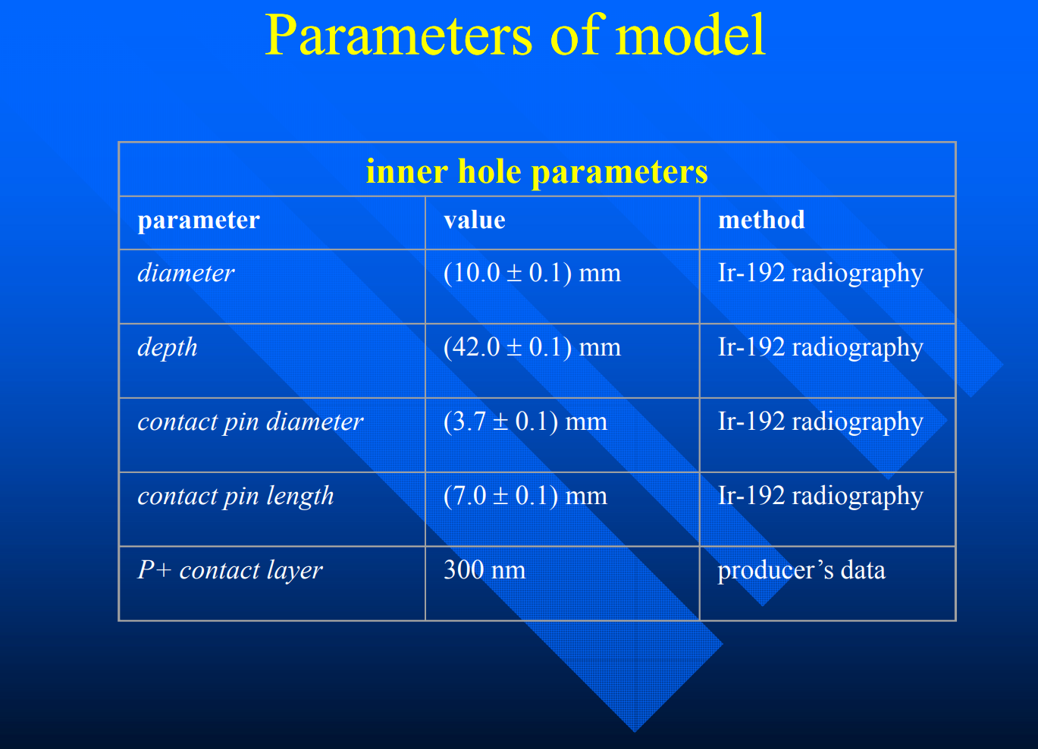

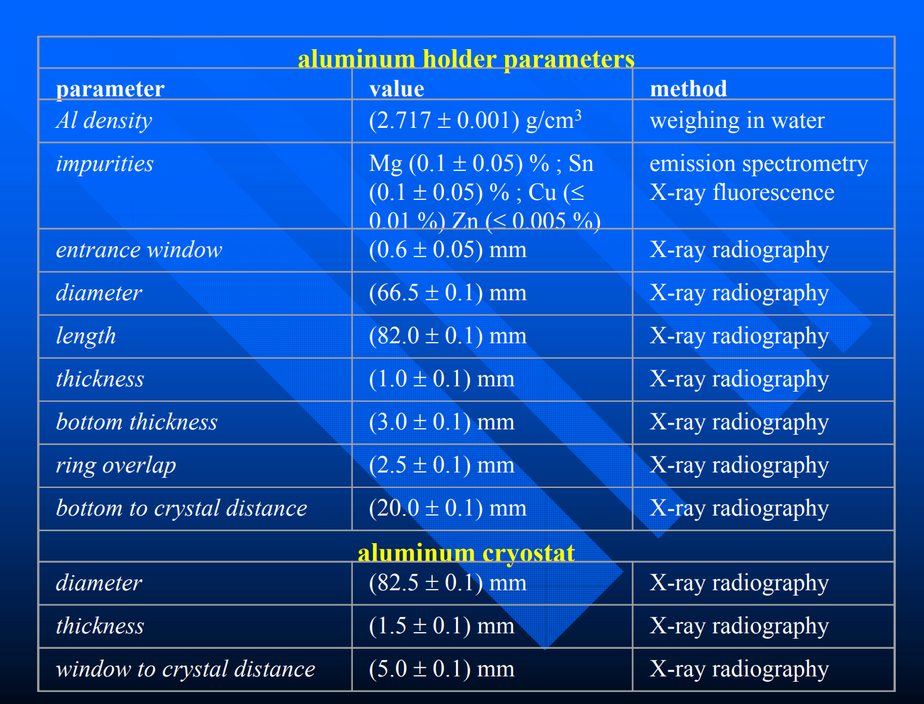

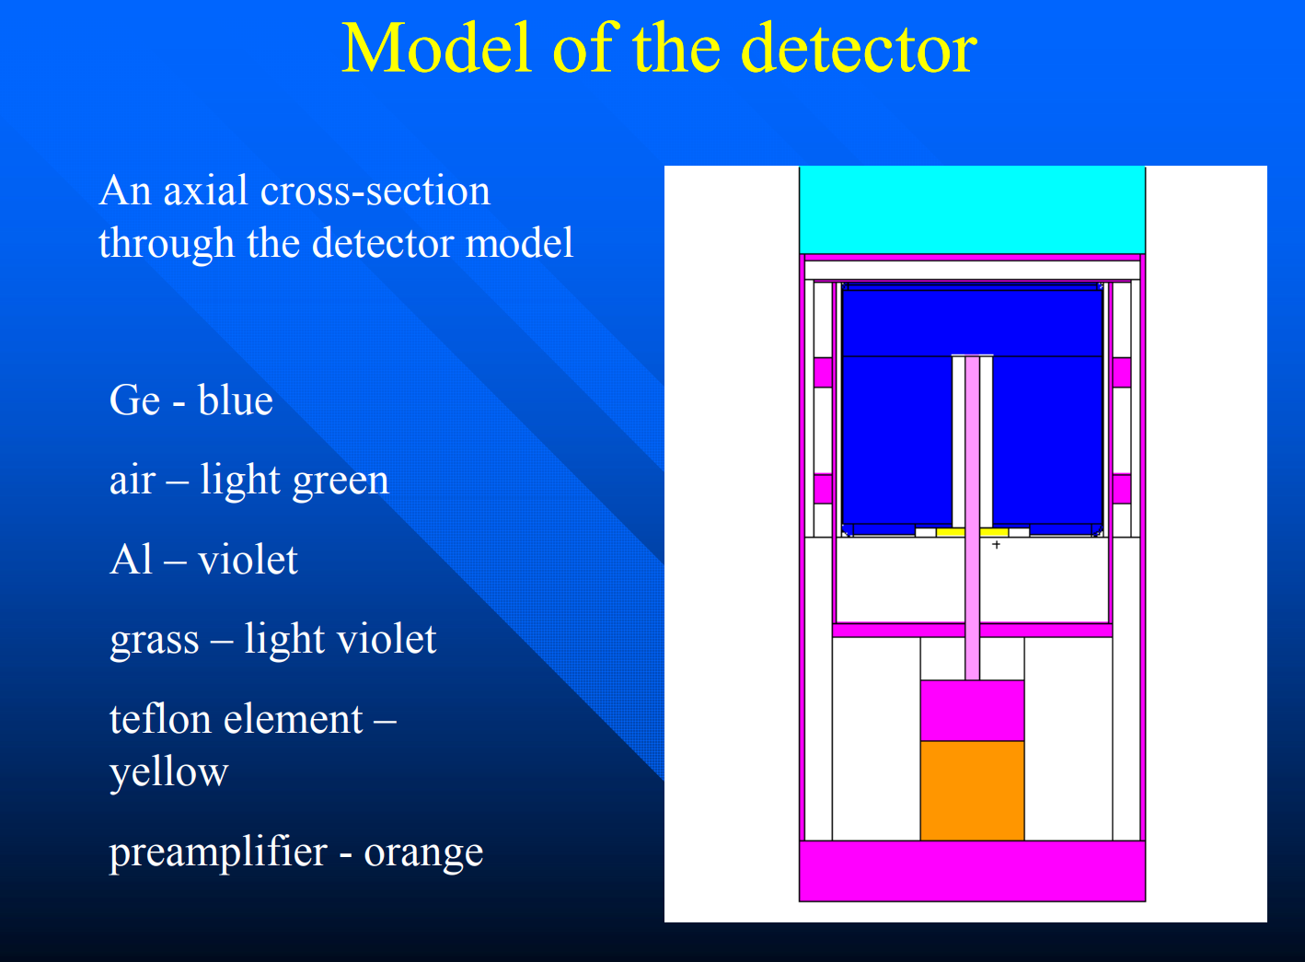

[Resolution and Sensitivity as a Function of Energy and Incident Geometry for Germanium Detectors (Keyser):](http://www.ortec-online.com/-/media/ametekortec/technical%20papers/high%20purity%20germanium%20detector%20applications%20and%20technology%20developements/efficiency-resolution-germanium-detectors-marc-03.pdf?la=en)

* Resolution and sensitivity change with position of incident photon
* Copper ring might have an affect down the side of the detector
* Conclusions: cannot always assume the detector to be of uniform thickness (found experimentally). And it has been found, that some detectors do have a uniform dead layer.

[Chapter 5: Full Energy Peak Efficiency Calibration fo HPGe Detector by MCNP:](http://shodhganga.inflibnet.ac.in/bitstream/10603/4710/14/14_chapter%205.pdf)

* Monte Carlo methods are free from coincidence summing
* These models, can be used to get the total efficiency required for coincidence summing corrections.
* Differences in manufacturer specifications and reality can occur due to temperature changes, uncertainty parameters (dead layer thickness and detector to endcap length differences).
* This issue can be resolved by: physically measuring the detector parameters, or by trying to match the experimental results by adjusting the paremeters.
* It has been observed, that there can be a dead layer thickness increase between 0.35 mm to 1.16 mm after 9 years of operation.
* Effect of Detector Parameters on the FEP Efficiency:
  + Varied detector parameters:
    - Ge Diameter – large effect (it is the overall volume that has the largest effect)
    - Ge Length
    - Inner Hole Diameter
    - Ge position with respect to the Be window – large effect
    - Dead layer – affects the active volume, and is also an attenuating layer that can stop less penetrating radiation
* Optimized Detector Geometry: The method of optimizing detector parameters to reproduce experimental data
  + Crystal Diameter, Length, and the dead layer thickness adjustments have obtained results with a 5-10% relative deviation.(Liye et al.2004),Binquan et al.2005, bochud et al 2006).
  + Tzika et al (2010) adjusted only the dead layer thickness and obtained results with 10% relative deviation
  + Karamanis (2003): increased the Ge-Al end cap distance by 8 mm, and the entrance Li dead layer by 600 um to get results within 5%
  + It’s been seen that most simulation codes can be used for routine measurements with 5-10% uncertainty – EUROMET exercise (lepy 2001)
  + Helmer 2003, Hardy 2002, Wang 2002 – obtained results less than 2% deviation
  + Budjas 2009, obtained results with an accuracy of 3% by adjusting the dead layer thickness and inner hole radius of a p-type detector.
  + Detector used: Closed End, Coaxial p-type DSG HPGe detector, 20% relative efficiency
    - 10E8 particles
    - See Figure:

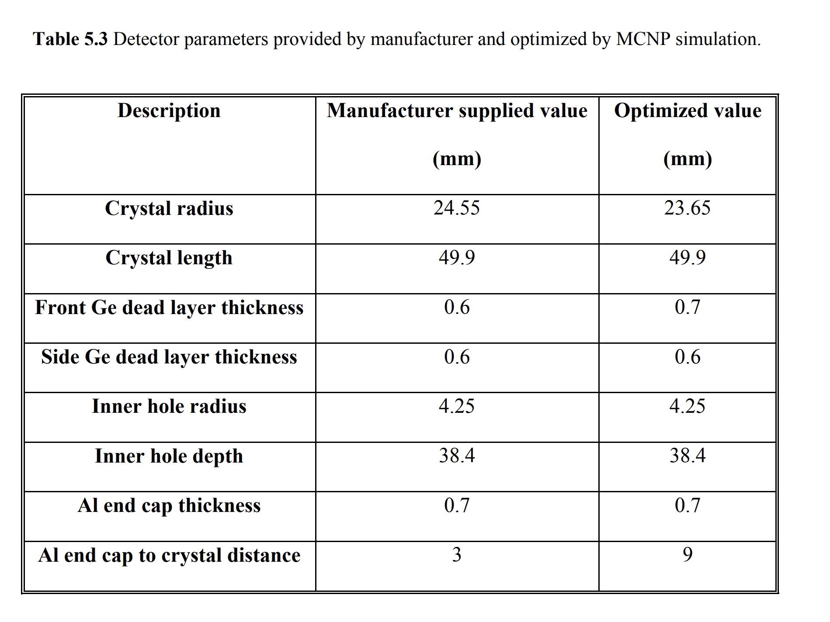

* + - There was found to be a strong dependence on sample-to-detector distance
    - Assume large dimensions measured by the manufacturer are not more than 10% off
    - Found that the Al end capt to crystal distance was the main source of discrepancy between the experimental and MCNP results. Huge change from 3 mm to 9 mm
      * I feel this is because the “active volume of the Ge crystal in reality is inefficient over the first few mm down the Ge crystal due to the geometry of the closed end coaxial. Not because the Ge crystal

Read Vargas et al. (2002) and kah(2003)

http://www.sciencedirect.com/science/article/pii/S0969806X16302791