**Problem 1 – Wavelength vs Wavenumber**

**Problem Statement: Wavenumber vs Wavelength**. Make an Excel chart recreation of Figure 6.6 in Petty with the radiance values in units of W m-2 sr-1 μm-1 and mW m-2 sr-1 cm. You’re going to need equation 6.1 to plot the Planck function curves, and you’re going to have to derive a conversion from wavenumber radiance units (mW m-2 sr-1 cm) to wavelength radiance units (W m-2 sr-1 μm-1). Use a LEEDR or MODTRAN plot to start. Slide set 4 can offer clues as to how to get Planck Functions in wavenumber or frequency radiance units.

**Fig 6-6**

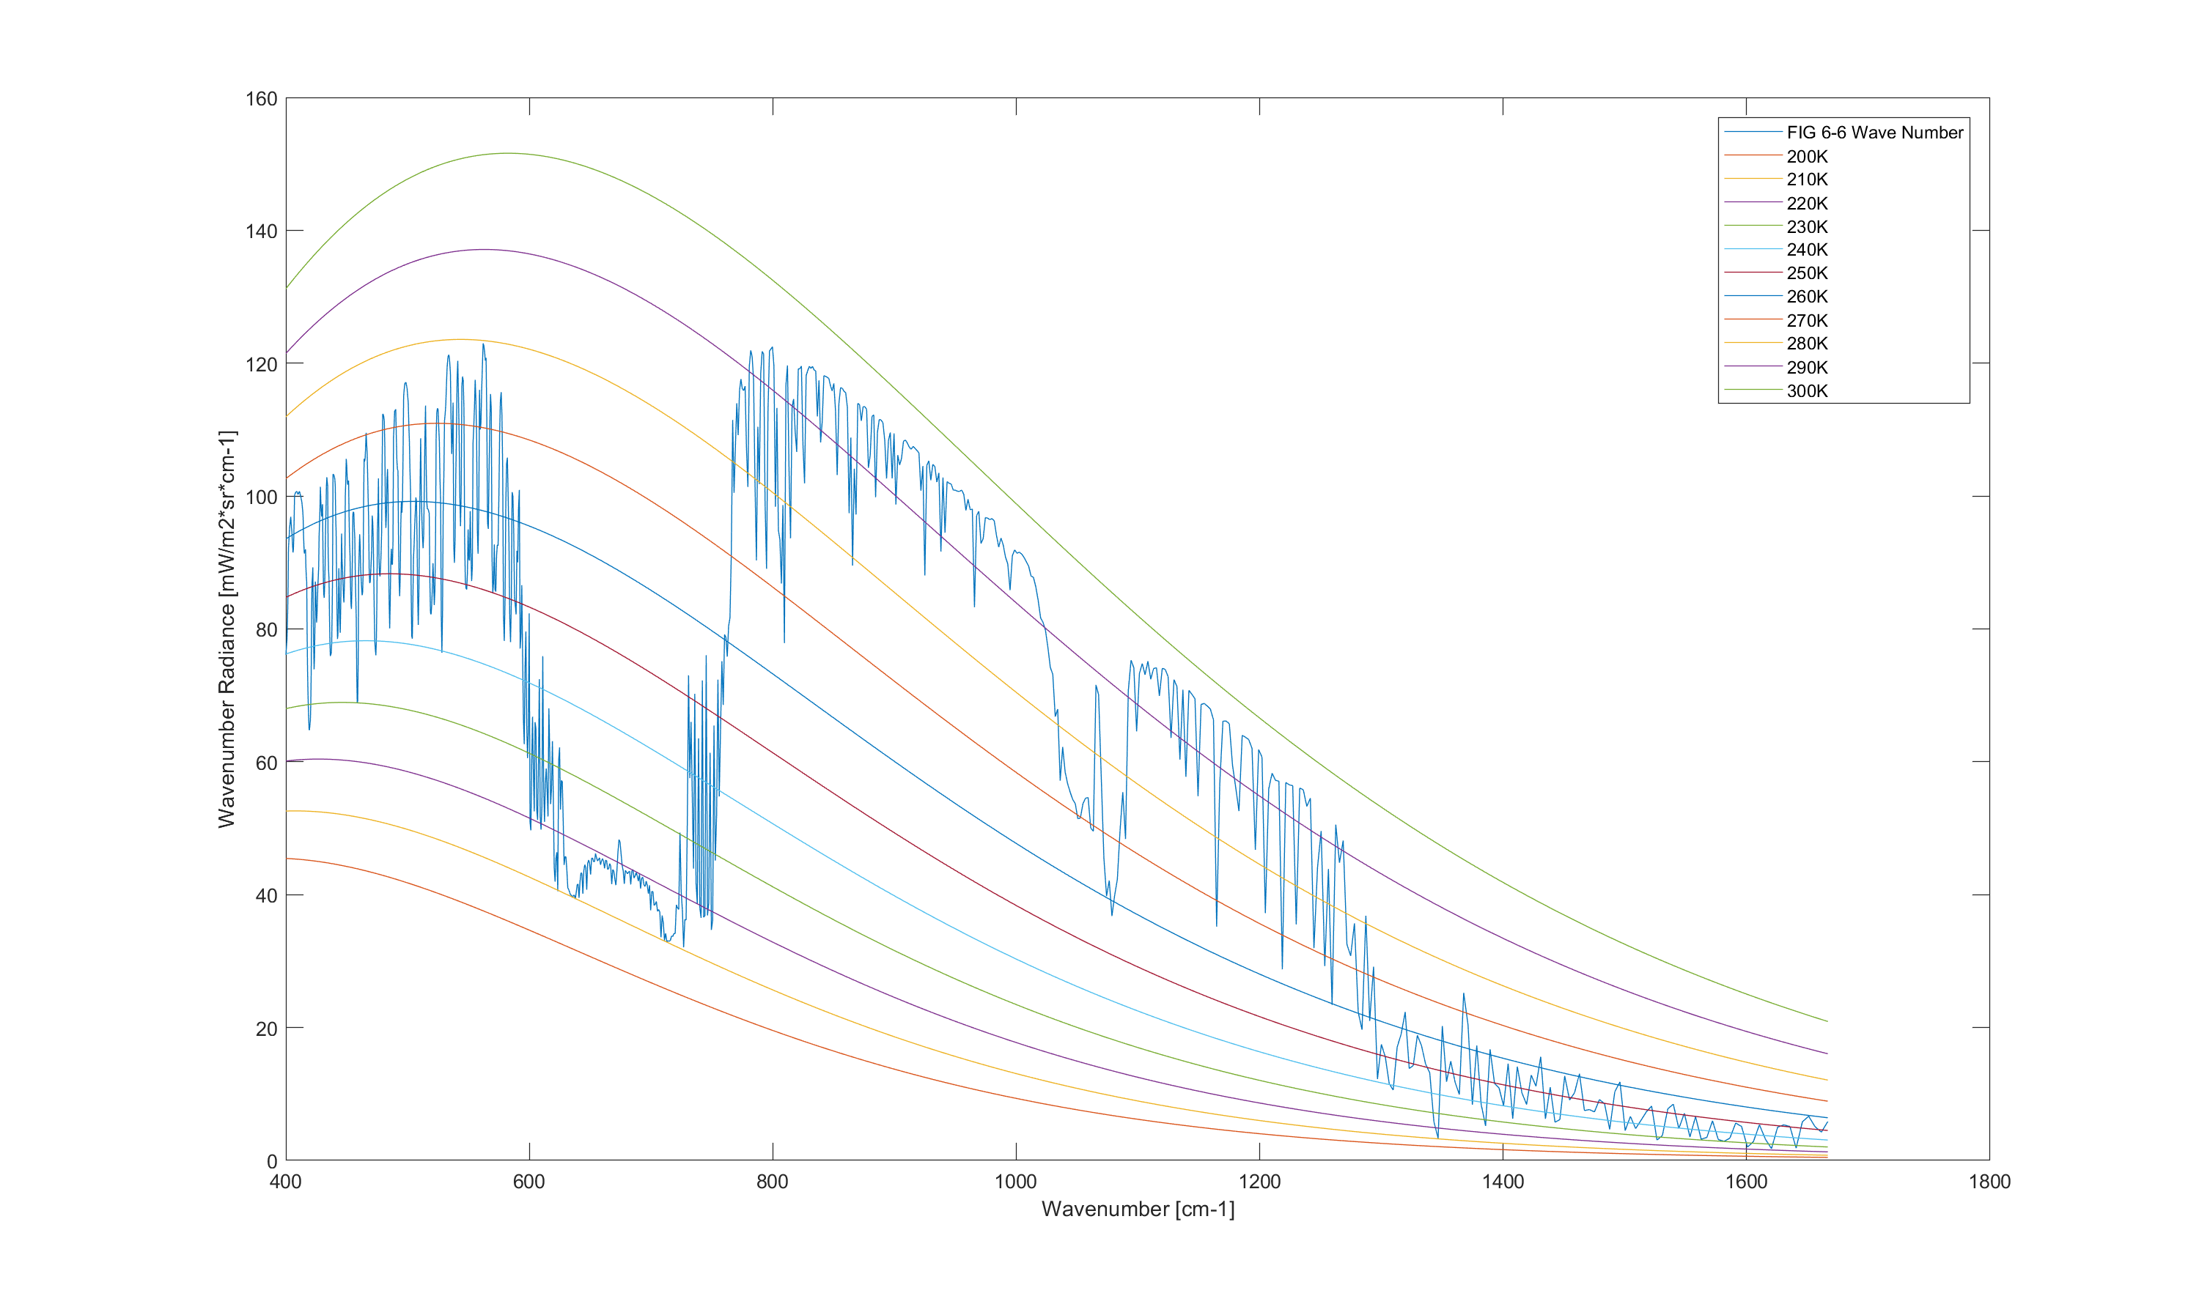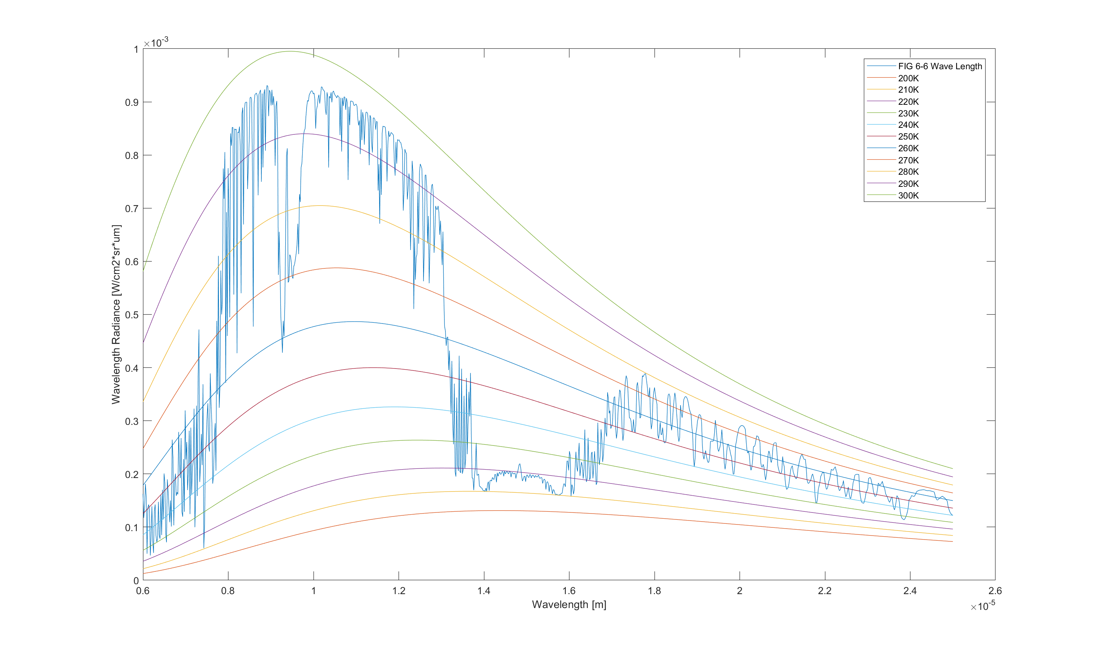

Fig 6-6 LEEDR Settings

1. Location
   1. 0 Lat, 180 Long
2. Atmosphere
   1. Standard
      1. Tropical
   2. 2000 Layers
3. Laser/Geometry
   1. Slant Path
      1. Altitude 100 kilometers
      2. Path Length 10 kilometers
4. Path Radiance Input
   1. Wavelength(μm) : 6.25 to 25
      1. Molecular Points: 1000
   2. Path
      1. Altitude: 100 kilometers
   3. Surface
      1. Temperature (K): 300

**Problem 2 – LEEDR vs MODTRAN**

**Problem Statement: LEEDR vs MODTRAN, LWIR**. In addition to Petty Fig 6.6, use both LEEDR and MODTRAN recreate to Petty figures 8.1, 8.2, and 8.3. You’ll have to save to excel or (or some other tool) and implement the conversion you used in #1 above to make the direct comparison to Petty’s figures. The objective here is to try to match as closely as possible to the satellite or ground-based sensor data as possible with the model output; and to determine which model affords the easiest way to get the best match.

**General Observations:** MODTRAN is not cable of creating the same plots as LEEDR due to the lack of weather controls, working surface types, and wavelength/number range. The lowest MODTRAN can go is a wavenumber of 500 cm-1. Additionally, temperature had to be put at unrealistic scenarios in order to get the simulated graph to come closer to matching what LEEDR and Petty showed for a few of the plots. With this in mind while MODTRAN is simplistic in what can be changed and a bit easier in terms of User Interface and speed; it is harder to use then LEEDR when recreating a range of plots.

**Fig 6-6**

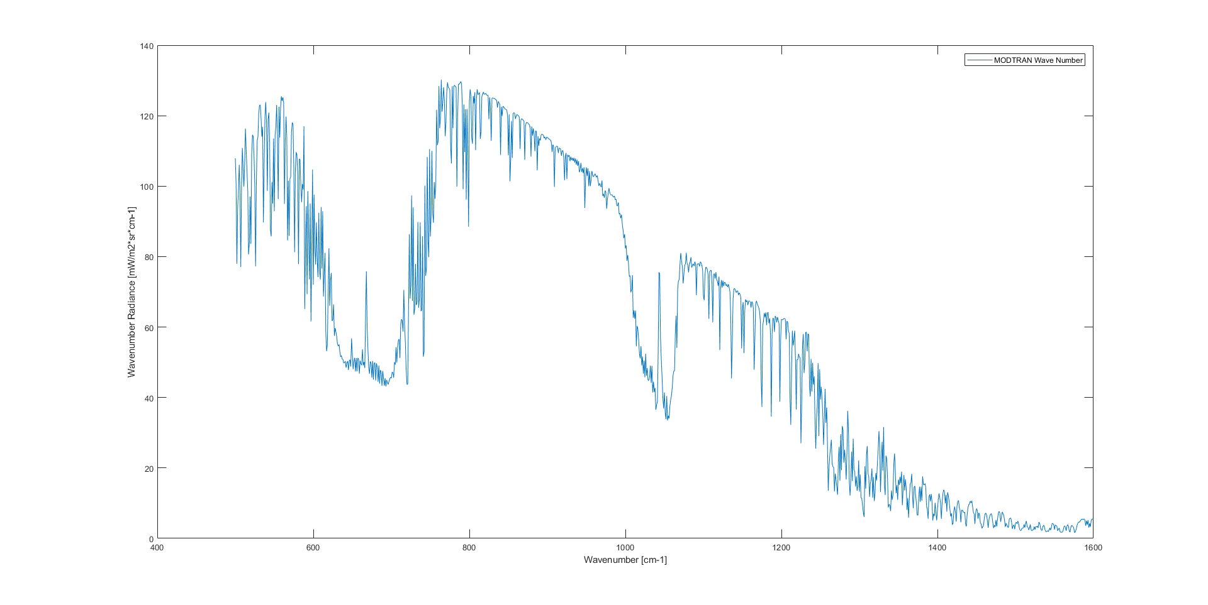

Fig 6-6 LEEDR Settings

1. Location
   1. 0 Lat, 180 Long
2. Atmosphere
   1. Standard
      1. Tropical
   2. 2000 Layers
3. Laser/Geometry
   1. Slant Path
      1. Altitude 100 kilometers
      2. Path Length 10 kilometers
4. Path Radiance Input
   1. Wavelength(μm) : 6.25 to 25
      1. Molecular Points: 1000
   2. Path
      1. Altitude: 100 kilometers
   3. Surface
      1. Temperature (K): 300

Fig 6-6 MODTRAN Settings

1. Atmospheric Profile
   * 1. 1976 US Standard
2. Ground and Geometry
   1. Surface Properties
      1. Ground Temperature : 27 C
   2. Path Type and Geometry
      1. Slant Path
         1. Observer Altitude 100 kilometers
         2. Target Altitude 0 kilometers
         3. Zenith Angle 180 Deg
3. Comparisons
   1. Wavenumber : 500 to 1600
   2. Data Resolution: 1
4. Orientation and Solar Position
   1. Observer Location : 0 Lat, 180 Long

**Fig 8-1**

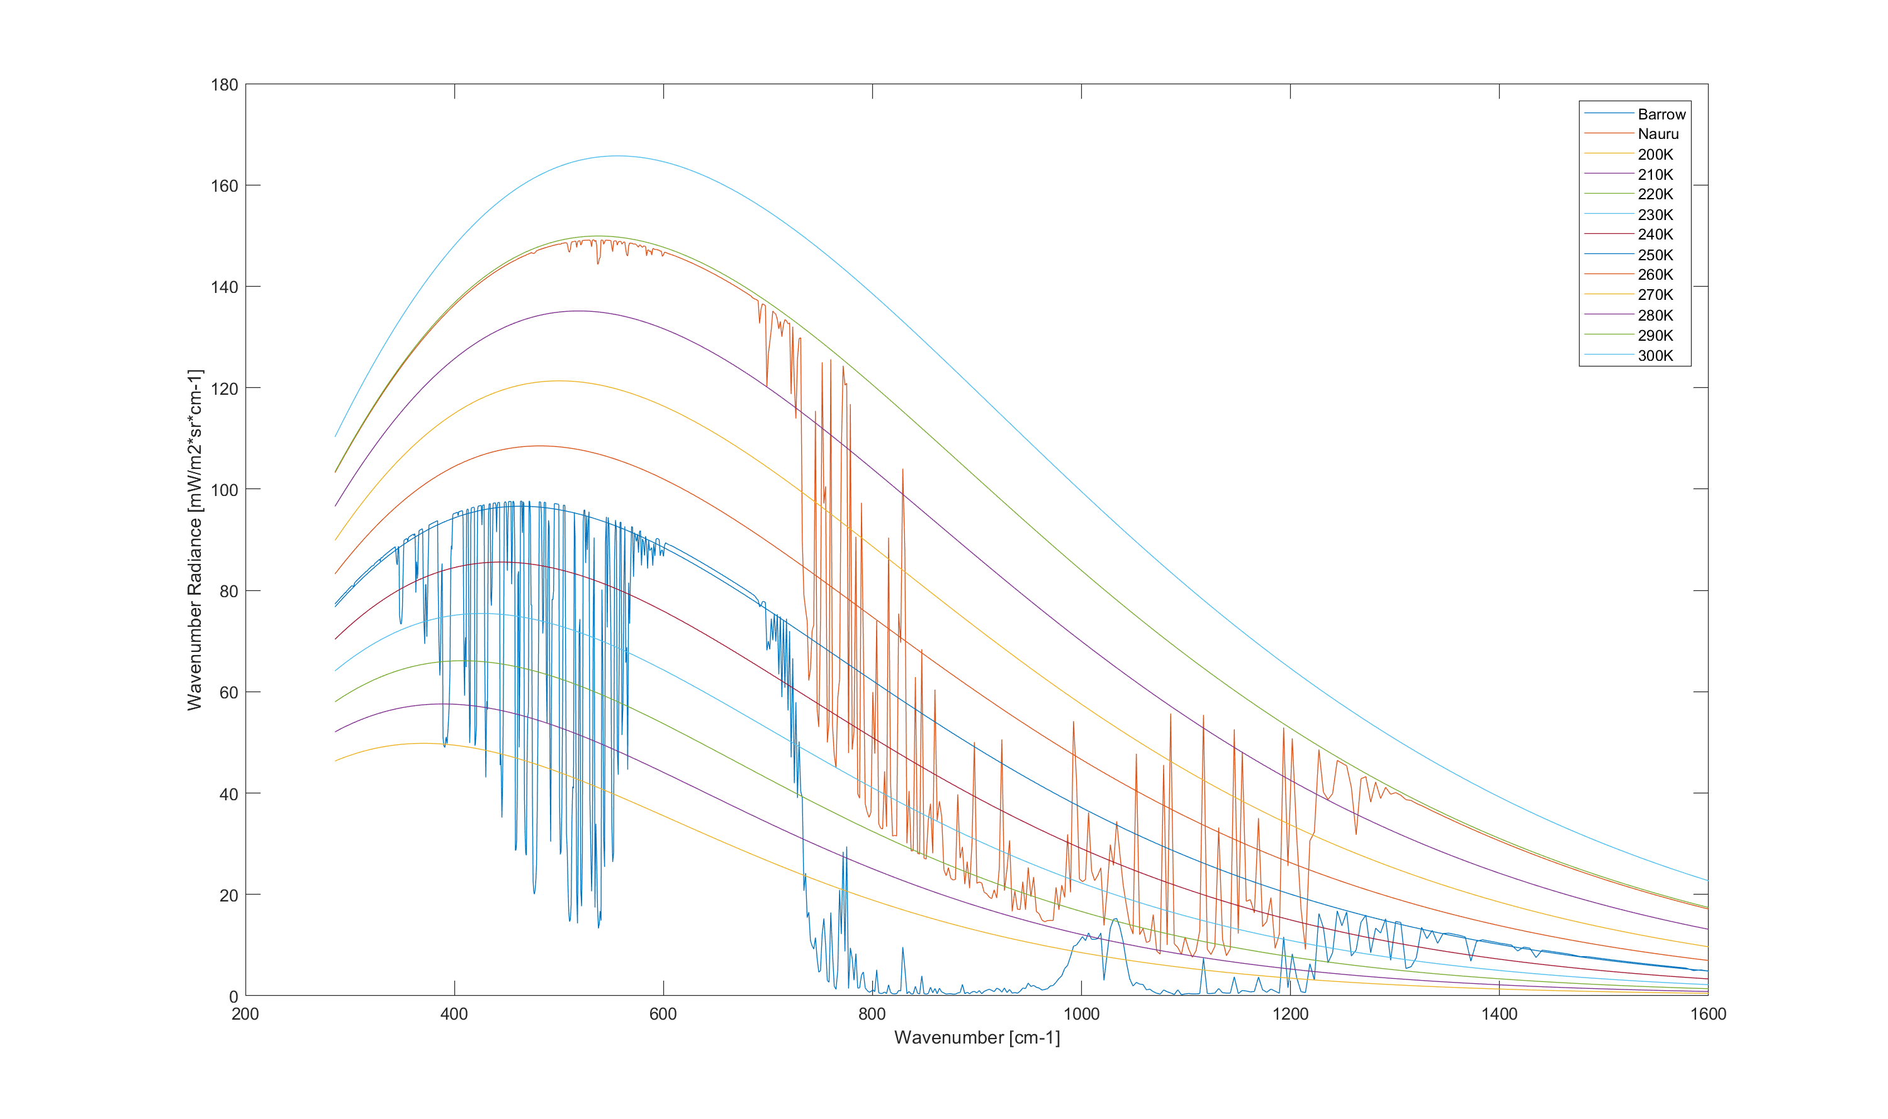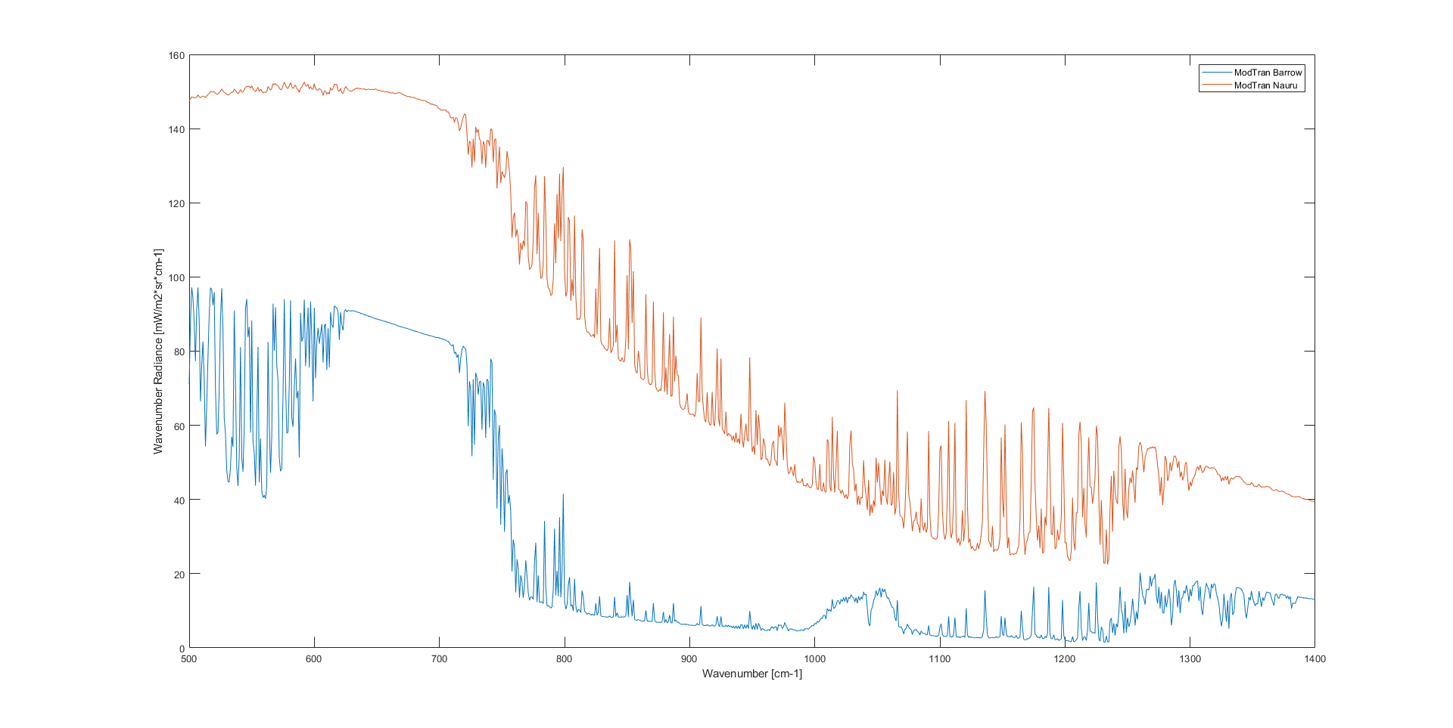

While the correct temperature for Nauru could not be reached it did match both the overall curve and radiance in the LEEDR plot. MODTRAN on the other had to be heavily manipulated to what could be considered unrealistic levels in order to match as closely as it did.

Nauru LEEDR Settings

1. Location
   1. 0.5 N Lat, 193 W Long
2. Atmosphere
   1. Standard
      1. Tropical
   2. 2000 Layers
3. Laser/Geometry
   1. Slant Path
      1. Altitude 100 kilometers
      2. Path Length 10 kilometers
4. Path Radiance Input
   1. Wavelength(μm) : 6.25 to 25
      1. Molecular Points: 1000
   2. Path
      1. Altitude: 100 kilometers
      2. Zenith: 0 deg
   3. Surface
      1. Temperature (K): 300

Barrow LEEDR Settings

1. Location
   1. 71.3 N Lat, 156.8 W Long
2. Atmosphere
   1. Standard
      1. Polar North
   2. 2000 Layers
3. Laser/Geometry
   1. Slant Path
      1. Altitude 100 kilometers
      2. Path Length 10 kilometers
4. Path Radiance Input
   1. Wavelength(μm) : 6.25 to 25
      1. Molecular Points: 1000
   2. Path
      1. Altitude: 100 kilometers
      2. Zenith: 0 deg
   3. Surface
      1. Temperature (K): 245

Nauru MODTRAN Settings

1. Atmospheric Profile
   * 1. 1976 US Standard
   1. Aerosol
      1. Maritime
2. Ground and Geometry
   1. Surface Properties
      1. Ground Temperature : -50 C
      2. Surface: Ocean
   2. Path Type and Geometry
      1. Slant Path
         1. Observer Altitude 0 kilometers
         2. Path Length 100 kilometers
         3. Zenith Angle 0 Deg
3. Comparisons
   1. Wavenumber : 500 to 1600
   2. Data Resolution: 1
4. Orientation and Solar Position
   1. Observer Location : 0.5 N Lat, 193 W Long

Barrow MODTRAN Settings

1. Atmospheric Profile
   * 1. Subarctic Winter
   1. Aerosol
      1. Rural
2. Ground and Geometry
   1. Surface Properties
      1. Ground Temperature : -100 C
      2. Surface: Snow Cover
   2. Path Type and Geometry
      1. Slant Path
         1. Observer Altitude 0 kilometers
         2. Path Length 100 kilometers
         3. Zenith Angle 0 Deg
3. Comparisons
   1. Wavenumber : 500 to 1600
   2. Data Resolution: 1
4. Orientation and Solar Position
   1. Observer Location : 71.3 N Lat, 156.8 W Long

**Note:** Surface types did not change the overall outcome by a significant amount when creating Barrow in MODTRAN.

**Fig 8-2**

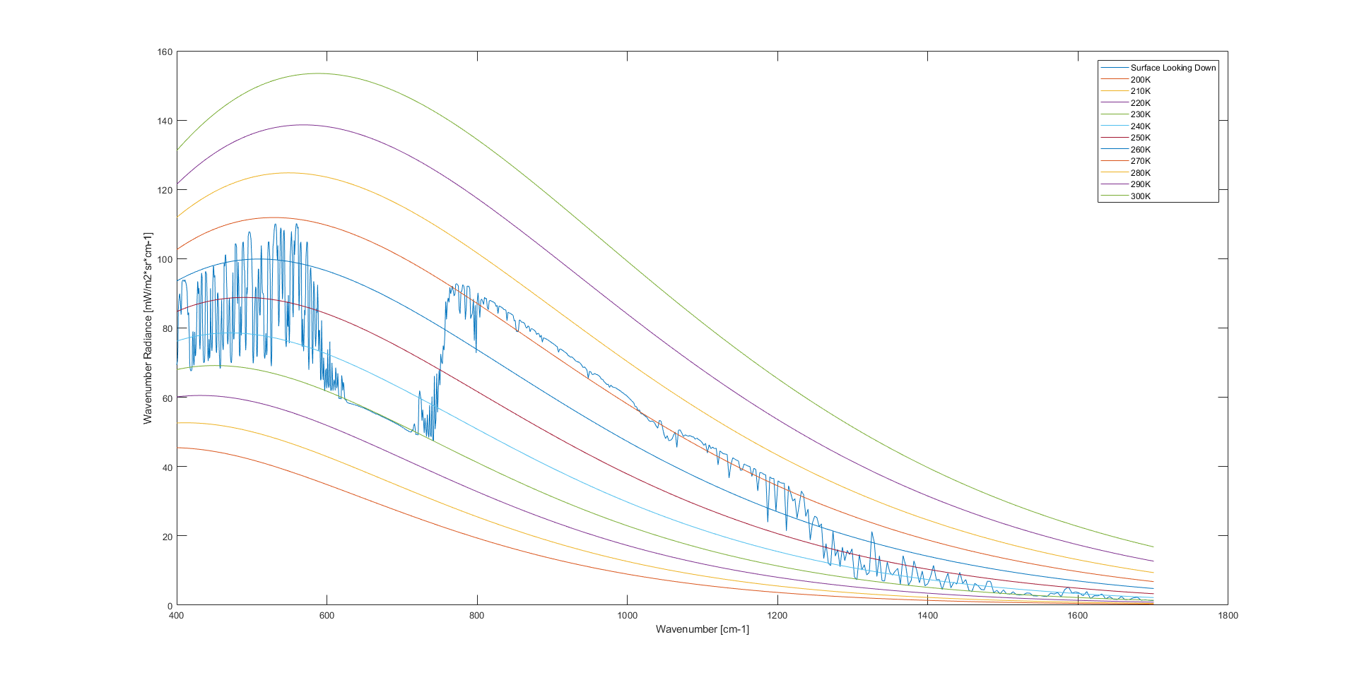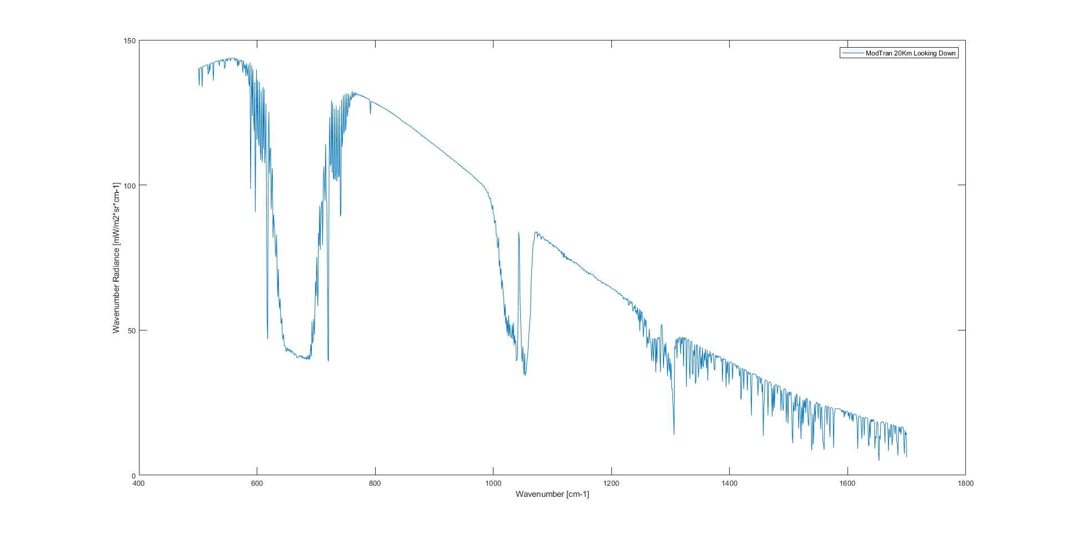

Something to note for these two plots is that the second point of interest appeared in the MODTRAN version at the cost of not matching the radiance. LEEDR was incapable of creating the second POI on the other hand.

20 KM Looking Down LEEDR Settings

1. Location
   1. 90 N Lat, 0 Long
2. Atmosphere
   1. Standard
      1. Polar North
   2. 2000 Layers
3. Laser/Geometry
   1. Slant Path
      1. Altitude 20 kilometers
      2. Path Length 10 kilometers
4. Path Radiance Input
   1. Wavelength(μm) : 5.88 to 25
      1. Molecular Points: 1000
   2. Path
      1. Altitude: 20 kilometers
      2. Zenith: 180 deg
   3. Surface
      1. Temperature (K): 273

20 KM Looking Down MODTRAN Settings

1. Atmospheric Profile
   * 1. Sub-Arctic Winter
   1. Aerosol
      1. Maritime
2. Ground and Geometry
   1. Surface Properties
      1. Ground Temperature : -10 C
      2. Surface: Ocean
   2. Path Type and Geometry
      1. Slant Path
         1. Observer Altitude 20 kilometers
         2. Path Length 20 kilometers
         3. Zenith Angle 180 Deg
3. Comparisons
   1. Wavenumber : 500 to 1700
   2. Data Resolution: 1
4. Orientation and Solar Position
   1. Observer Location : 90 N Lat, 0 Long

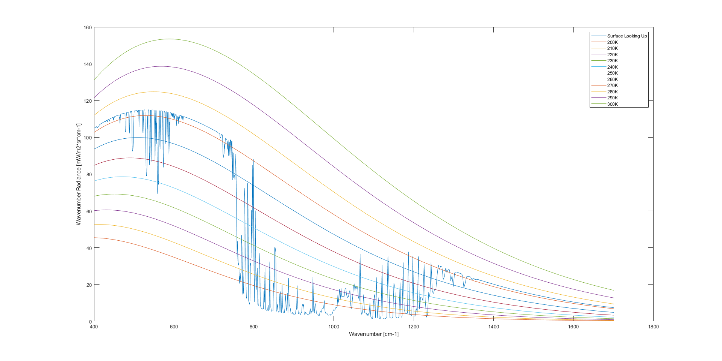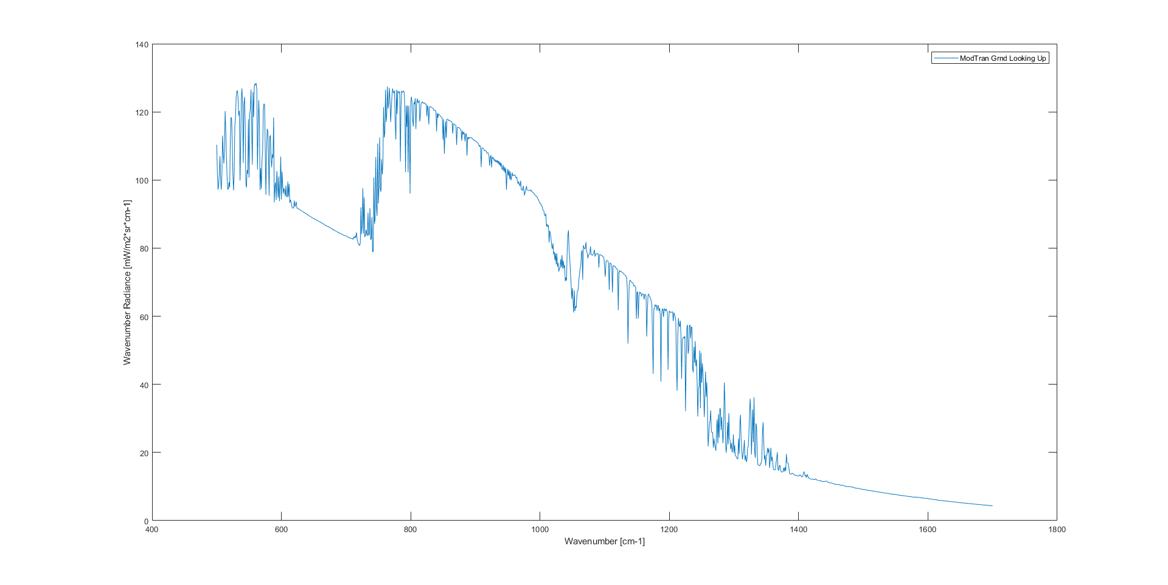

Ground Looking Up LEEDR Settings

1. Location
   1. 90 N Lat, 0 Long
2. Atmosphere
   1. Standard
      1. Polar North
   2. 2000 Layers
3. Laser/Geometry
   1. Slant Path
      1. Altitude 20 kilometers
      2. Path Length 10 kilometers
4. Path Radiance Input
   1. Wavelength(μm) : 5.88 to 25
      1. Molecular Points: 1000
   2. Path
      1. Altitude: 1 meter
      2. Zenith: 0 deg
   3. Surface
      1. Temperature (K): 273

Ground Looking Up MODTRAN Settings

1. Atmospheric Profile
   * 1. Sub-Arctic Winter
   1. Aerosol
      1. Maritime
2. Ground and Geometry
   1. Surface Properties
      1. Ground Temperature : -10 C
      2. Surface: Ocean
   2. Path Type and Geometry
      1. Slant Path
         1. Observer Altitude 1 foot
         2. Path Length 20 kilometers
         3. Zenith Angle 0 Deg
3. Comparisons
   1. Wavenumber : 500 to 1700
   2. Data Resolution: 1
4. Orientation and Solar Position
   1. Observer Location : 90 N Lat, 0 Long

**Fig 8-3**

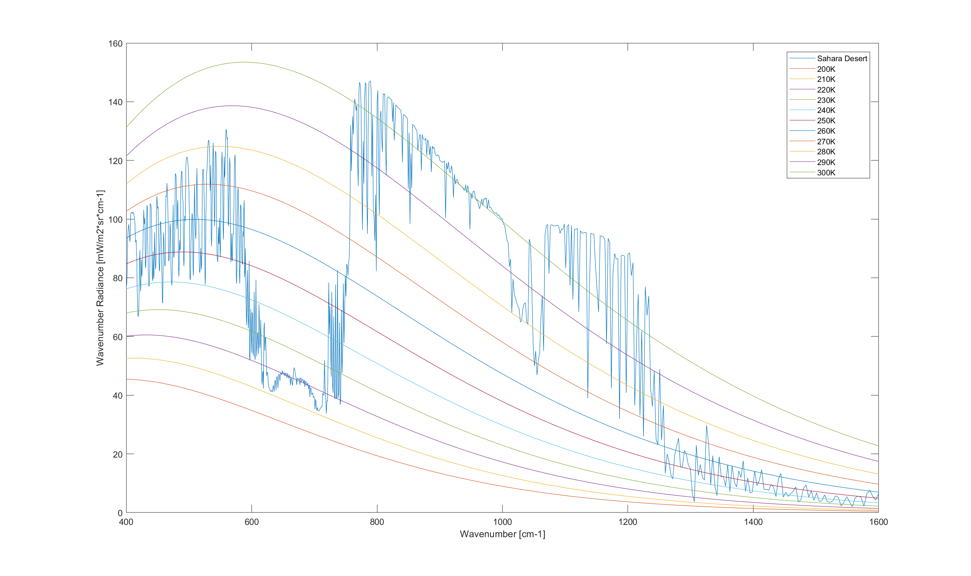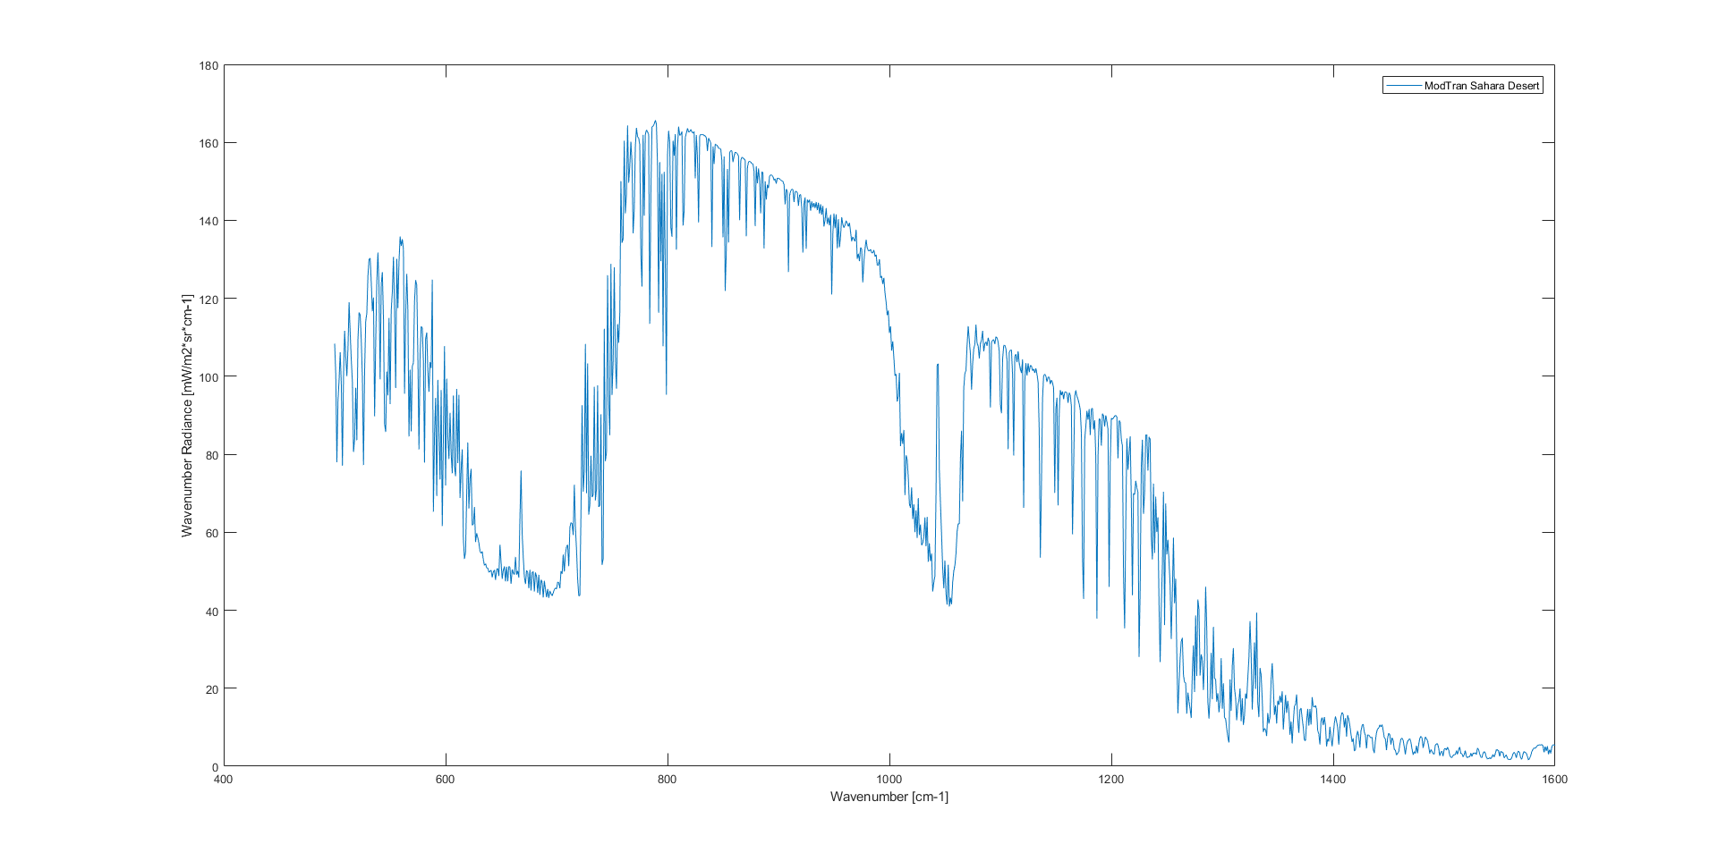

The MODTRAN plot matches better in terms of larger wavelengths while the LEEDR matches better in terms of smaller wavelengths. By looking at the radiance values it is possible to state that the MODTRAN plot likely hits the same temperatures that Petty depicts while the LEEDR plot does not quite get as hot.

Sahara Desert LEEDR Settings

1. Location
   1. 23 N Lat, 26 E Long
2. Atmosphere
   1. Standard
      1. Desert
   2. 2000 Layers
3. Laser/Geometry
   1. Slant Path
      1. Altitude 100 kilometers
      2. Path Length 100 kilometers
4. Path Radiance Input
   1. Wavelength(μm) : 6.25 to 25
      1. Molecular Points: 1000
   2. Path
      1. Altitude: 100 kilometers
      2. Zenith: 180 deg
      3. Resolution: 200
   3. Surface
      1. Temperature (K): 330

Sahara Desert MODTRAN Settings

1. Atmospheric Profile
   * 1. Standard
   1. Aerosol
      1. Desert Extinction
2. Ground and Geometry
   1. Surface Properties
      1. Ground Temperature : 57 C
      2. Surface: Desert
   2. Path Type and Geometry
      1. Slant Path
         1. Observer Altitude 100 kilometers
         2. Path Length 100 kilometers
         3. Zenith Angle 180 Deg
3. Comparisons
   1. Wavenumber : 500 to 1600
   2. Data Resolution: 1
4. Orientation and Solar Position
   1. Observer Location : 23 N Lat, 334 W Long

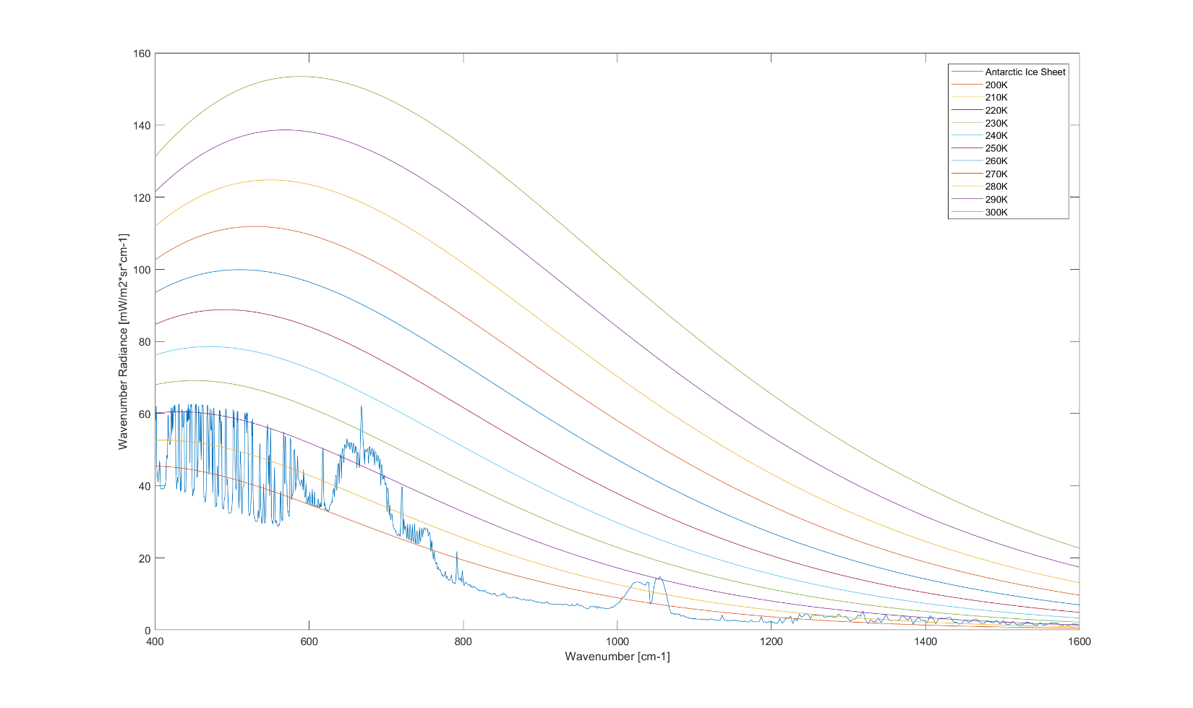

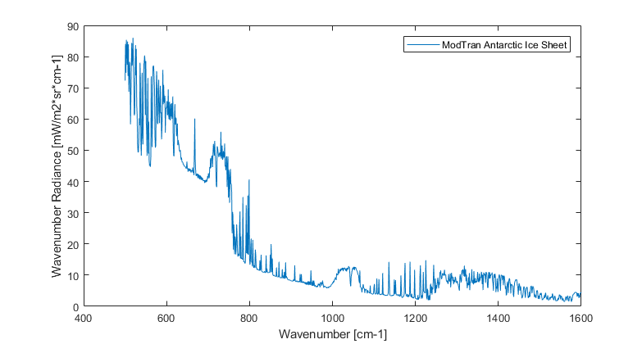

Both plots fail to get cold enough with low enough radiance values prior to the 800th wavenumber when compared to Petty. It should be noted that the LEEDR plot is a better overmatch for this figure, most likely since it could take advantage of NOMAD.

Antarctic Ice Sheet LEEDR Settings

1. Location
   1. -80 N Lat, 0 Long
2. Atmosphere
   1. NOMADs
      1. 26 September 2017
   2. 2000 Layers
3. Laser/Geometry
   1. Slant Path
      1. Altitude 100 kilometers
      2. Path Length 100 kilometers
4. Path Radiance Input
   1. Wavelength(μm) : 6.25 to 25
      1. Molecular Points: 1000
   2. Path
      1. Altitude: 100 kilometers
      2. Zenith: 180 deg
      3. Resolution: 200
   3. Surface
      1. Temperature (K): 184

Antarctic Ice Sheet MODTRAN Settings

1. Atmospheric Profile
   * 1. Standard
   1. Aerosol
      1. Desert Extinction
2. Ground and Geometry
   1. Surface Properties
      1. Ground Temperature : -89 C
      2. Surface: Sea Ice
   2. Path Type and Geometry
      1. Slant Path
         1. Observer Altitude 100 kilometers
         2. Path Length 100 kilometers
         3. Zenith Angle 180 Deg
3. Comparisons
   1. Wavenumber : 500 to 1600
   2. Data Resolution: 1
4. Orientation and Solar Position
   1. Observer Loc : -80 N Lat, 0 Long

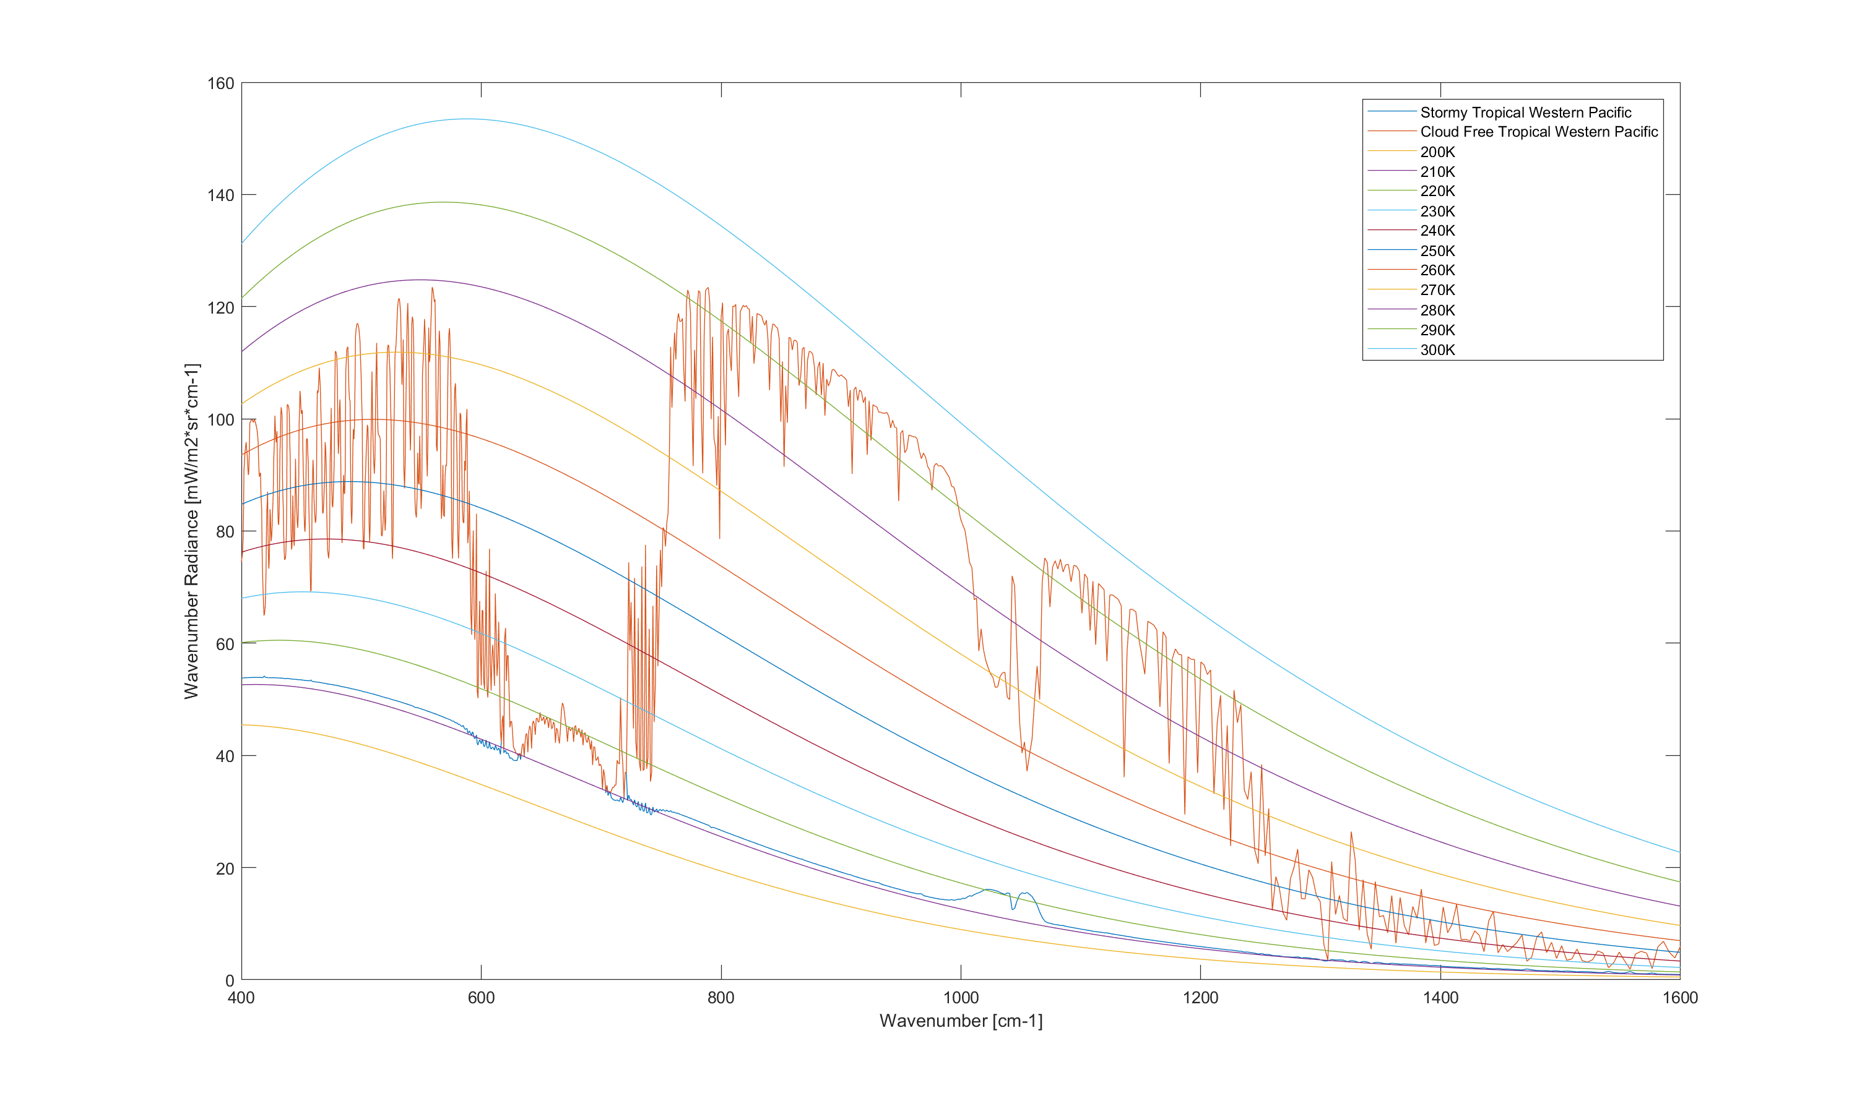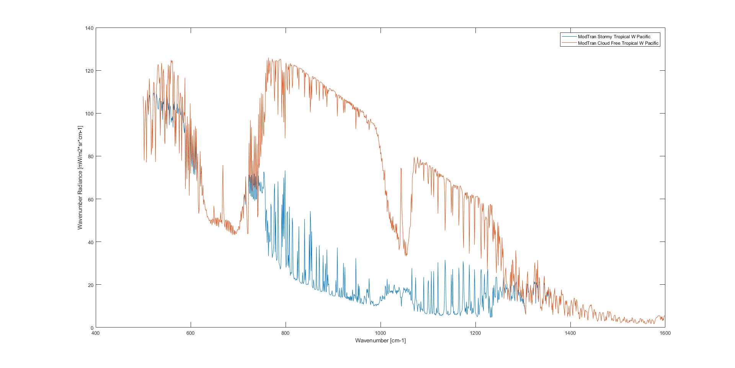

LEEDR’s rendition of this plot managed to match essentially perfectly with Petty. Meanwhile, the MODTRAN version failed to get remotely close until after the 800th wavenumber. This is most likely due to the weather effects that LEEDR has access to that MODTRAN does not.

Tropical Normal LEEDR Settings

1. Location
   1. 20 N Lat, 144 E Long
2. Atmosphere
   1. Standard
      1. Tropical
   2. 2000 Layers
3. Clouds/Rain
   1. Stratus Maritime
      1. Altitude (m): 1000 – 13700
4. Laser/Geometry
   1. Slant Path
      1. Altitude 100 kilometers
      2. Path Length 100 kilometers
5. Path Radiance Input
   1. Wavelength(μm) : 6.25 to 25
      1. Molecular Points: 1000
   2. Path
      1. Altitude: 100 kilometers
      2. Zenith: 180 deg
      3. Resolution: 200
   3. Surface
      1. Temperature (K): 300

Tropical Storm LEEDR Settings

1. Location
   1. 20 N Lat, 144 E Long
2. Atmosphere
   1. Standard
      1. Tropical
   2. 2000 Layers
3. Clouds/Rain
   1. Stratus Maritime
      1. Altitude (m): 1000 – 13700
4. Laser/Geometry
   1. Slant Path
      1. Altitude 100 kilometers
      2. Path Length 100 kilometers
5. Path Radiance Input
   1. Wavelength(μm) : 6.25 to 25
      1. Molecular Points: 1000
   2. Path
      1. Altitude: 100 kilometers
      2. Zenith: 180 deg
      3. Resolution: 200
   3. Surface
      1. Temperature (K): 300

Tropical Normal MODTRAN Settings

1. Atmospheric Profile
   * 1. Standard
   1. Aerosol
      1. Maritime
2. Ground and Geometry
   1. Surface Properties
      1. Ground Temperature : 27 C
      2. Surface: Ocean
   2. Path Type and Geometry
      1. Slant Path
         1. Observer Altitude 100 kilometers
         2. Path Length 100 kilometers
         3. Zenith Angle 180 Deg
3. Comparisons
   1. Wavenumber : 500 to 1600
   2. Data Resolution: 1
4. Orientation and Solar Position
   1. Observer Location : 20 N Lat, 216 W Long

Tropical Storm MODTRAN Settings

1. Atmospheric Profile
   * 1. Standard
   1. Aerosol
      1. Maritime
2. Ground and Geometry
   1. Surface Properties
      1. Ground Temperature : -90 C
      2. Surface: Cloud Deck
   2. Path Type and Geometry
      1. Slant Path
         1. Observer Altitude 100 kilometers
         2. Path Length 100 kilometers
         3. Zenith Angle 180 Deg
3. Comparisons
   1. Wavenumber : 500 to 1600
   2. Data Resolution: 1
4. Orientation and Solar Position
   1. Observer Location : 20 N Lat, 216 W Long

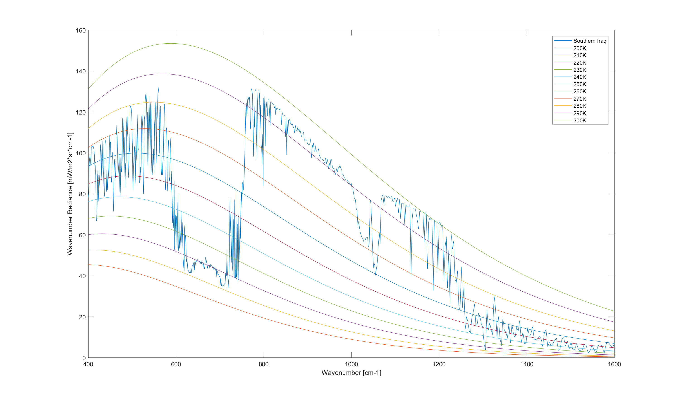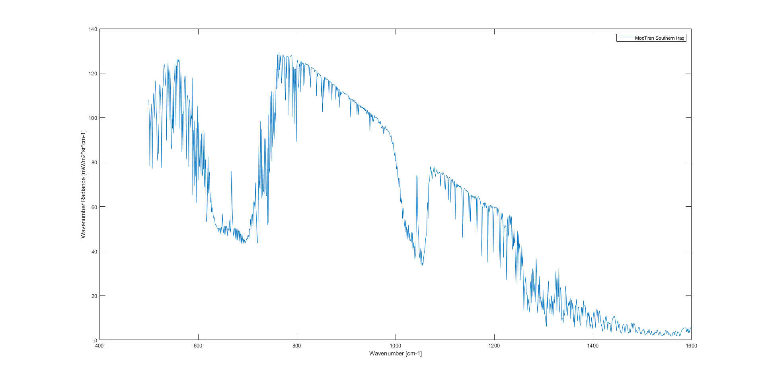

Neither plot could manage to have the same radiance and temperature for the early wavenumbers that Petty depicted. However they do match in later wavenumbers.

Southern Iraq LEEDR Settings

1. Location
   1. 31 N Lat, 44 E Long
2. Atmosphere
   1. Standard
      1. Desert
   2. 2000 Layers
3. Laser/Geometry
   1. Slant Path
      1. Altitude 100 kilometers
      2. Path Length 100 kilometers
4. Path Radiance Input
   1. Wavelength(μm) : 6.25 to 25
      1. Molecular Points: 1000
   2. Path
      1. Altitude: 100 kilometers
      2. Zenith: 180 deg
   3. Surface
      1. Temperature (K): 305

Sahara Desert MODTRAN Settings

1. Atmospheric Profile
   * 1. Standard
   1. Aerosol
      1. Desert Extinction
2. Ground and Geometry
   1. Surface Properties
      1. Ground Temperature : 32 C
      2. Surface: Desert
   2. Path Type and Geometry
      1. Slant Path
         1. Observer Altitude 100 kilometers
         2. Path Length 100 kilometers
         3. Zenith Angle 180 Deg
3. Comparisons
   1. Wavenumber : 500 to 1600
   2. Data Resolution: 1
4. Orientation and Solar Position
   1. Observer Location : 31 N Lat, 316 W Long

**Problem 3**

**Problem Statement: LEEDR in the Microwave**. This is a problem to determine atmospheric extinction effects in the microwave part of the spectrum. You going to use LEEDR only for this problem to recreate Petty figures 9.8 and 12.13. Again you will need the conversion developed in #1. Additionally, you will have to use the line-by-line function (instead of the correlated-k) to properly capture the effects in this longer wavelength portion of the spectrum.

**Fig 9-8**

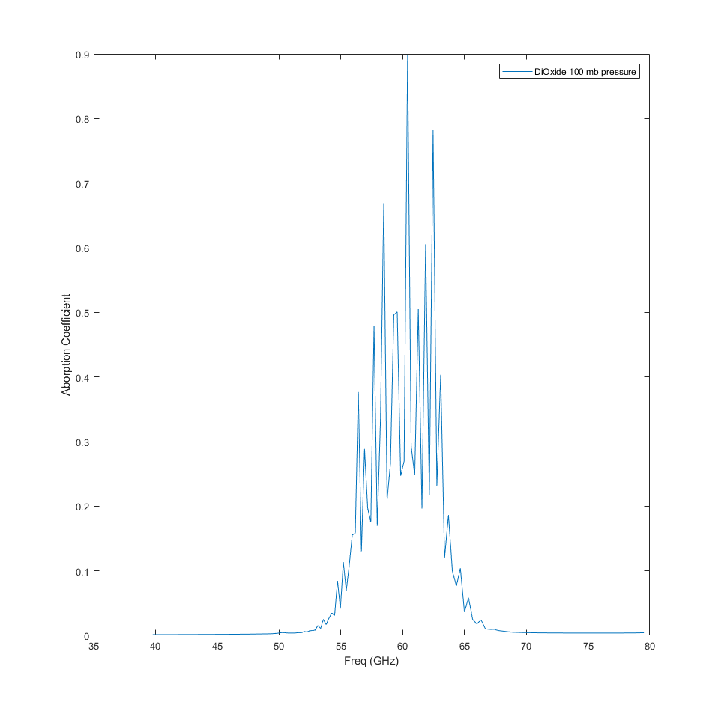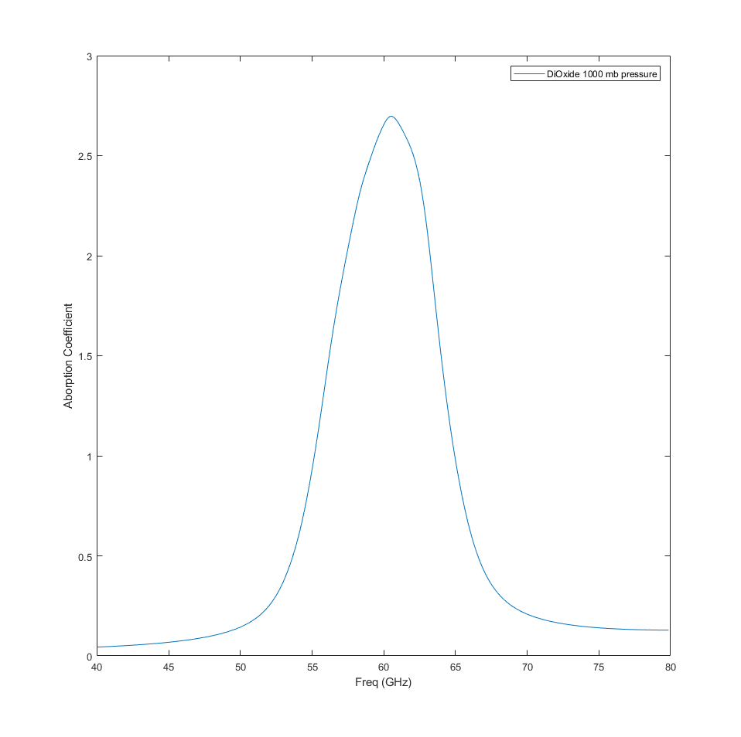

In order to reach the similar levels for the absorption coefficient when looking at a 100mb atmosphere the ground temperature had to be set at the same temperature as the 1000 mb pressure or else it would come out absorbing too little.

O2 100 mb - Left

1. Location
   1. WPAFB
2. Atmosphere
   1. ExPERT
   2. 200 Layers
3. Laser/Geometry
   1. Slant Path
      1. Altitude 100 kilometers
      2. Path Length 100 kilometers
4. Ground Level
   1. Pressure (mb): 100
   2. Air Temperature (F): 20
5. Comparisons
   1. Wavelength(m) : 0.003 to 0.01
   2. Points
      1. Molecular: 300
      2. Uncheck Correlated K

O2 1000 mb - Right

1. Location
   1. WPAFB
2. Atmosphere
   1. ExPERT
   2. 200 Layers
3. Ground Level
   1. Pressure (mb): Default
   2. Air Temperature (F): Default
4. Laser/Geometry
   1. Slant Path
      1. Altitude 100 kilometers
      2. Path Length 100 kilometers
5. Comparisons
   1. Wavelength(m) : 0.003 to 0.01
   2. Points
      1. Molecular: 300
      2. Uncheck Correlated K

**Fig 12-13**

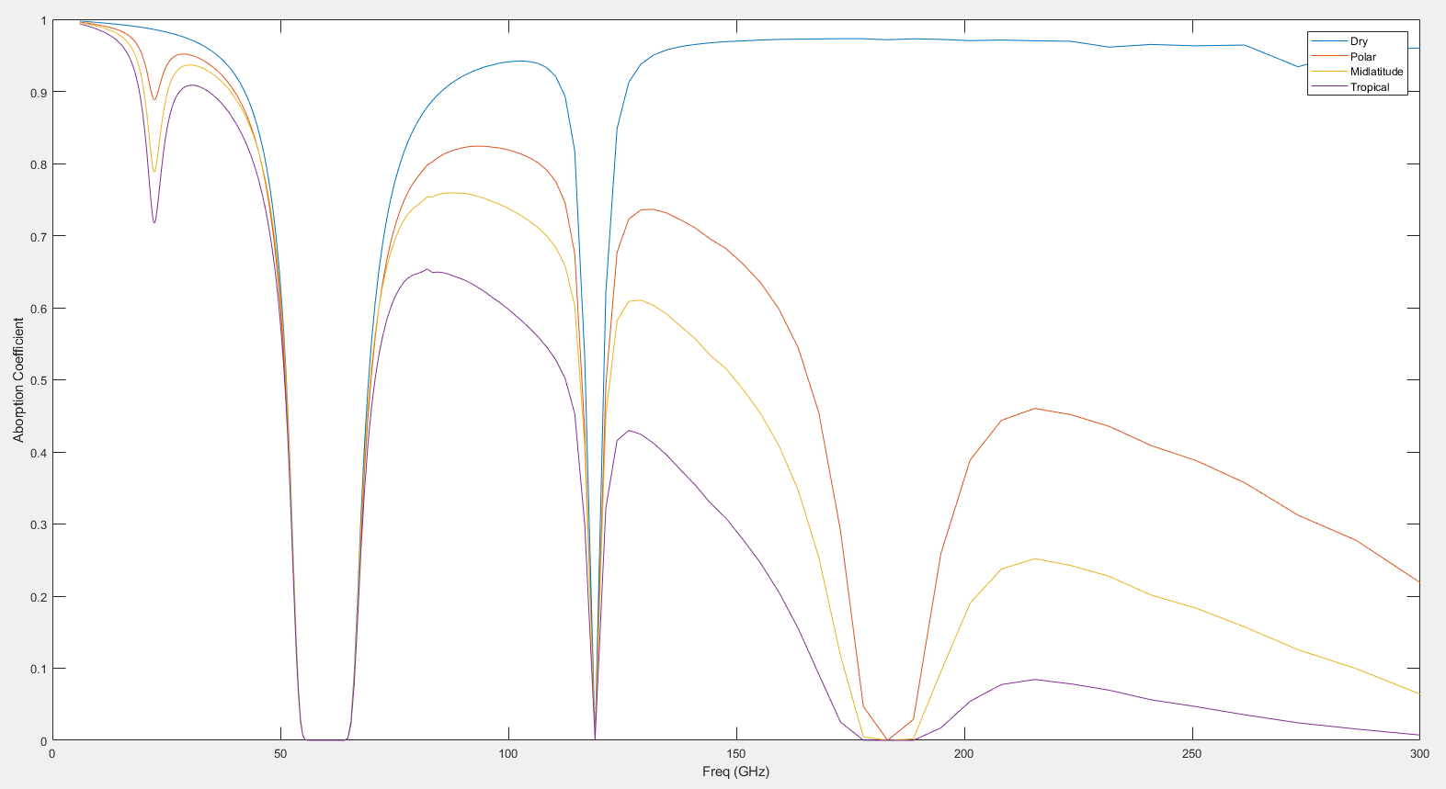

While the mid-latitude atmosphere did not reach the same level as Petty’s figure; the overall shape and pattern did come out as expected. That being that the dryer atmosphere’s second transmittance hump is about the same magnitude as the proceeding more humid atmospheres first transmittance hump.

Dry - Blue

1. Location
   1. WPAFB
2. Atmosphere
   1. Standard
      1. US 1976 Std Dry (No Season)
   2. 200 Layers
3. Laser/Geometry
   1. Slant Path
      1. Altitude 100 kilometers
      2. Path Length 100 kilometers
4. Comparisons
   1. Wavelength(m) : 0.001 to 0.05
   2. Points
      1. Molecular: 1000
      2. Uncheck Correlated K

Polar -Red

1. Location
   1. WPAFB
2. Atmosphere
   1. Standard
      1. Polar North
   2. 200 Layers
3. Laser/Geometry
   1. Slant Path
      1. Altitude 100 kilometers
      2. Path Length 100 kilometers
4. Comparisons
   1. Wavelength(m) : 0.001 to 0.05
   2. Points
      1. Molecular: 1000
      2. Uncheck Correlated K

Mid-Latitude - Yellow

1. Location
   1. WPAFB
2. Atmosphere
   1. Standard
      1. Desert
   2. 200 Layers
3. Laser/Geometry
   1. Slant Path
      1. Altitude 100 kilometers
      2. Path Length 100 kilometers
4. Comparisons
   1. Wavelength(m) : 0.001 to 0.05
   2. Points
      1. Molecular: 1000
      2. Uncheck Correlated K

Tropical - Purple

1. Location
   1. WPAFB
2. Atmosphere
   1. Standard
      1. Tropical
   2. 200 Layers
3. Laser/Geometry
   1. Slant Path
      1. Altitude 100 kilometers
      2. Path Length 100 kilometers
4. Comparisons
   1. Wavelength(m) : 0.001 to 0.05
   2. Points
      1. Molecular: 1000
      2. Uncheck Correlated K

Note: Mid-latitude North Standard Atmosphere actually reduced the transmission so it was not as representative of Fig12-13 in Petty as the Desert Atmosphere.