**Problem 1** (5 points) *discuss the significance of the spectral radius for the iterative solution of*

*A~x =~b, including how it is used to determine convergence and how it is related to the rate of convergence.*

The spectral radius determines the speed of convergence and if it is smaller than 1 it converges very slowly. So the larger the spectral radius the faster the convergence.

**Problem 2** Print the solution vector from each method converged to an absolute tolerance of 10􀀀6.

**Jacobi:**

Jacobi iterations: 25

Jacobi Solution Vector

[[ 61.11105884]

[ 83.33323925]

[ 88.88878435]

[ 83.33323925]

[ 61.11105884]]

Tolerance met at: 7.92128941434e-07

**Gauss Seidel:**

GSI iterations: 23

GSI Solution Vector

[[ 59.99996436]

[ 79.99994233]

[ 79.99994233]

[ 79.99994233]

[ 59.99996436]]

Tolerance met at: 5.88096677098e-07

**SOR:**

SOR iterations: 19

SOR Solution Vector

[[ 59.99996898]

[ 79.99994956]

[ 79.99994956]

[ 79.99994956]

[ 59.99996898]]

Tolerance met at: 6.76783457974e-07

**Problem 3**

**Part A (10 points)**

**Iterations:**

************ 1e-06 ***********

Jacobi iterations: 25

Jacobi Solution Vector

[[ 61.11105884]

[ 83.33323925]

[ 88.88878435]

[ 83.33323925]

[ 61.11105884]]

Tolerance met at: [ 9.40839318e-07]

GSI iterations: 23

GSI Solution Vector

[[ 59.99996436]

[ 79.99994233]

[ 79.99994233]

[ 79.99994233]

[ 59.99996436]]

Tolerance met at: [ 6.15658431e-07]

SOR iterations: 19

SOR Solution Vector

[[ 59.99996898]

[ 79.99994956]

[ 79.99994956]

[ 79.99994956]

[ 59.99996898]]

Tolerance met at: [ 7.06217714e-07]

************ 1e-08 ***********

Jacobi iterations: 34

Jacobi Solution Vector

[[ 61.11111072]

[ 83.33333269]

[ 88.88888811]

[ 83.33333269]

[ 61.11111072]]

Tolerance met at: [ 6.19481960e-09]

GSI iterations: 30

GSI Solution Vector

[[ 59.99999953]

[ 79.99999923]

[ 79.99999923]

[ 79.99999923]

[ 59.99999953]]

Tolerance met at: [ 8.17342752e-09]

SOR iterations: 25

SOR Solution Vector

[[ 59.99999966]

[ 79.99999946]

[ 79.99999946]

[ 79.99999946]

[ 59.99999966]]

Tolerance met at: [ 7.65949318e-09]

**Compare:** Iterations for 10E-6 for convergence versus relative error

**Jacobi:** Same iteration different breakout convergence

**Gauss Seidel:** Same iteration different breakout convergence

**SOR:** Same iteration different breakout convergence

**Which method required the least amount of iterations?** By comparing the convergence values we can infer that the SOR using the relative error would require the least amount of iterations.

**What do you observe about reaching a tighter convergence tolerance?** An increased amount of iterations is observed when the break out tolerance is lowered.

**Part B** (10 points) Perform an experiment to determine !opt for SOR. Explain your procedure and include the results.

I choose to use the brute force method by continuously looping until the difference in my perceived optimal values for *w* is less than the tolerance I set, in this case 1E-6.

I define my optimal *w* by creating two lists that append values as I move throughout all the possible values of *w* (0 to 2). The first list is comprised by the amount of iterations while the second is a list of the current *w;* these list of course end up being the same size. By finding the min of the iteration list and using that index for the *w* list I can determine the perceived optimal value. However to keep the loop going for better precision I reset my bounds of possible *w* by using the two indexed values around my “best” *w* as the new range. To break out of the loop I compare the relative difference of the “best” *w* and the previous “best” *w*

*Wopt* = 1.17331963004

**Problem 4** Attached as an analytic solution

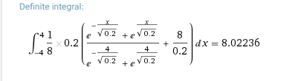

**Problem 5**

Plot: 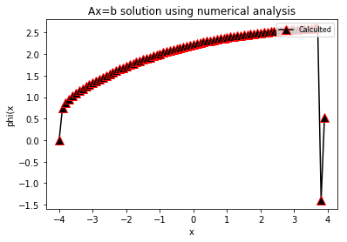

Max Error for h = 0.1 is: 14.1509454215

Compare answer to solution for Analytic solution in prb 4 using max error

**Problem 6**

Repeat 5 for h= 1, .5, .1, .05, .01

Max Error for h = 1 is: 333.996611559

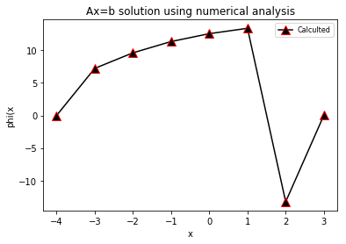

Max Error for h = 0.5 is: 110.827037012

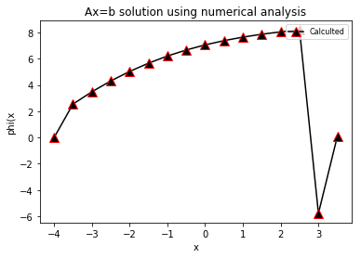

Max Error for h = 0.1 is: 14.1509454215



Max Error for h = 0.05 is: 10.687944599

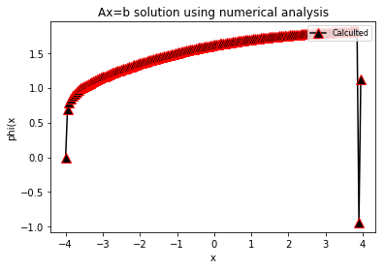

Max Error for h = 0.01 is: 14.6884176906

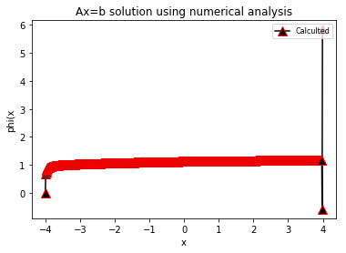

**What can you conclude about the relationship between the maximum error and the total number of meshes?**

Max error goes down as the mesh number goes up.

**What is the order convergence?**