Nicholas J. Quartemont and Robert S. Torzilli

[1]

Gaseous Detector Spectroscopy, Energy Calibration and Statistical Analysis

*Abstract*— Gamma ray spectroscopy is an important aspect of nuclear science modeling. MNCP5 can handle gaussian broadening of the full energy peak full width half maximum with special parameters. A 1.5”x1.5” Lanthanum Bromide detector was tested against sources of Eu-155, Na-22, Cs-137, and Co-60. The results provide constants of a, b, and c to be used in MCNP5 of 0.0308, 0.05224, and 0.8186. The standard error of the gaussian broadening full width half max function is 3 keV compared to the measured data.

*Index Terms*—Counting Statistics, Gamma-Ray Detection, Scintillation, Monte Carlo, NIM, Radiation Detection Electronics

# INTRODUCTION

M

ODELING nuclear radiation interactions with detectors is an important azTheory.

# Theory

energy, C is a normalization constant and A is the gaussian width [3]

# Experiment

A gas filled ionization detector was used for experiment with a standard NIM counting system electronics and a multi-channel analyzer (MCA). The MCA emulated with an ORTEC 926 ADCAM multichannel Buffer and a laptop with GammaVision [2].

The detector uses P-10 gas, which is a mixture of 90% argon and 10% methane [3]. The flow rate for the gas is set to 10 cubic feet per minute. The system was tested with a pulser to ensure operation. A counting curve was created to determine the optimal bias voltage for the detector. A bias of 1700 V is on the plateau of the counting curve and within the operational range of the detector.

Three sources were used for the experiment, Fe-55, Co-57, and Cd-109. The three sources span a range of gamma-ray energies from approximately 5 to 25 keV, which are all detectable by the gaseous detector. Other energy gamma-rays are present at higher energies; however, they are not detectable with smaller gaseous detectors at low pressure. The three sources used allow for the system energy calibration where the MCA channels are mapped to photon energy levels. A spectrum of all three sources individually and combined was acquired for analysis. The spectra were taken for approximately 300 seconds, and the combined spectra was taken for 45 minutes, 15 minutes with each source.

The Co-57 source was used to test counting statistics. The timing single channel analyzer (TSCA) was used to select the full energy peak (FEP) of Co-57 at 14.4 keV.

The source was placed 9 cm from the detector to achieve a count rate of 3-8 counts in 5 seconds. 300 trials of 5 second collection times were taken. The source was adjusted to 1 cm distance to the detector and an additional 300 trials of 5 seconds was collected with the source at a 5 cm distance to produce approximately . An additional test of 10 100 s count times was collected. The background count rate was collected for each position for 10 trials.

# Results and Discussion

The

Calibrated Source Spectrum With Radioisotopes identified

An energy calibration curve with the associated equation

Analysis of the Co-57 Sample (LAB 2)

# References

|  |  |
| --- | --- |
| [1] | X-5 Monte Carlo Team, "LA-UR-03-1987," Los Alamos National Laboratory, Los Alamos, NM, 2003. |
| [2] | W. R. Leo, Techniques for Nuclear and Particle Physics Experiments, New York: Springer-Verlag, 1994. |
| [3] | G. F. Knoll, Radiation Detection and Measurement, Ann Arbor, MI: Wiley, 2010. |
| [4] | "Lab Manual, Gaseous Detectors Week 1 of 2," NENG 605, AFIT, Winter 2017. |
| [5] | "Lab Manual Gaseous Detectors Week 2 of 2," NENG 650, AFIT, Winter 2017. |

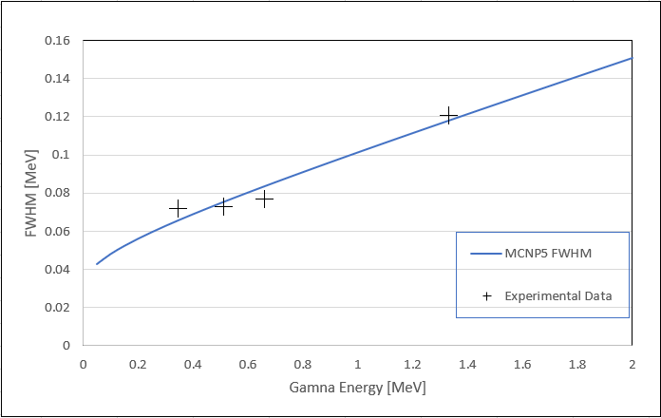

Fig. 5. MCNP5 Gaussian Broadening Term. The values for a, b, and c are 0.0308, 0.05224, and 0.8186, respectively.

1. .