Robert S. Torzilli and Nicholas J. Quartemont

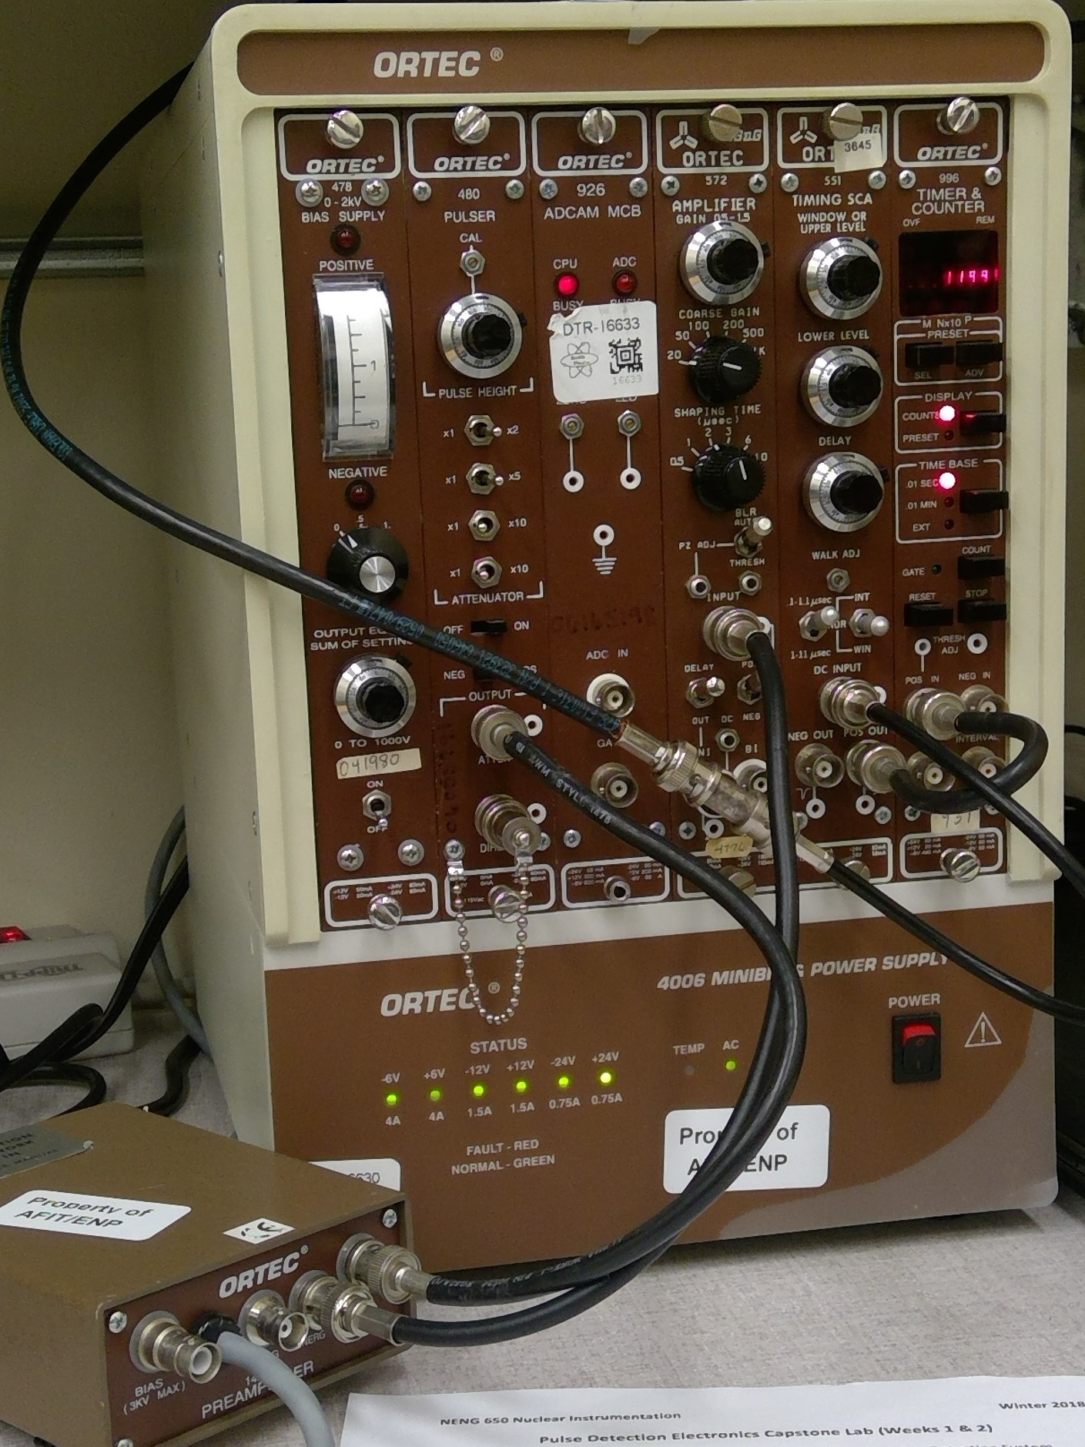[1]

Pulse Detection Electronics Capstone Lab

*Abstract*— Pulse detection and counting statistics are essential to nuclear engineering to enable the characterization and measurement of ionizing radiation. It is important to understand the setup of a nuclear instrumentation module (NIM) “bin”. The NIM bin setup is demonstrated with a pulser as the source, a pre-amplifer, a linear amplifier, a timing single channel analyzer, and a counter. Counting experiments were performed with 5 1-min counts, 2 2.5-min counts, 3 5/3-min counts, and 1 5-min count with the 60 Hz pulser source. The final count rate for each series of measurements is 3598 counts per minute with an error of 26.8 counts per minute. Overall, the setup and experimentation of the NIM provided an understanding of the detection modules and counting procedures.

*Index Terms*—Counting Statistics, Pulse Detection, NIM, Radiation Detection Electronics

# INTRODUCTION

N

UCLEAR radiations can be characterized with electric pulse electronics. Measuring incident radiation is essential for nuclear sciences and experiments. Radiation interactions with detectors produce information carries in the form of electrons or photons which can be analyzed by a Nuclear Instrumentation Module (NIM) “bin" [1]. The NIM bin enables spectroscopy of the incident radiation with various types of detectors.

The NIM bin contains various modules connected by coaxial cables. The NIM bin conforms to a standard in size and voltage requirements among other aspects which allows for a modular system of components. Components included for a general purpose counting detection system include a detector, detector bias, pre-amplifier, linear amplifier, oscilloscope, timing single channel analyzer, and counter [2]. Additional modules can be incorporated depending on the application of interest.

Fig. 1. General purpose counting system setup. The pulser, pre-amplifier, linear amplifier, timing single channel analyzer, and counter are connected in series via coaxial cables. The linear amplifier output is forked off to be viewed on an oscilloscope.

# Theory

The setup of a NIM detection system is critical for analysis of nuclear measurements. As stated, there are many components in a NIM bin detection system that require attention. A complete setup of a NIM bin detection system allows for the pulses created by a source to be counted and characterized for source energy. The explanation below focuses on the setup of a general nuclear detection counting system. A completed setup off the general purpose counting system is shown in Figure 1.

The first component in the detection of nuclear radiation is a detector or pulser. Examples of detectors are Geiger-Mueller tubes, proportional counters, scintillation counters, and semiconductor devices, each having a different application in

nuclear spectroscopy [2]. Each detector’s role is to convert the nuclear radiation into a detectable signal that can be analyzed. A detector bias is required depending on the detector type. The bias creates an electric field which is used to convert energy in to a measurable charge.

A pulser or pulse generator is used in the initial setup or calibration of a NIM bin [2]. The pulser can be used as a surrogate source to mimic a “tail pulse” of variable amplitude and polarization. The pulser or detector is connected to the pre-amplifier.

The pre-amplifier takes input from the detector or pulser as a source. The pre-amplifier is an intermediate amplification to increase the signal pulses for detection. Pre-amplifiers maximize the signal-to-noise ratio by cutting off the capacitance in a short time [2]. The pre-amplifier outputs a linear tail pulse that is the opposite polarity of the input from the source.

A linear amplifier functions to take the input from the preamplifier or detector and shape the tail pulse and amplitude. The standard NIM output is positive polarity with an amplitude of 0-10 V [2]. The linear amplifier has adjustable gain on the order of 10 to 1000. The settings on the amplifier offer a range of flexibility. The unipolar mode with long pulses is best suited for resolution, while the bipolar mode with short pulse input is best for high count rates [2]. An oscilloscope can be utilized anywhere in the chain of modules to inspect the pulses; however, the output of the amplifier is a good choice after the initial setup is complete.

TABLE I

Pulse Characteristics in NIM Bin Setup

|  |  |  |  |  |
| --- | --- | --- | --- | --- |
| Output Parameter | Pulser | Pre-Amplifier | Linear Amplifier | TSCA |
| Amplitude | 0.027 [V] | 0.124 [V] | 2.54 [V] | 6.08 [V] |
| Vmax | 0.005 [V] | 0.229 [V] | 2.57 [V] | 6.54 [V] |
| Vmin | -0.058 [V] | -0.049 [V] | -0.035 [V] | 0.16 [V] |
| Rise Time | 316 [µs] | 10.1 [ns] | 2.4 [µs] | 39 [ns] |
| Fall Time | 23 [ns] | 58 [µs] | 4.1 [µs] | 32 [ns] |

The timing single channel analyzer (TSCA) converts the tail pulse into a logic pulse for counting. Discrimination can be applied to change what is counted as a pulse. Common modes for TSCAs are integral, normal, and window mode [3]. Integral mode operates based on a minimum threshold voltage from a lower level discriminator (LLD) [2]. Normal mode allows for the discrimination range to be between an upper level discriminator (ULD) and LLD set independently [3]. The window mode sets the LLD as a threshold voltage and has a window of voltage above that is included for conversion to a logic pulse [3]. A TSCA can also modulate the timing of the pulse. Characteristics of the incident radiation can be built from the various modes of a TSCA.

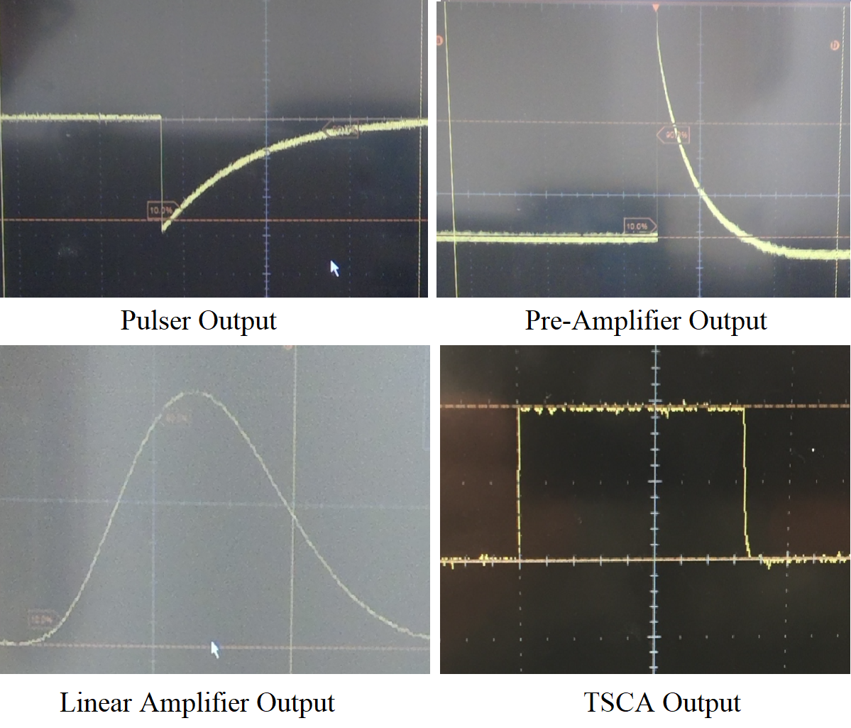

Fig. 1. Oscilloscope signal output from pulser, pre-amplifier, linear amplifier and timing single channel analyzer.

The counter converts the logic pulse created by the TSCA into a digital count. The discrete counts are built up for a pre-defined count time or count number, depending on the type of counter. The counter, under NIM standard, counts every logic pulse as a count. The output of the counts is of importance for nuclear detection and measurement. The energy bin constructed, type of detector, magnitude of the counts allows for the radiation to be characterized.

Binary counting statistics plays a fundamental role in nuclear experiments. Radioactive decay is characterized by the Poisson distribution [4]. Poisson distributions have properties based on the number of total counts if the probability of an individual occurrence is small and the sample size is relatively large. As cited by Leo, the mean (µ) of the counts (x) and the uncertainty (σ) with a given trial size (n) are related as follows.

$σ\left(μ\right)=\sqrt{\overline{x}/n}$ (1)

From the mean count and uncertainty of the total count, the count rate per unit time can be created by dividing by the measurement time. It is important to create the uncertainty before dividing by the measurement time [4]. The count rate can be used to determine the contribution of the signal within the bounds defined by the TSCA.

# Experiment

The testing includes the setup of a NIM general purpose detection system. After the system is setup, a counting experiment is performed using a pulser as a source.

An ORTEC 480 pulser is utilized to drive the signal for the counting experiment. The pulser is set to 0.72 pulse height, negative polarity, 10X attenuation, and on the ON position. A terminator of 100 Ω is connected to the “DIRECT” line. The output parameters for the pulser and other outputs are summarized in Table I. The pulse output from the oscilloscope is shown in Figure 2. The pulser operates with a frequency of 60 Hz.

The attenuated pulser output is connected by a coaxial cable to the test input on an ORTEC 142pc pre-amplifier. The test mode is used for pulsers. The preamplifier requires its own power source, independent from the NIM bin. The amplifier output from the “ENERGY” terminal is shown in Figure 2. The signal is inverted from the pulser and larger in magnitude.

The “ENERGY” output of the pre-amplifier is connected to the input on an ORTEC 572 Linear Amplifier. The course gain and fine gain are set to 20 and 0.624. The sampling time is 2 µs with BLR mode on and the delay switch on. The polarization is set to positive, which maintains the positive polarity from the pre-amplifer. The unipolar signal from the linear amplifier is shown in Figure 2.

The “UNI” output is connected to the DC input of an ORTEC 551 TSCA. The ULD is set to 5.1 V, and the LLD is set to 1.25 volts. The mode is set to NOR, which allows for independent adjustment of the levels of the LLD and ULD. The timing is set to 0.1 µs. The signal from the TSCA is shown in Figure 2. The output is a logic square pulse, which is optimal for the counter.

The “POS” output of the TSCA is connected to the “POS” input of an ORTEC 996 Counter. The counter has adjustable count times which are used for the counting portion of the experiment which includes 5 1-min counts, 2 2.5-min counts, 3 5/3-min counts, and 1 5-min count. The total counts during each trial are recorded and analyzed.

# Results and Discussion

The setup of the general purpose NIM counting system signals agree with expectations from theory. The output of the pulser is a negatively polarized tail pulse. The pre-amplifier changes the polarization to positive and increases the amplitude. The linear amplifier further increases the amplitude and shapes the signal into a unipolar mode for input into the TSCA. The TSCA finally converts the signal into a square logic pulse to be used for the counting experiment.

The results of the counting experiment show agreement with the expected count rate per minute. The counts detected for each trial, the mean counts, and the error in the counts using a Poisson distribution for the total counts in all trials are summarized in Table II. The values are all near 60 Hz multiplied by the count time in seconds. There is some error, which can arise from the timing of when the first pulse is counted and general noise and drift in the system.

TABLE II

Counting Experiment Results

|  |  |  |  |  |
| --- | --- | --- | --- | --- |
|  | 1-min  Counts | 5/3-min  Counts | 2 ½ -min  Counts | 5-min Counts |
| Trial 1 | 3599 | 5998 | 8995 | 17992 |
| Trial 2 | 3598 | 5999 | 8997 | [-] |
| Trial 3 | 3598 | 5999 | [-] | [-] |
| Trial 4 | 3598 | [-] | [-] | [-] |
| Trial 5 | 3598 | [-] | [-] | [-] |
| Mean | 3598.2 | 5998.67 | 8996 | 17992 |
| Error | 26.8 | 44.7 | 67.1 | 134 |

The count rate per minute and error is summarized in Table III for each series in the experiment. The error is relatively equivalent for each of the series as the total number of counts is nearly equivalent. Each series has a total of five minutes worth of counting. A single trial in a series has a larger relative error, but the combination of the trials results in the same error.

TABLE III

CounT Rate Results

|  |  |  |
| --- | --- | --- |
| Series | Count Rate  [Counts per Minute] | Count Rate Error  [Counts per Minute] |
| 5 x 1-min Counts | 3598.2 | 26.8 |
| 3 x 5/3-min Counts | 3598.4 | 26.8 |
| 2 x 2 ½-min Counts | 3598.2 | 26.8 |
| 1 x 5-min Count | 3598.4 | 26.8 |

The count rates and count rate errors are equivalent for each series of measurements. For reference, an individual trial from the 1-min counts has an error of 60 counts per minute based on the Poisson distribution. This demonstrates the effect of increasing the number of counts to lower the uncertainty.

# References

|  |  |
| --- | --- |
| [1] | "Lab Manual, Pulse Detection Electronics (Weeks 1 & 2)," NENG 605, AFIT, Winter 2018. |
| [2] | G. F. Knoll, Radiation Detection and Measurement, Ann Arbor, Michigan: Wiley, 2010. |
| [3] | ORTEC, "Model 551 Timing Single-Channel Analyzer Operating and Service Manual," Advanced Measurement Technology, Inc. , 2002. |
| [4] | W. R. Leo, Techniques for Nuclear and Particle Physics Experiments, New York: Springer-Verlag, 1994. |

1. .