Nicholas J. Quartemont and Robert S. Torzilli

[1]

LaBr3 Detector Gaussian Broadening

*Abstract*— Gamma ray spectroscopy is an important aspect of nuclear science modeling. MNCP5 can handle gaussian broadening of the full energy peak full width half maximum with special parameters. A 1.5”x1.5” Lanthanum Bromide detector was tested against sources of Eu-155, Na-22, Cs-137, and Co-60. The results provide constants of a, b, and c to be used in MCNP5 of 0.0308, 0.05224, and 0.8186. The standard error of the gaussian broadening full width half max function is 3 keV compared to the measured data.

*Index Terms*—Counting Statistics, Gamma-Ray Detection, Scintillation, Monte Carlo, NIM, Radiation Detection Electronics

# INTRODUCTION

M

ODELING nuclear radiation interactions with detectors is an important aspect of research in nuclear sciences. Monte Carlo N-Particle Transport Code Version 5 (MCNP5) has the capability of modeling the interactions to produce an expected gamma spectrum from a source. The goal of this project is to characterize the gaussian broadening of a 1.5”x1.5” Lanthanum Bromide (LaBr3) detector full width half maximum (FWHM) as a function of energy for use in MCNP5.

Inorganic scintillators can detect gamma radiation where the energy is converted to signals for processing. An ideal spectrometer would produce a delta function for the energy at the gamma ray full energy peak (FEP) [1]. The non-ideal response of the detector produces a spread in the energy deposited. Lanthanum halide scintillation detectors have effective scintillator characteristics including excellent energy resolution (3-4% at 662 keV), high Z, high density, and a fast decay time [2].

MCNP5 does not automatically handle the energy response in a detector with gaussian broadening of the energy peaks. Instead, the energy is deposited discretely. A realistic detector response will have spread in the energy. The gaussian broadening of the energy peak can be implemented by MCNP5 with user supplied inputs [3].

# Theory

Gamma radiation spectroscopy can be used to identify radioactive sources amongst other things. Gamma radiation interacts with matter though the photoelectric effect, Compton effect, and pair production. The FEP can be used to determine the radioactive source by the emission energy. Scattered photons have a continuum of energies under the FEP [1].

Additional peaks are present in the spectroscopy; however, they do not contribute as much to source characterization. The Compton edge occurs when maximum energy is transferred to an electron in a single Compton scatter. A backscatter occurs when a gamma scatters off surrounding material and back into the detector. An annihilation peak at 511 keV is produced with pair production.

The sources for this experiment are Europium 152, Sodium 22, Cesium 137, and Cobalt 60 with gamma energies of interest of 344.4 keV, 511 keV, 661.657 keV, and 1332.492 keV, respectively. The 1173 keV peak from Co-60 was cannot be used as effectively because the Compton edge from the 1332 keV peak interferes with the fitting of the full energy peak. The full energy peaks can be fit to a gaussian distribution, where σ is the standard deviation, C is a normalization constant, and µ is the peak gamma energy [2].

$g\left(E\right)=\frac{1}{Cσ} exp\left(-\frac{1}{2}{\left(\frac{x-μ}{2σ}\right)}^{2}\right)$ (1)

MCNP5 has a special treatment for gaussian energy broadening to better simulate energy peaks in a radiation detector [3]. The input requires a fit to a gaussian function, where E is the broadened energy, E0 is the unbroadened energy, C is a normalization constant and A is the gaussian width [3]

$f\left(E\right)=C exp\left(-{\left(\frac{E-E_{o}}{A}\right)}^{2}\right)$ (2)

The gaussian width (also the standard deviation here) is related to the full peak FWHM by:

$σ=A=\frac{FWHM}{2\sqrt{ln2}}$ (3)

The FWHM used by MCNP takes inputs to fit the energy broadening. The constants are detector dependent, so the constants are experimentally determined. The FWHM is fit to:

$FWHM=a+b\sqrt{E+cE^{2}}$ (4)

A least square method of fitting the data is suited for these types of datasets. The least square is iterated to minimize the value of the square of the deviations from the data to the fitted curve. The gaussian distributions generated and MCNP FWHM formula can be generated this way.

# Experiment

The testing includes the setup of a NIM general purpose detection system. After the system is setup, a counting experiment is performed using Cesium 137, Cobalt 60, Sodium 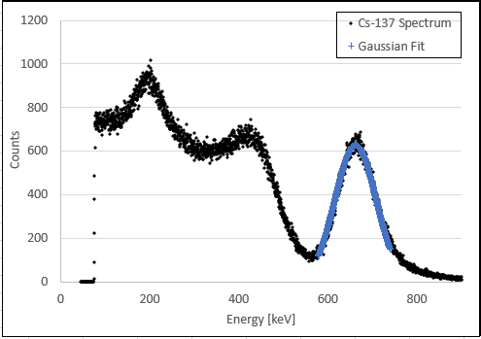22, and Europium 152 as sources. These were chosen since the expected peaks that were collected are easily separated from the others and are easily separated from their respective compton edges and back scatter.

A LaBr3detector was used to register the gammas and a MCB with Gamma Vision was used to create the spectrums individually. Sources were placed as close to the detector as possible without causing the dead time to exceed two percent. Each source was ran on its own and the set up was used for the entire duration without stopping for more than a few minutes. The time ran to collect each sources spectrum was varied since each source was different in how quickly the relevant peak could be identified. Gamma Vision was set to use its max amount of channels (8192).

Fig. 3. Collected Gamma Spectrum for Cs-137 Photopeak.

# Results and Discussion

The spectrum for each source is shown in Figures 1 through 4. Each spectrum was collected until a standard deviation within the peak could be calculated. The gaussian fit for each of the spectrums is highlighted in blue, or can be seen as the solid line. The Co-60 spectrum uses half of the gaussian fit as the other side is hidden in the dataset.

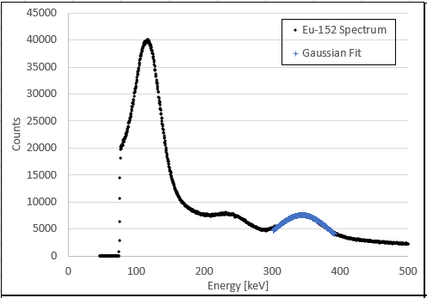

Fig. 4. Collected Gamma Spectrum for Co-60 Photopeak.

Fig. 1. Collected Gamma Spectrum for Eu-152 Photopeak.

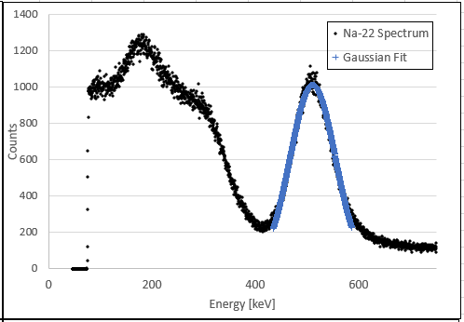

Fig. 5. MCNP5 Gaussian Broadening Term. The values for a, b, and c are 0.0308, 0.05224, and 0.8186, respectively.

Fig. 2. Collected Gamma Spectrum for Na-22 Photopeak.

The spectrum full energy peak data was fit to the gaussian distribution [3]. The resulting FWHM for Eu-152, Na-22, Cs-137, and Co-60 are 71.99 keV, 72.70 keV, 76.73 keV, and 120.76 keV, respectively. The FWHM increases with energy as expected for scintillation detectors [4]. The Co-60 1332 keV peak is partially concealed by the full energy peak from the 1173 keV peak. The data was only fit to the right half of the spectrum, so a half width was actually calculated.

The data for the FWHM was fit to the MCNP format with a least square method. The values for the constants a, b, and c are 0.0308, 0.05224, and 0.8186. It is important to note that MCNP has units of MeV. A plot of the MCNP formula for FWHM as a function of gamma energy is shown in Figure 5.

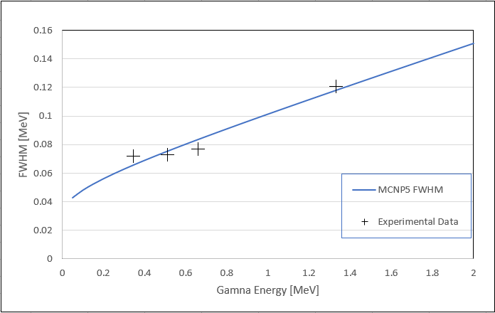

The data fit for the MCNP FWHM has a sum of least squares of 10.2987 keV2. The standard error from this is approximately 3 keV. A more accurate model could have been achieved with more data points being taken near 1 MeV. As a reminder, the parameters produced in this report for MCNP5 are for a 1.5’’ x 1.5’’ LaBr3 detector, and the parameters should not be extended to other detector types.

|  |  |
| --- | --- |
| [1] | "Lab Manual, NaI: Gamma-Ray Spectroscopy," NENG 605, AFIT, Winter 2018. |
| [2] | G. F. Knoll, Radiation Detection and Measurement, Ann Arbor, MI: Wiley, 2010. |
| [3] | X-5 Monte Carlo Team, "LA-UR-03-1987," Los Alamos National Laboratory, Los Alamos, NM, 2003. |
| [4] | W. R. Leo, Techniques for Nuclear and Particle Physics Experiments, New York: Springer-Verlag, 1994. |

# References

1. .