# SysEng 6103 Systems Life Cycle Costing - Summer 2020 Homework 2

**Assigned:** July 15, 2020 **Due:** July 22, 2020 until midnight CST

|  |  |  |  |  |  |
| --- | --- | --- | --- | --- | --- |
| Question: | 1 | 2 | 3 | 4 | Total |
| Points: | 30 | 20 | 20 | 30 | 100 |

# [30 points] [Set up necessary relations using factor notation, and then, solve by hand using interest factor tables. Include in the PDF file only.]

**Remark 1:** This is an individual homework, no collaboration is allowed.

**Remark 2:** Please show all your work and reasoning, as partial credit may be given for certain problems for legible, but inaccurate work. If I cannot easily decipher your work, it will be marked wrong.

**Remark 3:** The total of 100 points are distributed as shown in brackets before the questions.

**Submission Guidelines**

* Submissions should be in PDF file format for some questions/parts and in Microsoft Excel file format for others (indicated in bold letters before the question/part). Both files (1 pdf, 1 Excel file with multiple sheets for each relevant question and part) should be submitted through Canvas, before the due date and time.
* Filenames should start with the course code, your own name and a reference to the assignment, such as “SysEng6103 Doe Jane HW2...”
* Use 1 Excel sheet per 1 exercise, and label sheet tabs with Exercise# and highlight answers in the sheet.

Oil spills in the Gulf of Mexico have been known to cause extensive damage to both public and private oyster grounds along the Louisiana and Mississippi shores. One way to protect shellfish along the shoreline is to release large volumes of fresh-water from the Mississippi River to flush oil out to sea. This procedure inevitably results in death to some of the saltwater shellfish while preventing more widespread destruction to public reefs. Oil containment booms and other temporary structures can also be used to intercept floating oil before it damages sensitive fishing grounds. If the Fish and Wildlife Service spent $110 million in year 0 and $50 million in years 1 and 2 to minimize environmental damage from one particular oil spill, what is the benefit-to-cost ratio provided the efforts resulted in saving 3,000 jobs valued at a total of $175 million per year? Should they accept the plan? Assume disbenefits associated with oyster deaths amounted to $30 million in year 0. Use a 5-year study period and an interest rate of 8% per year.

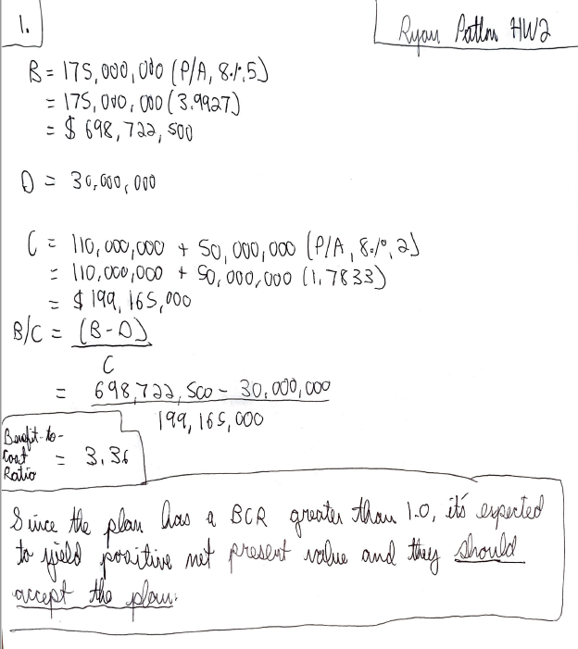

# [20 points] [Solve either by hand or using Excel and submit accordingly.]

Various techniques have been proposed to curb cross-border drug smuggling into a country. The costs of imple- menting each strategy along a particularly rugged section of the border are indicated below. The table also includes a score that is compiled based on deterrence, interdiction, and apprehension, with a higher score indicating bet- ter performance. For a budget of $60 million, determine which techniques should be employed on the basis of a cost-effectiveness analysis. *Note:* Activities are independent.

|  |  |  |
| --- | --- | --- |
| Activity | Cost, $ Millions | Score |
| 1. Tethered aerostats | 3.8 | 8 |
| 2. Boots-on-the-ground | 31.4 | 52 |
| 3. Fence | 18.7 | 12 |
| 4. Motion sensors | 9.8 | 7 |
| 5. Seismic sensors | 8.3 | 5 |
| 6. Drones | 12.1 | 26 |

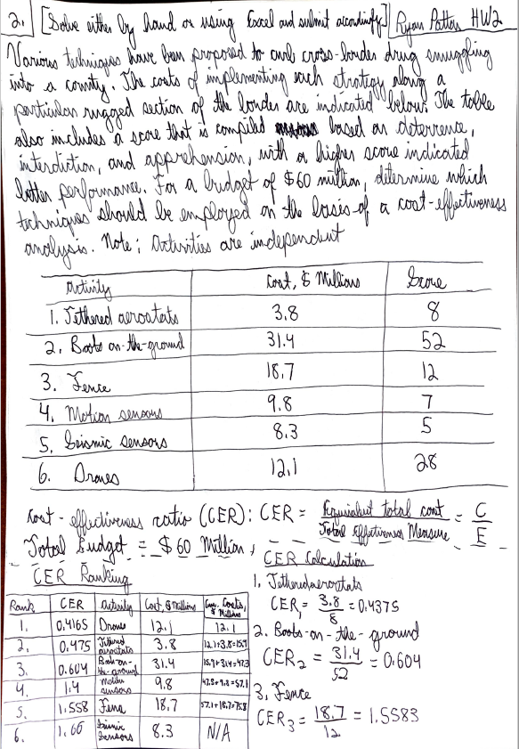

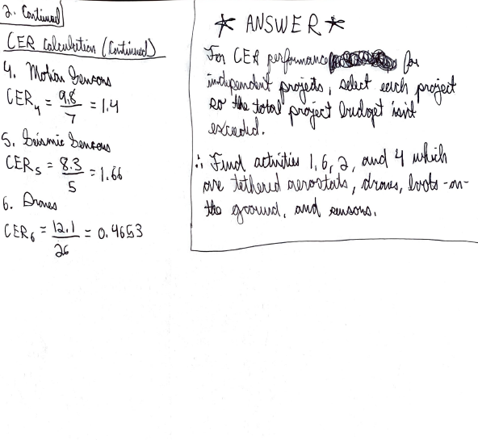

# [20 points] [Use Excel built-in function MIRR to calculate the external rate of return. Include in the Excel file only.]

The Martian Corporation, a space vehicle development company, is starting a new division that will develop the next generation launch missile engine configuration. The related net cash flows over the years are given below. Assume that the borrowing rate is *ib* = 12% and investment rate is *ii* = 25% per year.

Year CF (*×* 1,000 $) 0 -50,000

1 15,000

2 15,000

3 15,000

4 15,000

5 15,000

6 15,000

7 -8,000

Use Excel built-in function MIRR to calculate the external rate of return. For which MARR values should the company develop the next generation launch missile engine configuration?

# [30 points] [Use Excel built-in function(s) and submit in the Excel file only.]

A firm is considering replacing a currently-owned machine. The new machine will cost $31,000 and will have an estimated economic service life of 10 years with a salvage value of $2,500. Operating costs are expected to be

$1,000 per year throughout its service life. The machine currently in use had an original cost of $25,000 three years ago, and its service life (physical life) at the time of purchase was estimated to be seven years with a salvage value of $5,000. This machine has a current market value of $7,700. The firm’s minimum attractive rate of return is 12%. If the firm retains the old machine, its updated market values and operating costs for the next four years (its new estimated remaining life) will be as follows:

|  |  |  |
| --- | --- | --- |
| Year | Market value ($) | Operating costs ($/year) |
| 1 | 4,300 | -3,200 |
| 2 | 3,300 | -3,700 |
| 3 | 1,100 | -4,800 |
| 4 | 0 | -5,850 |

Using AW (annual worth as basis): Determine the economic service life (ESL) of the old machine only, compare its corresponding equivalent annual cost at its ESL with the equivalent annual cost of the challenger (assume that the challenger has 10 years of economic service life) and then, determine whether it is economical to make the replacement now.