Active vs Passive FTP explanation

From
https://ondemandelearning.cisco.com/cisco-ccsi/cbrops10/sections/2/pages/4

In this scenario, the ACL would most likely be applied inbound on the interface that is connected to the untrusted network. Clients on the trusted network can establish the FTP control channel by connecting to TCP port 21 on the FTP server. The connection is initiated with a three-way handshake. The first packet, sent from the client to the server, only sets the SYN flag in the TCP header and it presents the clients initial sequence number. The server then responds with a packet that has both the SYN bit and the ACK bit set. The server presents its initial sequence number and acknowledges the client initial sequence number. The client then completes the three-way handshake with an ACK, acknowledging the server’s initial sequence number. Note that all packets from the server that are associated with this connection have the ACK bit set.

FTP passive mode data channels can also establish. The FTP server will specify the ephemeral port to the client through the FTP control channel. The passive mode data channel is then opened with the client connecting to the server on the specified ephemeral port. As with the control channel, all packets from the server back to the client will have the ACK bit set.

However, standard mode FTP data channels will not function. The client will specify the ephemeral port to the server through the FTP control channel. The three-way handshake then begins with a TCP SYN sent from the FTP server to the client from source TCP port 20. This packet does not have the ACK bit set and hence the packet will be denied.

More here:
https://www.jscape.com/blog/active-v-s-passive-ftp-simplified

Active vs. Passive FTP Simplified: Understanding FTP Ports
Words By John Carl Villanueva
Last Updated: November 17, 2022
If there are problems connecting to your FTP Server, check your transfer mode. Let JSCAPE help you understand the difference in active & passive FTP.
If a client encounters problems when connecting to your FTP server, one of the first things you might want to check is your FTP data transfer mode. Depending on certain network configurations, this mode should be set to either active or passive. In this post, you’ll understand the salient points of active and passive FTP and learn how to avoid connectivity issues associated with them.

Before we talk about which mode is best for what scenario, let’s first cover one important topic: the two channels of an FTP session.

FTP Command Channel And Data Channel
A typical FTP session operates using two channels between the FTP client and server: a command channel and a data channel. As their names imply, the command channel is used for transmitting commands as well as replies to those commands, while the data channel is used for transferring data.
Unless you configure your FTP server differently, you will normally set your command channel to use FTP port 21. The FTP port you'll use for the data channel, on the other hand, can differ depending on which data transfer mode you choose. If you choose active mode, then the data channel will normally be FTP port 20. But if you choose passive mode, then the port that will be used will be a random port.

ftp_command_and_data_channels-resized-600

Note that the FTP ports we are referring to up to this point are only the ports on the server side. We'll include client-side FTP ports in our discussion in a short while.
Unless you configure your FTP server differently, you will normally set your command channel to use FTP port 21. The FTP port you'll use for the data channel, on the other hand, can differ depending on which data transfer mode you choose. If you choose active mode, then the data channel will normally be FTP port 20. But if you choose passive mode, then the port that will be used will be a random port.
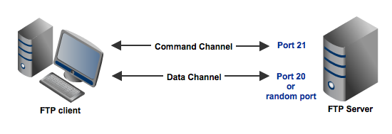
Note that the FTP ports we are referring to up to this point are only the ports on the server side. We'll include client-side FTP ports in our discussion in a short while.

Active Mode FTP
Among the two connection modes, active mode is the older one. Active FTP was introduced in the early days of computing when mainframes were more common and attacks to information security were not as prevalent.

Here's a simplified explanation on how an active mode connection is carried out, summarized in two steps. Some relevant steps (e.g. ACK replies) have been omitted to simplify things.

A user connects from a random port on a file transfer client to FTP port 21 on the server. It sends the PORT command, specifying what client-side port the server should connect to. This port will be used later on for the data channel and is different from the port used in this step for the command channel.
The server connects from port 20 to the client port designated for the data channel. Once the data connection is established, file transfers are then made through these client and server ports.

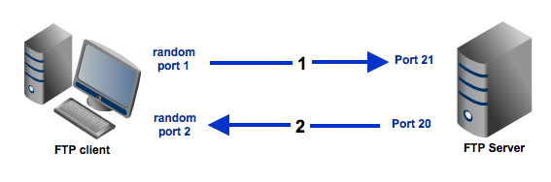
Passive Mode FTP
In passive mode, the client still initiates a command channel (control connection) to the server. However, instead of sending the PORT command, it sends the PASV command, which is basically a request for a server port to connect to for data transmission. When the FTP server replies, it indicates what data port number it has opened for the ensuing data transfer.

Here's how passive mode works in a nutshell:

The client connects from a random port to port 21 on the server and issues the PASV command. The server replies, indicating which (random) port it has opened for data transfer.
The client connects from another random port to the random port specified in the server's response. Once connection is established, data transfers are made through these client and server ports.

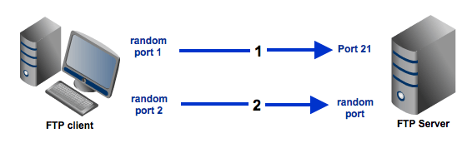

Active Mode vs Passive Mode FTP: Which Is More Suitable For You?
There's a reason why I opted to simplify those two diagrams above. I wanted to focus on the main difference between active mode and passive mode FTP data transfers. If you compare those two diagrams, one of the things that should really stand out are the opposing directions at which the second arrows (which also represent the data channels) are pointing to.

In this section, we'll focus on those second arrows and the ports associated with them.

In the active mode, the second arrow is pointing to the client. Meaning, the client initially specifies which client-side port it has opened up for the data channel, and the server initiates the connection.

By contrast, in the passive mode, the second arrow is pointing to the server. Here, the server specifies which server-side port the client should connect to and the client initiates the connection.

There shouldn't be any problem had there not been any firewalls in existence. But threats to information security are on the rise and hence the presence of firewalls is almost always a given. In most cases, clients are located behind a firewall or a NAT (which basically functions like a firewall). In such cases, only a select number of predefined ports are going to be accessible from the outside.

Remember that in an active mode configuration, the server will attempt to connect to a random client-side port. So chances are, that port wouldn't be one of those predefined ports. As a result, an attempt to connect to it will be blocked by the firewall and no connection will be established.

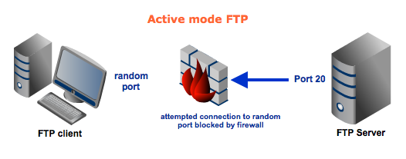

In this particular scenario, a passive configuration will not pose a problem. That's because the client will be the one initiating the connection, something that a client-side firewall won't have any problem with.

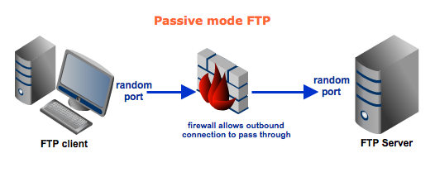

It's possible for the server side to have a firewall too. However, since the server is expected to receive a greater number of connection requests compared to a client, then it would be logical for the server admin to adapt to the situation and open up a selection of ports to satisfy passive mode configurations.

