BIOS226 – Topic 4 Workbook
Visualisation and Dimension Reduction

Student name:
Student ID:

This workshop develops your ability to interpret high-dimensional -omic data, critically evaluate visual outputs, distinguish biological from technical variation, and justify analytical decisions in a scientifically rigorous manner.
The skills you are building here:
- Data analysis literacy
- Statistical reasoning
- Scientific communication
- Critical thinking
- Research readiness

Part 1 – Understanding Key Terms (Dimension Reduction Analysis)
Please define, in your own words, the terms in the table below and how it relates to dimension reduction analysis. You may want to continue on with the analysis and come back to this table when you wait for jobs to run throughout the workshop.
Term | Definition in relation to DRA (in your own words)
High-dimensional data
Variable
Observation
Principal Component
PC1
PC2
Variance explained
Hierarchical clustering
Batch effect
Normalisation
Outlier

Part 2 – Principal Component Analysis in RNA-seq analysis (Dimension Reduction)
In the previous workshops we began analysing RNA-seq raw read data for quality using FastQC tool. We will continue ahead with this data but we will skip a few steps for now (steps we will cover in week 8). We will continue from a later stage in transcriptomic analysis (= after alignment to the reference genome), where we now have read counts for each gene in for each sample.
Import the gene counts files for this data into Galaxy:
- Click “Upload”
- Click “Paste/Fetch data”
- Paste the links below into the space then click “Start”
https://zenodo.org/record/6457007/files/GSM461176_untreat_single_featureCounts.counts
https://zenodo.org/record/6457007/files/GSM461177_untreat_paired_featureCounts.counts
https://zenodo.org/record/6457007/files/GSM461178_untreat_paired_featureCounts.counts
https://zenodo.org/record/6457007/files/GSM461179_treat_single_featureCounts.counts
https://zenodo.org/record/6457007/files/GSM461180_treat_paired_featureCounts.counts
https://zenodo.org/record/6457007/files/GSM461181_treat_paired_featureCounts.counts
https://zenodo.org/record/6457007/files/GSM461182_untreat_single_featureCounts.counts

DESeq2 is a tool in Galaxy that identifies differentially expressed genes in transcriptomic analysis (downstream to what we are doing this week – we will return in week 8). To do this, DESeq2 must first normalise the gene counts across samples… an

- Once they upload (turn green in history), search for “DESeq2” (Determines differentially expressed features from count tables)
- “how” = select datasets per level
- “Factor” Specify a factor name, e.g. effects_drug_x or cancer_markers = Treatment
- “Factor level” 1 = Treated
- “Counts file(s) = select all “treated” samples – there are 3 in total.
- “Factor level” 2 = Untreated
- “Counts file(s) = select all “untreated” samples – there are 4 in total.
- Click “Insert Factor”
- For the second factor, put the factor name as “Sequencing”
- Name the first factor level “PE” for paired-end reads
- Select all paired-end reads
- For the second factor, name it “SE” for single-end reads
- Select all single-end reads
- In “Advanced Setting” select yes for “Use beta priors”
- In “Output Selector”, be sure that the following is ticked:
  - Generate plots for visualizing the
  - Output normalised counts
- Click “Run Tool”
Once completed, click on the eye for “DESeq2 plots” and answer the questions below based on the generated PCA plot.

Questions:
- What percentage of variance is explained by PC1 and PC2?
- Do biological replicates cluster?
- Is there separation between conditions?
- Do you observe any clustering by batch/technical variable?
- Which PC appears to capture biological variation?

Part 3 – Interpreting PCA from Non-Normalised RNA-seq Counts
In RNA-seq analysis, DESeq2 normalises samples by estimating size factors that correct for differences in sequencing depth and RNA composition between libraries. It does this using a median-of-ratios method: for each gene, counts are compared to a pseudo-reference sample (the geometric mean across samples), and a sample-specific scaling factor is calculated so that most genes have comparable expression across samples. This approach assumes that the majority of genes are not differentially expressed and therefore adjusts counts to make samples statistically comparable before downstream analyses such as PCA or differential expression testing. This differs conceptually from DNA-seq normalisation, where coverage uniformity across genomic regions is the primary concern. In RNA-seq, gene length is an important biological factor because longer genes naturally accumulate more reads… while DESeq2 does not directly normalise by gene length for differential expression (as comparisons are made across samples for the same gene), gene length becomes relevant when comparing expression levels between genes – but more on this in week 8, we are focused on PCA output here.
Below is a PCA created from the same data as above but without normalisation. DESeq2 was not used for this as DESeq2 forces normalisation on the data. Use the PCA plot below to answer the questions below it.
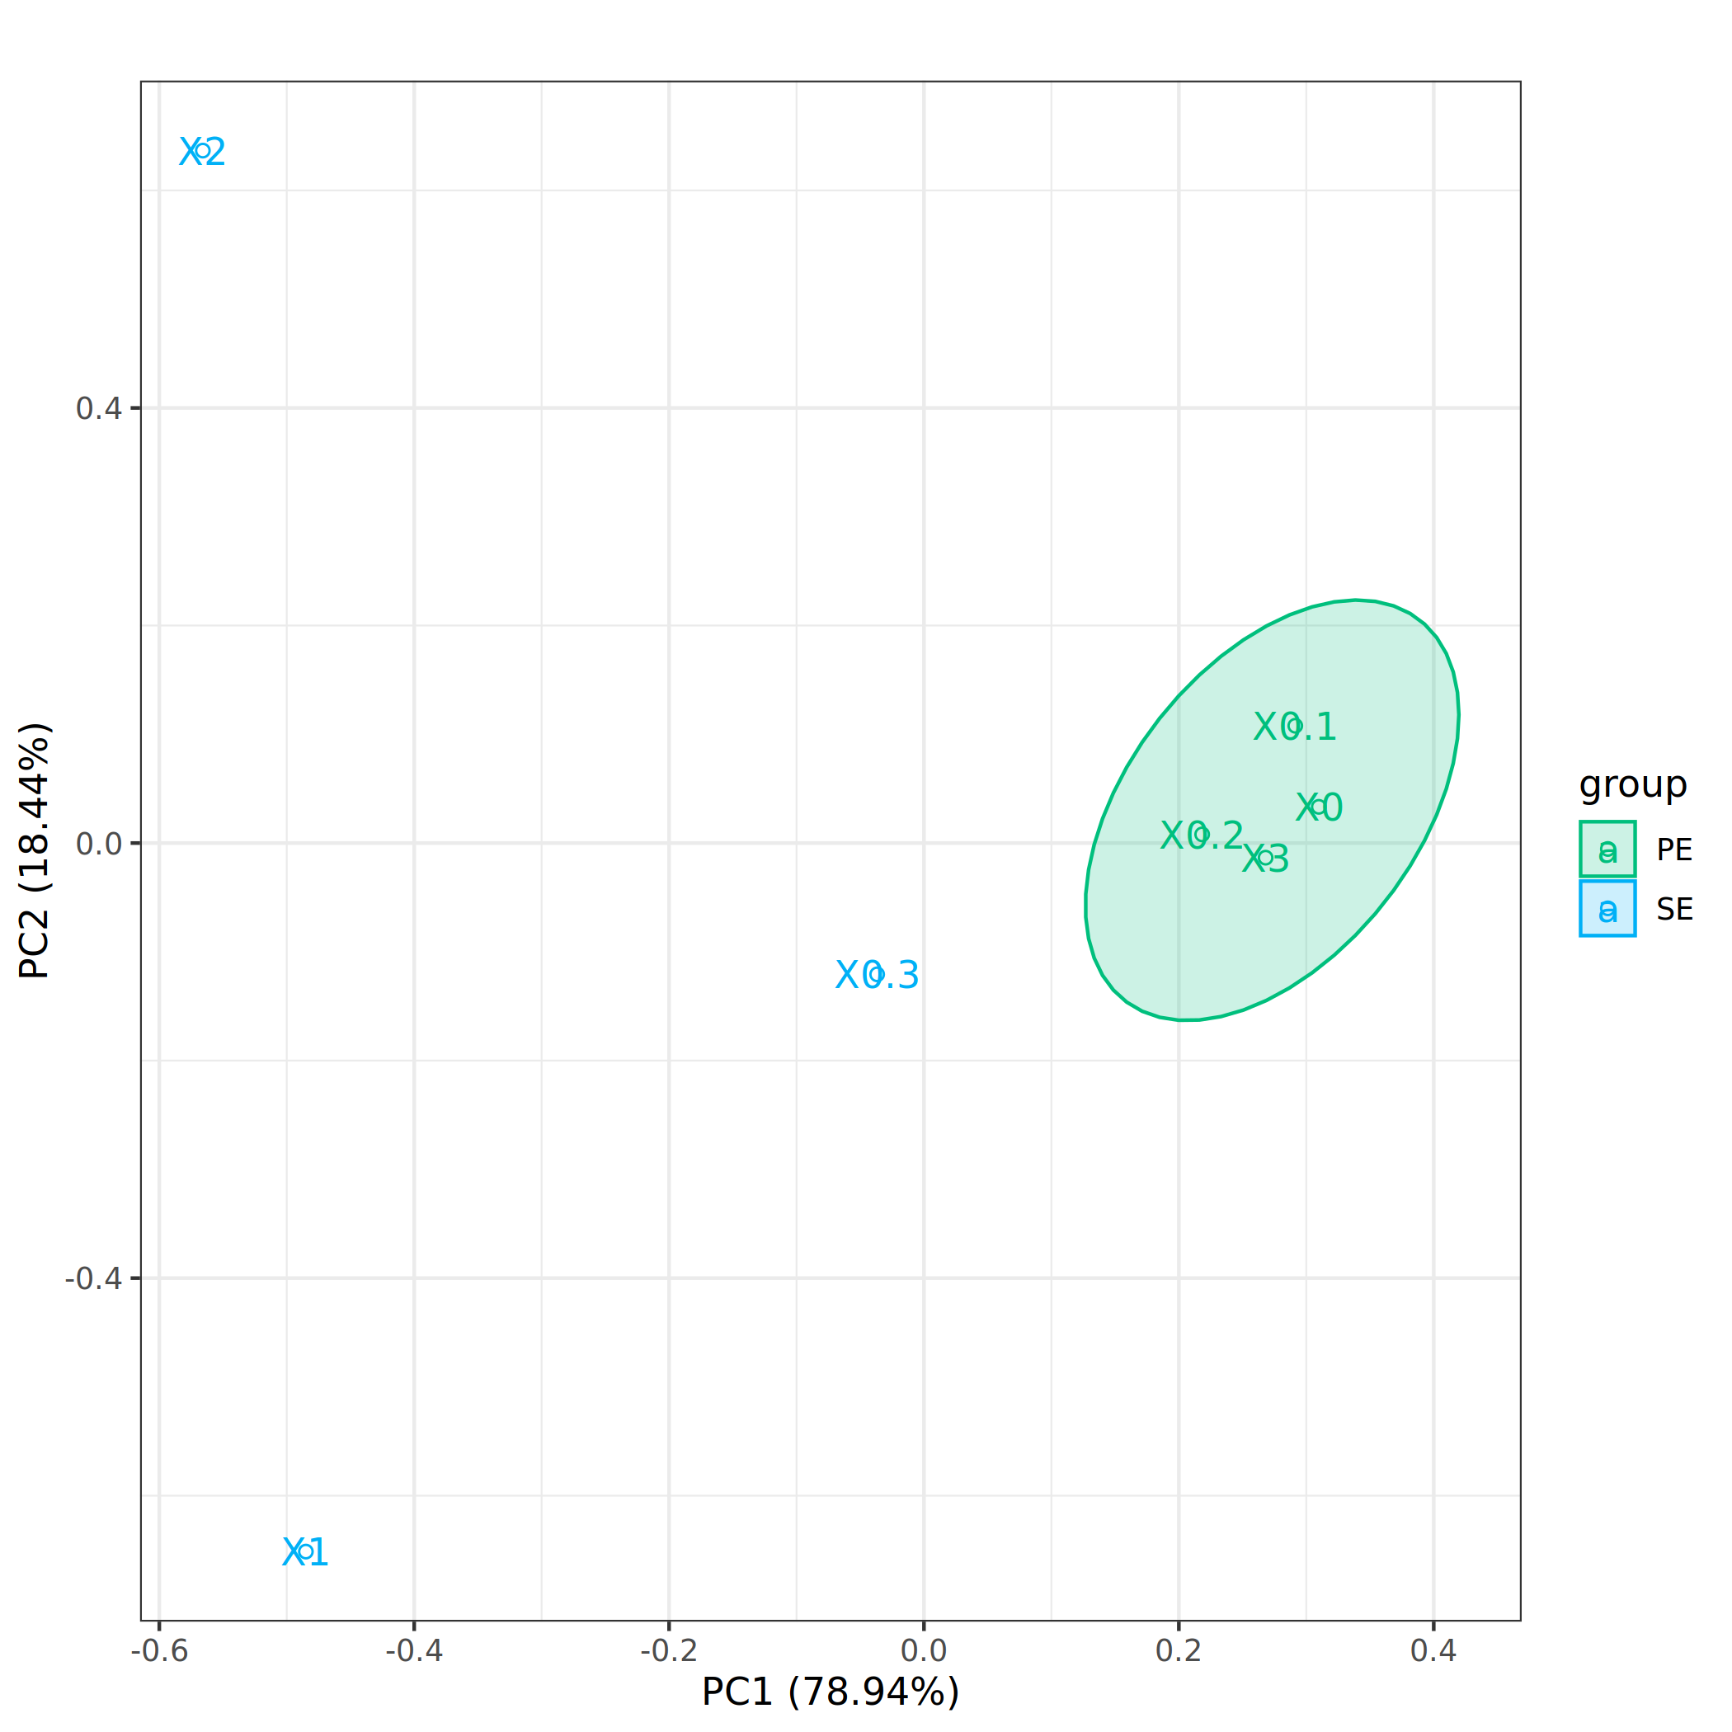
Treated
Questions:
- What proportion of total variance is explained by PC1 and PC2 combined?

- Is this proportion high or low compared to your DESeq2-normalised PCA?

- Based purely on the variance explained, would this PCA appear “strong”? Why?

- Do biological replicates cluster together clearly? Explain.

- Is separation between experimental conditions visible?

- Are any samples behaving as outliers? Describe their position relative to the others.

- Does the visual structure correspond to what you expect biologically?

- PCA captures the largest sources of variance. What might PC1 actually be representing in raw count RNA-seq data?

- Why would library size dominate variance in raw counts?

- Why does this effect reduce or disappear after DESeq2 normalisation?

- Now compare this plot to your DESeq2-normalised PCA… Which PCA better reflects biological differences between your conditions? Why?

- Now compare this plot to your DESeq2-normalised PCA… In your opinion, what does PC1 most likely represent in each PCA (the raw-count PCA and DESeq2 PCA)?
At the end of the worksheet, feel free to test your ability with Galaxy to create this PCA for yourself using the tool “PCA plot w ggplot2”.

Part 4 – Total Variance and Supervised vs Unsupervised Approaches (with Real-World PCAs)
In this section, you will interpret published PCA plots derived from gene expression data across four cancer subtypes: Burkitt lymphoma, Ewing’s sarcoma, Neuroblastoma and Rhabdomyosarcoma. The dataset consists of gene expression data from a subset of selected genes across tumour samples belonging to these four groups. Two PCA approaches were applied to the same dataset:
(a) Unsupervised PCA: Principal components are calculated using overall variance in the dataset, without using knowledge of tumour labels.
(b) Supervised PCA: Principal components are constructed to emphasise differences between the predefined tumour groups.
These figures illustrate how methodological choices influence the proportion of variance explained and the apparent clarity of clustering. Check out the figures below and use them to answer the following questions:
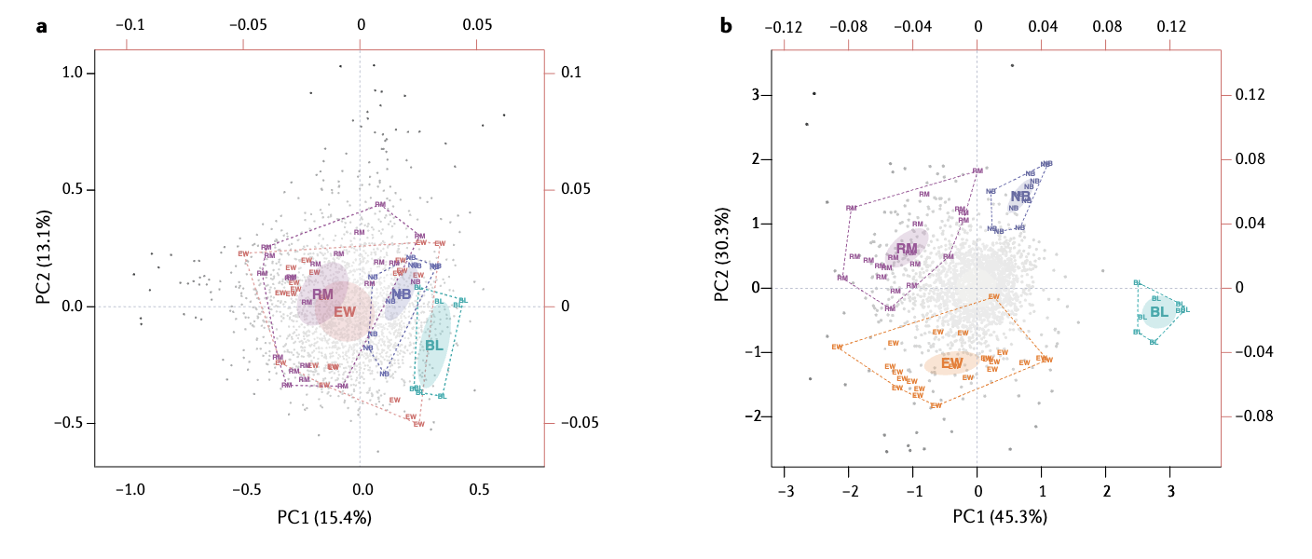
Questions:
- What percentage of total variance is explained by PC1 and PC2 in figure (a)?
- What percentage of total variance is explained by PC1 and PC2 in figure (b)?
- Which approach appears to explain more variance in the first two components?
- Does a higher percentage of variance explained automatically imply a better biological model? Explain your reasoning.
- In figure (a), do the four tumour subtypes form distinct clusters? Describe the degree of separation.
- In figure (b), how does the separation between tumour groups differ from panel (a)?
- Which plot shows clearer separation between tumour types?
- Why might supervised PCA show clearer separation between known groups?
- In your RNA-seq PCA you created earlier, was your analysis supervised or unsupervised?

Part 5 – Visualisation of lots of data with Heatmaps
Now you will generate and interpret heatmaps using your RNA-seq dataset in Galaxy. Rather than compressing the data into principal components, heatmaps display data values for individual genes across samples, allowing us to visualise detailed patterns and similarity structure directly. By combining colour-coded expression values with hierarchical clustering, heatmaps help reveal lots of data at once, including groups of co-expressed genes and similarities between samples.
This activity focuses on understanding heatmaps, not the actual data it portrays (week 8 content).
Head to Galaxy to generate a heatmap on the normalised counts file from DESeq2. We are not expecting a publishing level heatmap from this, however we can still interpret this first attempt:
- Download the file “Galaxy180-[Normalized counts for subset of genes].tabular” from Canvas – this has normalised gene counts for a subset of genes across all samples in this data
- Upload the file to Galaxy
- Find and select the tool “heatmap2”
- “Input should have column headers - these will be the columns that are plotted and row names” = select the file you just uploaded “Normalized counts for subset of genes”
- “Data transformation” = select “Log2(value+1) transform my data”
- “Scale data on the plot (after clustering)” = “Do not scale my data”
- “Enable data clustering” = “Yes”
- “Clustering columns and rows” = “Cluster rows and columns”
- “Labelling columns and rows” = “Label columns and not rows”
- “Type of colormap to use” = “Gradient with 2 colours”
- All other setting should be ok, click “Run tool”
Copy and paste the generated heatmap just below here:

On your heatmap, annotate the following components and provide their role in the heatmap for each:
- Dendrogram (rows):
- Dendrogram (columns):
- Colour key:
- Value range:
- Samples:
- Genes:
Questions:
- What is the range of values displayed (approximate minimum and maximum)?
- Do samples cluster according to biological condition?
- Are there visible blocks of genes with similar gene count patterns?
- Are the displayed values true counts or have they been transformed? If so, how?
Below is a heatmap of differentially expressed genes (which will become more familiar in later weeks). Using your knowledge of heatmaps, answer the following questions. 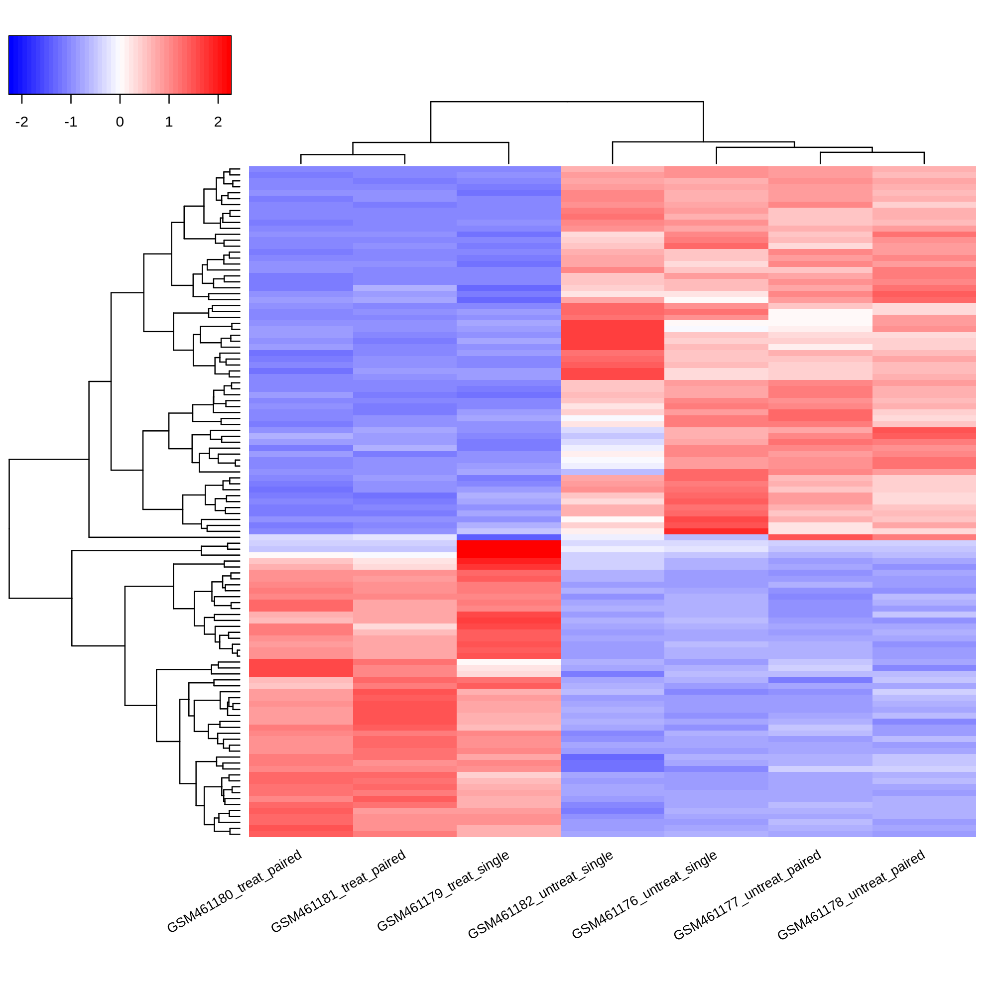
Questions:
- How does the colour range differ from the previous heatmap?
- Are there any obvious differences between the paired and single-end samples?
- If the values represented in the heatmap just above show relative gene expression (differentially expressed genes // mRNA levels), do you believe these results will be significant in describing the biology being tested (sample conditions)?

In our next sessions together, we will be focusing on genomic sequencing specifically.

END OF WORKSHOPS FOR WEEK 4

