BIOS226 – Topic 3 Workbook 1
Quality Control, Normalisation & Essential Statistics

Student name:
Student ID:

Work through this worksheet, fill in the tables and answer the questions that follow.

Learning Goals
By the end of this weeks workshops, you should be able to:
- Locate a sequencing dataset in a public repository (NCBI SRA)
- Identify key experimental and technical features of the data
- Load raw sequencing reads into Galaxy
- Perform quality control using FastQC
- Interpret FastQC outputs for paired-end DNA sequencing
- Understand how QC informs downstream analysis
- Explore how normalisation fits into multi-sample studies

Part 1 - Finding and understanding a dataset (using NCBI SRA)
Locate the dataset named SRR37127619:
- Go to NCBI: https://www.ncbi.nlm.nih.gov/
- By the search bar, click on the drop down menu where it says “All Databases” and select “SRA”
- Search for “SRR37127619”
Complete the table below with this sample’s feature information:
Feature | Expected answer
Organism
Experiment type
Library source
Platform
Layout
Read type
Questions:
- Is this genomic or transcriptomic data?
- Would you expect uniform genome coverage? Why?
- How many FASTQ files should this sample produce?
Part 2 - Loading data into Galaxy
We can pull this sample by it’s SRA code to Galaxy for analysis:
- Visit Galaxy following this link: https://galaxy-main.usegalaxy.org/
- It is best to create an account and log in – you have more memory and less risk of losing data.
- See the image below of Galaxy’s front page and familiarise yourself with:
  - Upload (upload or collect files)
  - Tools (this is where we utilise specific tools for specific tasks)
  - Tutorials and Training (feel free to explore in your own time)
  - History (these are the jobs your run = the files you process and analyse)
  - Account (account setting here)
  - “Eye Icon” (used to view files)
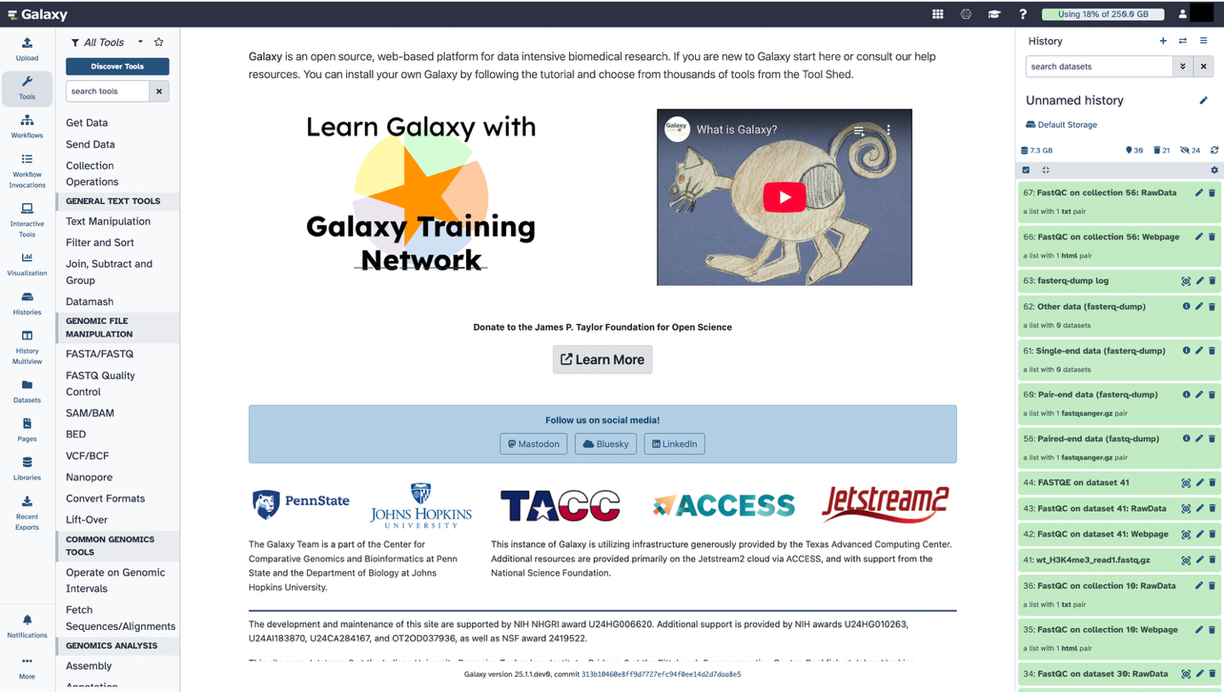
Next, import FASTQ files from NCBI SRA into Galaxy:
- In Galaxy “Tools”, search for the tool: “Download and Extract Reads in FASTQ format from NCBI SRA”
- Enter the accession: SRR37127619
- Run Tool with the standard settings
- Two FASTQ files should appear in your history, however, they may be inside a folder named “Pair-end data” that appears in your history.
  - If “single-end data” appears, this can be ignored or deleted.
- Inspect the raw FASTQ files by clicking on the “eye icon” for forward and reverse files there.
Questions:
- What information does each FASTQ entry contain?
- How do sequence and quality scores relate to one another?
- Do both FASTQ files look similar in structure?
- Are FASTQ files human-readable?

Part 3 - Quality control using FastQC
Run FastQC!
- FastQC is a tool and can be found in Galaxy – find it.
- Select the files as input in the “Raw read data from your current history”.
  - IMPORTANT: if you cannot find them as single files, do click “Dataset Collection” and find them there as a collection – running this will still create a separate FastQC report for forward and reverse.
- Run tool – all other options are not needed to be changed.
- Two files will be created 1) RawData and 2) Webpage – click the eye icon on the webpage to open the FastQC HTML report for both samples.
- Fill in the table below from your FastQC report results:

FastQC module | Forward (Pass/Warn/Fail) | Reverse (Pass/Warn/Fail) | Interpretation
Basic Statistics
Per base sequence quality
Per base sequence content
Per sequence GC content
Sequence Length Distribution
Adapter content
Overrepresented sequences
Questions:
- Are Forward and Reverse reads similar in quality?
- Are any warnings concerning for WGS data?
- Based on FastQC, is this dataset suitable for downstream analysis?
Part 4 - Quality control of RNA-seq data
You will now work with a bulk RNA-seq FASTQ file - this dataset represents transcriptomic sequencing, not genomic DNA. This data comes from this experiment: SRX014462 which has two samples (SRR031724 & SRR031725),
Complete the table below with these samples’ feature information:
Feature | Expected answer
Organism
Experiment type
Library source
Platform
Layout
Read type
HOWEVER, it has been subsetted for teaching and learning – these subsetted files can be obtained by:
- In Galaxy, click “Upload”
- A window should pop up – click “Paste/Fetch data”
- In the white box, paste these four weblinks as they are:
https://zenodo.org/record/6457007/files/GSM461177_1_subsampled.fastqsanger
https://zenodo.org/record/6457007/files/GSM461177_2_subsampled.fastqsanger
https://zenodo.org/record/6457007/files/GSM461180_1_subsampled.fastqsanger
https://zenodo.org/record/6457007/files/GSM461180_2_subsampled.fastqsanger
- Then click “Start” to load the fastq files into your history – no need to change anything else.
Questions:
- What biological molecules are sequenced in RNA-seq?
- Would you expect:
  - uniform genome coverage?
  - equal representation of all genes?
- How might RNA-seq differ from genomic DNA in QC metrics?
Now, let’s run FastQC on these files
- Run FastQC on the provided RNA-seq FASTQ files.
- Open the FastQC HTML reports.

Check your FastQC reports for differences between samples AND forward vs reverse results. Note and interpret all your thoughts for the FastQC modules / features below:

FastQC module | Any differences? | Interpretation
Basic Statistics
Per base sequence quality
Per base sequence content
Per sequence GC content
Sequence Length Distribution
Adapter content
Overrepresented sequences
Questions:
- Is higher duplication expected in RNA-seq compared to WGS? Why?
- Why might GC content be more variable?
- Would overrepresented sequences always indicate a problem in RNA-seq?

Part 5 - Comparing DNA vs RNA FastQC
Now compare the FastQC reports between DNA and RNA-seq reads
Feature | DNA-seq | RNA-seq
Coverage expectation
Duplication levels
GC content distribution
Biological vs technical bias

Part 6 - Exploring your own sequencing dataset
In later weeks, you will work with sequencing data for full analyses. This task helps you explore what data exists and whether it is suitable. Great opportunity to find data that you find interesting.

- Choose a biological interest:
  - an organism or
  - a biological process / gene or
  - a disease or condition
- Consider: would DNA-seq or RNA-seq be more appropriate for your interest?
  - Why – think of your reasoning.
- Revisit NCBI and find a dataset that you’re interested in, then fill in the table below:
Feature | Answer
Accession
Organism
Data type (DNA/RNA)
Platform
Layout
Number of samples
Biological Question or Differences

Consider: is raw FASTQ data available? Are there multiple samples? Is the dataset size reasonable? Could this be analysed in later workshops…?

Next week we will continue with more downstream QC and the Normalisation that follows.

