BIOS226 – Topic 3 Workbook 2
Quality Control, Normalisation & Essential Statistics

Student name:
Student ID:

After completing the first worksheet (Part 1-6), continue with the tasks in this worksheet. You may copy and paste the Parts in this worksheet to your first worksheet from this week to continue in one document – ready for the autoviva.
The skills you are building here:
- Reading alignment QC metrics critically
- Understanding why RNA-seq and DNA-seq differ after alignment
- Diagnosing problems in count matrices
- Understanding why we normalise before statistics
- Interpreting basic stats, not calculating them from scratch

Part 7 – QC after reads are aligned to a reference genome
Let’s revisit our DNA sequence fastq files from Workshop 1 (SRR37127619). After FastQC you should see that the data is good and usable quality. We will now align these DNA sequences to a reference genome, using the tool Bowtie2:
- In Galaxy, make sure you can see the work you produce in Workshop 1
- Search for “Bowtie2” – maps reads against reference genome
- Make sure “Paired-end” library is selected, not “Single-end”
- Select your DNAseq fastq data from Part 2 – these will likely be in a collection.
- Select reference genome = “eschColi_12”
- Save the bowtie2 mapping statistics to the history = “yes”
- Keep all other parameters and “Run Tool”
- We will return to Bowtie and BAM files in later weeks – for now, we just want to view the mapping statistics… Click the eye icon for the mapping stats from Bowtie2.
Questions:
- How many sequencing reads are in this sample?
- What percentage of reads were successfully paired?
- What is the overall alignment rate (%)?
- Using the alignment percentage, calculate approximately how many reads will proceed to downstream analysis.
- Suggest two biological or technical reasons why some reads may fail to align.
- Why is it important to identify the numbers of reads that have mapped to the genome?
- Is this alignment rate what you would expect for high-quality WGS data? Why or why not?
Part 8 – Viewing your aligned reads on the reference genome with JBrowse
In the previous Part we created a BAM file which contains the high quality reads that map to our genome. We can view these reads in mapped against the reference genome in JBrowse. JBrowse is a genome browser – you will find this on many bioinformatics databases, and we also can use it in Galaxy to view our own data. Note: typical bacterial WGS aims for around 30x coverage for reliable variant calling.
- Search for JBrowse genome browser tool
- Find the correct reference genome and select it
- Track Category = Alignments
- Annotation Track:
  - Track type = BAM Pileups
  - Track visibility = On for new users
- Run tool
- Once complete, click the eye icon.
- Tick the box for Alignments (and reference sequence if it is not already)
- Zoom in until you can see the reference sequence appear, just like the image below (in blue box):
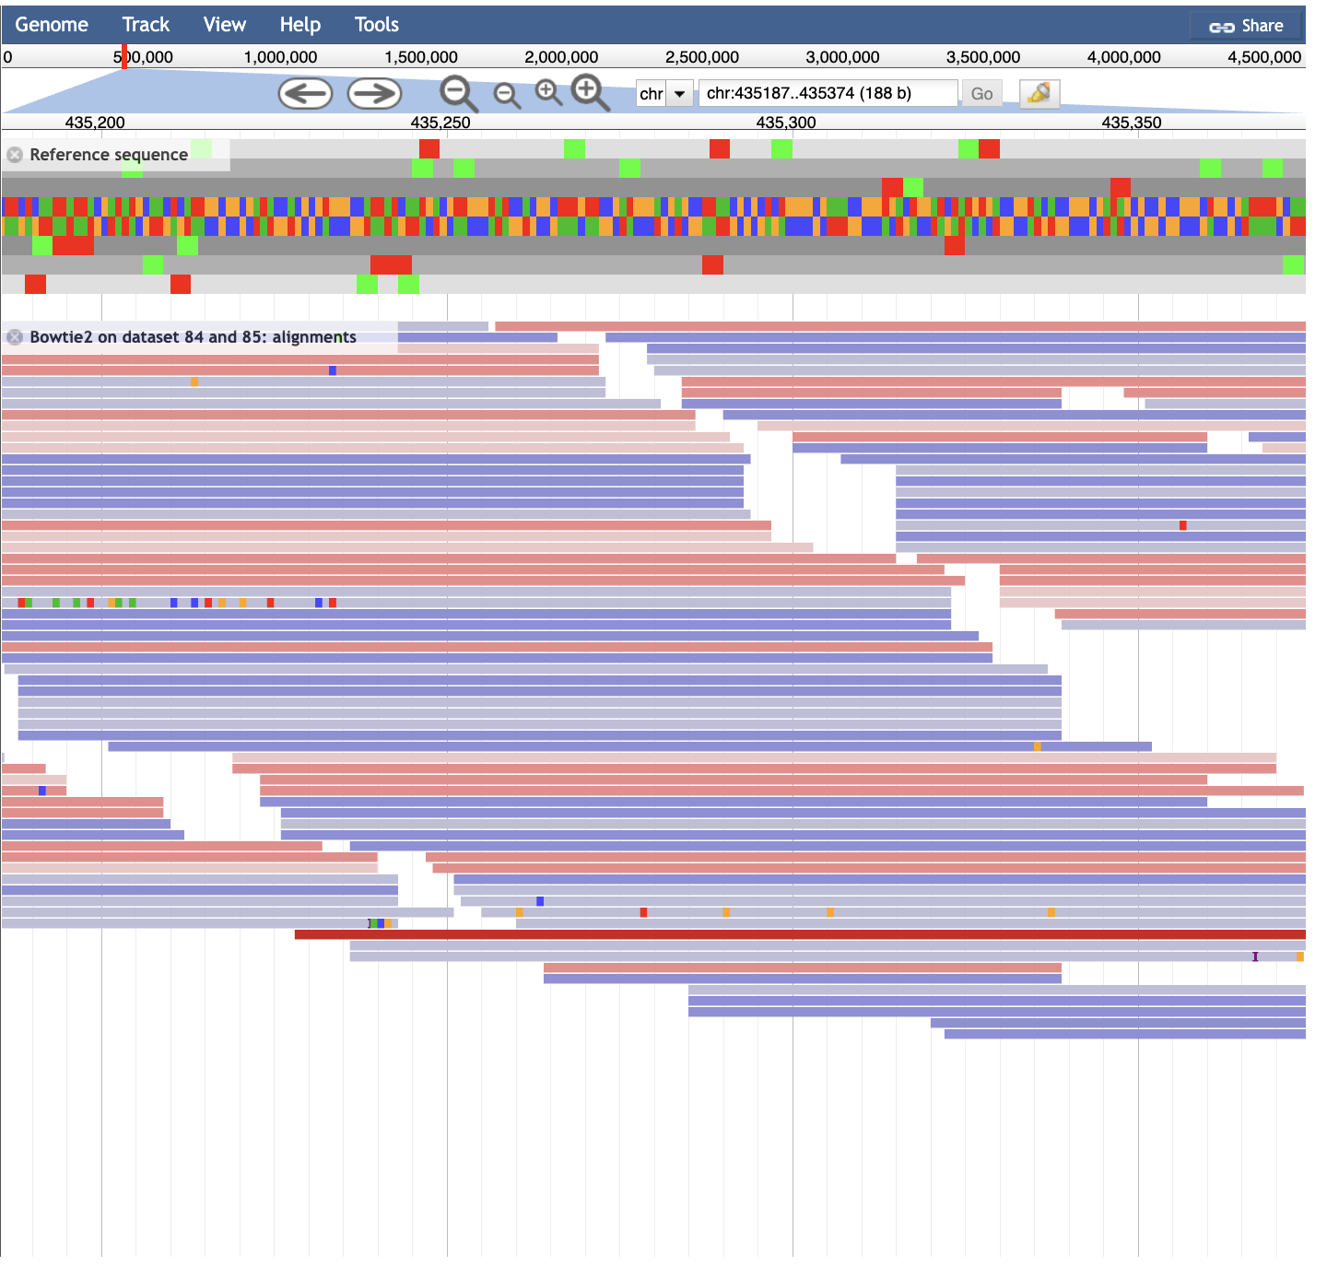
Single read!
- Now, zoom OUT to the point JUST BEFORE the Bowtie2 sequences are invisible (reference sequence will disappear, see below in yellow box):
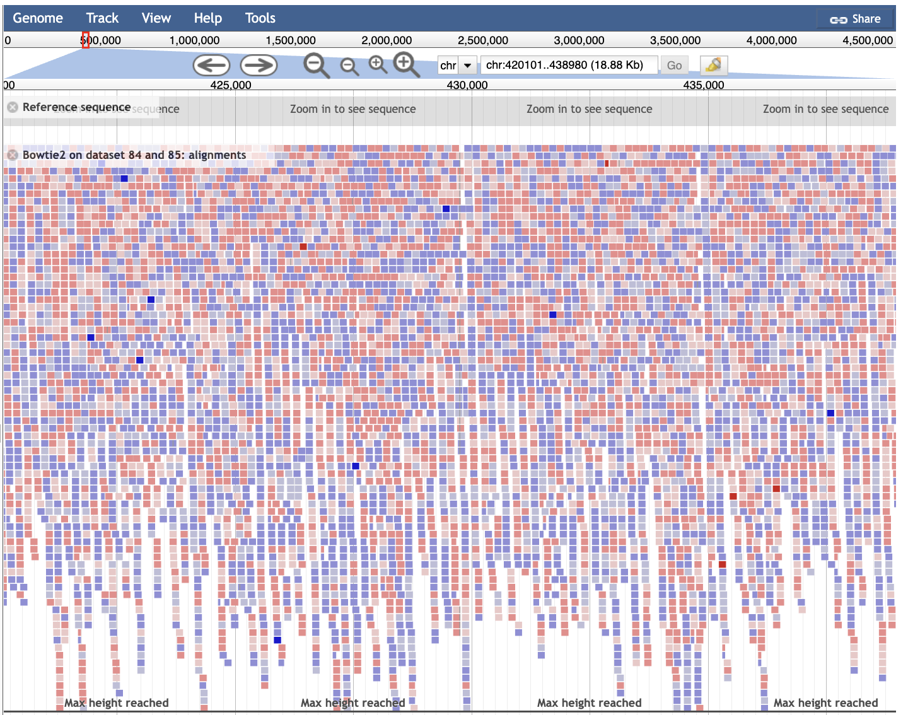
- Navigate to the start of the sequence – you can drag this slider to the beginning
- From here, view the number and magnitude of reads that map to each reference genome position and slide the across to position 500,000 (either click the arrows of click and drag)
Questions:
- In your opinion, is there sufficient coverage?
- Are there any regions of the genome without read coverage?
- Explain why whole genome sequencing data may show regions with no reads covering/aligning to them?
- Why would checking this be important for data interpretation?

Part 9 – Transcriptomic mapped reads in JBrowse
Since we will be covering RNA-seq in later weeks and time is sensitive, an image of mapped transcriptomic reads in JBrowse has been included below.
IMPORTANT:
- For RNA-seq data we use tool “RNA STAR” to map our reads (in orange box in figure below) to a reference genome (instead of Bowtie2)
- We also include a reference genome annotation file (.gtf / .gff) – this file contains important information like genes and their locations in the genome
- We will be covering this in more detail for out RNA-seq workshop
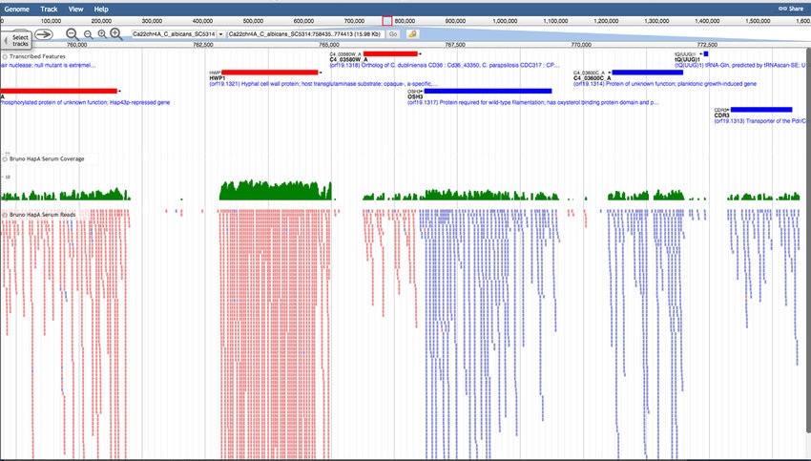
Annotated genes
Questions:
- Why do we often see gaps in transcriptomic read coverage across a genome?
- What genomic feature do these covered regions usually correspond to?
- Why do we not usually see the same pattern in whole shotgun DNA-seq?
- If one gene shows extremely high RNA-seq coverage, what does that indicate biologically?
- Would uneven RNA-seq coverage necessarily indicate a problem?
- Would uneven DNA-seq coverage necessarily indicate a problem?
Part 10 – Normalisation for DNA-seq
Now lets revisit the NCBI webpage for our DNA-seq data (SRR37127619) and investigate the other samples in this study for some normalisation. We will not do our own normalisation with real data until we cover genomics and transcriptomics weeks – but the concept will be explored here.
- Head to the NCBI webpage for our DNA-seq data = SRR37127619
- In “Study” click “All runs” (not the All runs for “Sample”)
- Navigate down to see all the runs in this study
- Look at the column “bases” (number of bases sequenced for the run) and “bytes” (size of the file for the run).
- Click on the arrow buttons by the side of these column names do sort them from largest, and then sorted them from smallest.
Questions:
- How many genomic sequencing runs can be found in this study?
- State the name of the run with the smallest number for “bases” and “bytes”:
- State the name of the run with the largest number for “bases” and “bytes”:
- Can these raw counts be compared directly between samples?
- Explain your answer:
- Would this issue affect WGS and RNA-seq equally?
- What does normalisation attempt to correct for?

Part 11 – Normalisation for RNA-seq
Scenario: You have mapped transcriptomic data to a reference genome and you find one of your samples has 10 million reads (Sample A), and the other sample has 30 million reads (Sample B). The table below has gene count data for Gene X.
Gene | Sample A | Sample B
Gene W | 1,000 | 3,000
Questions:
- Which sample appears to have higher expression of Gene X?
- Is this necessarily biologically meaningful?
To normalise this data we can use a tool named DESeq2. Instead of using total reads directly, to normalise RNA-seq data, methods like DESeq2 must:
- Assume most genes are not differentially expressed
- Estimate a “size factor”
- Scale samples accordingly
- Normalisation must still account for extreme expression changes!
Now let’s look at a more complex example:
Gene | Sample A | Sample B
Gene 1 | 1,000 | 1,000
Gene 2 | 2,000 | 2,000
Gene 3 | 1,000 | 10,000
Gene 4 | 3,000 | 3,000
Gene 5 | 100 | 100
Gene W | 1,000 | 3,000

Questions:
- Which gene(s) is/are biologically different between samples?
- How many genes show consistent gene expression across samples?
- Does normalisation completely eliminate all technical differences between samples? Explain.
- Why are some normalisation methods RNA-seq specific?

Closing Question:
In 5–6 sentences, explain why QC and normalisation are essential before performing statistical analysis on sequencing data.

In our next sessions together, we will be taking these analysis’ further to generate our own data. In the meantime, do take some time to work on Part 6 where you’re finding your own data that you’re interested in.
END OF WORKSHOPS FOR WEEK 3

