# Grader Scores Analysis

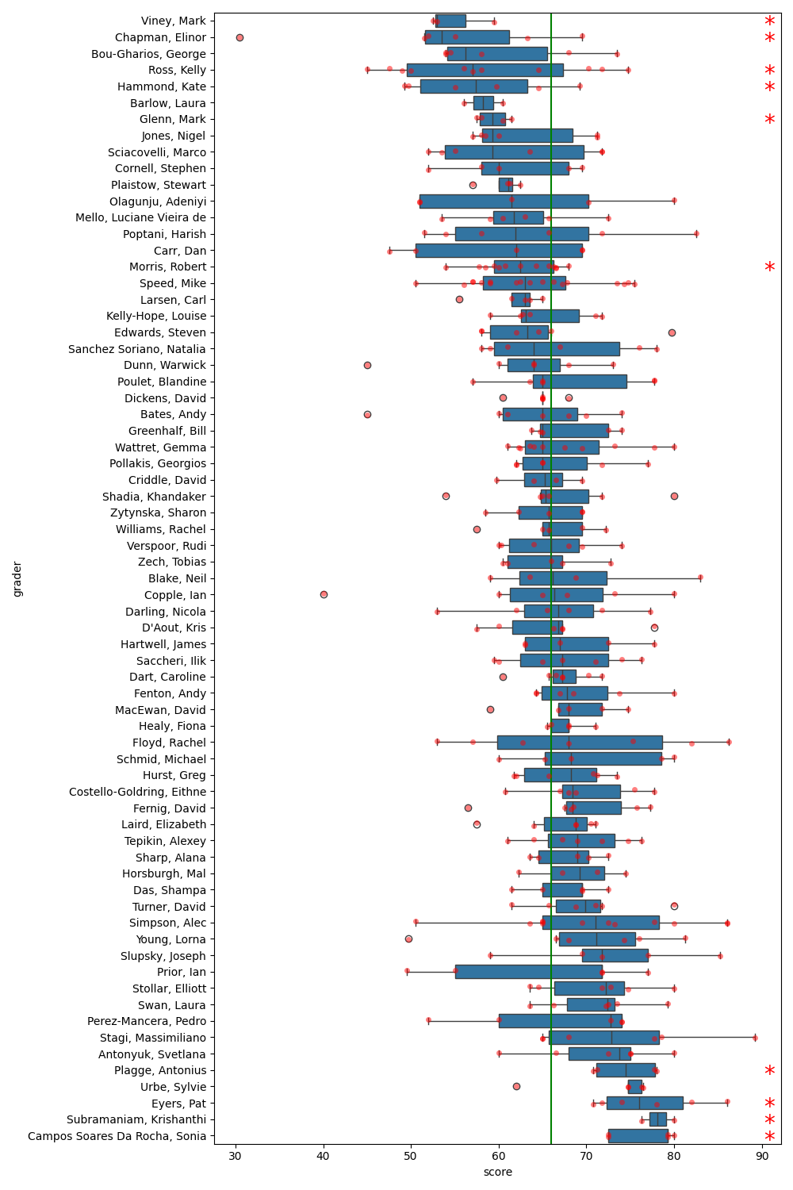

Figure 1: Boxplot of grader scores. The green line represents the global median score. Graders with significant differences in scores are marked with an asterisk.

## Significant Graders

|  |  |  |  |
| --- | --- | --- | --- |
|  |  |  |  |
|  |  |  |  |
|  |  |  |  |
|  |  |  |  |
|  |  |  |  |
|  |  |  |  |
|  |  |  |  |
|  |  |  |  |
|  |  |  |  |
|  |  |  |  |
|  |  |  |  |