# Grader Scores Analysis

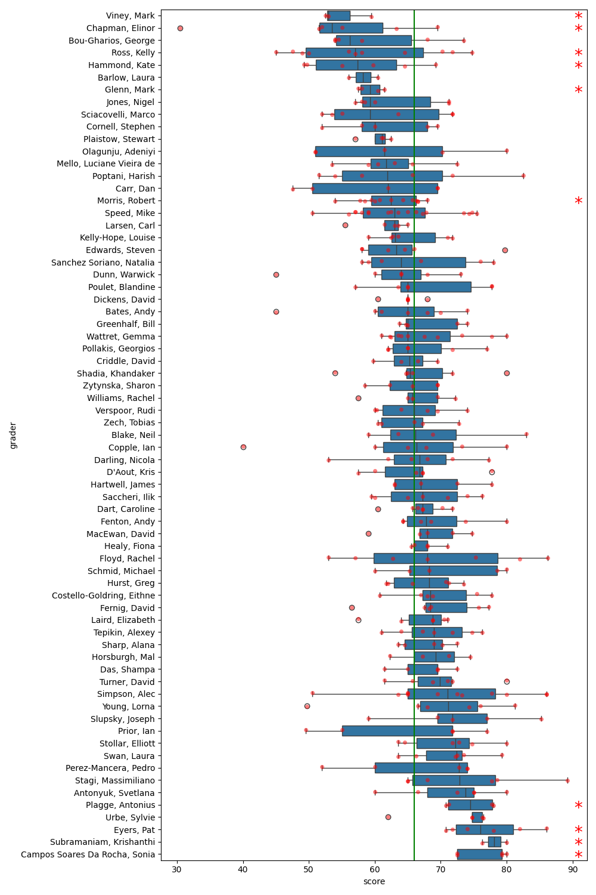

Figure 1: Boxplot of grader scores. The green line represents the global median score. Graders with significant differences in scores are marked with an asterisk.

|  |  |  |  |
| --- | --- | --- | --- |
| Grader | Median Score | Mean Score | P-Value |
| Viney, Mark | 53.00 | 55.00 | 1.78e-02 |
| Chapman, Elinor | 53.50 | 53.62 | 9.82e-03 |
| Ross, Kelly | 57.00 | 58.52 | 1.13e-02 |
| Hammond, Kate | 57.38 | 57.92 | 2.06e-02 |
| Glenn, Mark | 59.25 | 59.38 | 3.67e-02 |
| Morris, Robert | 62.50 | 62.33 | 3.75e-02 |
| Plagge, Antonius | 74.50 | 74.44 | 3.19e-02 |
| Eyers, Pat | 76.00 | 77.08 | 2.29e-03 |
| Subramaniam, Krishanthi | 78.12 | 78.12 | 3.97e-02 |
| Campos Soares Da Rocha, Sonia | 79.25 | 76.70 | 3.38e-03 |