**Vapour-Liquid-Solid Growth of Cadmium Telluride Nanowires**

**by Close-Space-Sublimation for Photovoltaic Applications**

B. L. Williams1*, B. Mendis, L. Bowen, D. P. Halliday, and K. Durose1

Department of Physics, Durham University, South Road, Durham, DH1 3LE UK

1 Now at the Stephenson Institute for Renewable Energy, University of Liverpool, Liverpool. L69 7ZF

* Corresponding author, email: b.l.williams@liverpool.ac.uk

**ABSTRACT**

Arrays of CdTe nanowires have been grown on conductive, flexible Mo substrates via the vapour-liquid-solid technique. A method of forming the arrays on a largely continuous CdTe film is described. For producing nanowire solar cells, this structure provides the advantage of preventing shunts. Nanowires having diameters in the range 100-500 nm and lengths up to 100 µm were generated. The influence of growth temperature, time and specifically pressure on the morphology of deposited layers was investigated. Further structural characterization by SEM, TEM and low temperature photoluminescence is presented.

**INTRODUCTION**

There has been considerable interest surrounding the fabrication of semiconductor nanowires for use in opto-electronic devices, including photovoltaic cells. Despite the large presence of CdTe in the field of photovoltaics, II-VI compounds are somewhat under-represented in the nanowire literature, compared to Si and III-V compounds. Indeed, vapour-phase based CdTe nanowire growth has rarely been reported [1].

Low dimensional structures demonstrate novel optical and electrical characteristics through quantum confinement, i.e. the conductance of nanowires becomes quantised when their diameters are comparable to the Fermi wavelength. For photovoltaics however, the primary benefit of incorporating nanowires will be that of introducing numerous radial p-n junctions to replace the traditional planar junction. In this geometry, carriers can reach the junction region by travelling distances shorter than the minority carrier diffusion length and consequently electron-hole recombination is quenched [2-4].

Semiconductor nanowires are commonly grown via the vapour-liquid-solid (VLS) process, first described by Wagner *et al.* [5]. The physical mechanisms of nanowire growth have been investigated in detail. For example, Wagner observed that the wire diameter was governed by the catalyst droplet diameter. The length and aspect ratio of wires has been discussed in terms of contributions from direct vapour impingement [6] and of diffusion limited migration [7].

Some examples of CdTe nanowire growth include Bi2Te3 catalysed ‘rods’ by a co-evaporation method [8], template-prepared nanowires [9], and catalyst-free CdTe nanorod arrays grown on ITO [10]. It has also been observed that the use of a layer of polyvinyl alcohol dramatically improved the size uniformity of vertically aligned CdTe nanowires, deposited by laser ablation [11].

Typically, the VLS method results in growth only at the catalyst sites and not directly on the substrate. Within photovoltaic cells however, continuous layers are required to prevent short circuiting. We present successful growth of CdTe nanowires on Mo foil via a modified VLS growth mechanism which results in largely continuous layers. The vapour source was provided in the ‘close space sublimation’ geometry [12]. Growth was performed on conductive substrates as this work is to progress towards the fabrication of photovoltaic devices. The effect of varying the growth pressure and temperature on the morphology of the structures is investigated using electron microscopy.

**EXPERIMENTAL DETAILS**

15 mm x 15 mm substrates, cut from 0.1 mm thick Mo foil (99.9% purity), were scrubbed with de-ionised water and blow dried using N2. Ultra thin Au films (~ 4 nm) were thermally evaporated onto the substrates and then annealed to form arrays of nano-sized spherical drops. The annealing step was performed within the chamber of the close-space sublimation equipment, so that vacuum was not broken prior to the CdTe deposition step. In the growth chamber, the substrates were held 10 mm above a powdered CdTe source (99.999%, Alfa Aesar). The equipment allowed a choice of ambient N2, O2 and H2 pressures and the source and substrate temperatures could be controlled using two separate heating elements. The Au films were annealed at a substrate temperature of 360°C, for 30 minutes under N2 pressures of 10-150 Torr. A shutter was placed between the substrate and source at this stage to prevent premature growth. The substrate and source were then raised to the desired growth temperatures and the shutter was removed for the allotted deposition time, to allow sublimated CdTe vapour to condense on the substrate.

CdTe was deposited using source temperatures of 520-600°C, onto substrates held at temperatures of 490-550°C, under N2 pressures of 10-150 Torr, for 10-60 minutes. Electron microscopy imaging and structural characterisation was carried out using a Hitachi SU-70 FEG SEM and a JEOL 2100F FEG TEM. Low temperature photoluminescence spectra were obtained using the 514 nm line of an Argon laser.

**RESULTS AND DISCUSSION**

**1. Nanowire Fabrication and Growth Mechanism**

Fig. 1 illustrates the successful Au-catalysed growth of CdTe nanowires. For this sample, the Au film was annealed under 25 Torr N2 and CdTe was deposited at Tsource = 550°C, Tsub = 520°C in 25 Torr N2 for 30 minutes. A distribution of nanowire length and diameter was obtained, with some wires exceeding 20 µm in length and with diameters in the range 100-500 nm. The nanowire diameter is considered to be governed by the Gaussian distribution of the Au catalyst drop diameters [5], measured for these samples from electron micrographs. Typically, the thinner wires were observed to grow to greater lengths than the thicker wires. This suggests that the diffusion of adatoms from substrate to catalyst is the predominant contribution to nanowire growth, as observed by Dubrovskii *et al.* [7]. In contrast, an adsorption-limited system would have resulted in the *thicker* wires growing at a faster rate. [6]. Energy-dispersive X-ray (EDX) spectroscopy taken from the ‘stem’ of a nanowire clearly shows Cd and Te Lα1 peaks (Fig. 1c). EDX also confirms the presence of an Au catalyst at the nanowire tip, proving that growth is via VLS.

The growth mechanism here is atypical of standard VLS growth however. A rough, thin film of CdTe, ~ 500 nm, established on the substrate before one-dimensional growth began. This initial film was directly observed in cross sectional SEM images and much shorter deposition times yielded no nanowire growth. The lattice mismatch of this system is very high (lattice parameter a = 0.648 nm and 0.315 nm for CdTe and Mo respectively) and so the resultant strain initially prevents coherent one-dimensional growth. Chuang *et al.* demonstrated that the critical nanowire diameter, above which coherent VLS growth cannot occur, is extremely small (of the order of a few nm’s) for highly mismatched systems [13]. Once a thin film of CdTe has established however, it effectively becomes the substrate of the system and there is no longer a mismatch, and one dimensional growth becomes favourable .

Cross sectional SEM imaging also confirmed that some of the smaller Au nanodots became trapped underneath the initial two-dimensional layer, and consequently did not catalyse nanowires (illustrated in the schematic in Fig. 1d). It is suggested that the higher vapour pressure associated with smaller droplets (the Gibbs-Thompson effect) prevents the necessary saturation of the droplet with dissolved material. The resultant nanowire density was therefore lower than that of the initial catalysts. If the wires were to be grown on a CdTe substrate however, Au-CdTe alloy droplets may form during the annealing stage and so it may be easier to obtain the saturation condition that is necessary for wire nucleation. Successful nanowire growth using such homoepitaxial systems is frequently reported [7, 14].

The arrays are not vertically aligned, rather they are highly disoriented. There may be a number of reasons for this: a) roughness of the underlying film, b) polycrystallinity of the underlying material, c) tilts due to misfit dislocations and d) kinks in the wires caused by growth defects. This shall be the subject of further investigation.

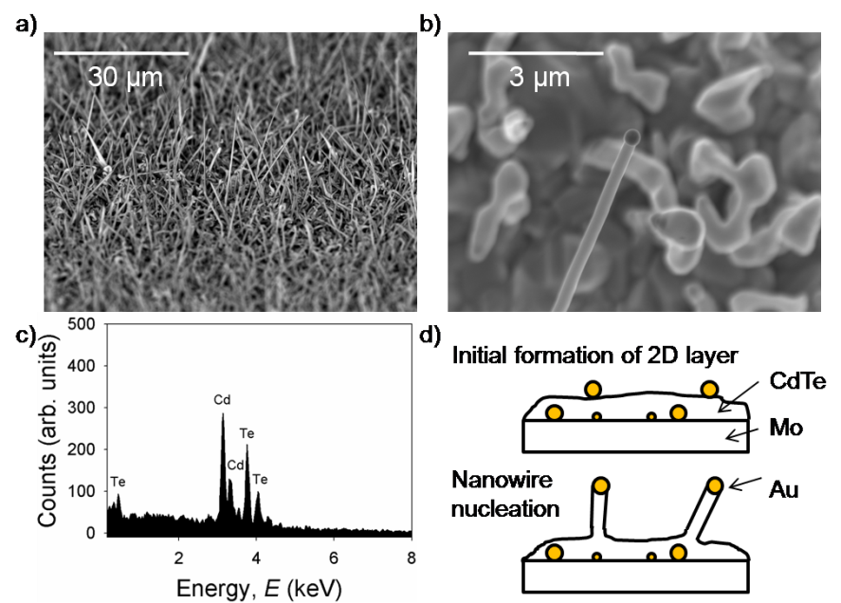

**Figure 1**. (a) Array of CdTe nanowires on a Mo substrate (20° tilt). (b) High mag. image of single nanowire. (c) EDX spectrum (d) Growth mechanism – a rough film of CdTe initially forms before nanowire growth can begin.

**2. Morphology dependence on growth pressure, temperature and time**

*Pressure:* Four samples were grown under different N2 pressures; 150, 100, 25 and 10 Torr at Tsource = 550°C, Tsub = 520°C for 30 minutes. As the pressure was decreased a change in the morphology of the structures, from two dimensional films to one dimensional nanowires, was observed. For example, Fig. 2a shows a rough but essentially two dimensional film grown under 150 Torr of N2 whereas Fig. 2d shows the nanowire arrays that are encouraged by reducing the pressure to 10 Torr. These observations may be explained as follows: for VLS growth to proceed, we have stated that is necessary for the liquid droplets to be saturated with dissolved material. Such conditions are achieved when the flux of incoming material exceeds that of loss from the droplet (due to wire formation and re-evaporation). In the present experiment, the vapour pressure of CdTe species (determined by the source temperature) was constant. However, the rate of arrival of species at the catalyst tip is influenced by the pressure of N2 which acts as a buffer. Under the relatively high pressures of N2, the arrival rate of CdTe species is insufficient to saturate the droplet and the conditions for VLS growth aren’t achieved, even when the growth times are extended. Nevertheless for lower pressures, VLS proceeds, as shown in Fig’s 2c and d.

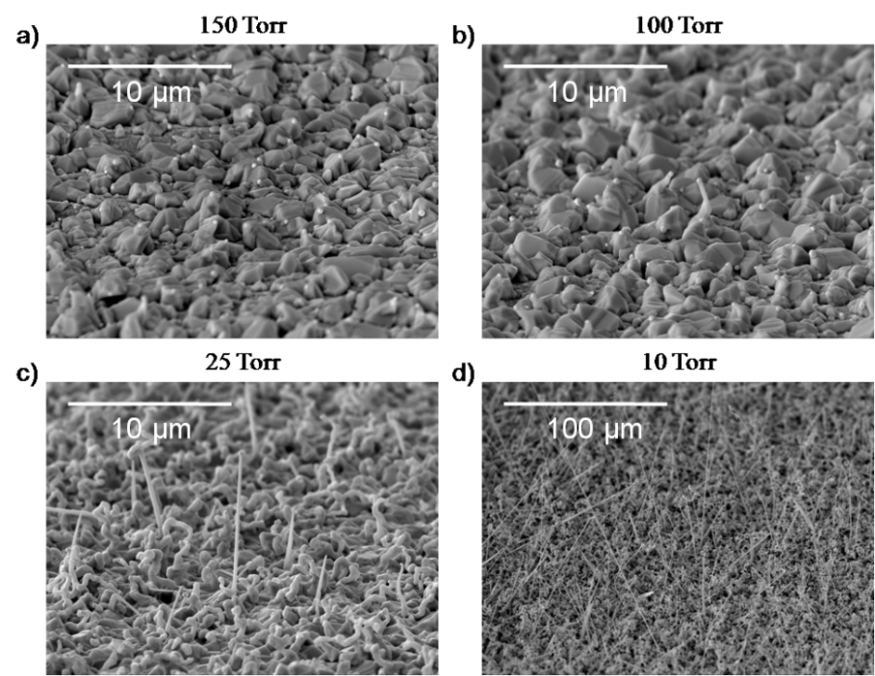

**Figure 2**. SEM images at 20° tilt of samples grown under different N2 pressures for 30 minutes at Tsource = 550°C, Tsub = 520°C.

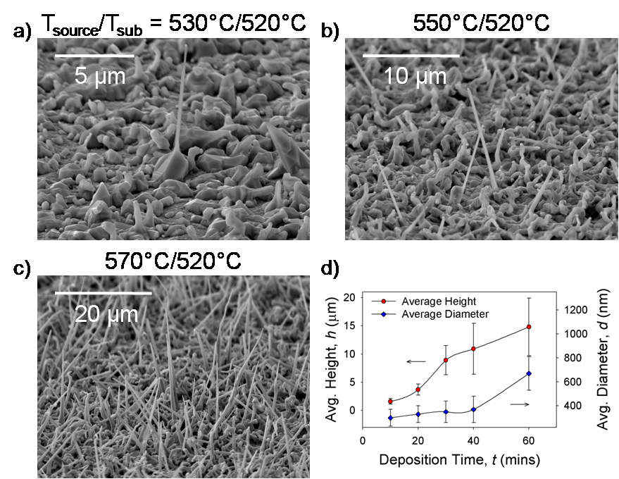

**Figure 3**. (a – c) SEM images at 20° tilt of samples grown at different source temperatures under 25 Torr N2 for 30 minutes. (d) Development of average nanowire length and diameter over growth time.

*Temperature:* Whilst keeping the *substrate* temperature at 520°C, increasing the *source* temperature resulted in denser arrays of longer nanowires (Fig. 3a – c). This was a direct consequence of the rise in deposition rate. The same trend was observed when using a substrate temperature of 490°C. At a higher substrate temperature (550°C) however, the nanowire density dropped and higher aspect ratios (i.e. longer and thinner) were achieved. Surface diffusion of adatoms is increased at higher substrate temperature and so adatoms are able to migrate to established nanowires, in favour of nucleating new wires. Crystallographic faceting of the wires was also more evident at 550°C with some of the wires exhibiting a rectangular cross section and tapering towards the tip, forming pyramid-like structures.

*Time:* The average length and diameter of nanowires grown for different lengths of time was calculated by measuring 100 wires from each sample. Fig. 3d plots the development of the wire dimensions. Initially the growth rate was low as the two-dimensional CdTe layer was established. Following nanowire nucleation, there was a period whereby nanowire length increased linearly with time. During this period the diameter of the nanowires remained constant, but then began to increase after 40 minutes. This onset of lateral growth correlates with a reduction in the growth rate of the nanowire length. Adatoms fail to reach the liquid catalyst at the tip of the nanowire once the wire length exceeds the surface diffusion length. Migration of the Au catalyst from the tip to sidewalls and also to neighbouring wires presents another limit to nanowire length, and there is some evidence that this occurred in our samples.

**3. Further Characterisation**

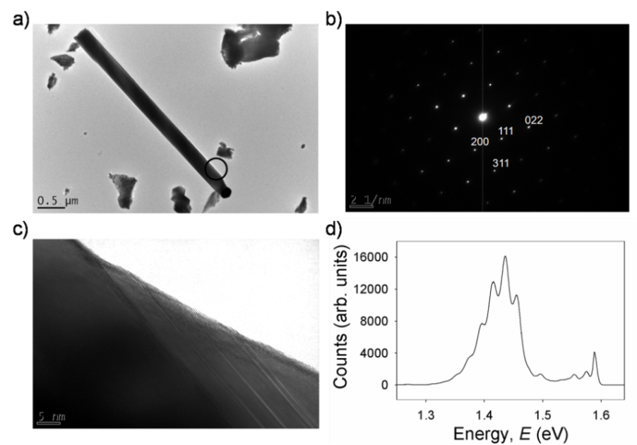

**Figure 4**. (a) TEM image of a CdTe nanowire. (b) Corresponding diffraction pattern showing growth is along the [111] direction. (c) HRTEM image of section circled in Fig. 4a reveals twinning defects. (d) Low temperature photoluminescence spectrum.

Fig. 4a is a TEM image of a single CdTe nanowire. Its corresponding diffraction pattern confirms that the wire is of zinc blende structure and its growth axis is along the [111] direction. D-spacings of 3.8 Å, 2.4 Å and 2.0 Å were calculated for the (111), (220), and (311) lattice planes respectively. These differ slightly from accepted values (3.73 Å, 2.28 Å and 1.96 Å) as a result of the slight non-stoichiometry that was measured by EDX analysis [15]. Twinning defects are an inherent crystallographic feature in nanowires of zinc blende structure [16] and have been seen to induce faceting of nanowire surfaces [17]. An HRTEM image of the section circled in Fig. 4a is displayed in Fig. 4c, showing such a defect.

A typical low-temperature (4K) photoluminescence spectrum from a nanowire structure is shown in Fig. 4d (nanowire length ~ 5-20 µm, diameter ~ 200-500 nm, density ~ 4 × 106cm-2). The spectrum shows a near band edge feature at 1.589 eV with a FWHM of 8 meV. This energy corresponds with the (A0X) peak normally seen in p-type single crystal CdTe, although the FWHM is more than twice the usual value. Two weaker features at 1.575 and 1.554 eV are also observed; their origin is unclear at this time although they may be phonon-related transitions. The spectrum is dominated by a broad band at 1.44 eV with a zero phonon transition at 1.455 eV and a series of 5 phonon replicas to lower energy. The peak separation corresponds well with the 21 meV energy of the LO phonon in CdTe. The Huang-Rhys phonon coupling parameter of this band is determined to be S=1.43. This indicates the band originates from a defect complex strongly coupled to the lattice. It is likely that the main contribution to the spectrum comes from the underlying two-dimensional film as opposed to the nanowires themselves. Ongoing work will clarify the origin of the spectra.

**CONCLUSIONS**

The vapour-liquid-solid technique has been successfully employed to grow arrays of CdTe nanowires on conductive, flexible Mo substrates. It has been demonstrated that the morphology of deposited material can be manipulated by varying specific growth conditions, namely temperature, pressure and deposition time. In contrast to standard VLS growth, a two dimensional thin film of CdTe initially forms, from which nanowires nucleate. The resultant continuous layer is desirable for solar cell applications as it would prevent short circuiting. A more controlled method of creating the two dimensional film will be used in future work, and methods of constructing core-shell heterojunctions, in view of developing full devices, will be investigated.

**REFERENCES**

1.L. Yang, R. Wu, J. Li, Y. F. Sun, and J. K. Jian, Materials Letters **65**, 17.

2.B. M. Kayes, H. A. Atwater, and N. S. Lewis, Journal of Applied Physics **97**, 114302 (2005).

3.M. D. Kelzenberg, D. B. Turner-Evans, B. M. Kayes, N. S. Lewis, and H. A. Atwater, Nano Lett. **8**, 710 (2008).

4.L. Tsakalakos, J. Balch, J. Fronheiser, B. A. Korevaar, O. Sulima, and J. Rand, App. Phys. Letters **91**, 233117 (2007).

5. R. S. Wagner and W. C. Ellis, Applied Physics Letters **4**, 89 (1964).

6.E. I. Givargizov and A. A. Chernov, Kristallografiya **18** (1973).

7.V. G. Dubrovskii, G. E. Cirlin, I. P. Soshnikov, A. A. Tonkikh, N. V. Sibirev, Y. B. Samsonenko, and V. M. Ustinov, Physical Review B **71**, 205325 (2005).

8.C. M. Ruiz, E. Saucedo, O. Martinez, and V. Bermudez, The Journal of Physical Chemistry C **111**, 5588 (2007).

9.I. Enculescu, S. Marian, E. Monica, E. Mihaela, I. Lucian, and N. Reinhard, phys. status solidi (b) **244**,1607 (2007).

10.X. Wang, J. Wang, M. Zhou, H. Zhu, H. Wang, and Q. Li, The Journal of Physical Chemistry C **113**, 16951 (2009).

11.S. Neretina and et al., Nanotechnology **18**, 275301 (2007).

12.J. D. Major, Y. Y. Proskuryakov, K. Durose, G. Zoppi, and I. Forbes, Sol. Energy Materials and Solar Cells **94**, 1107.

13. L. C. Chuang, M. Moewe, C. Chase, N. P. Kobayashi, and S. Crankshaw, App. Physics Letters **90**, 043115 (2007).

14.M. C. Plante and R. R. LaPierre, Journal of Crystal Growth **286**, 394 (2006).

15.H. Niu, L. Zhang, M. Gao, and Y. Chen, Langmuir **21**, 4205 (2005).

16.B. A. Korgel, Nat Mater **5**, 521 (2006).

17.J. Johansson, L. S. Karlsson, C. Patrik T. Svensson, T. Martensson, B. A. Wacaser, K. Deppert, L. Samuelson, and W. Seifert, Nat Mater **5**, 574 (2006).