Zn_{x}Sn_{x}O_{x} buffer layer devices

1.Growth of devices
1.1 TCO/Buffer
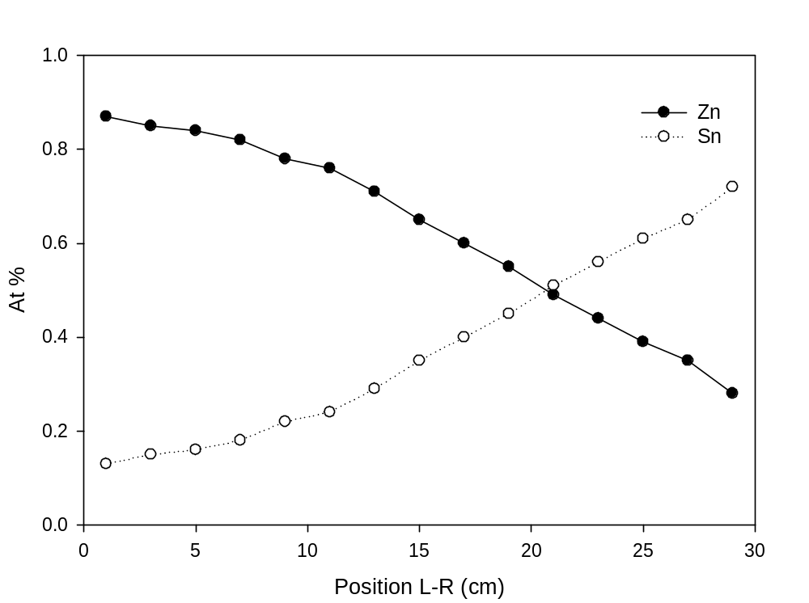
Fig 1: Zn and Sn concentration vs position on substrate L-R

The TEC 15 coated with graded composition ZnSnOx buffer layer (M140909-R5 , grown in a pure O₂ ambient) was divided into 5 x 5 cm pieces for device fabrication. Fig 1 shows the Zn At% as a function of position on the 30cm plate from left to right, with the left hand edge of the plate being defined as the Zinc-rich end. A series of six 5 x 5 cm devices were produced labeled A-F, as well as devices produced on ZnO and SnO₂ buffers for comparison.
1.2 Layer deposition and processing
All device layer deposition, post growth treatment and contacting was constant for each sample. The basic process is listed below;
CSS CdS – Growth for 1 min at T_{source} – 600°C. Growth ambient used was 60% O₂: 40% N₂, film thickness was ~100nm.
CSS CdTe – Pre-growth anneal at T_{source}- 480°C for 20 min in 50% H₂: 50% N₂ ambient. Growth performed at T_{source} – 615°C in two stages i) 30min in 20 Torr nitrogen followed by ii) 90s in vacuum.

CdCl₂ – Sample etched prior to CdCl₂ deposition in NP solution for 15s. 200nm CdCl₂ film deposited by vacuum evaporation. Samples annealed in air at 400°C for 20min.

Back contact – Samples NP etched for 10s before have a grid of 25, 5 x 5 mm gold back contacts added.
Note – Samples were produced out of sequence to minimize systematic error.
2 Results
2.1 Uniformity assessment
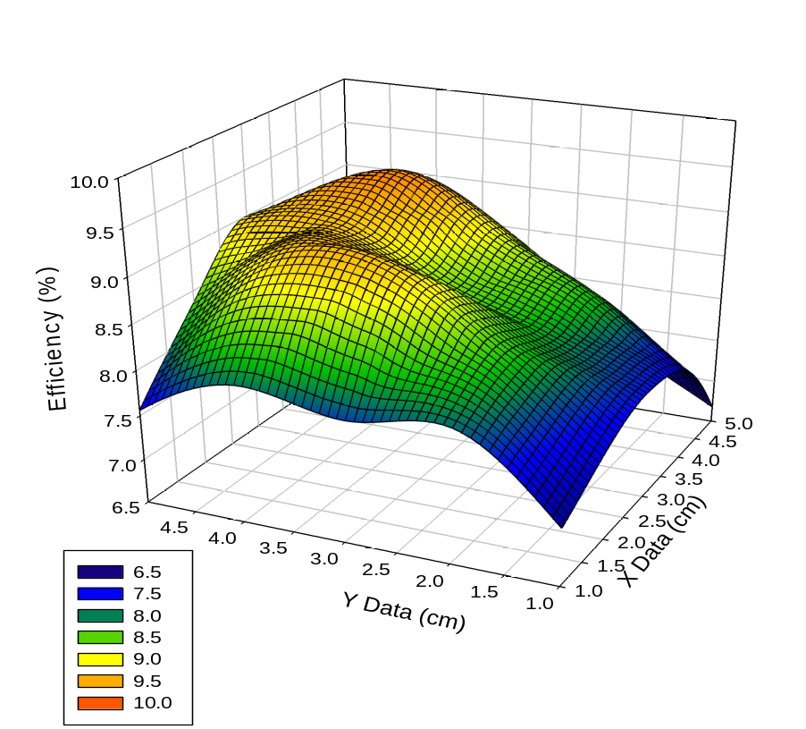
Fig 2: Performance variation of contacts across a 5 x 5 cm plate

As the composition of the buffer was graded across each device, ideally it would be preferred to compare the device performance as a function of contact position across each 5 x 5 cm device plate. However, due to the thickness variations arising from CSS deposition, as well as possible non-uniformity of annealing for the CdCl₂ treatment, it was anticipated this would not be possible. Figure 2 shows the efficiency variation as a function of contact position across a 5 x 5cm plate. The variation in performance observed is to changes in CdTe and CdS thickness rather than due to any change in the composition of the buffer layer. Because of the large variations seen the average performance of each device was determined using only the 9 contacts in the center of the plate, thus discounting the thinner material regions around the edges.
2.2 Device results
Position from left | Piece | Zn/Zn+Sn | Av. Eff % | Peak Eff
0-5cm | A | 0.85 | 8.76 | 9.36%
5-10cm | B | 0.8 | 8.94 | 10.01%
10-15cm | C | 0.65 | 7.72 | 9.26%
15-20cm | D | 0.6 | 7.40 | 8.25%
20-25cm | E | 0.45 | 6.76 | 7.23%
25-30cm | F | 0.35 | 6.76 | 7.58%
- | ZnO (100nm) | 1.0 | 9.76 | 10.90%
- | SnO₂ (100nm) | 0.0 | 1.09 | 2.27%

The above table shows the average and peak efficiency values for Zn_{x}Sn_{x}O_{x} cells, with ZnO and SnO₂ buffer samples for comparison, whilst figure 3 shows the average efficiency, fill factor, J_{sc} and V_{oc} plotted as a function of position. The first thing to note is that the ZnO based sample yielded the best device performance, whilst the SnO₂ based device had very low performance. In the case of the SnO₂ based device the poor performance appears to be due to poor adhesion of the CdS to the substrate. Visible bubbling was visible through the glass after CdTe deposition, this became even more pronounced after CdCl₂ deposition. This lends weight to the idea that the CdS growth is profoundly different on ZnO and SnO₂.
For the Zn_{x}Sn_{x}O_{x} buffer devices a number of trends can be discerned from the data in figure 3;
- The device performance is far better for Zn-rich rather than Sn-rich films.
- Variation is mainly due to changes in the device fill factor, as the efficiency and fill factor curves show similar trends. Rs and Rsh values (figure 4) show that FF loss is due to a combination of increased Rs and decrease in Rsh. The very low Rsh for sample F is due to over-etching the back surface prior to contacting.
- The J_{SC} appears to be independent of the buffer layer, variations are most likely due to variations in CdS thickness.
- V_{OC} seems to be strongly linked to the buffer resistivity, figure 5 shows comparable resistivity and V_{OC} plots. Sample C (10-15cm) has a significantly lower V_{OC} and accompanying resistivity. This is to be expected as previous work has suggested increased V_{OC} is the principle benefit of using a high resistance buffer layer, therefore as the resistivity of the buffer approaches that of the TCO the benefit of the buffer will be lost.
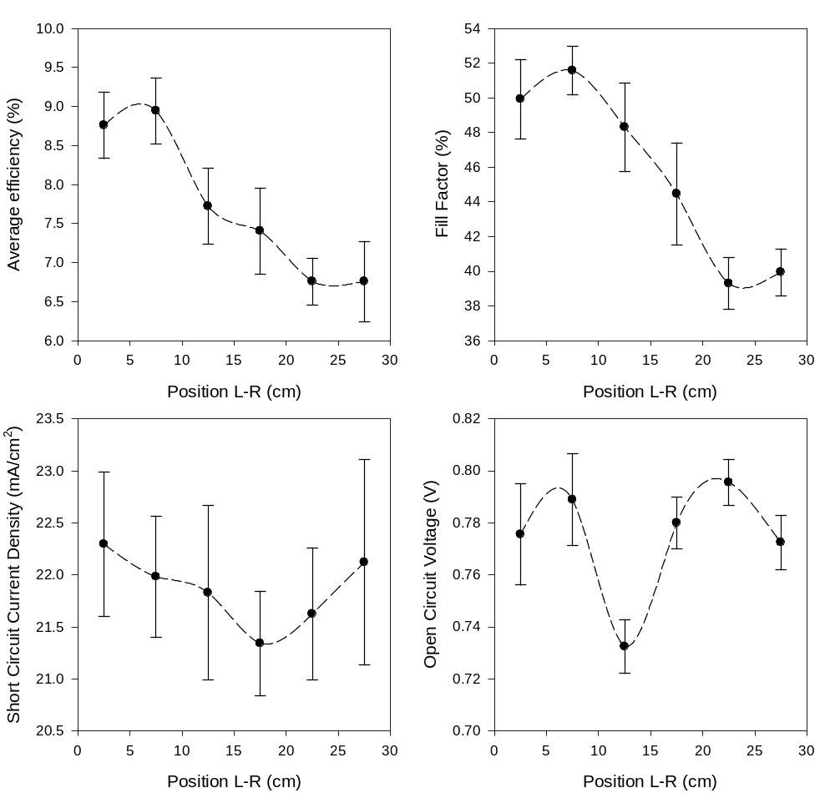
Fig 3: Device performance parameters vs substrate position

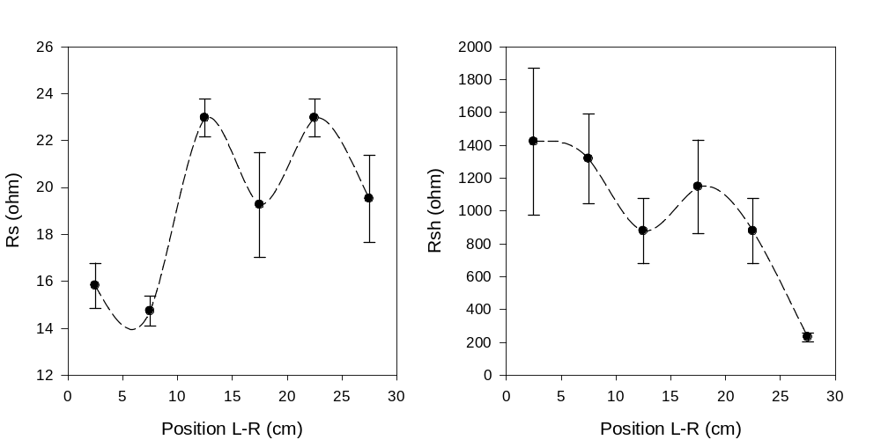
Fig 4: Rs and Rsh vs substrate position

Fig 5: Voc Vs position and resistivity vs position.
