**Characterizing the nanoscale morphology of Organic Metal Halide photovoltaic materials**

**Supervisors:** Dr Alan Dunbar (Lead), Department of Chemical and Biological Engineering,

Dr C. Rodenburg, Department of Materials Science & Engineering,

and Prof David G. Lidzey Department of Physics and Astronomy.

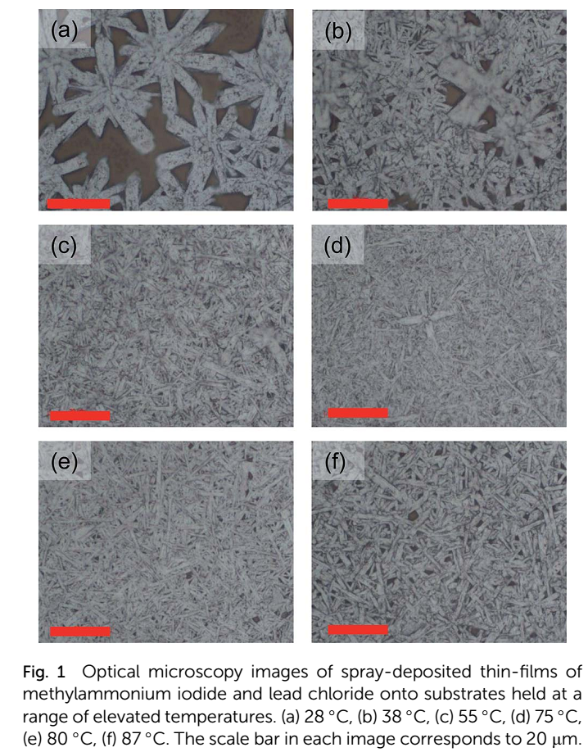**Background:** Organic metal halide materials that adopt the perovskite crystal structure show enormous potential to develop the next generation of low cost photovoltaic (PV) devices. New PV devices could potentially contribute substantially to clean electricity generation, provided devices can be made to operate with high efficiency, have extended lifetime and can be mass produced at low-cost. The current state of the art perovskite devices can achieve power conversion efficiencies of over 15% using materials that are cheap and relatively easy to process [1]. Considering the current industry leading conventional mass produced Si solar cells typically achieve PCE of about 18% and are expensive and difficult to process these new materials are rightly attracting a lot of research attention.

We have recently produced perovskites solar cells by spray coating (a technology easily scaled up to industrial production) which have achieved PCEs over 11% [2]. In order to achieve this success we had to optimise the processing temperature applied to the precursor solution during deposition by spray coating. Different processing conditions result in huge variations in the micro- and nano-scale structure of the active layer within these solar cells as shown in Fig 1. The efficiency of the resulting PVs is critically controlled by the micro- and nano-scale architecture of the device, as this controls both photon absorption and charge separation and transport efficiency which determine how photo-generated charges can be extracted from a device.

The presence of lead in the most commonly investigated perovskites material (CH3NH3PbI3-xClx) is considered to be a significant environmental concern because of the toxicity of lead and its associated compounds. Therefore there is a strong need to develop ways to reduce (or ideally replace) the lead within the perovskite active layer of this class of solar cells.

**Project description:** In this project, the student will investigate the influence of processing conditions on the micro- and nano-structure of the perovskite films. In the first instance they will investigate the conventional CH3NH3PbI3-xClx material as a function of solution deposition conditions and post deposition annealing conditions. This material can be made relatively easily from low cost commercially available precursor compounds. As can be seen in Fig 1 the morphology of the active layer can vary considerably depending upon these conditions. One of the main considerations for good device performance is known to be surface coverage for fairly obvious reasons. However, it is also evident that the crystal size also varies significantly in this sample set and therefore the amount of crystalline grain boundaries. One aim of this project will be to determine the importance of the crystal size and therefore amount of crystalline grain boundaries within this class of PV material. X-ray and neutron scattering will be used to confirm the crystal structure within the crystallites and quantify their average size. Grazing incidence wide angle x-ray scattering will be used to determine the crystal structure and intermolecular packing, and small angle scattering (both x-ray and neutron) will be used to quantify the typical crystallite size and the presence of any surface enrichment within the perovskite films. These results obtained at central facilities such as Diamond Light source and ISIS will be compared to local variations in crystallinity by in house microscopy techniques. This will be done through energy selective scanning electron microscopy (EF-SEM) can provide chemical contrast variations or crystallinity related contrast, depending on the selection of the filter energy In any case EF-SEM substantially improves the contrast available in a conventional SEM. This project aims to employ this state of the art technique to differentiate between the perovskite crystals and the amorphous grain boundaries thereby extracting highly valuable data about the crystal grains and grain boundaries occurring within these materials. We will also make significant use scanning probe microscopy techniques that are currently available in Sheffield. These include atomic force microscopy with quantitative nano-mechanical analysis which will permit mechanical properties of the perovskites films to be determined on nanometre length-scales.

Once the student has mastered these techniques using the fairly conventional perovskite PV materials they will progress onto reduce lead and lead free alternative materials such as CH3NH3PbySn1-yI3-xClx. The aim of the project is to help to further our understanding of interfaces between materials that are either crystalline or amorphous by correlating structural information with measurements of device performance. In particular, we believe that the size, distribution and connectivity of the various domains within a perovskite film will have a direct impact on both hole and electron mobility and will thus play a direct role in controlling device efficiency. The information from this work will feed directly into our device development programme and our material synthesis activity, and – we hope – will help develop PV devices with improved operational efficiency.

We have built a strong multidisciplinary team of supervision support for this project consisting of Prof David Lidzey in the Department of Physics and Astronomy who has extensive expertise in the field of PV device fabrication, Dr Conny Rodenburg in the Department of Materials Science and Engineering who is an expert in electron microscopy and its use to characterise PV materials and finally, Dr Alan Dunbar in Chemical and Biological Engineering who is a highly experienced user of x-ray and neutron scattering techniques to analyse these types of materials.

1. Liu, M., M.B. Johnston, and H.J. Snaith, *Efficient planar heterojunction perovskite solar cells by vapour deposition.* Nature, 2013. **501**(7467): p. 395-398.

2. Barrows, A.T., et al., *Efficient planar heterojunction mixed-halide perovskite solar cells deposited via spray-deposition.* Energy & Environmental Science, 2014. **7**(9): p. 2944-2950.