Cache Money
Group Members:
Taylor Cannon
Zac Lozano
James Kunze
Travis Cammack
Andres Echeverria
Rene Trevino

Problem:
We are creating a website that will contain information about different crises around the world. The goal is to spread awareness and an enduring resource for events that have far reaching impacts around the world.
The site is an endeavor with technologies that are new to our team members, such as Django, MySQL, HTML, CSS, and advanced Python scripts. The site will use relation data tables in MySQL to store and dynamically render the pages of the website so that the site will be easier to add information to in the future.

Use Cases:
This site has several potential users. This site might be used by students, or academics as a resource for researching international crises of the modern era. This site might also be used by people looking to keep up to date on international issues.

XML Schema:
The schema was designed in a joint effort by Taylor Cannon, Aaron Stacy, Stephen Chiang, and Vineet Keshari. The schema was designed to both conform to the criteria set out by the assignment and to allow for flexibility in database design. We require a single global tag called WorldCrises so that the information can be easily parsed by the ElementTree package built into Python. The XML file will be stored intermediately in the ElementTree data structure so that we can specify where the specific data goes in our MySQL database.

Import/Export:
Our import and export functionality was implemented by most of the team. We tried to modularize the functionality, breaking the importing and exporting down into subtasks. The process of importing consists of reading the xml file and storing in an ElementTree (xml_read). Then we pass the root of the ElementTree to our function that will parse the data and pass it to our Django models which will populate the MySQL database (xml_etree2mods). The exporting process is the converse of importing. We begin by reading the database into an ElementTree (xml_mods2etree). Then we parse the ElementTree and store the data in a formatted string (xml_etree2xml). Currently, we display the xml on the export pages.
Charts:
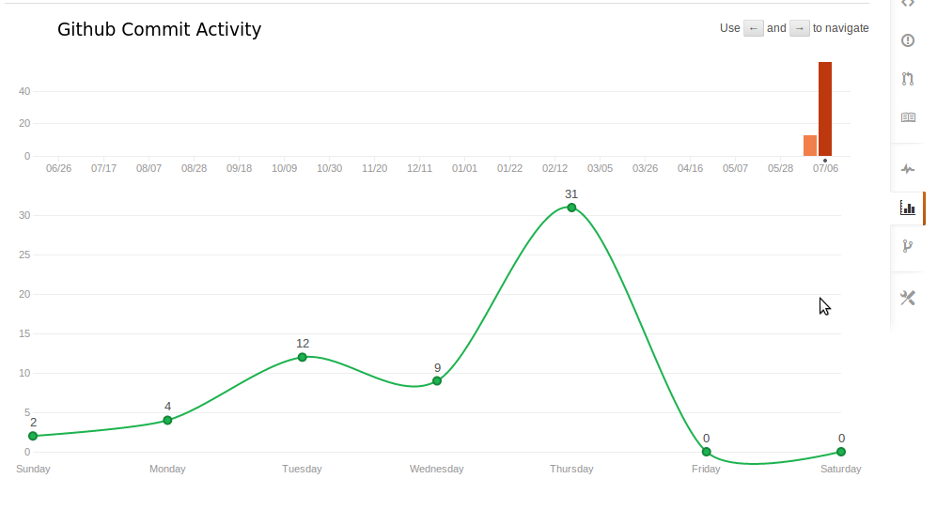
(this chart details the number of commits we had to git over the past week of the project)

Unit Tests:
Unit tests were implemented by James Kunze and Rene Trevino. We had significant difficulty even getting tests that could run. Django's testing suite normally tries to create a second database to test on, but as it does not have permissions to do so it fails. We got around this by changing the TEST_RUNNER to not make a new database, but means the testing database is the same as the regular database. This is unacceptable, and as the tests have to be runnable from the webpage it severely limited what we could actually test as almost all of our code works on the database. As such, what tests we have mostly just checked the static page views.

