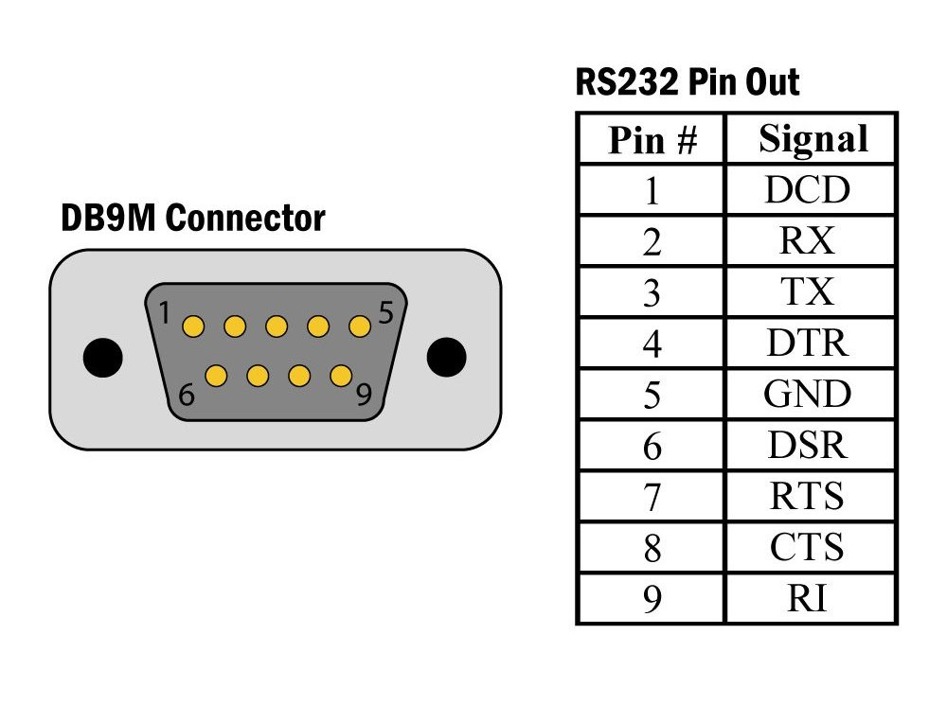

DB9M Connector AMI RTU

PIN2 (RX) -> RS232_TX

PIN3(TX) -> RS232_RX

