I don’t have Atmega 328: I use Metro M0 Express (Arduino)

I don't have these things:

* Battery 24V
* Relay 3.3V
* Motor
* SD Card
* Potentiometer

Wirings:

Metro M0 Express

A0 -> Analog Read for Potentiometer that change the Motor value

A2 -> Analog Output for Motor Velocity

D2 -> Digital Output for Relay

D3 -> Digital Output for Relay

GND -> Connect all GND together (Battery GND, ESP32 GND, others GNDs)

TX (PIN1) -> ESP32 (RX2) PIN

Relay

NO -> VIN Motor

NC ->

COM -> 24 V Battery

ESP32

D15 -> Digital Input - Button Pressed to send the data to Backend (Google Sheets)

How it should works:

1. Metro M0 Express turns on. It reads the analog value from the potentiometer and determines the speed of the motor.(Relay is used here to provide the power for the Motor)
2. When the button is pressed, Metro M0 Express will log 10 data and send the data to ESP32 via Serial.
3. ESP32 receives it and saves the data on the SD card.
4. When the button in ESP32, send the logs data to Google Sheets.

Demo Video:

https://drive.google.com/file/d/1ABy6gAeYv60vUWlBCA978ieWE8bijqa9/view?usp=sharing

View the message in Google Sheet : https://docs.google.com/spreadsheets/d/16SeK0BNRwFx132wfDX3DMPDfOuZqLAft4Dj6OkWECIw/edit?usp=sharing

How it work right now:

1. Type anything in the Serial USB in Arduino, it will send the data to ESP32

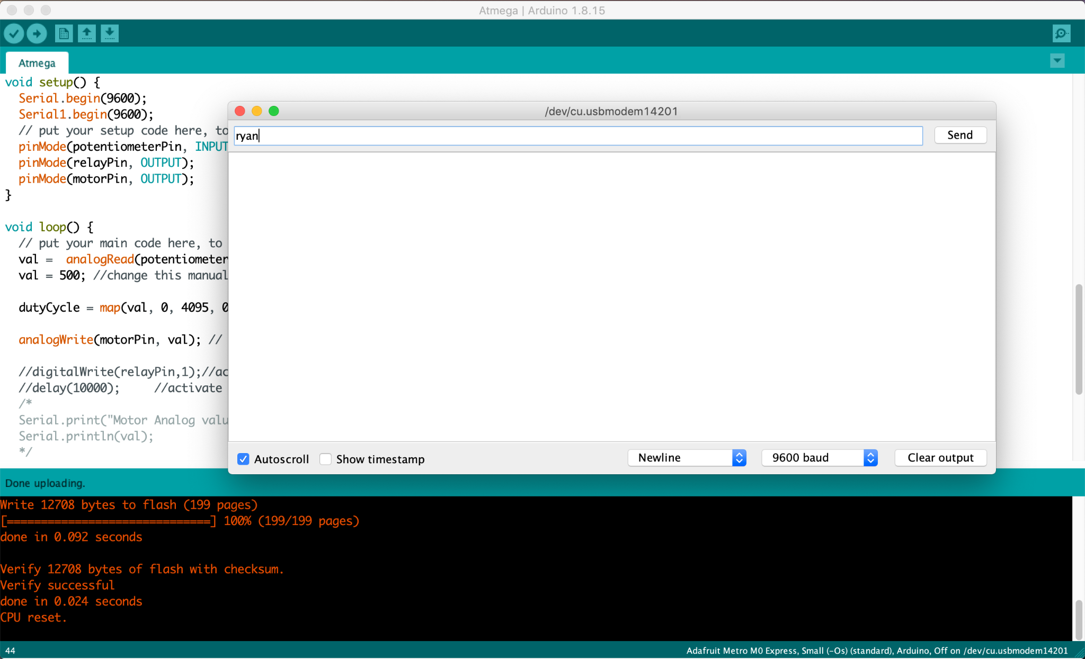

1. ESP32 received the data.

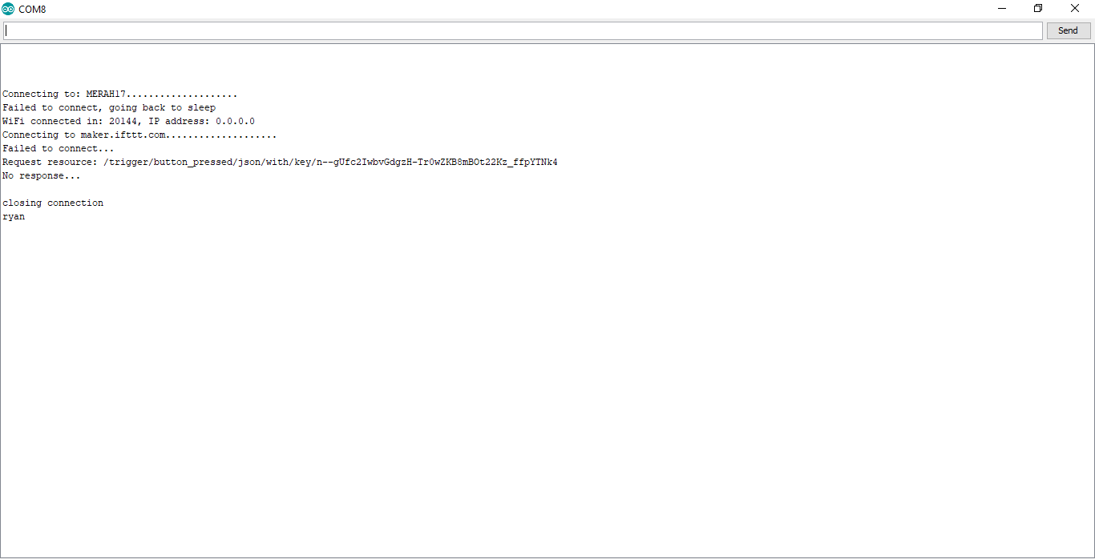

1. Pressed the Button on D15, it will send the data to the Backend (Google Sheets)

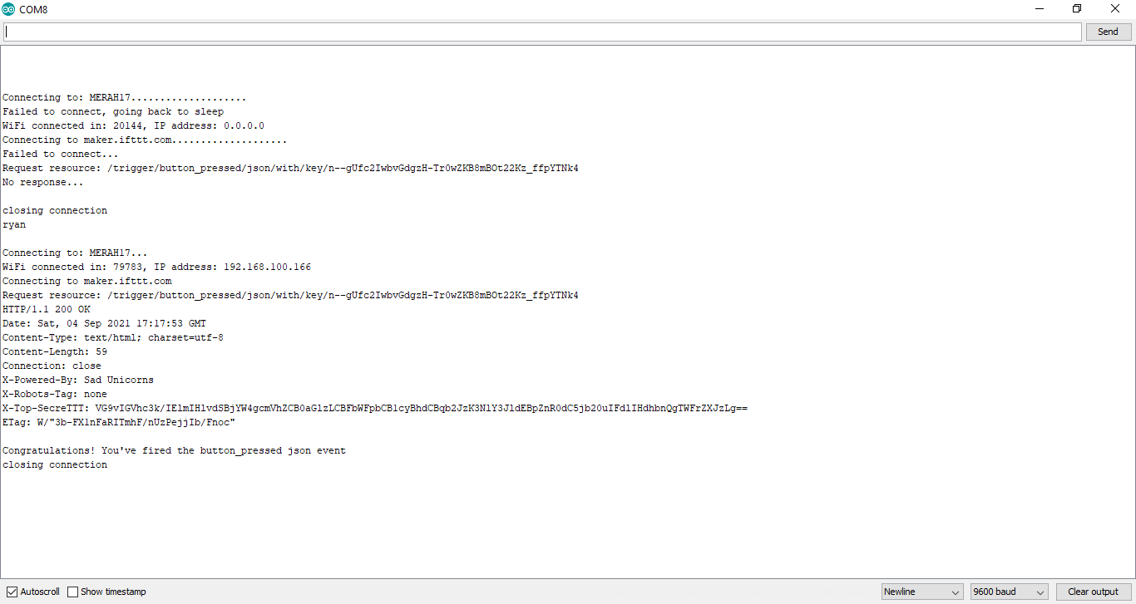

1. Data that we got from ESP32.

